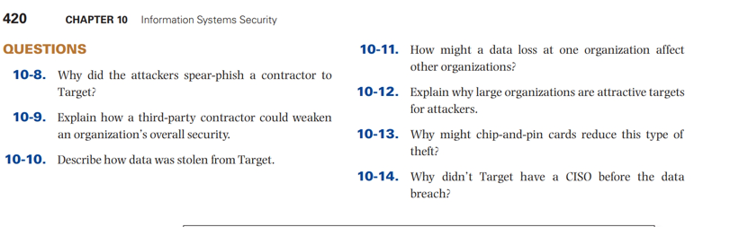

10-8
The attackers used spear-phishing in order to infect a Target third party vendor in order to gather keystrokes, screenshots and login credentials so as to easily access the vendor portal/server on the Target’s network.
10-9
The security shortcomings of the third-party vendors is every cybercriminal’s dream. The third-party could be a reason to data breach which is a security risk. In many cases, hackers use the third party to
get into systems of these companies.
10-10
The attackers first used spear-phishing to attack the third party named Fazio Mechanical Services. Then the attackers used malware names Trojan to compromise the systems such as Windows file server, and the POS terminals. The customer data was then sent continuously from the POS terminal to an extraction server within the Targets network.
10-11
Data loss could in one organization could affect the other organizations in one way or the other. For example, when the organizations share the same server, attackers can use one of the organization’s systems to attack another. Organizations that work together might be an easy one for the attackers. For example, network service providers of a company could attract the attackers to use the service provider to attack the organization.
10-12
Large companies are attractive targets for attackers because, they provide a huge chunk of money once the deal goes through. No attacker want to do a tedious and risky job for small amount of money. large companies have a wide range of systems, channels e.g. POS terminals which make it easy for the attacker to carry out their mission.
10-13
The chip-and-pin cards help in reducing theft and contain the right security measures (EMV technology) for the information contained in the card. Information in chip-and-pin cards is encrypted and if the credit card chip reader used once, it cannot be used to make a frequent purchase.
10-14
Target did not have a CISO before the data breach because the company was not ready for the attack until it came. The company saw no need of having a CISO before until the loss and they wanted no more losses in the future that is why they had to hire a CISO.

