https://sso.losrios.edu/idp/profile/SAML2/Redirect/SSO?execution=e1s1

You click on the link above;

Username; W1742061
Password; Norton@1234

Then after you get access, click on “Canvas” as highlighted below,

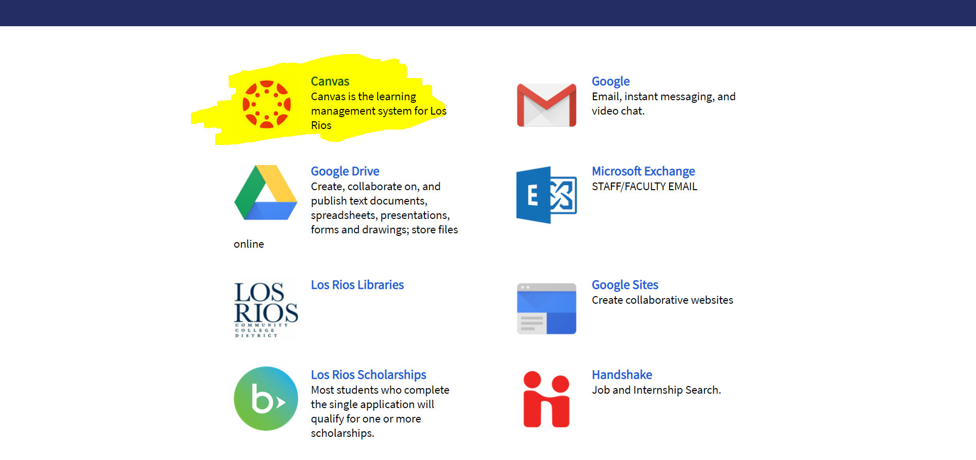

Then click on “Courses” as highlighted below;

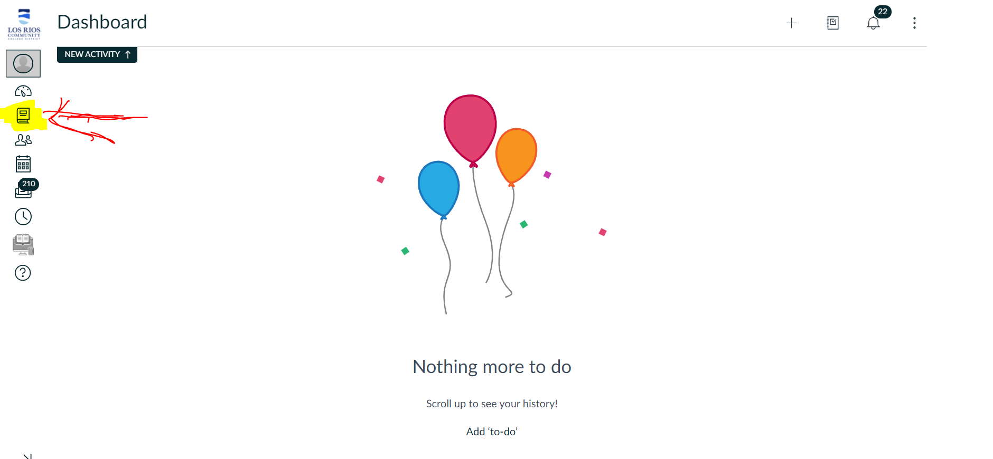

Then click on “Fa19 CISP 360 (Combined)” as highlighted below;

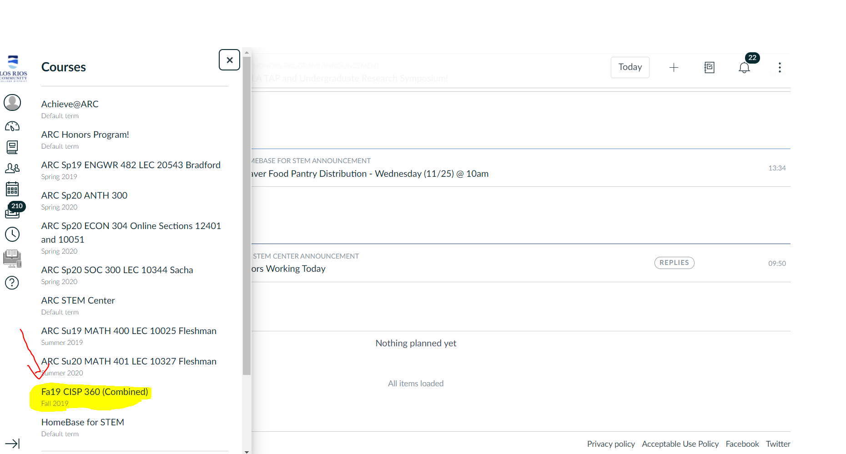

After you access the course, click on “Modules” as highlighted below;

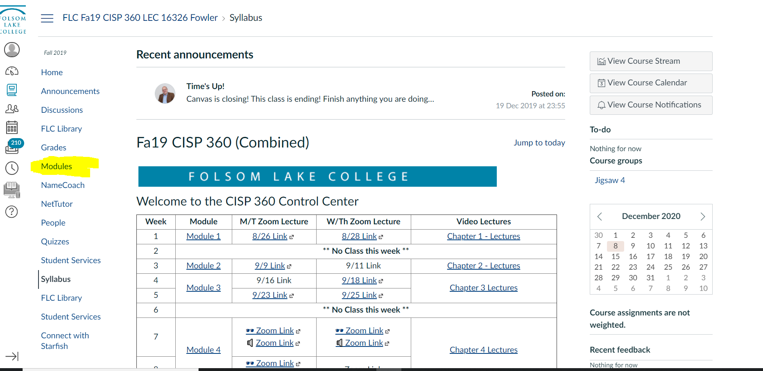

Once you access modules, you will see that there are 9 modules. Each module contains a quiz, except module 1 and module 2 (Because I already took the quiz for both of these modules.) As you go through module 3, 4, 5, 6, 7, 8, and 9, you will see that each one of them contain a quiz, which will be highlighted below as well.
