CRIJ2361.07- Online

INTRODUCTION TO THE CRIMINAL JUSTICE SYSTEM

Fall, 2017
Professor: Dr. Steven Cuvelier | Class Rm: No classroom
Office: Hotel 220 | Office Hrs: Online Daily.
Telephone: 936 294-1641 | Or by appointment
E-Mail: Steve@shsu.edu

TEXTBOOK: Cole, Smith and DeJong. The American System of Criminal Justice, 14th ed. Cengage Learning. 2015. ISBN: 978-1285458991

COURSE DESCRIPTION
This is an introductory course designed to familiarize you with the facets of the criminal justice system, the sub-systems and how they interrelate, processing of offenders, punishment and its alternatives, and the future of the criminal justice system.
This class will make extensive use of Blackboard to facilitate learning and communication. Lecture materials and links to resources will be posted on the class site. You are expected to take personal initiative in self-assessing your understanding of course material by taking learning checks that are available on the class site. In addition, discussion assignments will be given across the semester that will require you to read and post material to the discussion board.
There will be an exam with each assigned chapter. The exams consist of items drawn at random from the test bank. The exam can be taken at any time up to two weeks from the first day the chapter is assigned.
Frequent and regular activity in this class will be essential for successful completion.

Course Policies
GRADING: Grades will be assigned on a percentage basis on the total of 520 points. Letter grades will be assigned on a 90/80/70 percent scale. (Note: Work completed on units 14 and 15 will be counted as extra credit.)
Exams (13 x 20 pts) | 260
Discussions (13 x 20 pts) | 260
Learning checks are provided to prepare you to take the exams. Each learning check will be 20 randomly drawn questions from the chapter. You many practice as many times as you wish before taking the test. There are no points gained or lost from repeated attempts but your
Exams will be objective and timed. You will be allowed 10 minutes per 20-question exam. If you have practiced on the associated learning check, the allowed time should be more than adequate. However, for those who have registered special needs with the university, I will work with you in whatever way is necessary to make appropriate accommodations.
Discussions involve review of a video, reflection on certain questions or issues raised by the video and then responding to the reflections posted by others. There is a rubric that will be used to grade your performance. Please consult the Blackboard site for the rubric details.
MAKE-UP EXAMS: You will take exams individually which will not require a make-up policy.

Assignment Schedule
You have two weeks from the assignment dates to complete the chapter exams. You can add to your discussions throughout the semester.
Date |  | Reading | Online Discussion
Aug
24 |  | Chapter 1
  Read: NYC Crime Rates Fall.
  This article based upon published statistics and is written from a "progressive" political position.
  What conclusions are reached by this author, regarding the role of the police in abating crime?
  What implications does this article support for law enforcement policies?
  Express your challenge or support for this position.
31 |  | Chapter 2 | Read: Fraternity Dosed Women with Date-Rape Drug  What do you think those responsible would say in their own defense?  Do you think that their action constitutes a crime? If so, what criminal charge should they receive?  If others in the fraternity knew about this but did not participate are they still liable?
Sept
7 |  | Chapter 3 | Read: Kelly Thomas Beating Death by Police  As a mentally ill person, Kelly Thomas was unable to comply to police orders as quickly or as completely as the police wanted. He was visibly confused by what he perceived as conflicting orders (e.g., While sitting on the curb Kelly was repeatedly told... "put your legs out, put your hands on your knees." Kelly would stretch his legs out, then draw them in to put his hands on his knees. This agitated the officers who, using expletives and threats would repeat the orders. A confused and frustrated Kelly then got up to walk away, which initiated the deadly beating.  While not charged in Kelly's death, the two officers were fired. The latest information indicates that one is working as an officer in another city, the other has retired on a $75,000 per year income and is suing the city of Fullerton for "wrongful termination."  - Can you relate this issue to more current aggressive and deadly behavior by the police?  - Discuss the use of force by police. What constitutes necessary and excessive force?  - Why might the jury have found the police officers not guilty?
16 |  | Chapter 4 | Read: Civil Forfeiture Laws and The Continued Assault On Private Property  Discuss the purpose behind civil forfeiture and how it can result in abuse and “stealing” money from innocent citizens.  What can be done to establish a balance of justice for the guilty and innocent people caught up in the civil forfeiture net?
23 |  | Chapter 5 | Which of the three functions of law enforcement do you think is the most important? How does your opinion compare to that of the general public?
30 |  | Chapter 6 | Read this article: What is it like to be a Female Police Officer?  What types of issues must female officers overcome?  What can be done to overcome some of these issues?  What do you see as the strengths or weaknesses of females in law enforcement?
Oct
5 |  | Chapter 7 | Read the article: Lawsuits against Dallas Police costing the city millions  Examine the list of lawsuits and the money paid out for alleged wrong-doing by members of the Dallas Police Department.  Take a position on Police Chief Brown's statement regarding "no excuse" for policy or training violations leading to monetary payout to those subjected to these violations.  Should those who are truly committing a crime be compensated for police misconduct?
12 | Chapter 8 |  | The purpose of this exercise is to consider the balance between civil liberties and public safety.  Read the article "Plain View Doctrine"  Discuss what constitutes plain view and apply the doctrine to the following scenario:  Your cellphone is in the car on the passenger seat. It is on, but locked with a password. A police officer stops you on a traffic violation. The officer suspects that you were texting while driving (falling under an impaired driver statute).  Is a locked phone’s content in plain view if the phone is in plain view? Should the officer be able to seize the phone and use whatever evidence may be found on it against you?  Would your answer change if the officer had not encountered you in this stop but someone who "resembled a jihadist"?
19 | Chapter 9 |  | Read the transcript: Courting Disaster – Budget Cuts Take Heavy Toll on L.A. Courts  Discuss consequences of the budget cuts in the LA County Superior Courts.  How it might impact the administration of justice?  The Superior Courts also handle criminal cases. How will criminal justice be impacted?  What compromises or measures may be taken to handle the increased workload?  Can justice truly be upheld when the system is impaired with inadequate resources? Who will be the losers?
26 | Chapter10 |  | Read the article: Prosecutorial Misconduct  Discuss the negative consequences of prosecutorial misconduct on the criminal justice system.  What pressures do you think may produce misconduct?  Are there circumstances where prosecutorial misconduct may be excused?
Nov
2 | Chapter 11 |  | Read: "Wrongful Convictions"  Despite the substantial risk of wrongful convictions, why would prosecutors resist any effort to limit their use of one defendant's testimony against another?  How could current legal practice be changed to limit the risk of wrongful conviction? What impact might changes have on security a correct conviction?  The appellate process is imperative to safeguard against wrongful convictions. Does the appellate process provide equal protection for all defendants?
9 | Chapter 12 |  | Read the article: Is Mass Incarceration the New Jim Crow?  Discuss the original Jim Crow laws and their purpose.  Why does Alexander argue that mass incarceration is the New Jim Crow?  Do you agree or disagree with is argument?
16 | Chapter 13 |  | Read the article: "The U.S. Prison Incarceration Rate: The Largest in the World"  Do you believe that this is really true that the U.S. has the largest incarceration rate in the world?  Discuss the causes and negative consequences of the rising incarceration rates.  Does this reflect well or badly on the U.S.?
23 | Chapter 14 |  | Read the article: San Diego Mayor Bob Filner.  What was Bob Filner's offense?  Some of the accusations were old. Does that damage the credibility of the accusers in your opinion? Why or why not?  What would be the likelihood that he would be accused and tried 10 years ago?  Assume that some of Filner violations occurred at a time when such actions were generally tolerated by society. Would it be just or unjust to prosecute him on those violations today?
30 | Chapter 15 |  | Read: Kentucky Ends CCA Contract  What is Kentucky's reasons for ending the contract with CCA (Corrections Corporation of America)?  CCA's Lee correction facility claims to run the most effective drug rehabilitation program in the state. How likely is it that this program would be equally successful if run by the Kentucky department of corrections? Why?  Based upon this article, what are the pros and cons of ending the CCA contract?
All work must be submitted no later than 11:59 p.m. on December 7.

COURSE TOPICS AND OBJECTIVES:
Chapter 1
- Discuss how public policies on crime are formed
- Recognize how the crime control and due process models of criminal justice help us understand the system
- Explain: “What is a crime?”
- Describe the major types of crime in the United States
- Analyze how much crime there is and understand how it is measured
Chapter 2
- Describe who is likely to be victimized by crime
- Discuss the impacts of crime on society
- Identify the justice system’s responses to the needs of crime victims
- Describe the theories put forward to explain criminal behavior
- Analyze crime-causation theories and apply them to different groups of offenders
Chapter 3
- Describe the goals of the criminal justice system
- Discuss the different responsibilities of federal and state criminal justice operations
- Analyze criminal justice from a system perspective
- Identify the authority and relationships of the main criminal justice agencies, and understand the steps in the decision-making process for criminal cases
- Describe the criminal justice “wedding cake” concept
- Discuss the possible causes of racial disparities in criminal justice
Chapter 4
- Describe the bases and sources of American criminal law
- Describe how substantive criminal law defines a crime and the legal responsibility of the accused
- Describe how procedural criminal law defines the rights of the accused and the process for dealing with a case
- Analyze the United States Supreme Court’s role in interpreting the criminal justice amendments to the Constitution
Chapter 5
- Describe how policing evolved in the United States
- Discuss the main types of police agencies
- Analyze the functions of the police
- Describe how the police are organized
- Analyze influences on police policy and styles of policing
- Discuss how police officers balance actions, decision making, and discretion
- Describe the importance of connections between the police and the community

Chapter 6
- Discuss why people become police officers and how they learn to do their jobs
- Describe the elements of the police officer’s “working personality”
- Analyze factors that affect police response
- Describe the main functions of police patrol, investigation, and special operations units
- Analyze patrol strategies that police department employ
Chapter 7
- Describe the new technologies that facilitate crime, assist police investigations, and affect citizens’ rights
- Discuss the issues and problems that emerge from law enforcement agencies’ increased attention to homeland security
- Analyze the policing and related activities undertaken by private-sector security management
- Discuss the ways police can abuse their power and the challenges of controlling this abuse
- Identify the methods that can be used to make police more accountable to citizens
Chapter 8
- Know the extent of police officers’ authority to stop and search people and their vehicles
- Understand when and how police officers seek warrants in order to conduct searches and make arrests
- Know whether police officers can look in people’s windows or their backyards to see if evidence of a crime exists there
- Analyze the situation in which police officers can conduct searches without obtaining a warrant
- Understand the purpose of the privilege against compelled self-incrimination
- Understand the exclusionary rule and the situations in which it applies
Chapter 9
- Describe the structure of the American court system
- Analyze the qualities that we desire in a judge
- Identify the ways that American judges are selected
- Describe the pretrial process in criminal cases
- Discuss how the bail system operates
- Analyze the context of pretrial detention
Chapter 10
- Describe the roles of the prosecuting attorney
- Analyze the process by which criminal charges are filed, and what role the prosecutor’s discretion plays in that process
- Identify the other actors in the system with whom the prosecutor interacts during the decision-making process
- Discuss the day-to-day reality of criminal defense work in the United States
- Describe how counsel is provided for defendants who cannot afford a private attorney
6. Analyze the defense attorney’s role in the system and the nature of the attorneyclient relationship
Chapter 11
- Describe the courtroom workgroup and how it functions
- Discuss how and why plea bargaining occurs
- Analyze how juries are chosen
- Identify the stages of a criminal trial
- Describe the basis for an appeal of a conviction
Chapter 12
- Describe the goals of punishment
- Identify the types of sentences that judges can impose
- Discuss what really happens in sentencing
- Analyze whether the system treats wrongdoers equally
Chapter13
- Describe how the American system of corrections has developed
- Analyze the roles federal, state, and local government play in corrections
- Discuss the law of corrections and how it is applied to offenders and correctional personnel
- Describe the direction of community corrections
- Explain why the prison population has more than quadrupled in the last three decades
Chapter 14
- Analyze the philosophical assumptions that underlie community corrections
- Discuss how probation evolved and how probation sentences are implemented today
- Describe the types of intermediate sanctions and how they are administered
- Analyze the key issues facing community corrections at the beginning of the twenty-first century
Chapter 15
- Describe the three models of corrections that have predominated since the 1940s
- Discuss how a prison is organized
- Analyze how a prison is governed
- Describe the role of correctional officers in prison
- Discuss what it is like to be in prison
- Analyze the special needs and problems of incarcerated women
- Describe programs and services that available to prisoners
- Discuss the nature of prison violence

DISCUSSION FORUM RUBRIC

This rubric will be used to assign points to all discussion forums. An additional point will be assigned based upon [the number of words]/150, up to 6. E.g., 900 words = 6 points. The number of characters typed may be used with 5 characters treated as 1 word.
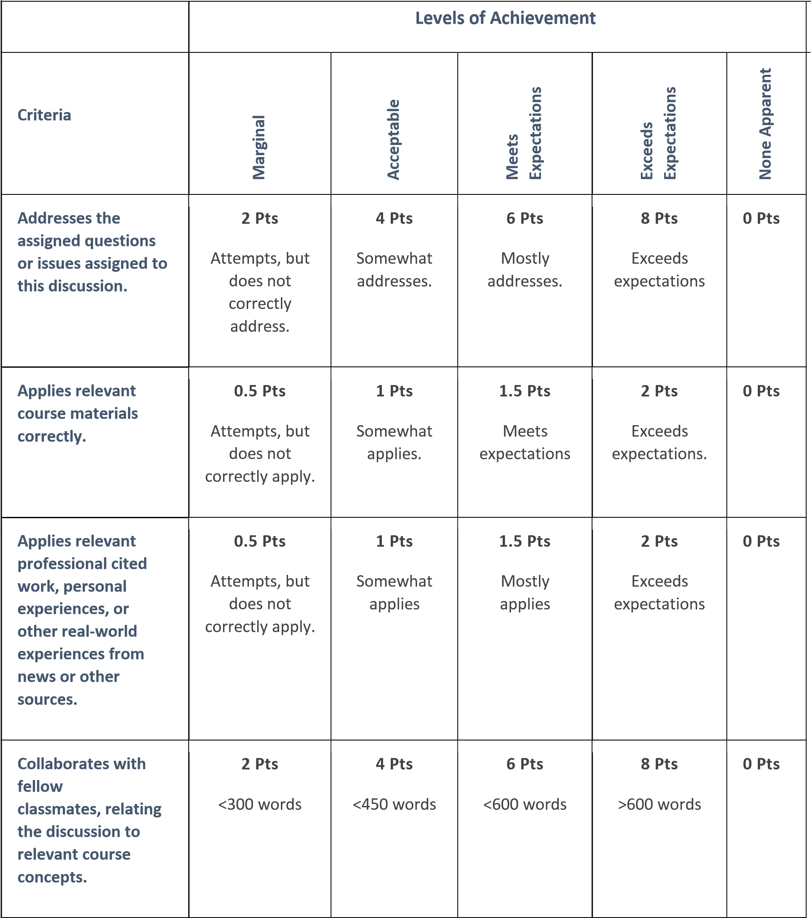

University Policies and Services
Students should refer to the following sites for updated language on the following policies and services.
ACADEMIC HONESTY:
http://www.shsu.edu/administrative/faculty/sectionb.html#dishonesty
DISABLED STUDENT POLICY:
http://www.shsu.edu/~vaf_www/aps/811006.html
SERVICES FOR DISABLED STUDENTS:
http://www.shsu.edu/~counsel/sswd.html
STUDENT ABSENCES ON RELIGIOUS HOLY DAY POLICY:
http://www.shsu.edu/catalog/scholasticrequirements.html#holyday
USE OF TELEPHONES AND TEXT MESSAGERS IN ACADEMIC CLASSROOMS AND FACILITIES:
http://www.shsu.edu/~vaf_www/aps/documents/100728.pdf

