Concept Map for Smoking Cessation and Alcohol Abuse
Student’s Name
Professor’s Name
Institutions Affiliation
Course
Date

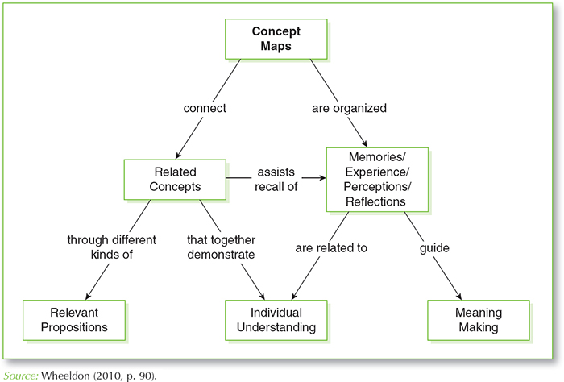

The concept map above is purposely created to help reach and connect with many people smoking and abusing alcohol. Research shows that most people using various substances are associated with mental illness or disorders, so the first and foremost step to reach and help them get required medical services is to connect with them via various kinds of propositions. Connecting smoking and alcohol abuse to mental illness is a significant moral and ethical responsibility to aid such people quite these immoral behaviors.
Another way to help victims of drug abuse is through organizing awareness campaigns, safety, and health talks in various institutions such as schools and prisons to create awareness among drug users. With this in mind, victims can relieve their uncomfortable, irritability, and anxiety feelings that most do experience while quitting smoking and alcohol abuse.
Now, the most critical part after organizing awareness talks and connecting with drug addict victims is guiding and positioning them for help.
As a professional, I am particularly suited to assist the victims in the local community since my profession has an array of tools that mainly emphasize behavior change or modification. For instance, cognitive therapy, motivational interviewing, commitment and acceptance therapy, and other sorts may help victims in the community stop smoking and alcohol abuse (Hu et al., 2018).

Reference
Hu, Y., Zong, G., Liu, G., Wang, M., Rosner, B., Pan, A., ... & Sun, Q. (2018). Smoking cessation, weight change, type 2 diabetes, and mortality. New England Journal of Medicine.

