WALMART INC. AND KROGER CO. ANALYSIS
Name
Institution
Date
Walmart’s Basic legal, social and economic environment in which they operate
Analysis of Walmart Inc. and Kroger Company:
Walmart has a mission that is rather converted into a slogan of offering products at low prices. One could worry as to where the intervention of the state is, and that is why I review the company’s legal environment. The company is subjective to laws of the state as The Kroger Co. is. These companies comply with the food safety regulations required in the economy as a health measure to the consumers. Also, they are required to comply with the employment regulation which is an opportunity to them. Both companies are expected to respect any tax reform by the Senate as long as they are to remain operating. For instance in 2000, Walmart began a war on sugar prices which was countered by small scaled competitors before the German Federal Cartel Office responded (Bengtsson et al., 2018). On the other hand, Kroger recently faced a law suit as a result of the deforestation cases caused by commercial agriculture – grocery retailing.
Social: Social-cultural factors affect consumer preferences. Walmart observes the diversity of culture, healthy lifestyle and urban migration. Kroger observes social groups as it brands products (Kroger, 2017).
Economic: As for Walmart, economic changes present relevant pressures. Economic environment is vital as it determines revenues to every company (Jorgensen, 2018). Walmart seeks to stabilize major economies, growing the developing economies and lowering unemployment rate in the US. Kroger faces deflated grocery prices hence it cannot profit on the business (Sheldon, 2017).
Managerial, operational, and financial issues impacting the organizations including:
Despite the lead in retail industry, Walmart has failed in employee training and development –poor customer service has been reported. Additionally, the management has totally failed connect with their customers. The company has many managers at different levels who possibly don’t differentiate their roles (Panos, 2016). Kroger’s management is prone to sacking thus changing corporate systems over and over. “Class at work” is another problem of the management – they keep a distance from the grocery stores.
The biggest financial issue facing Walmart is the low cost of its stock. It seems to have streamlined sales as profits were falling in 2010 through 2014. Kroger is serious financial problem, averagely, in the previous years it has reported least profits. Revenues $397 million and expenses worth $740 million, as at November 2018 (google Data).
Company Culture and Performance: Walmart is known for its reduced prices. This is a culture that the company introduced and it has becomes their competitive strategy. It is thus performing as the best retailer in US. Kroger, is the second top grocer company in US but it operates on state pricing and that is why it is far much behind Walmart despite the quality products.
Promotion Policies: Walmart has promotion packages for its employees but in undecided rates. It is again dependent on the economic performance. Kroger promotes employees annually at a rate of 2 percent.
Strategic Decisions Making; Kroger has a defined strategic plan that includes direction to allocate resources in pursuit of its motive. It uses SWOT analysis as well as PESTLE analyses funded by management. Having a record of un-thought decisions, Walmart has a strategy of making decisions. Analysis of factors is made through PESTLE and then decisions arrived at.
Decision-Making Style: Both companies use rational models of decision making.
Management Style: Walmart has a transformational style of management which is a pipeline of building leaders. It also promotes high performance by employees – transactional management. Kroger, utilizes visionary management.
Leadership Style: both companies use functional leadership models.
Communication Style: Extemporaneous style is used by Walmart and Kroger uses Manuscript style.
Use of SWOT Tool: Walmart has used the SWOT tool to brave its strengths and takes chances on opportunities as it works on threats and weaknesses, and so is the Kroger Company.
Operations Strategy Framework: Both frameworks are represented below;
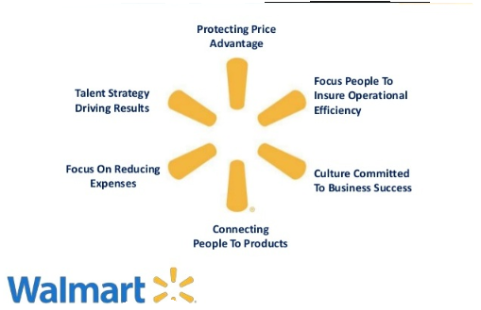

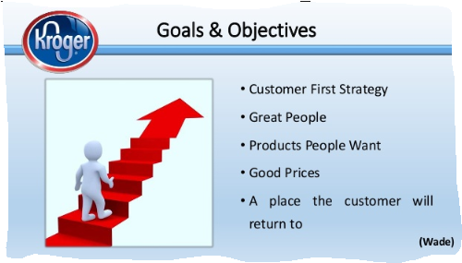
Analyze the impact of potential change factors as they relate to the functions of management for both organizations including:
Changing External Conditions:
Change is inevitable in any organization. Walmart’s management is profit driven but it doesn’t invest on employee competence. A change would design a supportive management that embraces employees growth and hence yielding an employee competitive company. To Kroger, factors of change would lead to a sustainable management that can be dwelt on for a good accounting period.

References
Bengtsson, L., & Tavassoli, S. (2018). The Role of Business Model Innovation for Product Innovation Performance (No. 2018/4). Lund University, CIRCLE-Center for Innovation, Research and Competences in the Learning Economy.
Jorgensen, J. T. (2018). The Foreign Corrupt Practices Act Turns 40:" Reflections on Walmart's Enhanced Ethics & Compliance Program". Texas A&M Law Review, 5(1), 237-252.
Kroger. (2017). Notice of 2017 annual meeting of shareholders: 2017 proxy statement and 2016 annual report. The Kroger Company. Available from http://ir.kroger.com/Cache/1500099541.PDF?O=PDF&T=&Y=&D=&FID=1500099541&iid=4004136

Panos Mourdoukoutas, (2016). “Walmart's Outdated Management Style Is Failing Customers.” https://www.forbes.com/sites/panosmourdoukoutas/2016/01/30/walmarts-outdated-management-style-is-failing-customers/#60fb63e713ae
Sheldon, I. M. (2017). The competitiveness of agricultural product and input markets: a review and synthesis of recent research. Journal of agricultural and applied economics, 49(1), 1-44.

