COM114 – Spring 2021

Assignment 1 (10%)
Video Analysis Assignment

Individual Submission

Student Name: | Section:
Student ID: | Grade: /100

Question 1: (50 points)

Instructions:

- Watch the video using the following link:
https://www.youtube.com/watch?v=ofaK3jijcxs



- Analyze the video in detail by answering the following questions:

  - What are the communication settings in this video?
  - What are the communication contexts in this video?
  - Is the communication successful? Why?
- Write your answer in a paragraph of no less than 200 words.
Video Analysis:

The setting in which communication this video is taking place is verbal communication in which the speakers are mainly making use of a loud speaker to make their remarks. The speakers make used of words to share information with other individuals. The verbal element of communication involves words that the speakers use, the way they are heard as well as interpreted. This communication was featured by having the ability to speak clearly, and listen. The communication context in which the interaction took place was an interpersonal communication. This is because it takes place when two or more individual communicate and exchange information of ideas. The is because this conversation involves all the elements of the interpersonal communication. There are the communicators who are taking part in the conversation, the message being passed which involved facial expressions, tone of voice, gestures as well as body languages. The interaction involved feedback where the communicators were sharing their ideas which were really differing. The communication was not successful since there the individuals had contrasting ideas on what to do. Each one of them had a solution though they had contrasting purposes. At one time the two heads confused the subordinates since they were giving orders which had contrasting aims.
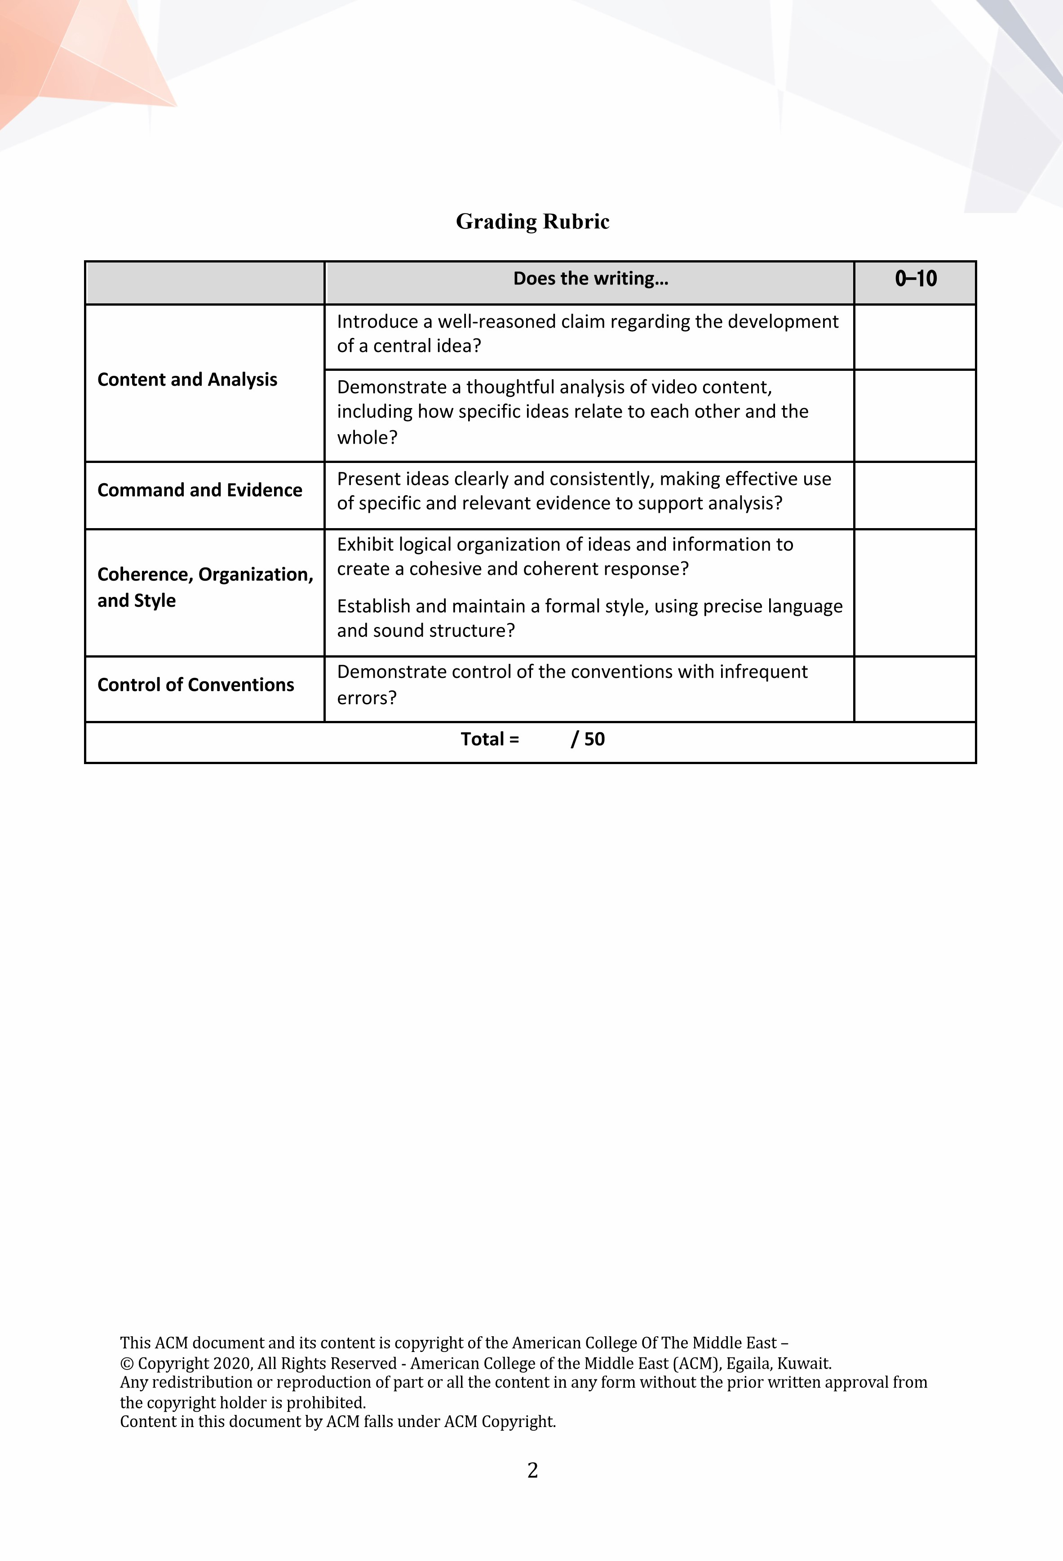


This ACM document and its content is copyright of the American College Of The Middle East
–

© Copyright 2020, All Rights Reserved
-

American College of the Middle East (ACM), Egaila, Kuwait.

Any redistribution or reproduction of part or all the content in any form without the prior written approval from
the copyright holder is prohibited.

Content

in this document by ACM falls under ACM Copyright.

3

Question

2:

(
30

points)

List

the different charcteristics of communication. Explain
TWO

of them in
detail
.

The most essential characteristics of communication include at least two individuals. Communication should involve at least two individuals. This involves the individual sending and the receiving. The sender that sends information is referred to as the communicator while the person receiving information is referred to as the receiver. Communication must contain purpose. Basically communication should have a message. A message refers to the subject matter of communication. If there is no message, then there will be no communication since the main purpose of communication is to develop an understanding. The receiver should understand the message that is sent and should respond effectively (Veldhuijzen, et al., 2007).
Question 3: (20 Points)
Explain one example (From your life) of a situation when communication was not successful and explain why the communication failed in that situation
At one time in my work place there was a time when my boss sent a series of questions pertaining my experience at the workplace through email. I responded to the email using yes and no responses. My boss had to call to ask for clarifications to some of the questions.
This communication failed since the yes and no responses were confusing to my boss and he required clear, detailed and comprehensive response

References

Veldhuijzen, W., Ram, P., Weijden, T., & Niemantsverdriet, S. (2007). Characteristics of communication guidelines that facilitate or impede guideline use: A focus group study. BMC Family Practice, 8(1), 31

