Topographic map assignment
Students’ name
Name of the institution

ASSIGNMENT 1
The map used is the downloaded Nettie West Virginia Topo Map
- Provide the following
- Publisher
Published by the United States Geological Survey in the year 2019
- The title?
The title of this map is Nettie West Virginia Topographical map
- The scale
The scale of this map is
1: 24000
That is 1km= 1000m
- Features noted in the legend
In the legend, the following feature is shown
Roads
Creeks
Cities
Ridges
Summits

2 . Precursory look at your map. What features can you see? Are there mountains, rivers, highways? Provide a brief description of what the terrain might be thought to be.
The terrain is the natural features that make up an area. For instance, an area can be inhibited by many hills, rocks, or even forest. Therefore we can term that area as having a hilly terrain.
On this map, there are rivers, mountains, and also highways. With the presence of a few mountains and ridges and having many highways, the terrain of this area is that there is a lot of plat with a lot of rocks. This makes the area only suitable for transport and carrying out business activities due to the availability of towns and cities.

- A point of interest on your map. What is this feature? Please explain this feature using your knowledge.
From the map, my point of interest is the White buck Knob. This is a summit feature. This feature lies at an approximate elevation of 3238 feet as displayed in the USGS Nettie west Virginia quad topo map. This summit feature lies in the coordinates of Latitude and Longitude as, 38.1348372,- 80.655089.

ASSIGNMENT 2
1. Contour interval
Contour intervals are what space the contour lines. Alternatively, contour lines ‘Topo maps’ as the main features of a map. In a deep statement contour interval is the difference occurring between two elevations that separate two contour lines ( Nawez et al. 2016).
Contours are calculated by finding the difference in the index contours or elevations. Then after getting the elevation difference, divide this by the number of contour lines separating the index line ( the darker or thicker lines ). Therefore in our case, the contour interval is
We have
5 contour lines
Highest elevation-2600
Lowest elevation-2400
Difference between the two=2600-2400
=200
Then after getting this difference in elevation you divide by the number of contour lines between the index lines which is
200/5
40 ft is the contour interval
2 The highest and the lowest summits between Beech Knob, Laurel Knob, and the Rocky Ridge.
Between the three; the Laurel knob is the highest
Rocky knob medium
Beech knob lowest
The reason supporting this is that;
Contour lines in Laurel Knob are very close together hence making it the highest while contour lines in the Beech knob are far apart hence making it the lowest
3. The name of the creek to the north of beech knob and Laurel Knob.
By definition, a creek is a stream of water that is not man-made but natural and is much smaller in size, and is always a tributary to a river.
The creek name is the line, Laurel Creek
4 Gradient of the south side of Rocky Ridges; using 2800m elevation as the lowest point of elevation
When one wants to find the gradients in a topographic map, one should understand that the gradient and slope are two words that can be interchanged. A gradient is important for environmentalists since it helps them know environmental issues that may occur in a given area. For instance, Erosion is important when the gradient of an area is known. Below is a procedure to calculate the gradient of an area.
- A line is drawn perpendicular to the lines showing contours
- Measure the line and change it into feet by using what legends gave in the map
- Calculate gradient by subtracting low contour lines elevation that was drawn from the elevation of the other side drawn.
- The answer is divided by the distance represented in the feet of the line you drew.
- Multiply the number by 100 to bring the slope percentage for the ridge
When doing this calculation first know the “rise”
In our case, the highest elevation is 3000ft while the lowest is 2800
Rise is given by the highest elevation minus the lowest which contour interval must be subtracted from it. That is
Lowest elevation 2800- 40 = 2760ft
Highest elevation 3000ft
Therefore the “ rise” is given by
3000- 2760 =240ft
Then the “ run” is the horizontal difference which is 2mi in our case
Gradient =rise/run
= 240/2
120ft/mi
Convert miles into feet
1 mi = 5280 feet
Therefore 2mi =10560 ft
120/10560 =0.077

If this is required in % you just multiply by 100
That is 0.077 by 100= 7.7% slope or gradient.
5. Approximate distance between Nettie and Odell town?
The approximate distance between the two is found by measuring the distance by use of a ruler. Approximately the distance between the two points is
6.25 inches where

1 inch = 0.38 mi therefore 6.25 inch is equivalent to
2.38 mi
6. List all major cities through which state Route 20 passes through.
Route 20 is a two-way lane road that passes through the following in the map.
- Boston
- Cleveland
- Chicago

7. Summit Potato Hole Knob. What is the total relief from the top of the Potato Hole Knob and Hominy creek?
The relief of an area is given by the elevation difference between the two points of concern. That is the lowest elevation of that area is subtracted from the highest elevation.
2400 ft is the highest elevation
2200 ft is the lowest elevation

Relief= 2400-2200
200ft

A COPY OF THE MAP
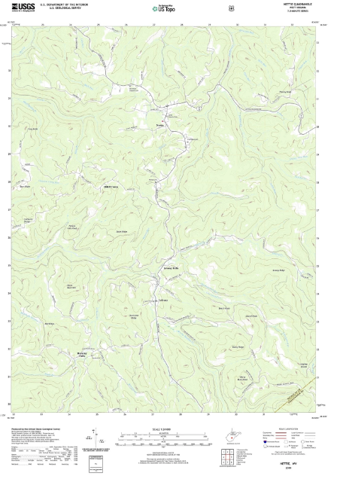
https://elevation.maplogs.com/poi/nettie_wv_usa.251818.html

References
https://elevation.maplogs.com/poi/nettie_wv_usa.251818.html
Newaz, A. A. R., Jeong, S., Lee, H., Ryu, H., Chong, N. Y., & Mason, M. T. (2016, May). Fast radiation mapping and multiple source localization using topographic contour map and incremental density estimation. In 2016 IEEE International Conference on Robotics and Automation (ICRA) (pp. 1515-1521). IEEE.

