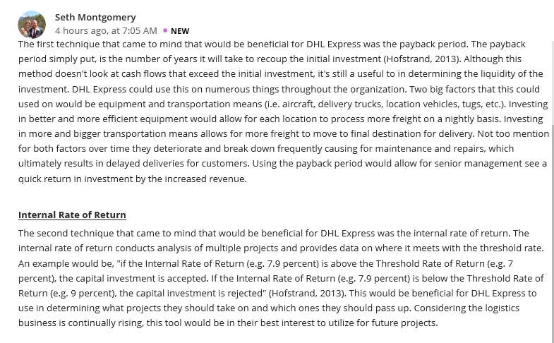
Reply 1
Hi! Montgomery
I absolutely agree with your point of view, Payback period is for sure a beneficial technique that DHL Express Company can use. The company profits seem to depend hugely on this technique, though it also ignores the value of money besides cash flows that exceed the initial investment. Equipment and transportation are two factors that make huge impact to DHL Express’ profits and therefore careful decision should be made upon them. Customers would not receive goods on time and in good condition if not for better delivery methods. According to my opinion, payback period would be the ideal technique for Seth use in making transportation decisions. Consequently, Internal Rate of Return would be a second best choice since it factors the time value of money which payback period ignores. Internal rate of return is a useful tool in evaluating projects or investments. DHL Express `would easily determine whether it lost or made money on a project. Thus, if a new project’s internal rate of return exceeds the company’s required rate of return, it is most likely that the project will be accepted. If the internal rate of return is less than the required rate of return, then the project will be rejected. DHL’s future projects would therefore be beneficial if internal rate of return technique is used

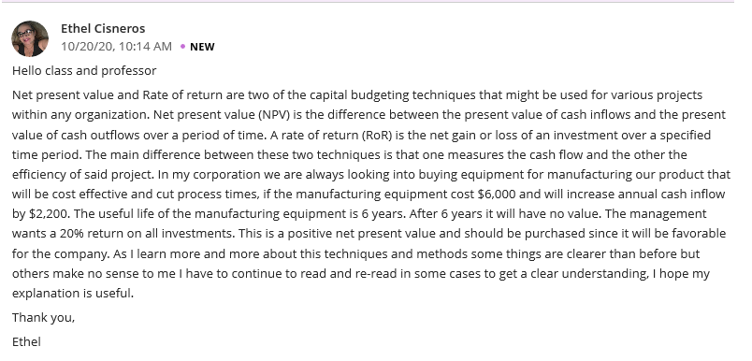
Reply 2
Hello Cisneros
It’s logical to note that both techniques can be relevant in determining whether a project is desirable or will add value to the organization. Net Present Value is though more beneficial because it takes into account factors that change, such as the difference in discount rates. Besides purchasing manufacturing equipment, furthermore, an organization can utilize the Net Present Value technique in cost reduction projects majorly through the automation of tasks that are currently done manually if the labor cost is high. Besides that; the purchase of more automated equipment machine if the present value of cost savings is higher than the previous cost of the present value. In a nutshell, both Net Present Value and the Rate of Return are used in capital budgeting to determine whether an expansion opportunity or new investment is worthwhile.

