- arctan ($\frac{1}{\sqrt{3}}$) = 30º
cos(30º) = $\frac{\sqrt{3}}{2}$

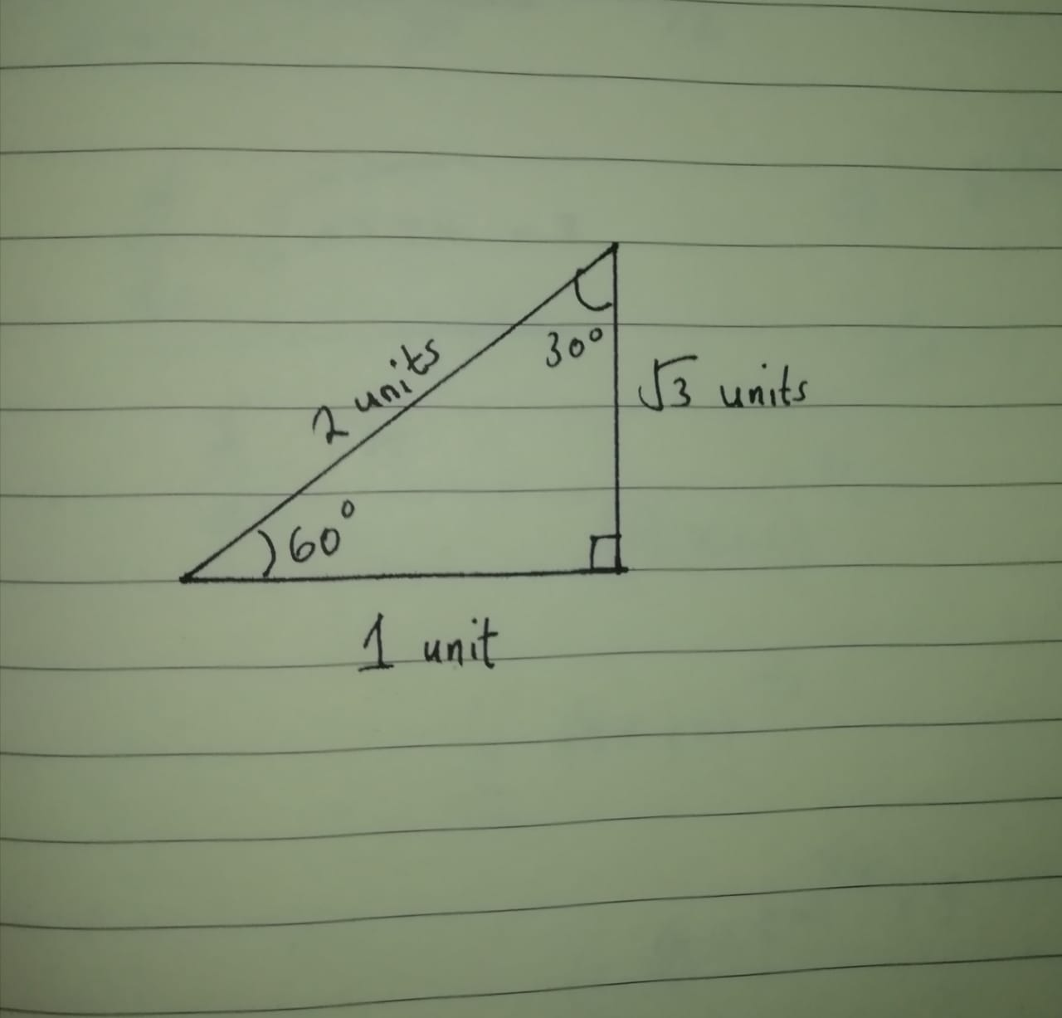

- $\lim_{x→0}\left(\frac{\sqrt{9x+a}-3}{x}\right)=\frac{3}{2}$

$$\lim_{x→0}\left(\frac{\sqrt{9x+a}-3}{x}\right)= \lim_{x→0}\left(\frac{\frac{d}{dx}(\sqrt{9x+a}-3)}{\frac{d}{dx}(x)}\right)$$

Differentiating the numerator using chain rule:

$$\frac{d}{dx}\left(\sqrt{9x+a}-3\right)= \frac{9}{2\sqrt{9x+a}}$$

$\lim_{x→0}\left(\frac{\frac{d}{dx}(\sqrt{9x+a}-3)}{\frac{d}{dx}(x)}\right)= \lim_{x→0}\left(\frac{9}{2\sqrt{9x+a}}\right)$ = $\frac{9}{2\sqrt{a}}$
$\frac{9}{2\sqrt{a}}$ = $\frac{3}{2}$

$$a=9$$

- 1st Case:

$$\frac{1}{\sqrt{x^{2}-1}}$$

$$x^{2}-1>0$$
$$x^{2}>1$$
-1 > x > 1

2nd Case:

$$\frac{1}{\sqrt{1-x^{2}}}$$

$$1-x^{2}>0$$
$$x^{2}<1$$
-1 < x < 1

Since the domain of $\sin^{-1}{x}$ = [-1,1] , $\frac{1}{\sqrt{1-x^{2}}}$ is the correct answer.

- $\lim_{x→0}\left(\frac{arctan⁡(x^{2})}{x arcsin⁡(x)}\right)$

$Applying L^{'}Hopital^{'}s rule$:

$\lim_{x→0}\left(\frac{arctan⁡(x^{2})}{x arcsin⁡(x)}\right)$ = $\lim_{x→0}\left(\frac{\frac{d}{dx}(\arctan\left(x^{2}\right))}{\frac{d}{dx}(x arcsin⁡(x))}\right)$

$\frac{d}{dx}(\arctan\left(U\right)$ = $\frac{U'}{U^{2}+1}$

$\frac{d}{dx}(\arcsin\left(U\right)$ = $\frac{U'}{\sqrt{1-U^{2}}}$

$$\frac{d}{dx}(\arctan\left(x^{2}\right)= \frac{2x}{x^{4}+1}$$

$\frac{d}{dx}(\arcsin\left(x\right)= \frac{1}{\sqrt{1-x^{2}}}$

$\frac{d}{dx}\left(x\arcsin\left(x\right)\right)=x(\frac{1}{\sqrt{1-x^{2}}})$ + $\arcsin\left(x\right)$

$\lim_{x→0}\left(\frac{arctan⁡(x^{2})}{x arcsin⁡(x)}\right)$ = $\lim_{x→0}\left(\frac{2x}{(x^{4}+1)(\frac{x}{\sqrt{1-x^{2}}} + arcsin⁡(x))}\right)$
Simplifying:
$$\frac{2x}{(x^{4}+1)(\frac{x}{\sqrt{1-x^{2}}} + arcsin⁡(x))}= \frac{2x\sqrt{1-x^{2}}}{(arcsin\left(x\right)\sqrt{1-x^{2}}+x)((x^{4}+1))}$$

$Applying L^{'}Hopital^{'}s rule$:

$\lim_{x→0}\left(\frac{2x\sqrt{1-x^{2}}}{(arcsin\left(x\right)\sqrt{1-x^{2}}+x)((x^{4}+1))}\right)$ = $\lim_{x→0}\left(\frac{\frac{d}{dx}(2x\sqrt{1-x^{2}})}{\frac{d}{dx}((arcsin\left(x\right)\sqrt{1-x^{2}}+x)((x^{4}+1)))}\right)$

$$\frac{d}{dx}\left(2x\sqrt{1-x^{2}}\right)= \frac{2(-2x^{2}+1)}{\sqrt{1-x^{2}}}$$
$\frac{d}{dx}((arcsin\left(x\right)\sqrt{1-x^{2}}+x)((x^{4}+1)))=(x^{4}+1)\frac{d}{dx}((arcsin\left(x\right)\sqrt{1-x^{2}}+x)$ + $\frac{d}{dx}\left(x^{4}+1\right)(arcsin\left(x\right)\sqrt{1-x^{2}}+x)$

= $(\frac{xarcsin(x)}{\sqrt{1-x^{2}}}$ + 2)($x^{4}+1$) + $(arcsin\left(x\right)\sqrt{1-x^{2}}+x)(4x^{3})$

$$\frac{d}{dx}((arcsin\left(x\right)\sqrt{1-x^{2}}+x)((x^{4}+1)))= \frac{-5x^{5}\arcsin\left(x\right)+4x^{3}\arcsin\left(x\right)+6x^{4}\sqrt{1-x^{2}-xarcsin\left(x\right)}}{\sqrt{1-x^{2}}}+ 2$$

$$\lim_{x→0}\left(\frac{2x\sqrt{1-x^{2}}}{(arcsin\left(x\right)\sqrt{1-x^{2}}+x)((x^{4}+1))}\right)= \lim_{x→0}\left(\frac{\frac{2(-2x^{2}+1)}{\sqrt{1-x^{2}}}}{\frac{-5x^{5}\arcsin\left(x\right)+4x^{3}\arcsin\left(x\right)+6x^{4}\sqrt{1-x^{2}-xarcsin\left(x\right)}}{\sqrt{1-x^{2}}}+ 2}\right)$$

Substituting x with 0:

$\frac{2(-2{*0}^{2}+1)}{\sqrt{1-0^{2}}}$ = 2

$\frac{-5{*0}^{5}\arcsin\left(0\right)+4{*0}^{3}\arcsin\left(0\right)+6{*0}^{4}\sqrt{1-0^{2}-0*arcsin\left(0\right)}}{\sqrt{1-0^{2}}}+ 2$ = 2

$\lim_{x→0}\left(\frac{arctan⁡(x^{2})}{x arcsin⁡(x)}\right)$ = $\frac{2}{2}$ = 1

- Sin(arctan(3)+arctan(2)) = sin(arctan(3))*cos(arctan(2)) + cos(arctan(3))*sin(arctan(2))

Let arctan(3) = x
tan(x) = 3

Let arctan(2) = y
tan(y)=2

Sin(arctan(3)+arctan(2)) = sin(x)*cos(y) + cos(x)*sin(y)

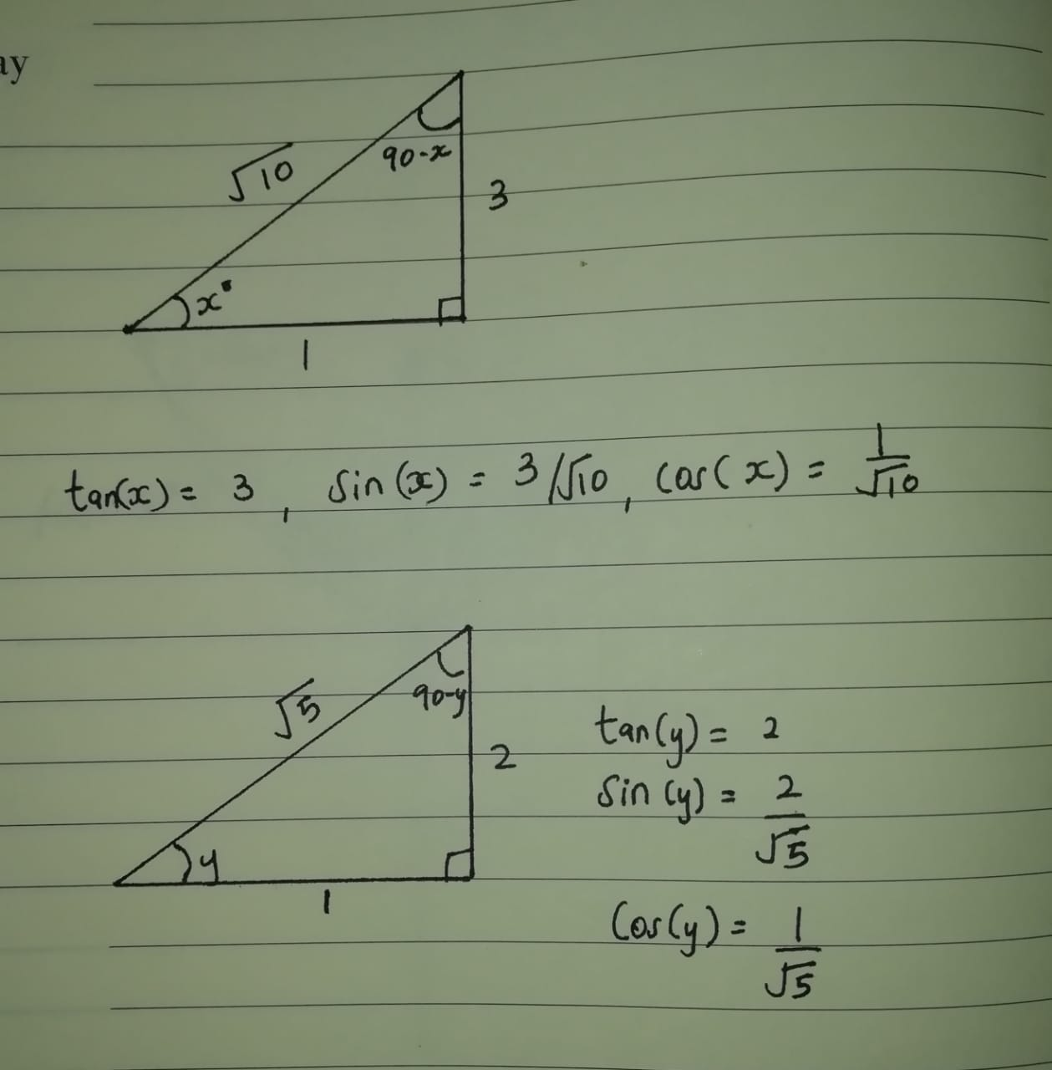

Sin(arctan(3)+arctan(2)) = $\frac{3}{\sqrt{10}}$*$\frac{1}{\sqrt{5}}$ + $\frac{1}{\sqrt{10}}$*$\frac{2}{\sqrt{5}}$

=$\frac{\sqrt{2}}{2}$

- $\lim_{x→-∞}\left(xln(1+\frac{1}{x})\right)$ = $\lim_{x→-∞}\left(\frac{d}{dx}(xln(1+\frac{1}{x}))\right)$

$Applying L^{'}Hopital^{'}s rule$:
$$\lim_{x→-∞}\left(\frac{ln(1+\frac{1}{x})}{\frac{1}{x}}\right)= \lim_{x→-∞}\left(\frac{\frac{d}{dx}(ln\left(1+\frac{1}{x}\right))}{\frac{d}{dx}(\frac{1}{x})}\right)$$

$\frac{d}{dx}\left(\frac{1}{x}\right)$ = $\frac{-1}{x^{2}}$

Solve $\frac{d}{dx}\left(ln\left(1+\frac{1}{x}\right)\right)$

Applying chain rule:

= $\frac{1}{1+x}$*$\frac{d}{dx}\left(1+\frac{1}{x}\right)$ = $\frac{1}{1+x}$*$\frac{-1}{x^{2}}$ = $\frac{-1}{x(x+1)}$

$\lim_{x→-∞}\left(xln(1+\frac{1}{x})\right)$ = $\lim_{x→-∞}\left(\frac{ln(1+\frac{1}{x})}{\frac{1}{x}}\right)$

$$\frac{d}{dx}\left(xln\left(1+\frac{1}{x}\right)\right)= \frac{x}{x+1}$$

$$\lim_{x→-∞}\left(\frac{ln(1+\frac{1}{x})}{\frac{1}{x}}\right)= \lim_{x→-∞}\left(\frac{x}{x+1}\right)$$
$Applying L^{'}Hopital^{'}s rule$:

$$\lim_{x→-∞}\left(\frac{x}{x+1}\right)= \lim_{x→-∞}\left(\frac{\frac{d}{dx}(x)}{\frac{d}{dx}(x+1)}\right)$$
$$\frac{\frac{d}{dx}(x)}{\frac{d}{dx}(x+1)}= \frac{1}{1}$$

$$\lim_{x→-∞}\left(xln(1+\frac{1}{x})\right)=1$$

- $\int_{a}^{b}{\frac{e^{x}}{1+e^{2x}}}$

Applying U-substitution:

u = $e^{x}$
$\frac{du}{dx}$ = $e^{x}$

= $\int_{a}^{b}{\frac{e^{x}}{1+u^{2}}}$*$\frac{ du}{e^{x}}$

$$\int{\frac{du}{1+u^{2}}}$$

But $\int{\frac{du}{1+u^{2}}}=arctan⁡(u)$

=arctan($e^{x}$)

$\int_{a}^{b}{\frac{e^{x}}{1+e^{2x}}}$ = arctan($e^{x}$)$\left\{\begin{aligned}b \\ a\end{aligned}\right.$

= arctan($e^{b}$)- arctan($e^{a}$)

$\lim_{x→a}\left(\frac{\int_{a}^{x}{f(t)dt}}{f(x)}\right)$ = $\lim_{x→a}\left(\frac{\int_{a}^{a}{f(t)dt}}{f(x)}\right)$

But $\int_{a}^{a}{f(t)dt}=f(a)$

$Applying L^{'}Hopital^{'}s rule$:
$$\lim_{x→a}\left(\frac{\int_{a}^{a}{f(t)dt}}{f(x)}\right)= \lim_{x→a}\left(\frac{\frac{d}{dx}(\int{f(t)dt)}}{\frac{d}{dx}(f\left(x\right))}\right)$$
=$\lim_{x→a}\left(\frac{f(x)}{f'(x)}\right)$ ; f(a) = 0

Thus $\lim_{x→a}\left(\frac{\int_{a}^{x}{f(t)dt}}{f(x)}\right)=0$

- T(b)= $\frac{1}{2}$(2$\sqrt{b}*b$) = $b^{\frac{3}{2}}$

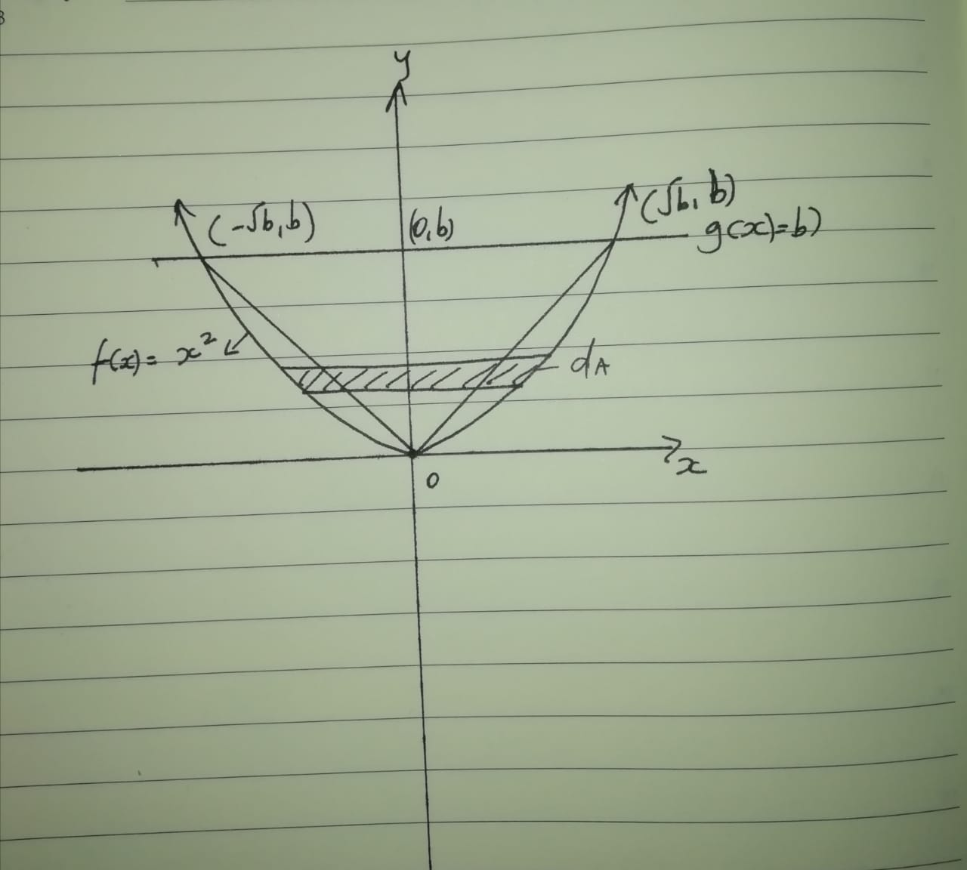

A(b)=$2\int_{0}^{b}{\sqrt{y}}$ = 2*$\frac{2}{3}$* $y^{\frac{3}{2}}\left\{\begin{aligned}b \\ 0\end{aligned}\right.$
=${\frac{4}{3}b}^{\frac{3}{2}}$

$\lim_{b→0}\left(\frac{T(b)}{A(b)}\right)$=$\lim_{b→0}\left(\frac{b^{\frac{3}{2}}}{{\frac{4}{3}b}^{\frac{3}{2}}}\right)$

=$\frac{3}{4}$

- $\lim_{x→∞}\left(x(a^{\frac{1}{x}}-1)\right)$ = $\lim_{x→∞}\left(\frac{(a^{\frac{1}{x}}-1}{\frac{1}{x}}\right)$

$Applying L^{'}Hopital^{'}s rule$:
$$\lim_{x→∞}\left(\frac{a^{\frac{1}{x}}-1}{\frac{1}{x}}\right)= \lim_{x→∞}\left(\frac{\frac{d}{dx}(a^{\frac{1}{x}}-1)}{\frac{d}{dx}(\frac{1}{x})}\right)$$

$\frac{\frac{d}{dx}\left(a^{\frac{1}{x}}-1\right)}{\frac{d}{dx}\left(\frac{1}{x}\right)}= \frac{\frac{a^{\frac{1}{x}}\ln\left(a\right)}{x^{2}}}{\frac{1}{x^{2}}}$ = $a^{\frac{1}{x}}\ln\left(a\right)$

$\lim_{x→∞}\left(a^{\frac{1}{x}}\ln\left(a\right)\right)$ = ln(a)*$\lim_{x→∞}\left(a^{\frac{1}{x}}\right)$

$$\lim_{x→∞}\left(a^{\frac{1}{x}}\right)= a^{\lim_{x→∞}\left(\frac{1}{x}\right)}$$
=$a^{0}$ = 1

$\lim_{x→∞}\left(a^{\frac{1}{x}}\ln\left(a\right)\right)$ = ln(a)*$1$

$$\lim_{x→∞}\left(x(a^{\frac{1}{x}}-1)\right)=ln⁡(a)$$

