Calipers
Student Name
Institution Affiliation

Calipers
Introduction
This is a tool that is basically used in measuring a given distance that is between two opposite sides of a certain object. When dealing with calipers and their types most of them permit readings out measurement on a given rules scale, digital display or a dial. The calipers represent a simple tool for measurement just like a compass in that it has inward and as well the outside points that face each other. If in any case of correcting the calipers, the calipers are adjusted in that to fit all the points that are to be measured. Later the caliper is removed and the in distance is taken to measuring tool just like a ruler to record the measurement. The caliper is an essential tool in various fields, for instance, woodworking, mechanical engineering, medicine, science, and metalwork.
Calliper
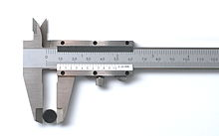
Figure1: Calliper detailed view (Toussaint 1983)

The origin of the calipers
The ancient caliper was discovered in Greek Giglio near the Italian coast. It was wooden in which it had a feature of a fixed as well as the movable jaw. Followed this was a bronze caliper, it was basically used for measuring minutes in the error of Chinese dynasty. Its inscription was that it was from gui-you day, which was actually the new moon of the first month that first day of Shijian period. Observing the caliper it was noted that it had a slot and pin which was graduated using inches and also tenths in reference to an inch.
Considering the modern Vernier calipers was graduated by thousands of inch. This one was first discovered by Joseph R. Brown in the years of 1851. It served as the first tool to measure exact measurements which were able to be sold at a given price that is outside the ordinary machinists.
Old caliper
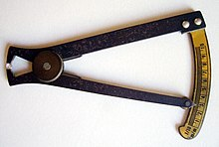
Figure 2: Calliper with graduated bow0-10mm

Types of calipers
Inside caliper
They are basically used to measure the size of an object from inside. They are two, in that the first one requires manual adjustment towards prior fitting. Its settings concerning fine are performed, in a way of tapping the legs of the caliper using the hard surface up to an extent of them passing the object. When that is achieved a light push is performed against the central pivot as it spreads the legs to the right dimensions as it provides the correct measurement. A consistent feel is maintained so that a uniform repeatable measurement is achieved.
The other type of inside caliper is that it permits on the adjusting screw to be more careful adjustment while maintaining the tool in the workplace.

Two inside calipers
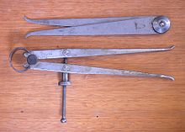
Figure 3: Two inside calipers (Toussaint 1983)

Outside calipers
These are the type of calipers that are basically used to measure the external size of a certain object. It also obeys the normal rules of calipers concerning techniques and observations. There are limitations and usage in that if not followed in the correct way they can lead to inaccuracy measurements. This is because the calipers tend to provide the highest level of accuracy as well as capable of providing the repeatability. They are efficient when dealing with distances of large coverage for instance when used to record the measurement of a pipe with a bigger diameter. It cannot be appropriate to use the vernier caliper since it does not support the capacity to handle this large diameter. It is also noted that they are made from a material with high carbon steel.

Three outside calipers
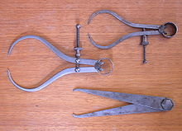
Figure 4: Three outside calipers

Divider caliper
In the field of metalworking, it is normally referred to as the compass. It plays a great role in marking locations. The endpoints are just maintained in a sharp condition so as to serve the purpose of scribes. In its operation, one leg is placed in the dimple. This dimple is created by a prick punch while the other leg is pivoted to scribe a line on the surface of the workplace which leaves a circle or an arc on this surface. This device is also used to measure the distance that exists between two points on a map. This kind of calipers is mostly used in the field of the medical profession.
A pair of dividers
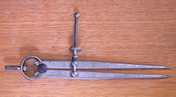
Figure 5: A pair of dividers (image from Edwards et al 1955).
Oddleg caliper
This is kind of calipers that are normally used in scribing a line in reference to a set distance on the edge of a particular workplace. The leg that is bent is designed in a way that to run along the edge of the workplace as the scriber makes a mark in a given predetermined distance. This line is usually parallel to the edge.

Oddleg calipers
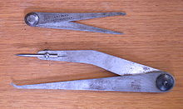
Figure 6: Oddleg calipers (image from Fletcher 1962).

Vernier Caliper

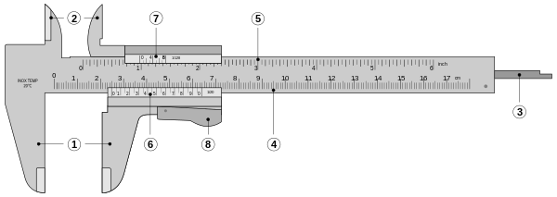
Figure 7: Detailed Vernier caliper (image from Hayes et al 1988)

The labeled parts of a vernier caliper are as follows.
Number one is the outside jaws that are large for measuring external diameter as well as the width of an object. 2 is the inside jaws which are small for measuring internal diameter of a certain object. 3 is the depth rod for measuring a depth of a hole or an object.4 is the main scale metric that is marked in reference to mm. five is the main scale imperial which is marked with reference to inches as well as fractions. Six is the vernier scale metric which is responsible to provide interpolated measurements to better than 0.1 mm. seven is the vernier scale imperial provides measurements of interpolated in fraction form of the inch. 8 is the retainer used to block movable parts for easy transferring of measurements.
The vernier has three categories of calipers, dial, digital, and micrometer caliper. To start with a dial caliper, it is used to read the final fractions concerning millimeter and also simple dial.
Mitutoyo dial caliper
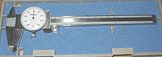
Figure 8: Mitutoyo dial caliper (image from Hayes et al 1988)

Digital caliper
It has a digital electronic display for displaying the figures as a numeric value.
Digital caliper
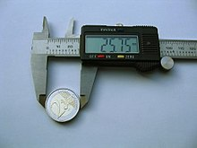
Figure 9: Digital Caliper (image from Toussaint 1983)

It uses a calibrated screw for the purpose of measurement which is referred to as the external micrometer caliper gauge.

References
Edwards, D. A. W., Hammond, W. H., Healy, M. J. R., Tanner, J. M., & Whitehouse, R. H. (1955). Design and accuracy of calipers for measuring subcutaneous tissue thickness. British Journal of Nutrition, 9(2), 133-143.
Fletcher, R. F. (1962). The measurement of total body fat with skinfold calipers. Clinical science, 22, 333-346.
Hayes, P. A., Sowood, P. J., Belyavin, A., Cohen, J. B., & Smith, F. W. (1988). Sub-cutaneous fat thickness measured by magnetic resonance imaging, ultrasound, and calipers. Medicine and science in sports and exercise, 20(3), 303-309.
Toussaint, G. T. (1983, May). Solving geometric problems with the rotating calipers. In Proc. IEEE Melecon (Vol. 83, p. A10).

