Calorimetry
Lab partner
date
Title: Calorimetry
Lab number: 8
Your section number

Objective
To determine the latent heat of fusion of ice.

Theory and equations
We will experimentally prove that heat energy lost by a hot body is equal to heat energy gained by the cold body.
Determination of the latent heat of ice.
Q= heat evolved (equal to heat absorbed-heat released) in joules (J), mass (m) in kilograms (kg), c= specific heat capacity in J/kg.K.
Q=MC*change in temperature
Q=+-ML (phase change)

Data and observations
Procedure A
Measure the mass temperature of two samples of water at different temperatures measure the final temperature after mixing. Compare the prediction.
Observation A
Mass of Styrofoam cup: 7 degrees Celsius
Mass of hot water: 153.3g
Room temperature: 20 degrees Celsius
Cold water: 7 degrees Celsius
Hot water temperature: 45 degrees Celsius
Mix of room/hot: 30 degrees Celsius
Water (M, Temperature T1)
Mixed with water ( Mass M2, Temperature Tz)
Reaches a final temperature Tf
Tf=M1T1+M2T2/M1+M2=30

Procedure B
Measure the mass of each sample prepare the sample at 0 degrees Celsius, add to water of known mass and temperature. Measure the final temperature. Calculate the specific heat and compare with accepted value.
Observation B
Temperature of warm water: 37 degrees Celsius
Mass: 71g
Aluminum cube mass: 42.6g
Brass cube mass: 66.6g
Water temperature after cooled brass: 28.0 degrees Celsius
Water temperature after cooled aluminum: 33.0 degrees Celsius

A sample (Mass Ms, Temperature Tz) is marked with water (Mass Mw, Temperature Tw) and researches a final temperature Tf.
MsCs (Tf-Ts) + MwCw (Tf-Tw)=0
Cs=-MwCw (Tf-Tw)/Ms (Tf-Ts)

Procedure C
Measure the mass of an ice cube. Prepare a cup of warm water. Measure the temperature of the water, add the ice cubes and stir until fully melted. Measure the final temperature. Calculate the latent heat of fusion and compare with the accepted value.
Observation C
Mass of cup: 5.4 g
Mass of ice cube: 12.7g
Mass of warm water: 96g
Temperature of warm water: 46 degrees Celsius
Temperature after stirring ice: 37 degrees Celsius
An ice cube (Mass M1=g, T=0 degrees Celsius) is mixed with warm water. Mass Mw, Temp Tw and reaches a final temperature Tf.
+M.Lf+M.Cw (Tf-0 degrees Celsius) +MwCw(Tf-Tw)= 0
M.Lf=-M.CwTf-MwCw (Tf-Tw)
Lf=Cw=[Mw/M1(Tw-Tf)-Tf

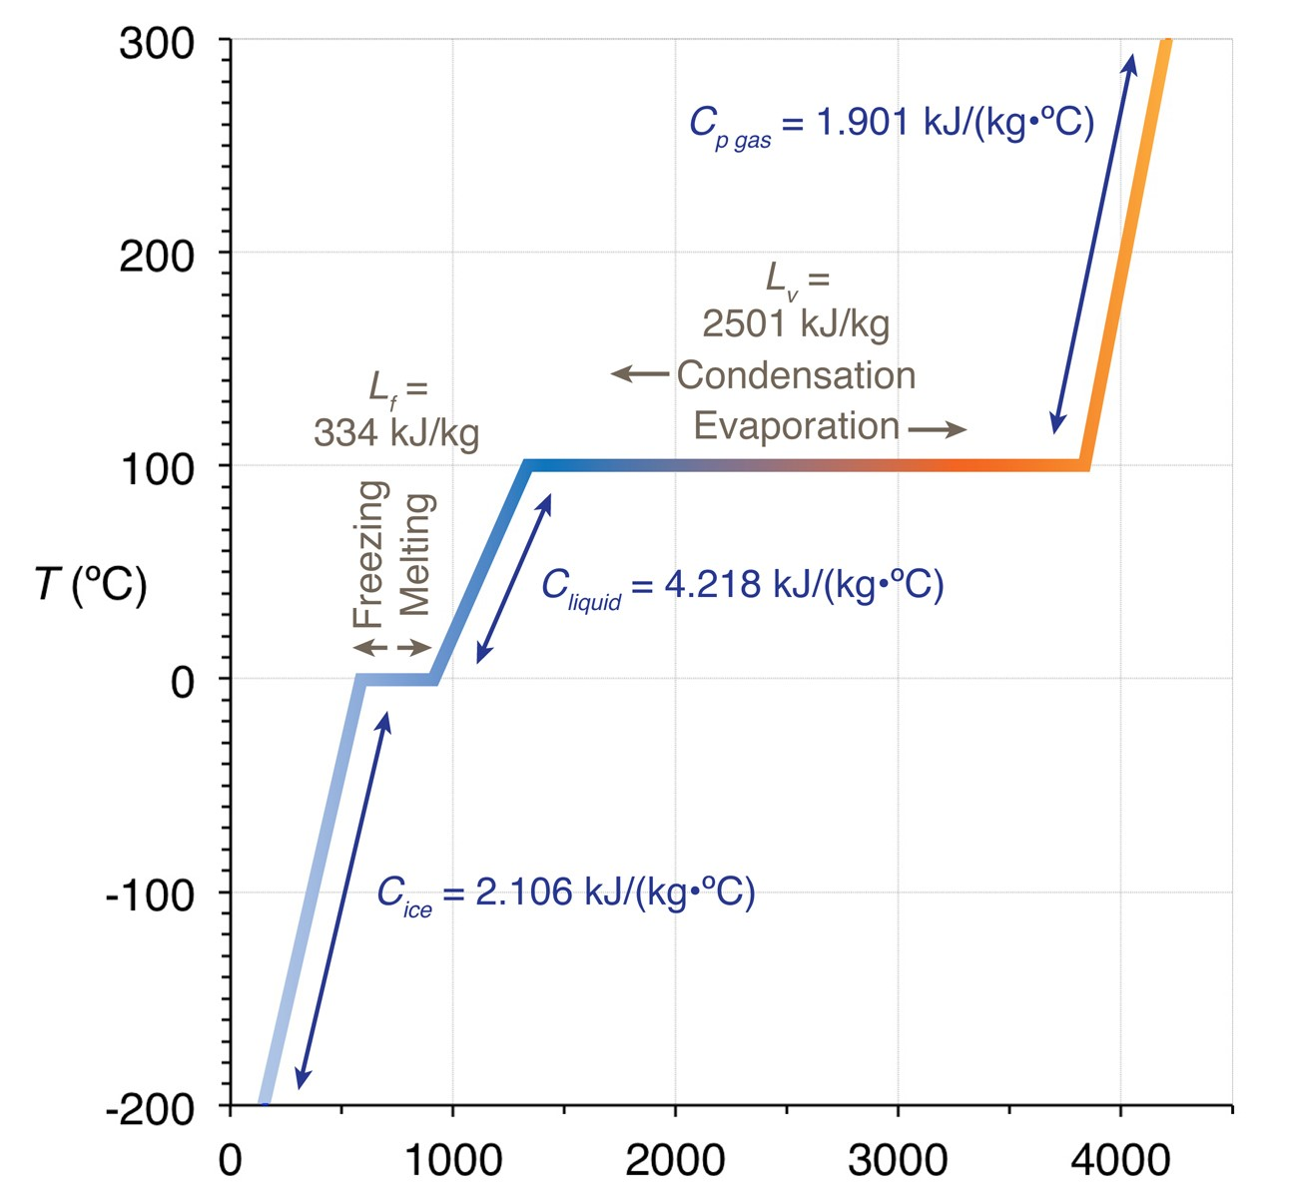
Discussion
Final temperature is 37 degrees Celsius
latent heat of fusion = Lf=Cw=[Mw/Ml(Tw-Tf)-Tf
=96/12.7(46-37)-37
=310.3 J/g
310.3 J/g was our experimental value while the accepted value is 334 J/g. The difference might have occurred due to the assumption that no heat is lost when Styrofoam cup was used in the place of a calorimeter, which is a systemic error, thus the experiment value is lower than the accepted value.

