Cartography
Name
Institutional Affiliation

Austin and Travis County Plat Maps
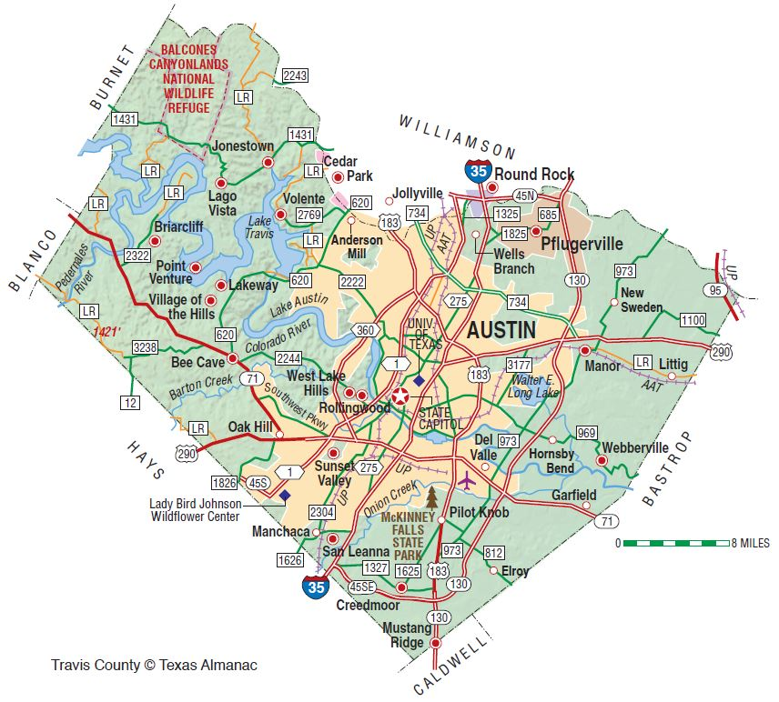
This is a map of Austin and Travis county Plat Map. The theme of this map is the roads that are represented by the proportional region through the aggregated area. The map contains the feature of Austin and Travis County as represented through the illustration provided in the map. This is an essential feature that has been used to show different regions as demonstrated within the graphical representation. The map contains major divisions of areas and lands within the region, which provides clear illustration of the area (Francaviglia, 2015).
The scale of the map is that of a city is 1 to 25000. It one of the largest areas within the United States. Buildings and roads are the most important elements that are recognized within the map area. The urban development within the map has been portioned with the roads and the towers. The significant land marks such as transmission lines, railways and power areas are the main areas that have been significantly represent the areas that have been significantly represented within the map (Benchmark Maps, 2019).
References

Benchmark Maps. (2019). Texas road & recreation atlas. Santa Barbara, California: Benchmark Maps

Francaviglia, R. V. (2015). The shape of Texas: Maps as metaphors. College Station: Texas A & M University Press.

