Case study: The Karate Kid -2010 (film).
Name.
Institution.
Date.

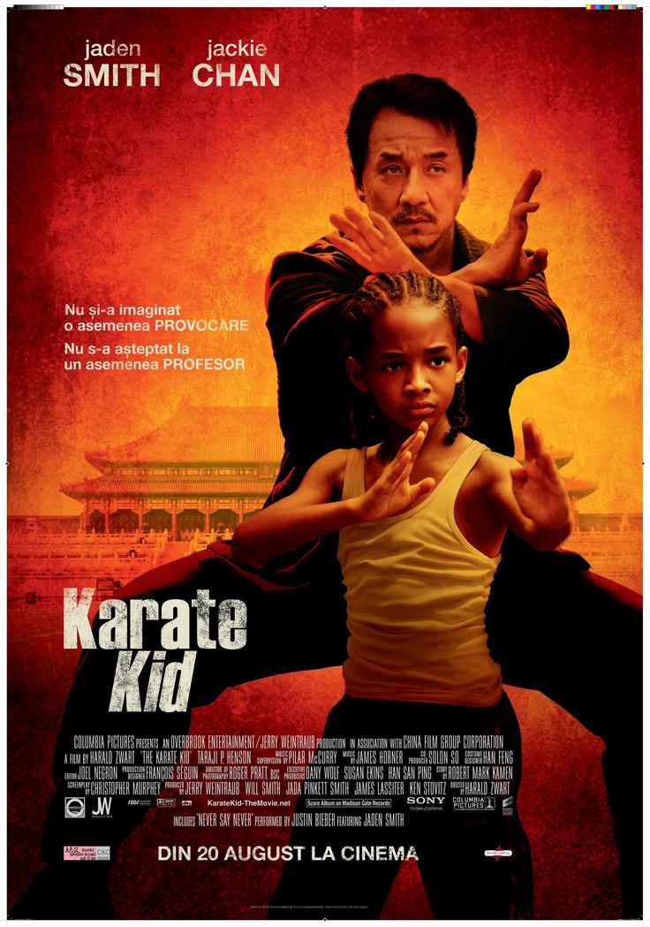

Introduction.
The Karate Kid -2010, is a drama film based on martial arts which was directed by Harald Zwart and its main characters are; Jaden Smith, Jackie Chan and Taraji P. The film was set in China, and its action is run through Kung Fu. The plot of the film features Dre (Smith) who is twelve years old and focuses on his movement with the mother from Michigan to Beijing –China. In Beijing, Dre is brought up in a brutal neighborhood where he is subjected to bullying by Zhenwei Wang. During his exploration of the new neighborhood, Dre makes a couple of friends and the most significant ally is Mr. Han (played by Chan). Mr. Han is a kung fu master and teachers Dre the secrets and the principles of self-defense. Dre learns these skills effectively and can alienate himself from bullying. It is evident that his motivation arises from the challenges he faces from the community and the zeal to achieve the same prowess in self-defense like his master. The film-the Karate Kid will be used as the basis of my case study, and a focus will be laid on the major characters in analyzing aspects of concern to motivation and trust, personality, and happiness and this will be supported by credible research.
Motivation and Trust.
Motivation refers to an internal process that initiates and guides a person act or put more efforts towards a certain goal. While trust, on the other hand, is the aspect of having a firm belief in ability and strength of something or someone (Bell, 2017). Motivation and trust, therefore, are the expectancy component that entails self-efficacy as well as control beliefs geared towards attaining a particular goal. Different motivation theories can be applied in this case, but the most appropriate is the Maslow's hierarchy of needs theory. This theory is presented in a pyramid form and was developed by Maslow who argued that human beings are motivated by their needs and the desire to achieve self-actualization (Huitt, 2014). Human beings usually move from the low level to the top level in this theory. The needs from the bottom to the top are as follows; physiological needs, safety need belongingness and love, self-esteem and self-actualization. Maslow argued that when humans achieve a lower need, they strive to achieve the next at a higher scale.

Application of the Maslow's motivation theory.
The main character of focus in this theory is Dre. Dre and his mother move from Detroit to Beijing due to the mother's job transfer. This job is arguably the basis of Dre's satisfaction as the mother can support him with necessities such as food, shelter and clothing and hence, he is physiologically satisfied. After achieving the physiological satisfaction, Dre's zeal to achieve safety needs is apparent. At first, he is attacked by Cheng whom has also fallen for Meiying and Dre's desire to be protective and secure prompts him to venture into martial art training.
Dre is also ready to win against the school bullies, and Mr. Han facilitates his achievement. In the end, he manages to win the Kung fu tournament. It is also evident that the achievement of safety Grants Dre the opportunity to interact with Meiying whom he loves and this depicts the need of belongingness and love needs. Also, Dre's sustainable relationship with Han is an attempt to achieve belongingness. By winning the support of other students, that of Han, Meiying and achieving safety needs through Kung fu, Dre accomplishes his self-esteem facet and feels a sense of accomplishment. The film evidently ends when Dre is still young, but it is indisputable that he would use all his accomplishments to achieve the highest levels of Maslow's motivation theory which is self-actualization.
The trust matrix and its application.
The trust matrix presents the hierarchy of different levels of trust between people at the start of interaction to the end. The matrix is founded on the assertion that the level of trust among people should be elevated as they continue to interact. The two main characters of focus in this movie and the levels of trust are Dre and Han. The start of the film features Dre and Han who are in the process of building their relationship and trust. At the beginning, Dre is bullied and attacked by Cheng and Han comes to his rescue despite the two characters being new to each other. Han combats Dre's attackers, mends his injuries and promises to teach him Kung fu (Berry, 2012).In this case; it can be argued that the two are in the intent stage of trust which is based on care, transparency, and openness. At the end of the movie, Dre achieves competency in Kung fu and wins the trophy in the tournament. Dre also bows in respect of Han after his meticulous performance, and this is a definite assertion that the two reaches the results stage of trust which is the basis of reputation and performance.

Personality and its application in the film.
Personality is the mixture of qualities or characteristics that make an individual's distinctive feature. In The Karate Kid, the personality of different characters has been influenced by their id, ego, and superego. The id, ego and the superego are arguably the basic parts of human personality which were developed by Sigmund Freud in the theory of psychoanalytic personality. The id is arguably the part of the personality which requires instant gratification of satisfaction of needs. When the needs of the id are not met, then one becomes tense and anxious (Alexander et al., 2015). The ego deals with reality and seeks to fulfill the desires of the id in a socially accepted mechanism, and hence gratification may be delayed. The superego seeks to balance between the id and the ego, and it is based on morals and the judgment between what is right and wrong. The character that seems to be driven by id is master Li who is Cheng's teacher. Despite the fact that he is a professional in martial arts, Li teaches his students that they should never show mercy on enemies and should act swiftly and hence, this is an immediate gratification which is irrational (The Karate Kid, 2012). Due to his id, Master Li challenges Dre to have an abrupt fight with Cheng.
Dre, on the other hand, is driven by ego, and this is through the assistance of Han, his master. Dre is ready to learn the principles of martial arts not for violence but due to self-defense, and hence, his ideals are socially acceptable. In the car repair incident, Dre also assists Han to work hard to forget his family loss. On the other side, Han is motivated by his superego and hence, he is a role model to Dre. Han opposes Li's idea for Dre and Cheng to fight abruptly but proposes that the two should take part in a contest (Desser, 2012). Han also teaches Dre that martial arts is meant for self-defense and not for bullying others and this proves his focus on the superego which is the basis of socially accepted principles.
Happiness/ the PERMA model and its application in the film.
The PERMA model is comprised of five critical components of psychological fitness and happiness; these elements are believed to assist people to realize a life of fulfillment, meaning, and happiness. The PERMA model is based on the assertion that happiness can be achieved through diverse aspects and there is a focus on positive emotions, engagement, relationships, meaning, and accomplishments. There are two critical components of the model which can be applied in the film-Karate Kid, and these are engagement and accomplishment. Dre, for instance, finds happiness from his engagement in martial arts training. It is this training which accords him focus and the zeal to achieve safety and respect from his friends. The relevance of the second component; relationships is depicted through Dre and Han who focus on the creation of a sustainable relationship for the achievement of success in martial arts.
Conclusion.
In the end, the film-Karate Kid confirms the effective application of various theories of motivation trust, happiness, and personality. The storyline was well planned to enhance motivation, credibility, competence, characters and intend. Moreover, accomplishment acts as the source of happiness and satisfaction among the actors. The focus on the majority of the principles described is evident through the two primary characters who operate in unison, and these are Dre and Han. Through them, we are exposed to diverse theories of motivation, levels of trust, the levels of personality and the concept of happiness.

References.
Alexander, F., Glueck, B. T., & Lewin, B. D. (2015). The psychoanalysis of the total personality: The application of Freud's theory of the ego to the neuroses.
Bell, J. (2017). Andre the Giant: Life and Legend. Children's Book and Media Review, 38(9), 37.
Berry, M. (2012). Chinese cinema with Hollywood characteristics, or how The Karate Kid became a Chinese film. In The Oxford Handbook of Chinese Cinemas.
Desser, D. (2012). The martial arts film in the 2000s. Film genre, 77-109.
Huitt, W. (2014). Maslow's hierarchy of needs. Educational psychology interactive.
The Karate Kid (2010) ''' ᴴᴰ []../,. (2017). YouTube. Retrieved 24 September 2017, from https://www.youtube.com/watch?v=jaBxr9h2xSk.

- Questions

Charisma, Power, and Influence
- Who do you feel is the most and least charismatic characters in the case study? What types of power do those two people demonstrate?

Intelligence
- Who do you feel are the two most intelligent characters in the case study? What types of intelligence do they demonstrate?

Brainstorming and Decision-making
- Using decision-making steps describe one of the main decisions that the main characters had to make in the case study.

- Sample Case Study Structure

See Case Study #1 for a sample case study writing structure.

- Submission Instructions and Marking Rubrics

**PLEASE NOTE THE FOLLOWING SUBMISSION INSTRUCTIONS. YOUR GRADE MAY BE AFFECTED**

