Cell Lab (50 points)

Directions: Write your answers below each question. There are 5 Parts to this lab. Upload and submit the assignment in the Cell Lab Assignment.

Part 1. Using a microscope (10 points)
You will need Adobe Flash for the microscope viewing:
Once downloaded for free, you may have to activate it. When you go to the microscope link, it will give you a prompt for a simple click to activate your Flash.
This animation will give you virtual hands-on practice adjusting and using a microscope: Practice using a microscope.
1. Which slide did you view?
2. Using the ocular housing, which power lens did you choose?
3. What did you observe? (Describe the cell in your own words.)
4. Change your lens power. What is your lens power now?
b. What else did you have to adjust to view your specimen?

Part 2. The Eukaryotic Cell – Plants & Animals (10 points)
View the Eukaryotic Cell

I. Choose Animal Cell (choose link below “Welcome to the Cells alive! Cell Module”)
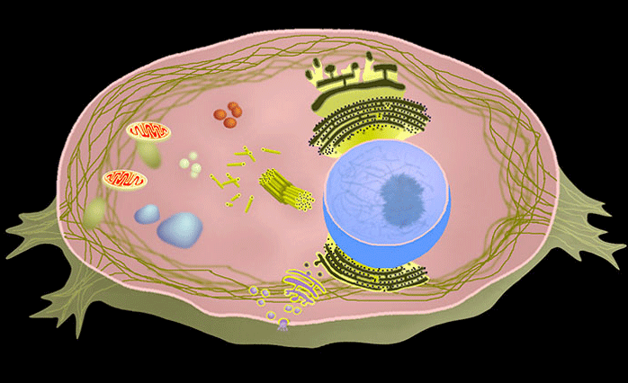
Click on each of the organelles to show where they are and their function.
1. Which 2 organelles are not found in animal cells?
2. The cell’s DNA is within what organelle?
3. Which organelle is known as the powerhouse or power center of the cell?
b. It is called the powerhouse or power center of the cell because it produces what energy-carrying molecule?

II. Choose Plant Cell (choose link below “Welcome to the Cells alive! Cell Module”)
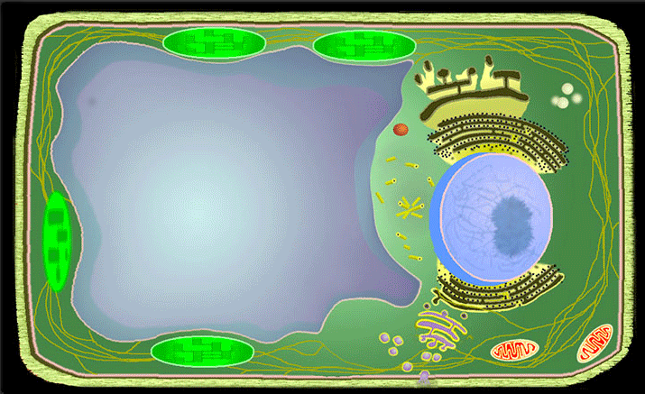
Click on each of the organelles to show where they are and their function.
1. Name one organelle not found in plant cells?

Part 3. Cheek Smear Cells (6 points)
Look at this image of cheek cells under the microscope.
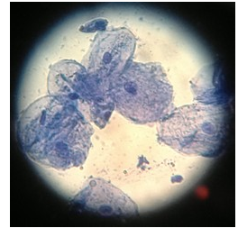
You are looking at several cells taken from the inside cheek of a student.
1. The large dot within each cell is the largest organelle known as what?
2. Is this a eukaryote or prokaryote cell?
b. What do these cells have or not have that identifies them as eukaryote or prokaryote?

Part 4 Cellular Transport (12 points)
Refer to your chapter on 5.2 Passive Transport

I. Passive Transport
Let’s take a look at this animated activity on Diffusion

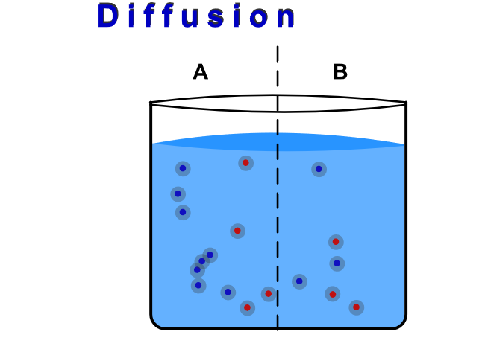
1. What is meant by “the plasma membrane is selectively permeable?
2. The animation shows a concentration gradient. The definition of a concentration gradient is an area of ______ ______ adjacent to an area of _______ _________.
3. In the animation, which side has more molecules at the start?
4. The particles move back and forth until they reach no net movement or a lack of a concentration gradient, known as ___________ __________.

5. “Molecules move constantly in a random manner, at a rate that depends on their mass, their environment, and the amount of thermal energy they possess, which in turn is a function of temperature.” (Section 5.2)

Watch the animation as the temperature is raised or lowered. Refer to Factors That Affect Diffusion – Temperature in your chapter section 5.2.

Explain why the molecules in the animation move faster as the temperature is raised?

II. Bulk Transport
Watch the 12-second Live video of Phagocytosis - a macrophage (type of white blood cell) engulfing a bacteria.
1. Refer to your reading to explain the purpose of the cellular function of phagocytosis.

Part 5: What is the fastest animal -- it may not be a cheetah! (7 points)
Read and view short video on the one-celled Spirostomum
1. Now it’s your turn to find an interesting study, research, or already-established fact about cells. Write a brief summary in your own words. Use quotes where necessary. Give definition of scientific words. Give the source of your information.
You may use one of these sources to get ideas or search your own:
https://phys.org/
Seeking Single Cell Secrets
National Institute of Health – Stem Cells
Ideas to search: single cell study; single cell research; cell research

Your Response:

End of Lab
Attribution:
This lesson was compiled for BIOL 160, Pierce College at JBLM. It is licensed under a Creative Commons Attribution 4.0 license and contains content from:

Eukaryotic Cells by Biology by OpenStax College is licensed under a Creative Commons License 4.0 International
Links within lesson from University of California and National Science Foundation
and University of Delaware
Image Attribution:
“Microscopes” by Phillip Martin for educational use
“Plant and Animal Cell” By Cells Alive is used for educational purposes.
“Cheek Smear” by Biology Corner is licensed under a Creative Commons License 4.0 International .
“Diffusion” from WISC-online of Wisconsin Technical Colleges is licensed under a Creative Commons License CC BY NC 4.0

