Traditional Ceramics
Student Name
Institutional Affiliations
Date

Traditional Ceramics
Traditional ceramics are artistic artifacts made from standard and naturally occurring materials like clay, quartz and feldspar. These forms of ceramics are made with high precision in conjunction with skills. The resultant is an item with high strength, hardness, resistance to wear and tear corrosion, and resistance to high temperatures. The different forms of traditional ceramics impact people differently. For instance, some inspire, some educate, and some are just made for sheer fun.

Traditional 1: Inspiring
Bindweed Yunomi by JoAnn Axford
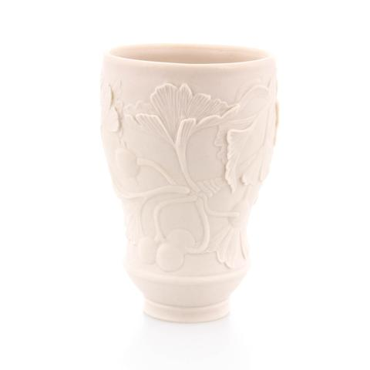
Axford 2004 Porcelain cone measuring 3X3X3.5”H

This artifact by Joann is not that different from the many pieces I have seen. But it is unique in a way that the lover of pottery can understand; I found it interesting because of the exterior design and appearance. The colour presents the primary subject matter behind the hands that assembled the pieces. The porcelain vase is appealing to the eye with its traditional and partly contemporary design. It merges the historical perspectives of the Asians and their religions. Hence, it is inspiring because it provides a playful appearance. It looks soft and humble. It references the 21st Century technological world but in the absence of the social and political haywires.

Tradition 2: Inspiring
Wooded Cup and Saucer by Jeff Irwin
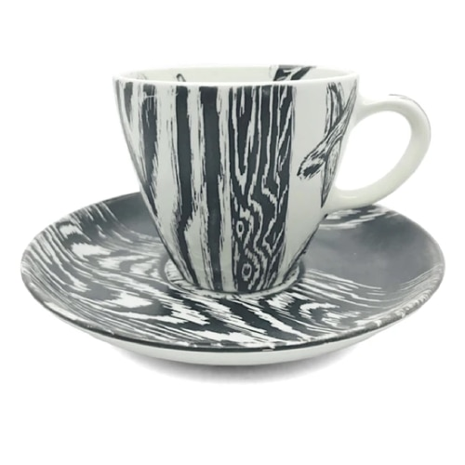
Commercially-made cup and saucer, hand decorated
Cup: 3" x 3.25" (diameter) Saucer: .75" x 6" (diameter)
This piece by Jeff Irwin, if not closely observed, can be mistaken for a contemporary ceramic. What is more interesting is the fact that the cup and the saucer are both made of purely handcrafted wood. This piece of work is the next generation of pottery skills. Furthermore, Irwin has more eye-catching designs like this and some even better, the cup and saucer. I find the work of Irwin inspirational since he, among a few others, can craft wood and make such an outstanding piece of pottery. This piece has merged both the traditional potter style s and the contemporary style to produce an element that one cannot dare take off their eyes. The only problem is that beauty is a perception of singularity. Finally, the artistic design of the colouring in black and white paint through a balance of graphic and painterly glaze application brings out the image of the bark of a tree in its natural state.
Tradition 3: Inspiring
Bird Form by Randy Johnson
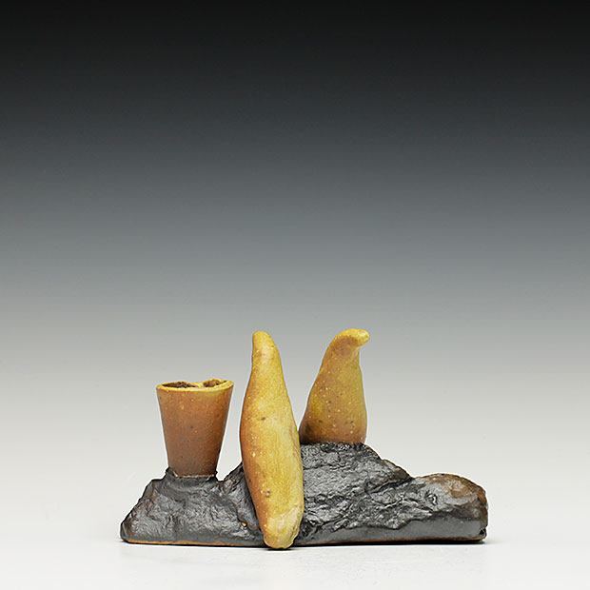
Yellow glaze, black slip measuring 4x7x3.5."
This is a one-of-a-kind traditional ceramic pottery design. Randy Johnson describes his work as an accurate representation of the cultural values and beliefs. There are plentiful other pieces of ceramics, but this captured my eyes. I do not know what they mean, but the creation is inspirational. I picked this piece because I want to study it more and get to the design meaning of the objects depicted in the art. This traditional ceramic is inspiring because it has put an entire tradition and culture of one community in one single imagery. The work is further straight forward and makes visual sense, although there is a lot of hidden meaning that requires decoding personally.
Tradition 4: One to Replicate
Leg Vase by Ann Crista Ames
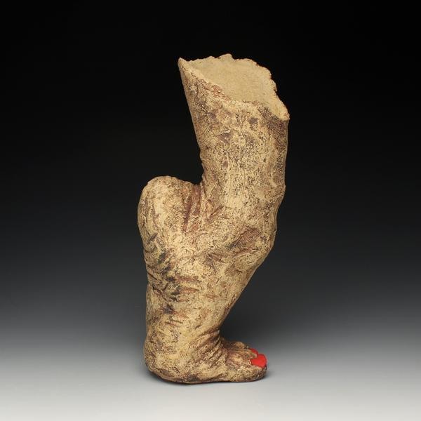
AME-C-035 measuring 13x6x5."
This piece of art by Crista Ames is a unique type of vase. Like all other vases, its functions can be predicted quickly. On the other hand, the human leg with hills up decodes a deeper meaning of the purpose of the vase. The adaptability and diversification of human nature, the leg vase provides the implication of a traditional ceramic type of the foot when viewed for the first instance, can be concluded as to whom it may belong to and their legal background.
The artist Ann is loud and clear. The message is aired out, and I would like to replicate this artifact because it speaks out about the nature of and behaviour of humans, especially ladies. The nail is painted red, and the extent of the bend depicts a woman. Besides, the deeper meaning is the primary concern of my erg to replicate this work.
Traditional 5: One I Dislike
Turtle Creature Flask by Liz Collins
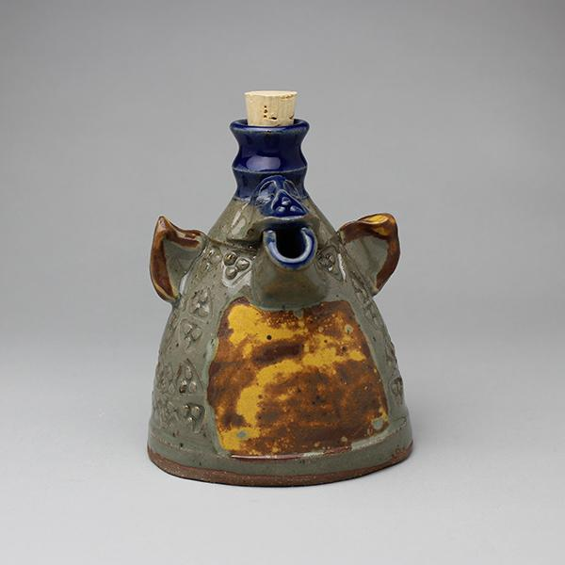
LIZCOL-0001 measuring 5" x 4.5" x 6.5"

Art and design is one field where finding things that humans don't like is difficult. Every bit of traditional ceramic techniques is distinct in its way. Considering that different people have different tastes and preferences, I would say this art piece is not of my taste, but the term dislike would be close to the description. The Turtle Creature Flask, in my opinion, was made from a lack of inspiration. The design is awkward. The turtle with piggy ears and a mouth like an elephant trunk, I would say that it is too much mixture of animalistic representation in the artifact. Maybe the intention was to make a flask as a commodity rather than embracing the art through the flask. By the look of its appearance, the piece qualifies to be a traditional ceramic. The colour appearance, shape and decorations all point to an artifact used for decorative purposes. Its explicit purpose is quickly and predictable by merely looking at the piece.

References
Liz Collins. Turtle Creature Flask
https://public.theclaystudio.org/public/shop/item/34375/Liz%20Collins/Turtle%20Creature%20Flask

JoAnn Axford. Bindweed Yunomi

https://www.clayakar.com/collections/artist-joann-axford/products/axford2004

Crista Ann Names. Foot Vase
https://store.redlodgeclaycenter.com/collections/crista-ann names/products/foot-vase
Randy Johnson. Bird Form
https://www.schallergallery.com/exhibition/595/Randy-Johnston-INTERSECTION-functional--sculptural

