1) Draw Lewis structures for each of the following molecular compounds. Be sure to include any lone-pair electrons.
1. H₂S
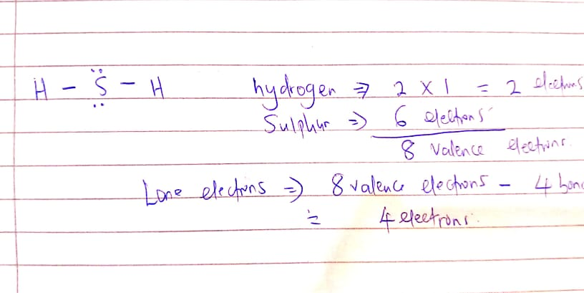
2. PH₃
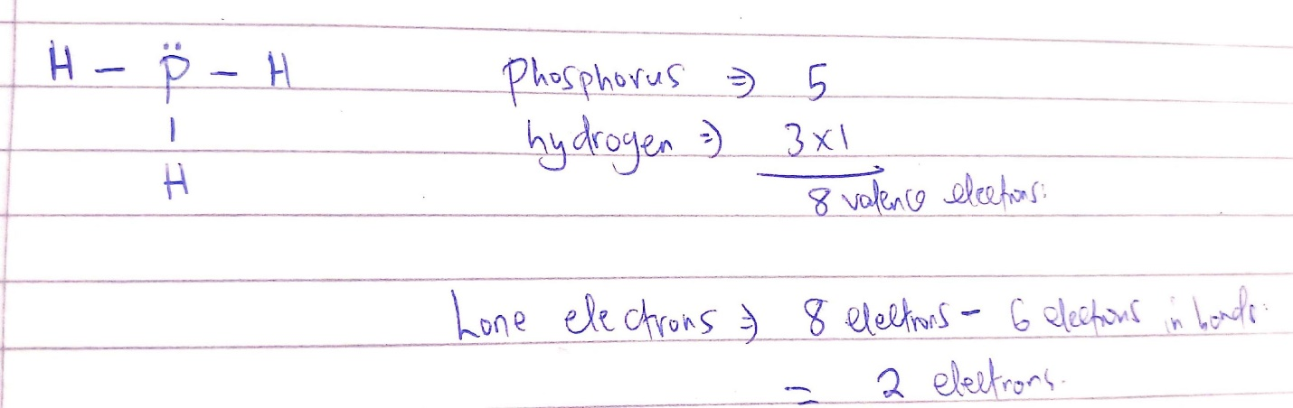

3. HCN
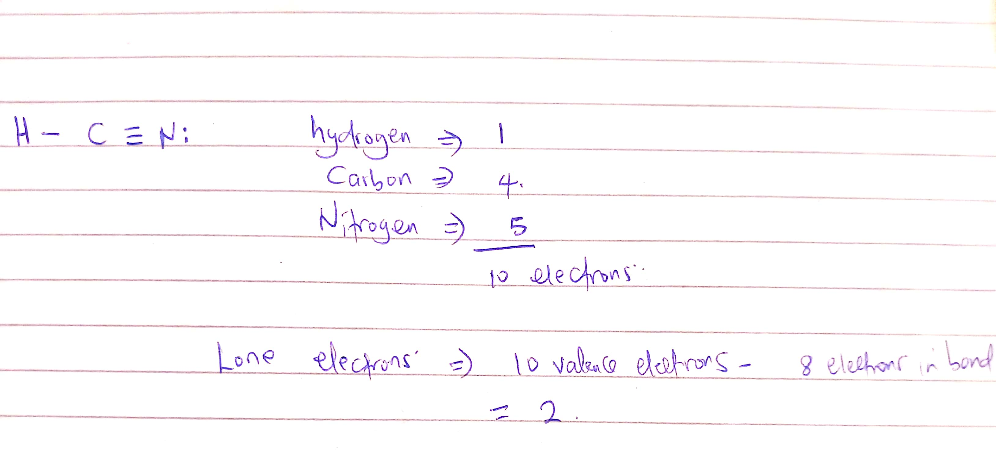
2. Draw a Lewis Structure and a Condensed Structural Formula for each of the following organic -molecules.
Organic molecule | Lewis structure | Condensed structure
C₄H₁₀ | 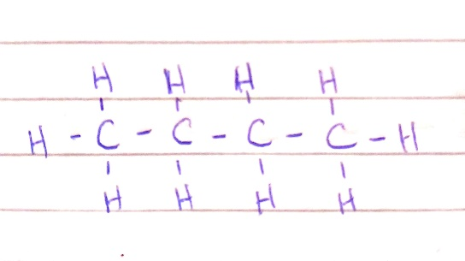 | 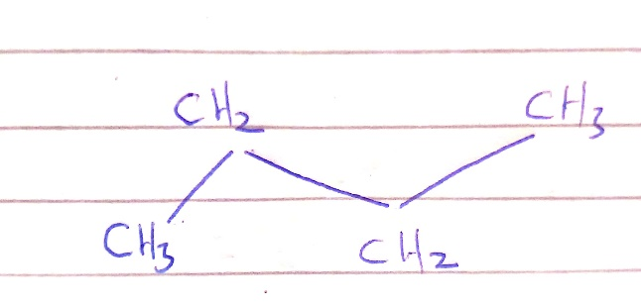
C₄H₈ | 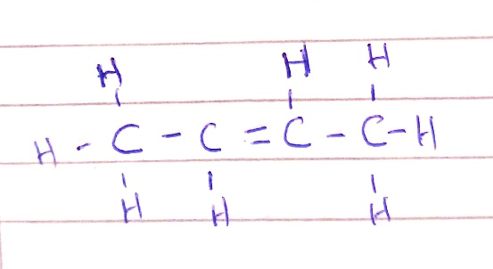 | 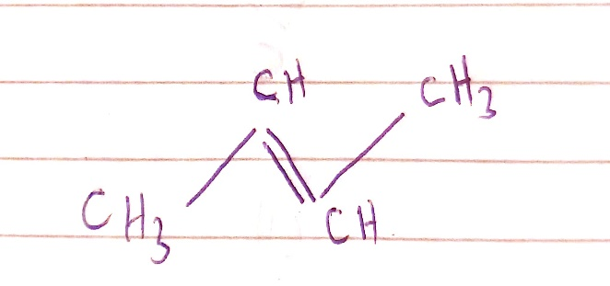
C₄H₆ | 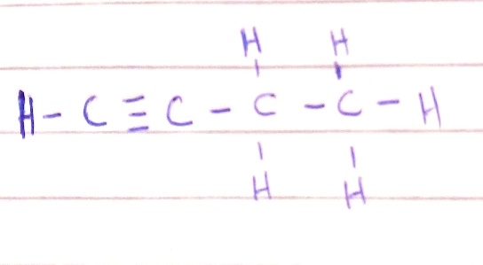 | 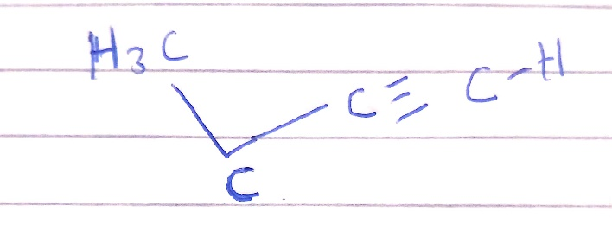

3) Name the following organic compounds.
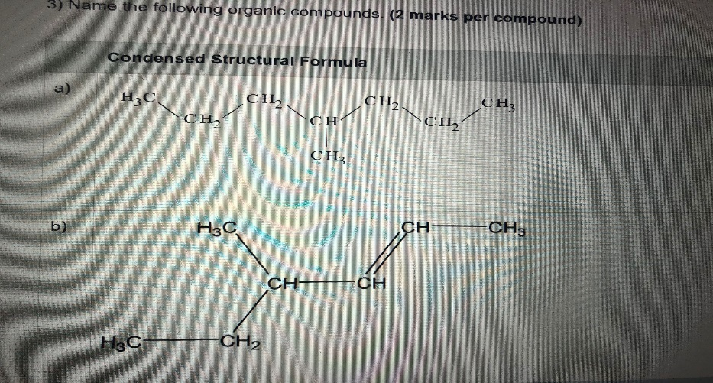
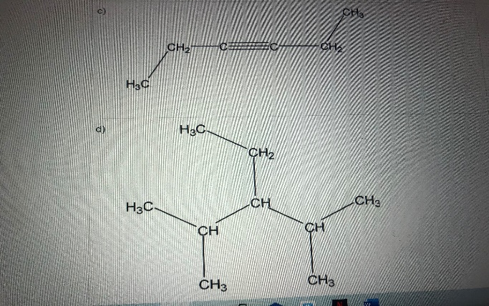
- 4- methylheptane
- 4- methylhex-2-ene
- 3-hexyne
- 3-ethyl-2,4-dimethylpentane

4) Draw condensed structural formulas for the following organic structures.
a) 2-hexene
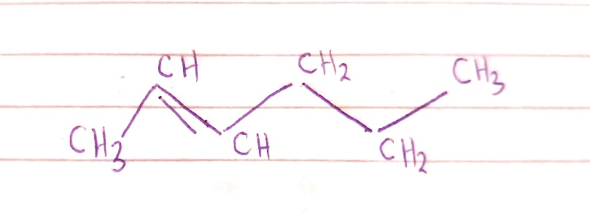
b) 3-ethyl-3-methylheptane
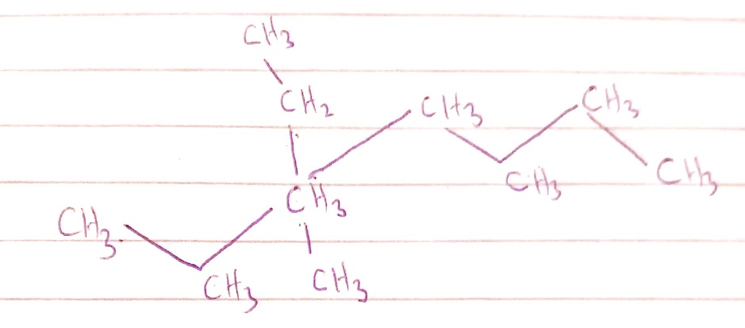

c) 1-butyne
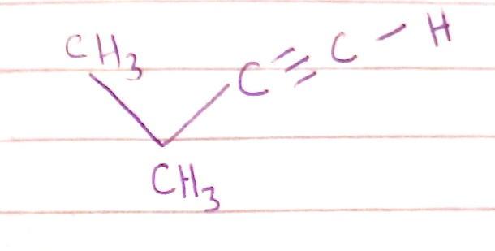
- 2, 5, 6-trimethyloctane
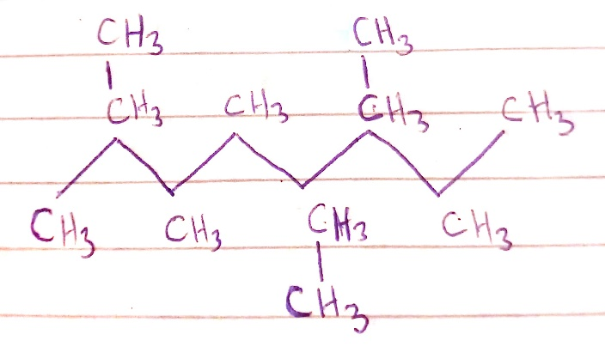

5) Identify the functional group present in each organic compound.

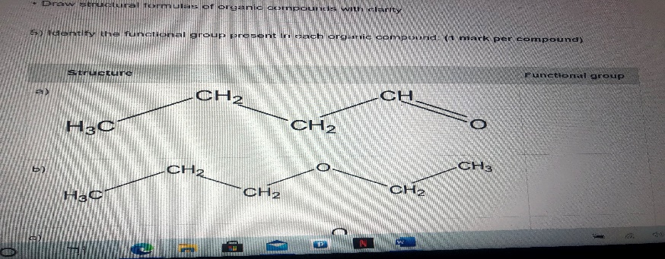
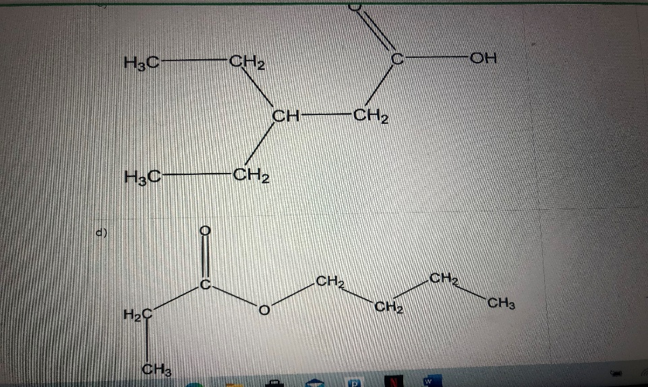
- C=O
- C-O-C
- –COOH
- - COOC
6) Classify the following reactions. (1 mark per reaction)
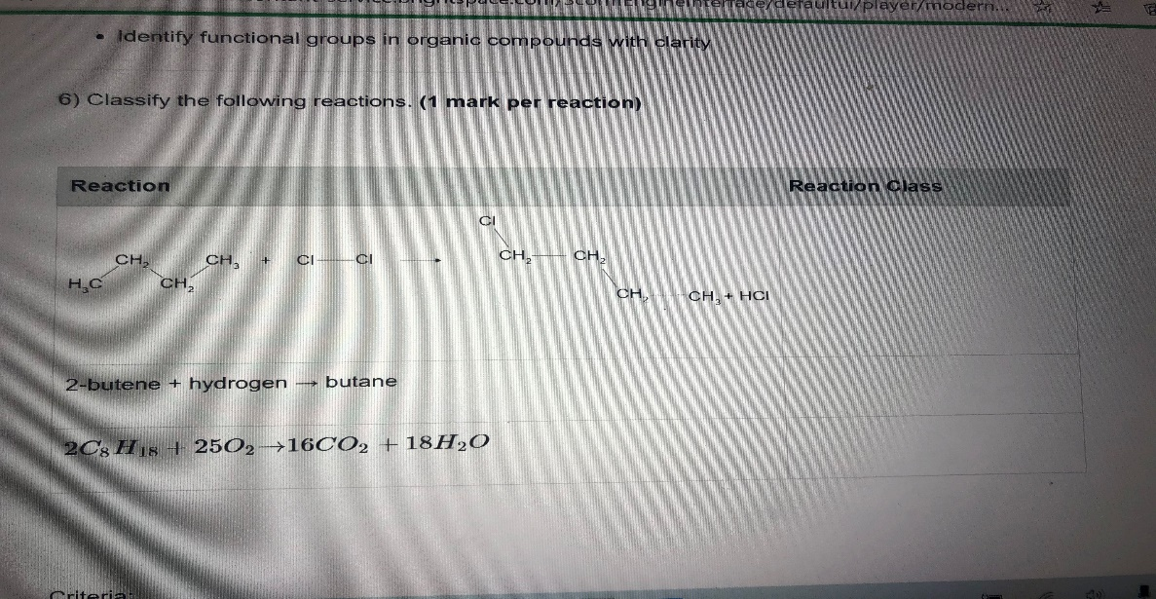
- Substitution of alkanes
- Hydrogenation
- Combustion
7) For each of the following compounds,
Draw the Lewis structure of a compound with clarity and accuracy (2 marks per chemical). Determine if a chemical bond is either non-polar, polar, or ionic with clarity and accuracy (1 mark per chemical). Determine if a compound is either non-polar, polar, or ionic with clarity and accuracy (1 mark per chemical)
- CF₄
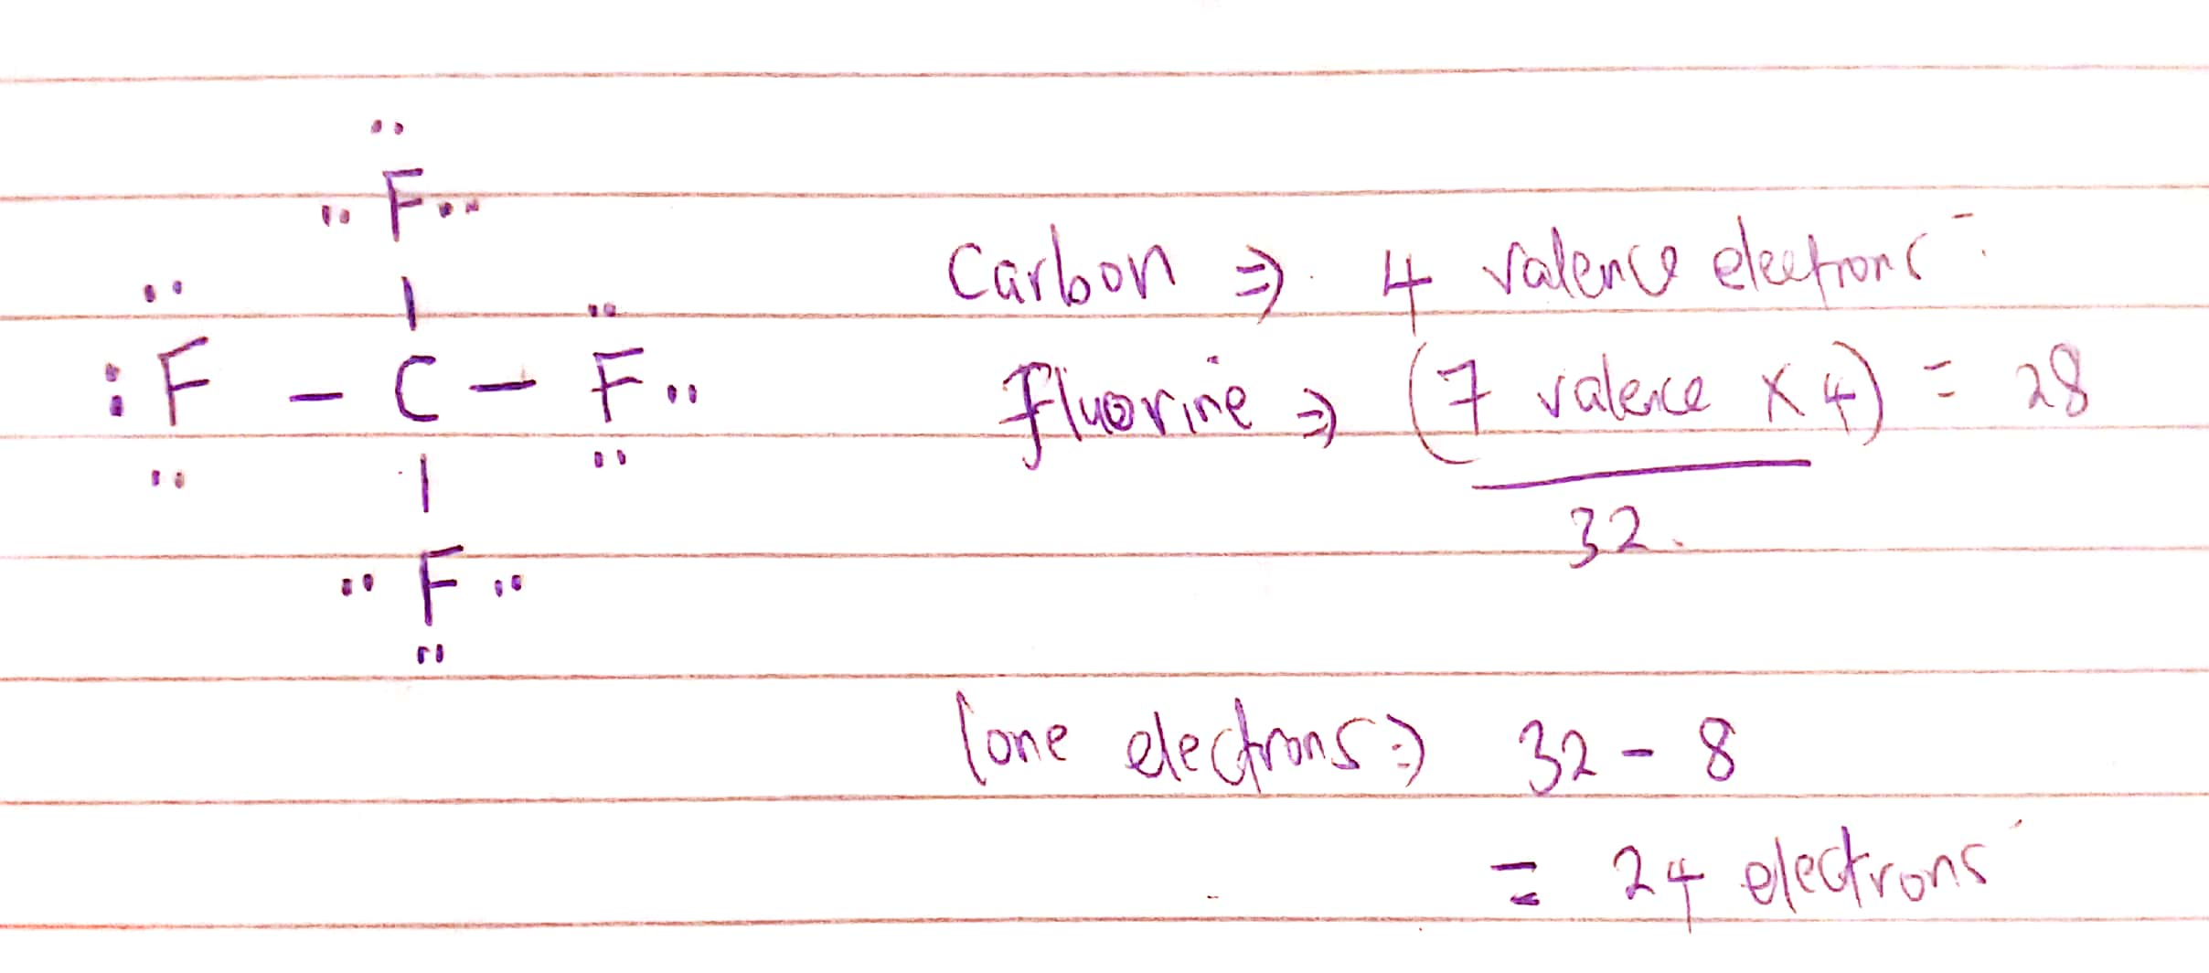
The CF₄ molecule is non-polar due to the fact that its structure is purely symmetrical leading to the loss of net dipole movement. This leads to cancelling out of the adjacent electron pairs of fluorine.
- HBr
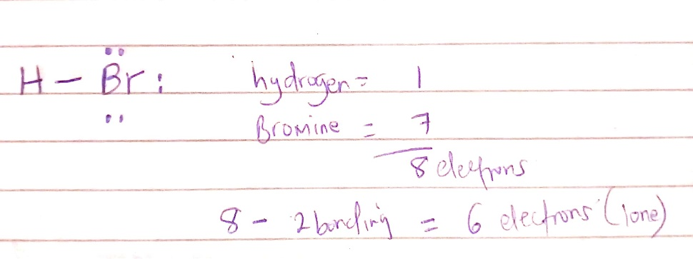
Bromine has a partial negative charge while hydrogen has a partial positive charge due to the electronegativity difference created between the two. This makes the compound HBr to be a polar compound.
- N₂
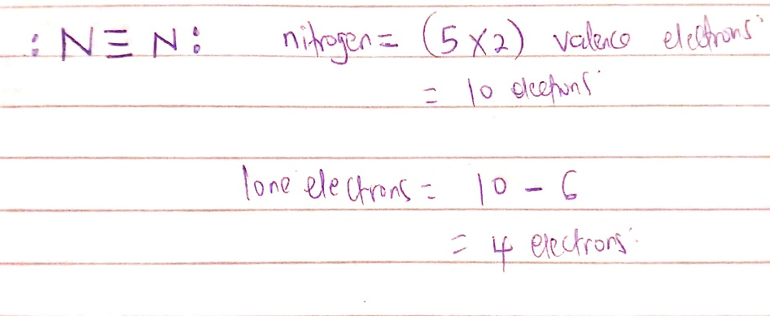
N₂ is a diatomic molecule which has a linear structure. This diatomic nature makes the net dipole movement to be zero because of the equal charge proportion. Thus, N₂ is a non-polar molecule.

