Leadership Style
Student’s Name:

Lecturer’s Name:
Course Title:
Date:

Effective leaders have a style or a combination of several styles that usually makes them to be successful in providing guidance and inspiring their employees. Leaders who are successful in running organizations are capable of driving creativity and productivity, while at the same time improving on the bottom line of the business. At times leaders might end up being ineffective due to the leadership style that they chose to use –at times leaders might choose leadership styles which do not correlate well with the industry within which they operate in or even the type of people that they are attempting to lead. This paper is going to tackle my leadership style which is coaching.
My Leadership Principles
One of my leadership principles is that of exhibiting passion which I think is the best way to motivate my teammates. The enthusiasm for what the group is working on, the I-Core project, shows the commitment and the sense of stability and it also energizes them to keep on working hard. The project is filling a large part of my life and I believe that it is worthy sacrificing our time, resources and energy for. At times when I feel stressed or down, I recall that as a leader I do not have the luxury of allowing this to affect me as well as those whom are working under me.
Choosing my team is the second principle of leadership that I have. I believe that team selection is imperative for all leaders. The process of choosing teammates shows my ability to find the set of skills and knowledge that are relevant to a certain field or industry. When it comes to the point of selecting my teammates, I normally look for teammates who will understand my vision and also those who have a certain set of competencies. I also choose teammates from all walks of life since they will come with different set of skills that will complement each other. At times it is difficult to find a person who has all the skills that are required for a certain job, but it might be possible to find teammates who can complement each other in terms of skills.
The third principle of leadership that I have is that being responsible. It is important for any leader to understand that in any group that they lead that everything and everyone is their responsibility. The teammates will always look up to their leader for the final say on all the things that they do, so that there will be no room for blame. I have got to appreciate and learn to embrace this obligation, and also to take responsibility whenever I go wrong since before the teammates that I lead will always have the final say from me before embarking on anything.
I also follow the principle of being self-motivated. Teammates will always work well whenever they are motivated and thus I find it to be my responsibility to have them motivated. As a great leader, I motivate my teammates openly and without hesitation. I have always being rewarding creativity so that I can have the teammates keep on brainstorming for more ideas towards finishing our project. For the I-Core project to have real steps towards accomplishment, ideas need to remain fresh and relevant.
The last leadership principle that I follow is that of having a clear visions and goals. This means that having a clear vision for the team, where it fits into the industry and the plan that I have to make the project serve well its purpose. Thus, in this case it will be important to have goals set that are relevant to the kind of project that is at hand.
My Leadership Model in a Visual Form
Situational Leadership
In the above model of leadership, the focus is on the prevailing level of teammates –their capability and capacity to execute their assigned tasks in an effective way and to complete the tasks. In this style of leadership, the leaders typically has a much better awareness of his teammate’s capabilities. The latter perception translates that deadlines and expectations of the work process are much more realistic and the teammates better feel that their leader can relate to them. Also, situational leadership model allows team leaders to push the rest of the team members to continue working on their own skills and also start initiatives that are meant to improve their capabilities and knowledge. Thus, as a result, the group’s talent pool keeps on growing making it possible for the group to realize its ultimate goals. The group will also be assured of continued evolution that will enable it to meet its current needs and keep it abreast of the challenges that might ensue as time goes by.
Fig. 1
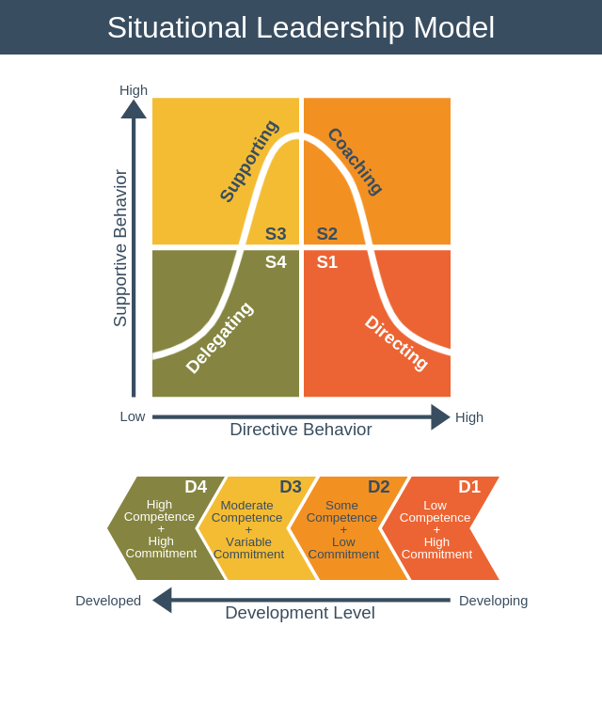
https://expertprogrammanagement.com/wp-content/uploads/2018/11/Situational-Leadership-Model.png
Ethical Perspective I Use in Making Business Decisions
Facts
Fundamental authority in business ethics generally speaking anticipates that associations should perceive express good benchmarks, which every now and again infers different things to different people. As affiliations continue to create and develop, new individuals are contracted who probably won't have undefined good models from individuals beforehand working in the association. A differentiation in ethics much of the time changes how individuals approach the essential authority process. Associations much of the time use the affiliation's mission statement to manufacture a framework for helping individuals choose moral business decisions.
The two Principles that I Want to Continue Working on
Two of the principles that I want to continue working on is that of choosing my teammates and that of being self-motivated. I expect to receive critics on the principle of choosing my teammates since I will always go for the people whom I think we can work together smoothly. There are times when a person might be expecting to be selected to join a certain group and he or she ends up not being picked and then critics start from that point. Also, at times I might motivate some of my group members openly without hesitation and then the rest of the group members ends up criticizing my actions although they were in order with some of the things that might have taken place in the group.
Steps to Improve in Each of these Areas
For the case of improving on choosing of teammates, I will look for good communicators so that I can have people whom we can communicate effectively. Effective communication is very essential in having a group accomplish its goals in an effective manner. The other step that I will take to improve on choosing of the teammates is that of seeking members who are well-organized. Members who are well organized will ensure that the group organizes itself in a way that will enable it to have its goals realized.
On the other hand, with regard to improving on motivation of the workers I will have in place ways that will foster collaboration within the team. I will also offer the teammates opportunities for self-development so that they can improve on areas that they might be having some weaknesses.

Bibliography
EMMANUEL, DR L R. 2019. LEADERSHIP PRINCIPLES FOR SUCCESS. [S.l.]: XULON PRESS.
Fellowship of Christian Athletes. 2011. The greatest leader ever: essential leadership principles. Ventura, Calif: Regal.
Fernando, A. C. 2010. Business ethics and corporate governance. Delhi: Dorling Kindersley (India), licensees of Pearson Education in South Asia.
Iqbal, Talha. 2011. The impact of leadership styles on organizational effectiveness: Analytical study of selected organizations in IT sector in Karachi. Munich: Grin Verlag
Rajbhandari, Mani Man Singh. 2015. Critical Perspective on Situational Leadership Theory. Leadership Readiness for Flexibility and Mobility. The 4th Dimensions on Situational Leadership Styles in Educational Settings.

Iqbal, Talha. 2011. The impact of leadership styles on organizational effectiveness: Analytical study of selected organizations in IT sector in Karachi. Munich: Grin Verlag
Fellowship of Christian Athletes. 2011. The greatest leader ever: essential leadership principles. Ventura, Calif: Regal.
EMMANUEL, DR L R. 2019. LEADERSHIP PRINCIPLES FOR SUCCESS. [S.l.]: XULON PRESS.
Rajbhandari, Mani Man Singh. 2015. Critical Perspective on Situational Leadership Theory. Leadership Readiness for Flexibility and Mobility. The 4th Dimensions on Situational Leadership Styles in Educational Settings.
Fernando, A. C. 2010. Business ethics and corporate governance. Delhi: Dorling Kindersley (India), licensees of Pearson Education in South Asia.

