*6.7
The code:
import java.text.DecimalFormat;
import java.util.*;
public class InvestmentMethod
{

public static void main(String[] args)
{

Scanner input = new Scanner(System.in);

System.out.println("Enter the Investment Amount");
int investmentAmount =input.nextInt();

System.out.println("Enter the Anual Interest rate");
double InterestRate = input.nextDouble();

double monthlyInterestRate = InterestRate/1200;

System.out.println("The amount invest: $" + investmentAmount);

System.out.println("Annual interest rate:" + InterestRate +"%");

System.out.println("Years" +"\t" + "Future Value");
int years=0;
DecimalFormat df = new DecimalFormat("###.##");
while(years<30)
{

years++;

System.out.println(years + "\t" + df.format(futureInvestmentValue(investmentAmount,monthlyInterestRate,years)));
}
}//end of main
public static double futureInvestmentValue (double investmentAmount, double monthlyInterestRate, int years)
{
double futureInvestmentValue =0.0;

futureInvestmentValue =investmentAmount * Math.pow(1 + monthlyInterestRate, years * 12);

return futureInvestmentValue;
}
}
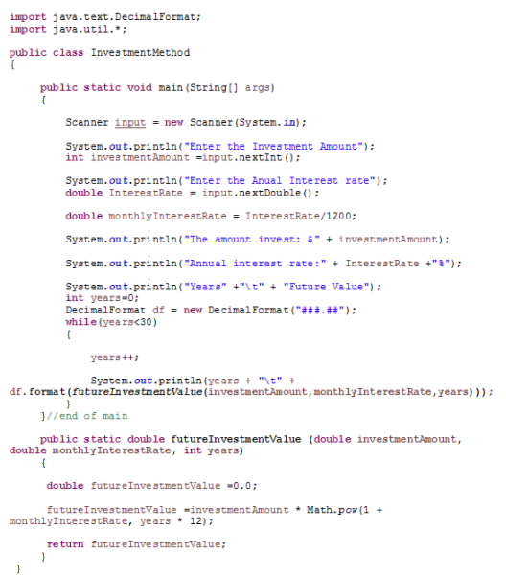
The output:
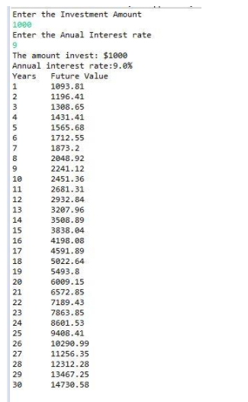

**7.3
The Code:
//import the required packages
import java.util.Scanner;
//Define a class
public class Int_occur
{
//Define the main() method
public static void main(String[] args)
{
//declare the required variable
int i = 0;

//Define the scanner class
Scanner obj = new Scanner(System.in);

//declare an array
int[] arr = new int[100];

//for loop
for (i=0; i<100; i++)

//Define the array
arr[i] = 0;

//Print statement
System.out.print("Enter the integers between 1 and 100:\n ");
//prompt the input
i = obj.nextInt();
//while loop
while(i!=0)
{
//increment the value
arr[i]++;

//prompt next value
i = obj.nextInt();
}
//for loop
for (i=0; i<100; i++)

//check whether there is occurrence
if (arr[i] != 0)
{
//check whether the occurrence is only one
if(arr[i]==1)
{
//print statement
System.out.print(i+" occurs "+arr[i]+" time \n");
}
else
{
//print statement
System.out.print(i+" occurs "+arr[i]+" times \n");
}
}
}
}
Output
Enter the integers between 1 and 100: 2, 5, 6, 5, 4, 3, 23, 43, 2 0
2 occurs 2 times
3 occurs 1 time
4 occurs 1 time
5 occurs 2 times
6 occurs 1 time
23 occurs 1 time
43 occurs 1 time

**8.37
import java.util.Scanner;
public class Main
{
public static void main(String[] args) {
//Declare the Message for Question
String strCapitalQuestion = "What is the Capital of ";
//Declare the Message for Wrong Answer
String strWrongAnswer = "The correct answer should be ";
//Declare the Message for Correct Answer
String strCorrectAnswer = "Your Answer is Correct ";
//Declare the Message for correct count
String sCorrectCountMsg = "The Correct Count is ";

//declare and initilzie the scanner class
Scanner scan = new Scanner(System.in);

//Get the user input in this string
String sAnswer = "";
//Declare the correct count
int iCorrectCount = 0;
//Declare the State and Capital 2 dimentinoal array
String[][] StateWithcapital = {
{"Alabama", "Montgomery"},
{"Alaska", "Juneau"},
{"Arizona", "Phoenix"},
{"Arkansas", "Little Rock"},
{"California", "Sacramento"},
{"Colorado", "Denver"},
{"Connecticut", "Hartford"},
{"Delaware", "Dover"},
{"Florida", "Tallahassee"},
{"Georgia", "Atlanta"},
{"Hawaii", "Honolulu"},
{"Idaho", " Boise"},
{"Illinois","Springfield"},
{"Indiana","Indianapolis"},
{"Iowa","Des Moines"},
{"Kansas","Topeka"},
{"Kentucky","Frankfort"},
{"Louisiana","Baton Rouge"},
{"Maine","Augusta"},
{"Maryland","Annapolis"},
{"Massachusetts","Boston"},
{"Michigan","Lansing"},
{"Minnesota","St. Paul"},
{"Mississippi","Jackson"},
{"Missouri","Jefferson City"},
{"Montana","Helena"},
{"Nebraska","Lincoln"},
{"Nevada","Carson City"},
{"New Hampshire","Concord"},
{"New Jersey","Trenton"},
{"New Mexico","Santa Fe"},
{"New York","Albany"},
{"North Carolina","Raleigh"},
{"North Dakota","Bismarck"},
{"Ohio","Columbus"},
{"Oklahoma","Oklahoma City"},
{"Oregon","Salem"},
{"Pennsylvania","Harrisburg"},
{"Rhode Island","Providence"},
{"South Carolina","Columbia"},
{"South Dakota","Pierre"},
{"Tennessee","Nashville"},
{"Texas","Austin"},
{"Utah","Salt Lake City"},
{"Vermont","Montpelier"},
{"Virginia","Richmond"},
{"Washington","Olympia"},
{"West Virginia","Charleston"},
{"Wisconsin","Madison"},
{"Wyoming","Cheyenne"}
};

//Loop through the each and every element in the array declared above from 0 to 49
for(int i=0; i< StateWithcapital.length; i++){
//Ask the questin to user for each State
System.out.print(strCapitalQuestion + StateWithcapital[i][0] + "?");

//Get Answer from user
sAnswer = scan.nextLine();

//Check the Answer entered by user is correct or not against the answer we declared in array above
if(sAnswer.trim().equals(StateWithcapital[i][1].trim())){
//Print message for correct Answer
System.out.println(strCorrectAnswer);
//Increament the Correct Count
iCorrectCount += 1;
}else{
//Print message for wrong answer
System.out.println(strWrongAnswer + StateWithcapital[i][1]);
}
}

//Print the total correct count
System.out.println("");
System.out.println(sCorrectCountMsg + iCorrectCount);
}
}

Chapter 7 (Eliminating Duplicates)
import java.util.*;
class RemoveDuplicates
{
public static void main(String[] args) {
Scanner input = new Scanner(System.in);
int[] number = new int[10];
System.out.print("Enter ten numbers: ");
for (int i = 0; i < number.length; i++) {
number[i] = input.nextInt();
}
int[] newList = eliminateDuplicates(number);
System.out.println("The distinct numbers are: ");
for (int i = 0; i < newList.length; i++){
System.out.print(" " +newList[i]);
}
System.out.println();
}
public static int[] eliminateDuplicates(int[] list) {
//to start comparison, compare first # i, with # k and check if =
int[] dup = new int[10];
int j = 0, I = 0;
//Fills the array with 0's.
for (int i = 0; i < list.length; i++){
dup [i] = 0;
}
int count = 0;
for(int i = 0; i < list.length; i++)
{
boolean duplicate = false;
for(j = 0; j < count; j++)
if(list[i] == dup[j])
{
duplicate = true;
break;
}
if(!duplicate)
{
dup[count] = list[i];
count++;
}
}
int [] newArray = new int[count];
for(int i = 0; i < count; i++)
newArray[i] = dup[i];
return newArray;
}
}

*9.5
import java.util.Calendar;
import java.util.GregorianCalendar;
public class CalenderDemo {
public static void main(String[] args) {
GregorianCalendar calendar = new GregorianCalendar(); // Today's date
int year = calendar.get(Calendar.YEAR);
int month = calendar.get(Calendar.MONTH) + 1;
int day = calendar.get(Calendar.DAY_OF_MONTH);
/* Displaying Current Date using
GregorianCalendar Class */
System.out.println("Current Year: " +year);
System.out.println("Current Month: " +month);
System.out.println("Current Date : " +day);
System.out.println(" ");
// set new time january 1 1970
calendar.setTimeInMillis(1234567898765L);
// print the new time
int nyear = calendar.get(Calendar.YEAR);
int nmonth = calendar.get(Calendar.MONTH) + 1;
int nday = calendar.get(Calendar.DAY_OF_MONTH);
System.out.println("Year: " +nyear);
System.out.println("Month: " +nmonth);
System.out.println("Date : " +nday);
}
}

