Collar with Medallions
Name of the Student
Instructor’s Name
Date
Collar with Medallions

This artwork is known as a collar with medallions containing coins of Emperors Lucius Verus and Alexander Severus and Julia Domna, wife of Emperor Septimius Severus and Mother of Geta and Caracalla. These imperial portraits coins are widespread in the third century A.D. The date of this piece of art is ca. A.D. 225; it is from Egypt, therefore, being a Memphite region, which is in Memphis, with a period of Roman time (Metmuseum.Org 2019). The medium of the art is gold, and its dimensions are the length of the chain is 91cm. The credit line is considered to be a gift of Edward S. Harkness in 1936 to the museum after being purchased from Howard Centre by Harkness in 1924. The collar’s accession number of 36.9.1, and it contains coins, costume, gold, jewelry, medallions, metal, and necklaces as part of materials used to make the collar.

Collar with Medallions containing 5 Gold coins
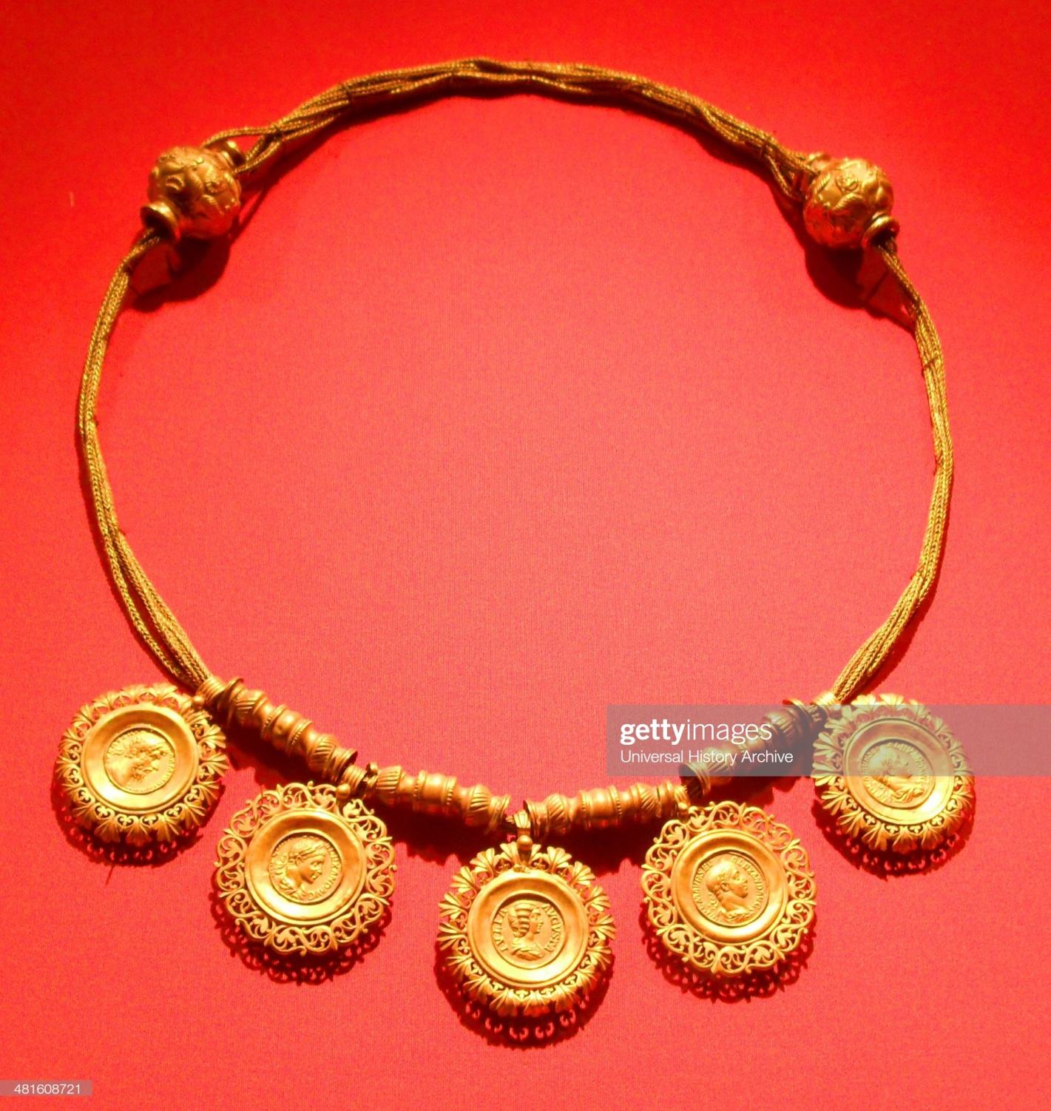

The collar is gold in color; it has five coins, each with a face on it representing the authority in the Roman period. The necklace has three threads, and it is in a circular form (Lansing 1940). Since the whole art is in gold, and it represents the Emperors of Rome, it is value becomes priceless. For this reason, Edward gave it as a gift to the museum because of its priceless value. It does not occupy a big space since it is a collar; it might be the size of a person’s neck. The purpose of the necklace was to honor and remember roman leaders who served during the A.D. period. The collar was made to represent the members of the Roman imperial family. The art is in a museum showed how imperial authority was essential and honored by its people.
The primal symbol of the collar is honoring and respecting the imperial family. Today, people get tattoos, necklaces, and bracelets that have people’s names and faces on them. The tattoos and the names on the chain and bracelets are of people one loves, cares for, is considered a hero or a heroine, and best celebrity. Mothers, brothers, guardians, wives, and fathers are some of the common tattoos that people have showing their significance in a person’s life. Some people do tattoos based on bible verses, symbols that have a significant meaning in their lives, and people’s faces, among others. In the current world, when a gift is offered to somebody, it is considered priceless, especially if it is from a special person, and t is not sold. The gift will be treasured, and the receiver of the gift will make it the art of value. Selling a gift is considered a bad sign due to the sacrifice that the giver took to give out the art. The collar gifted to the museum was considered priceless, and the latter did not sell the artwork because they understood the value of the piece, and today, the collar is among the pieces of the ancient artwork in the museum of the era between 1 and 500 AD according to the met museum. It is essential to understand the implications of the collar to the imperial family, and it showed it is essential to respect and honor the family. The artwork also describes the ancient history, political circumstances, and religious affiliations of Egyptians. The historical information is about the political rule of Rome, creating more knowledge of history.

Works cited
Lansing, Ambrose. Ancient Egyptian Jewelry. [The Museum Press], 1940.
Metmuseum.Org, 2019, https://www.metmuseum.org/art/metpublications/mmajournals?&pt=%7bAA2EA5AF D293-44E9-B972-579457F115AB%7d&searchtype=C&&pg=13.

