My day as an Adorable Teddy Bear named “Ted”.
zzz!!! The winter is really cold, I would keep myself inside the sheets the day long.
Cold! Cold! Cold!, it’s unfortunate that I won’t stay outside for the entire day.

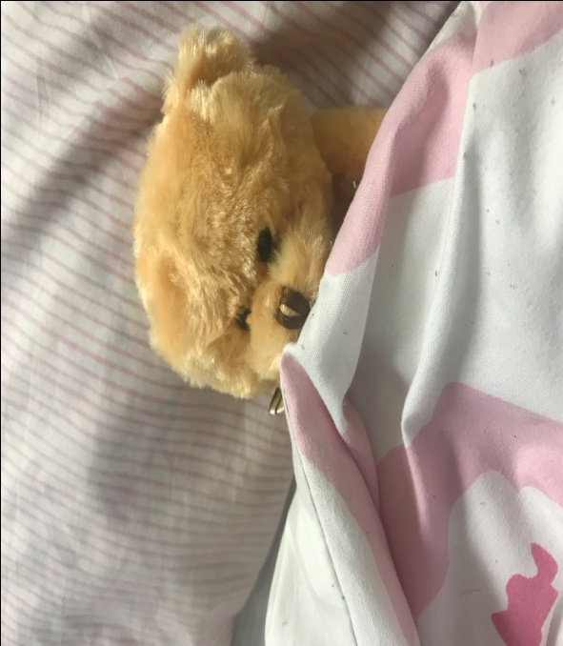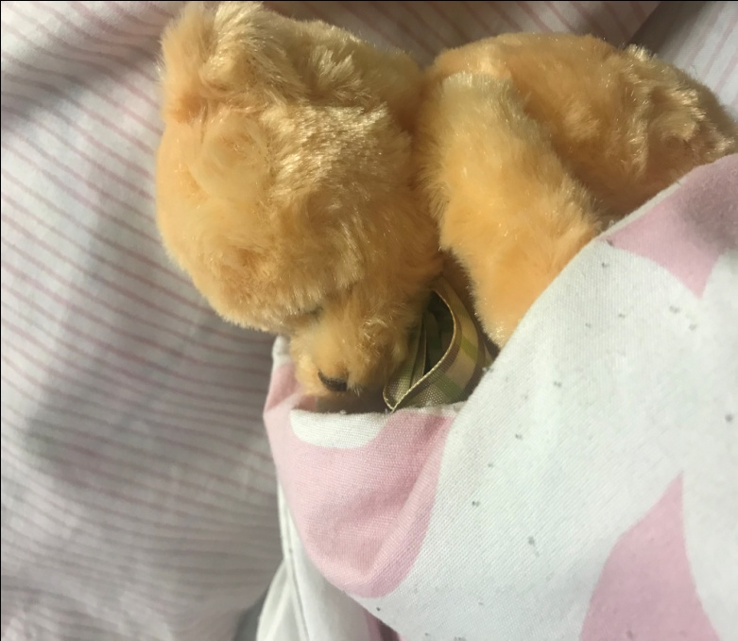
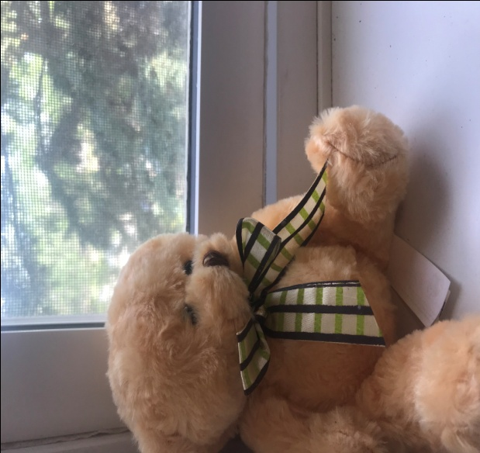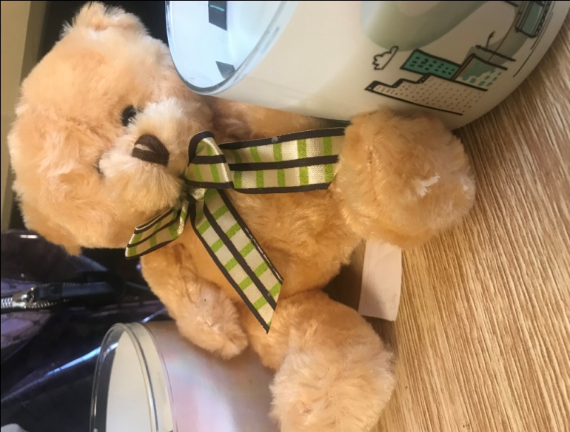
Oops: let me get some candle lit warmth
Oh my God!!The weather outside is even worse.
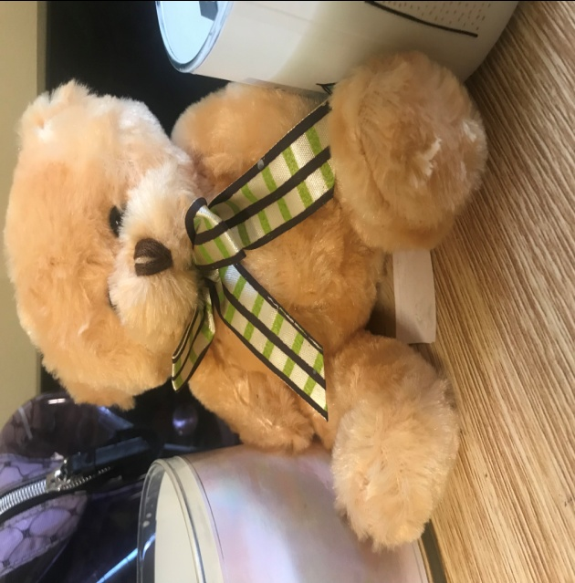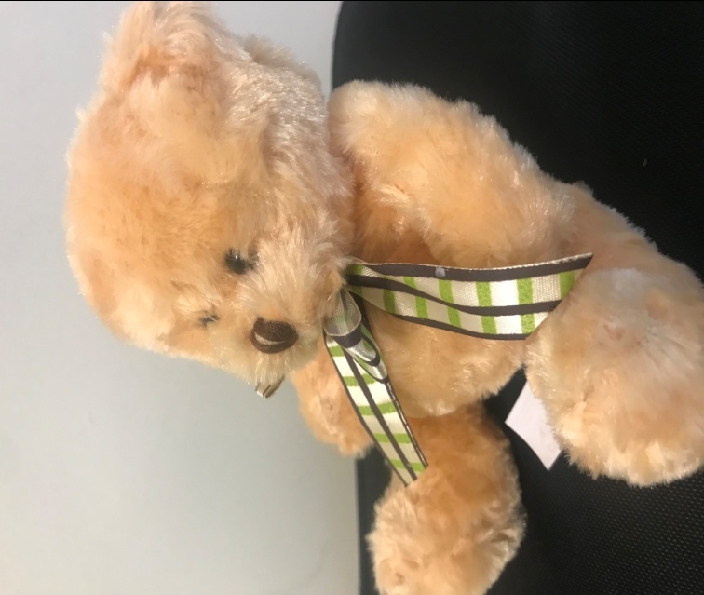
Oops!! My tummy feels empty, I have to feed as soon as possible.
Resting also makes my days, it is about time I make myself comfortable. THIS home is mine!!!
Alas!! It feels cold still, let me sit upright and

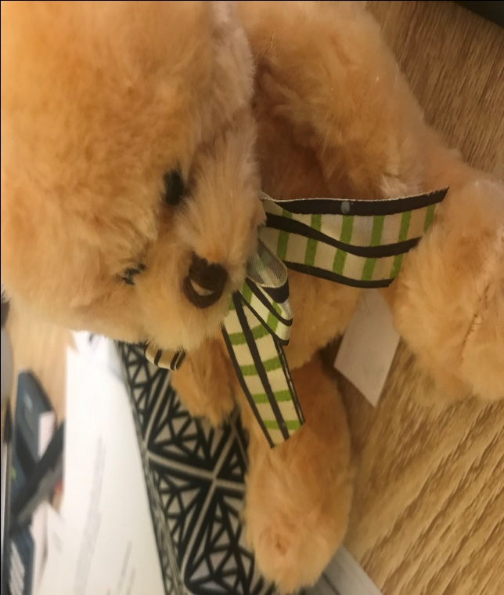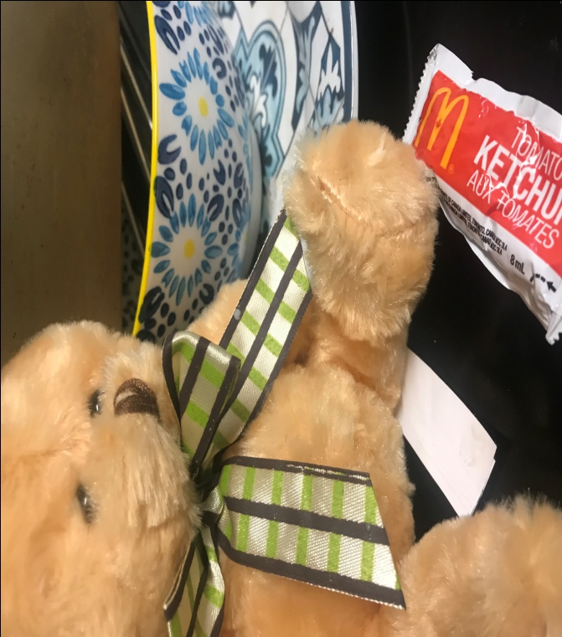
Oh my!!There is nothing to feed on in this house. This feels sad but my ketchup tomato sauce still works !! Poor Bear!!!
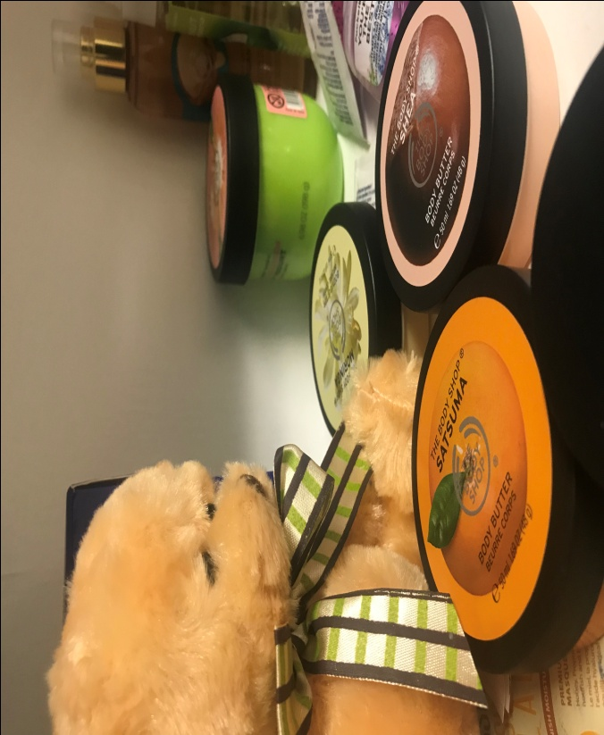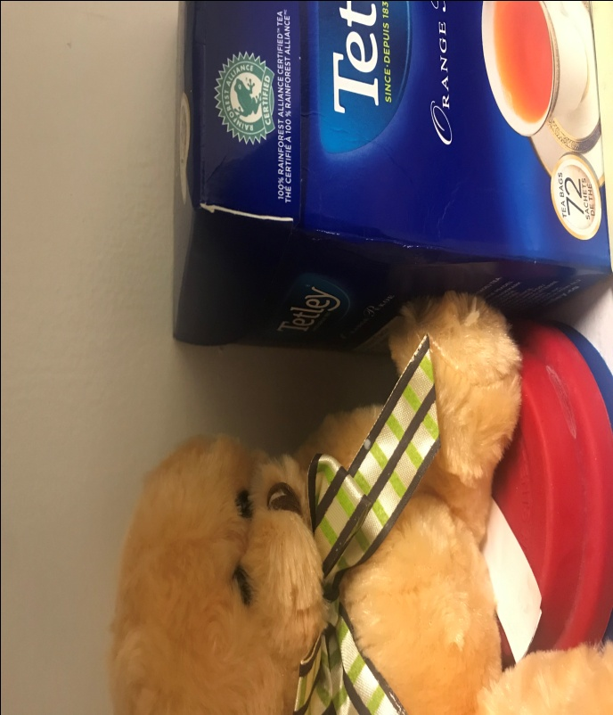
By the way, I also need to look good, my look is a priority, let me get my face makeup.
Hurray; I got a solution for the weather. I will make some Tetley Tea and I will be good to go. This is my favorite flavor. Yaaaaaaaaaaaaaaay!1!!
This cover story depicts the daily routine of “Ted” especially in the cold weather. Ted prefers to keep warm in the house especially tucked under the sheets on the sofa. The routine involves keeping warm, resting, feeding and applying makeup.

