Community Support PowerPoint/Pamphlet
You will choose to create either a PowerPoint presentation or a pamphlet to be used in presenting to a community or church group in order to solicit support for substance abuse/addiction treatment. In your presentation or pamphlet, discuss the prevalence of addiction and what communities can do to help. Use at least 3 statistics regarding addiction, and give at least 3 ideas of ways communities can help. Make sure to document your sources in current APA format.

PowerPoint Instructions:
Your presentation must be completed in Microsoft PowerPoint and must include the following:
- At least 10 slides (not counting the title slide or reference slide);
- A script (at least 100 words for each slide) as a guide for presenting the information;

Include a script in the notes section of each slide for the presenter.
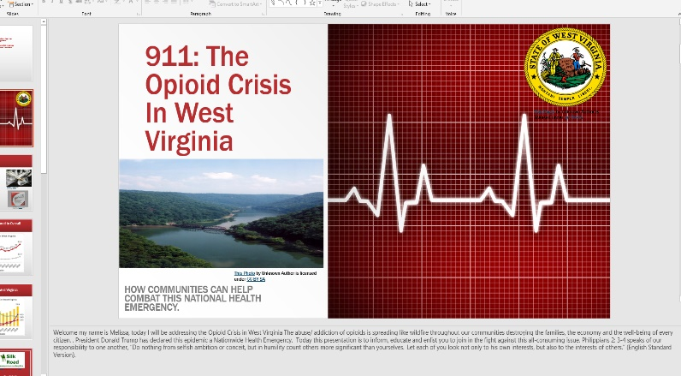
- A minimum of 3 statistics and 3 suggestions for community help; and
- A title page and a reference page.

Pamphlet Instructions:
Your pamphlet may be constructed in either Microsoft Publisher or Microsoft Word and must have an attractive, appealing design. It may be bi-fold or tri-fold, but it must include the following:
- Information on both sides of the paper;
- 8 ½ X 11 or 8 ½ X 14 paper size;
- A minimum of 3 statistics and 3 suggestions for community help; and
- A separate reference page to be submitted with the pamphlet.
Here is a link to an online instructional tool for creating a brochure in Microsoft Word https://www.displays2go.com/Guide/How-Create-Pamphlets-Flyers-Word-25

