IN CLASS PROJECT – CREATIVE DEVELOPMENT
YOUR REPORT IS TO BE HANDED IN NEXT WEEK

STATION 1
MARK / 10
(guide – half page)

While enjoying some of the munchies, please comment on the impact of the packaging that you see these products using. What is effective? What isn’t?
Incorporate elements of design, packaging, color and appeal in your answer.

Provide your analysis on three of the items.

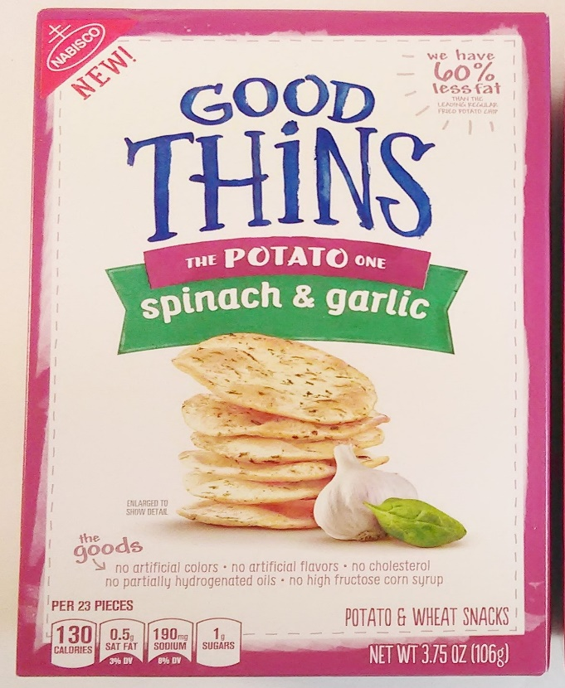
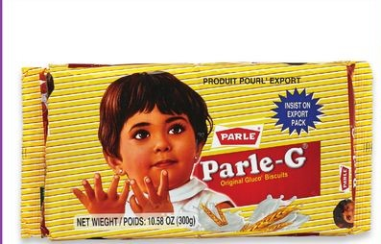

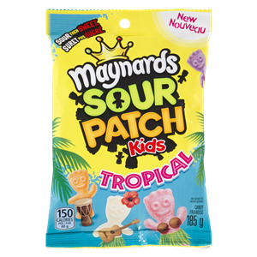

STATION 2
MARK / 30
(guide two pages)

Get your creative juices flowing and come up with a BIG IDEA. Develop a creative strategy, including name and how you will brand it, using brainstorming, mindmapping and / or idea association, for two of the following products: ( draw pictures )
- A device that traps and kills cockroaches. It is shaped like a little house and is currently only sold in Japan. It will be launched in Canada this fall.
- A highly fuel-efficient road scooter, in “smartie box” colors.
- A new holiday drink from Starbucks – you decide the holiday and the drink name. Please don’t use a current product / holiday that Starbucks already does!

STATION 3
MARK / 20
(guide one page)

Using the link to ads, pick three of the campaigns. For each one, answer the following

How does the ads used attract the following creative elements?
- The attention of the consumer
- The consumer interest in the product
- The credibility of the product
- The consumer’s desire to try the product
- The appeal of the message – does it make sense and is it memorable
- The action required on the part of the consumer
- How would you assess its effectiveness?
https://www.creativebloq.com/inspiration/print-ads-1233780

STATION 4
MARK / 20
(guide full page)

Pick the products given below.
- Come up with an identity for the product that you think it could be used for. Be creative here…don’t tell me what it is ACTUALLY used for!
- Clearly identify the primary audience for the product
- Pick a medium to best advertise these products
- Write ad copy for these products (20 words minimum)
- Give a thumbnail sketch of how your ad will appear

- Describe which medium would be best for your products and why ( ie social media; print; tv; etc.,..)

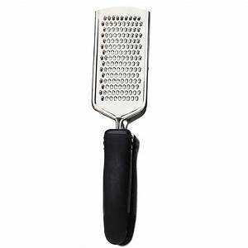cheese grater
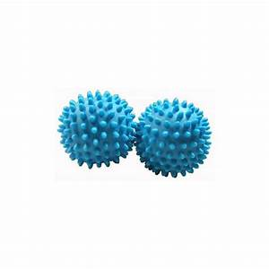dryer balls

STATION 5
MARK / 20
(guide half page)

Match the celebrity! Each of these celebrities has an impact on product advertising, based on their own reputation and associations. Pick an appropriate and different product for THREE celebrities only, and explain why you made that choice.

You are providing a rationale for why the celebrity should be used to sell a specific product. DO NOT use a product already associated with the celebrity but instead, do some of your own thinking about what the celebrity should be associated with. Base your answer on what you know the celebrity is associated with. Which personality traits do we admire or what successes or failures do we associate with them?

Provide at least a paragraph to explain your recommendations.
(PICK ONLY 3)
- Beyonce
- Taylor Swift
- Roger Federer
- Barack Obama
- DwayneThe Rock Johnson
- J K Rowling
(By the way, these folks were some of the biggest earners in 2018 average at $87 million per yer)

