Humanitarian Crises
Student’s Name
Institution Affiliation
Date of Submission

Humanitarian Crises
The humanitarian crisis in Syria
According to Sida (25 February 2019), Syria is experiencing one of the largest displacement crisis with half of its people have been displaced from their original homes. 6.2 million people have been displaced from Syria and 5.6 million refugees have registered in the different countries with neighboring countries such as turkey having the largest population of refugees. The humanitarian assistant they receive is not sufficient to cater to their needs. Another crisis in Syria is brought about with heavy military operations from the Syrian Army with the support of the Russian Federation which includes bombs to fight Syrian rebels but the civilians become causalities which have led to the death of many Syrian residents this operations breach, the international humanitarian laws. Another crisis in Syria is brought out with many military operations from different countries such as France, Iran, Israel Turkey, and the UK. These military groups are distributed in different parts of Syria and violet international humanitarian laws, making the number of Syrian citizens to flee from these areas due to the intensive use of military force on the ground. U.S.A decision of pulling out of Syria their military increases the risk of the creation of more rebel territories (Sida, 15 April 2019).
This military operation has led to the destruction of health facilities, education facilities, infrastructure and an increased number of refugees fleeing to different countries. These problems are very essential to the Syrian people thus should be addressed. There are ways different stakeholders that help to stop the crisis in Syria. The government of Syria has taken control of some regions and the fighting in those regions has stopped (Sida, 15 April 2019). The countries with Syrian refugees are putting pressure on the refugees to return to Syria in the controlled regions especially Lebanon and Jordan. There are varies organizations such as UNHCR, Sida, and UNHCR are trying to help the refugees with the basic needs as they try to find a solution to the ongoing crises. There are varies deals between the government of Syria with other organizations and countries to find a lasting peace plan for Syria. I think more is being done to end this crisis by the Syrian government and other stakeholders involved.
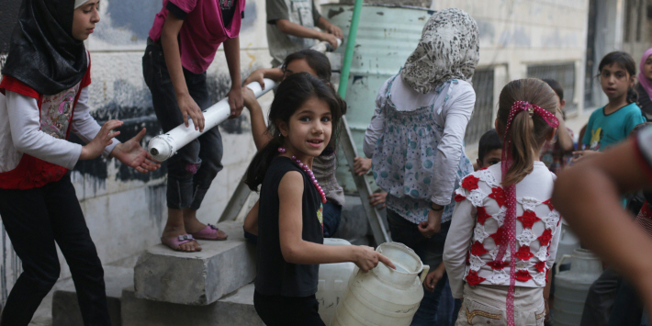
The photo was taken by Bassam Khabieh @UNICEF
Some of the Syrian girls fetching water, from one of the water projects funded by UNICEF in the Douma area where there was a large Scarcity of water. Most Syrian children have a problem accessing water which leads to the risk of contracting diseases (Sida, 25 February 2019).

References
Sida, (25, February 2019) Crisis Analysis Syria, Syria regional Humanitarian Crisis Analysis, Retrieved from https://www.sida.se/globalassets/sida/eng/how-we-work/humanitarian-aid/hca-2019/hca-syria-crisis-2019.pdf
Sida,( 15 April 2019)Ongoing Humanitarian Crisis, Our humanitarian assistance in Syria, retrieved from https://www.sida.se/English/how-we-work/our-fields-of-work/humanitarian-aid1/ongoing-humanitarian-crises/our-humanitarian-assistance-in-syria/

