ANT 201: CULTURAL RESEARCH PROJECT
WINTER 2021
TOTAL POINTS: 25

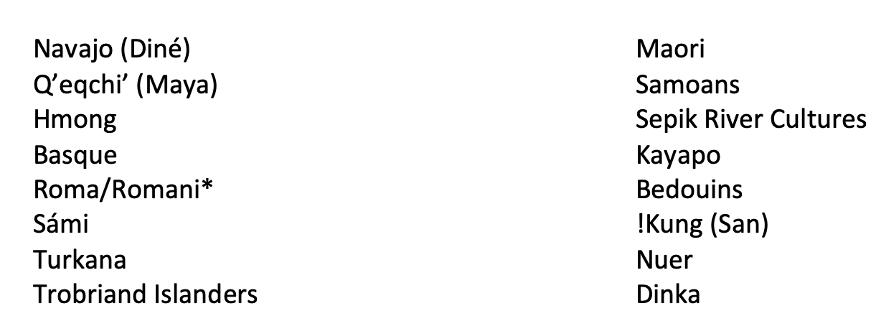
Instructions: Select a culture you are interested in researching further from the list of approved cultures. Cultures you may select from**:
*The Romani culture is distinct from that of Romania, or the ancient Romans. Roma/Romani refers to the cultural and ethnic group found throughout Europe and the Near East.

**Cultures not on this list: please email your professor for approval prior to beginning assignment

Once you have selected your culture, select one category from the following list that you are interested in exploring further:

- Kinship and Marriage
- Religion and Rites of Passage
- Economic/Political organization
- Sex and Gender/Gender Roles
- Environment/Sustainability/Subsistence Strategies
- Artistic Expression/Arts &Entertainment

PART 1: ANNOTATED BIBLIOGRAPHY (TOTAL: 10 POINTS)

Instructions: You will be responsible for submitting a minimum of ten (10) peer-reviewed, annotated references that relate to your culture and/or topic(s). You will submit your completed annotated bibliography using the assignment link on Blackboard as a file attachment in Microsoft Word or PDF format only; assignments that are not in these formats will be ineligible for credit. Your citations may be a combination of general articles on your culture, and articles that are specific to your selected topic. The research that you use is expected to be of academic quality; in other words, your references should come from books and journal articles that have been peer reviewed. Ideally, you should look for references published in Anthropology journals or written by Anthropologists; you may, however, find useful information in books and journals pertaining to Sociology, Geography, and other social sciences.

Each reference that you submit must conform to the following guidelines:

- It must be in a citation format (such as MLA, APA, AAA). Incomplete references (that are missing publication titles, dates, authors, pages, etc....) will not receive full credit.
- As this is an annotated bibliography, you must provide a 2-3 sentence description of what relevant information (pertinent to your culture / topic) you found in the article. References missing annotations will not be eligible for credit.
- Include your name, course section, culture, and topic(s) at the top of your paper or on a separate title page.
- Each reference must be from a peer-reviewed published book or journal article that is from an academic publisher, written by an Anthropologist or other professional academic researcher, or from a peer-reviewed journal publication (a few examples: American Anthropologist, Journal of Latin American and Caribbean Anthropology, Journal of Linguistic Anthropology, etc.)
- Websites and online or print newspaper/magazine articles (e.g.: National Geographic, livescience.com) are not considered valid references for this assignment. You may not use textbooks, articles from class, or online encyclopedias (e.g.: www.britannica.com) as references.
- This course focuses on cultures living around the world today. While you may include references that touch on historical aspects of these cultures, you should select articles that discuss these cultures as they exist today (e.g.: if you select the Qʼeqchiʼ Maya, this means you should focus on the modern cultural group living in areas of Mexico (Yucatán)/Guatemala/Belize today, and not on the Pre-Columbian Mayan Civilization).

To find appropriate references consult the following resources on the WCC Library website and beyond; DO NOT USE GOOGLE.
- One Search Library Resources: Available as a search box on the WCC Library home page (http://www.wccnet.edu/resources/library/). This, and the advanced search option, will give you access to academic journals when you login with your WCC ID and password.
- E-Articles/E-Books: A tab just above One Search on the WCC Library Home Page; select Ebrary under E-Book Collections. These e-books can be downloaded or read online.
- Use MeLCat: MelCat allows you to borrow books and journals from college and university libraries throughout the state of Michigan. It typically takes 7-10 days for your materials to arrive at WCC; you can search MeLCat from the WCC Library website under “Borrow from Another Library” http://www.wccnet.edu/resources/library/melcat/
- Directory of Open Access Journals (DOAJ): Go to http://doaj.org Most of the articles on DOAJ are full-text and peer-reviewed.

Suggestions for Completing Your Research:

- Use Resources to Help Format Citations! Getting your references into a specific Citation format can be a pain – consider using free software, such as Zotero: http://www.zotero.org or online resources, such as Easybib: http://www.easybib.com or the Purdue Online Writing Lab: http://owl.english.purdue.edu/owl/section/2/ to ensure that your list of references is formatted correctly. The WCC Writing Center can also help with formatting your citations.
- Take Notes! When you find something surprising or just “interesting” in your research, make a note of it; it is easier to see the “big picture” of a topic looking at a page of notes than it is a pile of articles or books!
- Approach your topic with an open mind: Understanding your topic means approaching it without bias and recognizing when your own values/beliefs conflict. Understanding how your own beliefs differ and why is just as important as the research you collect.
- Use the Library Research Toolkit: It contains many helpful hints on how to find books and articles relevant to your topic; the videos are great! You can find it at http://libguides.wccnet.edu/researchtoolkit. There is a Toolkit specifically designed for doing research in Anthropology: https://libguides.wccnet.edu/anthropology
- When in doubt, Ask A Librarian! This feature on the WCC library homepage allows you to directly contact a librarian for help with database searches, finding research articles, and general questions about the WCC library databases.

PART 2: POWERPOINT PRESENTATION & DISCUSSION BOARD POST (15 POINTS)

PowerPoint Creation (10 points): For the second part of the Cultural Research Project, you will create a PowerPoint presentation that includes the information you gathered from your Annotated Bibliography in Part 1 (see course schedule for due date). If you create the presentation in Google Docs or another format, you will need to convert your section of the presentation to PowerPoint or PDF format before submitting it to Blackboard.

Posting to the Discussion Board (5 points): After submitting your PowerPoint to Blackboard using the “Assignments” link, you will upload and post your PowerPoint to the “Discussion Board” forum on Blackboard. To complete this portion of the assignment, you must comment on at least two (2) other student’s PowerPoints (100+ words/approx. 1 paragraph) posted to the Discussion Board

Your final submission should include all of the slides listed below, pictures that you intend to use, and a list of your citations. I will evaluate your presentation based on these criteria:

- Amount of detail about your culture (5 points): Does your PowerPoint address specific aspects of your culture’s beliefs, values, and practices, and does it address these topics in sufficient detail (in more detail than would be found in an Encyclopedia, for instance). Include research gathered in Part 1!
- Anthropological perspective (2.5 points): Have you attempted to explain the cultural beliefs, values and practices of your topic using concepts and theories from Anthropology (in other words, have you applied concepts from class in your presentation)?
- References (2.5 points): Is there a slide at the end for the books and articles used? Are there references for images used in your presentation? Are these references in a proper citation format (such as APA, AAA, MLA, etc...?).
- Post your PowerPoint to the Discussion Board in Blackboard. You must post at least two comments on other student’s Discussion Board submissions to receive credit for this portion of the assignment. (5 points)

Guidelines for your PowerPoint

Your PowerPoint should include the following slides:
- Introduction with name/topic/class section.
- 1 Slide with name of culture and basic information (language, geographic region etc.)
- Approx. 4-6 Slides on chosen topic with specific information drawn from annotated articles from Part 1. Example: A PowerPoint focusing on Romani Arts & Culture might have three slides on musical expression and two on visual art/poetry.
- 1 Slide with References cited for information included in PowerPoint (These sources should come from your Annotated Bibliography)
Instructions for PowerPoint:
- Information should be provided in bullet-point form, do not include large portions of text. Like any other assignment, the information included on the slides should be in your own words (i.e. do not copy-paste information from online resources)
- You must provide some kind of visual material related to your individual topic. Do not simply include text outlines.
- DO NOT INCLUDE VIDEO! You are welcome to suggest websites where you can find a video related to your topic, but it is your responsibility to communicate your findings– not a video.
- Provide a “References Cited” slide at the end of your PowerPoint. This should include references for ALL materials presented in your presentation. You should also include a reference for your photographs; these can be listed as URL’s at the end of your References Cited section.

Guidelines for Written Assignments

Unless otherwise specified by your instructor, all written assignments completed outside of class must conform to the following guidelines. If you are having difficulty with an aspect of a particular assignment, I'll be happy to look at a single rough draft of your work before the submission deadline to provide general comments for improvement. Rough drafts should be emailed to me directly from your WCC email account and must be received at least five (5) days prior to the due date for the assignment.

ASSIGNMNETS THAT DO NOT CONFORM TO THE FOLLOWING GUIDELINES WILL BE INELIGIBLE TO RECEIVE FULL CREDIT.

1. All assignments completed outside of class must be typed, use a 12-point font, have 1” inch to 1.25”
inch margins and must be double-spaced. Times New Roman or another easily legible font is preferred.

2. All final drafts of assignments must be submitted through the appropriate assignment link on Blackboard and must be in Microsoft Word (.DOC or .DOCX) format, or Adobe Acrobat (.PDF) format unless otherwise specified**. Assignments submitted in any other format will not receive points. The file name of your assignment should include your name, the assignment name, and the name of the class. **PowerPoint is acceptable for this assignment
3. All outside references must be cited in your assignment, both in the body of your paper (such as Smith, 2017) and in a references cited section at the end of your paper. Any information from an outside source used in an assignment and not cited is plagiarism, regardless of your intentions or how the information was used. You should use AAA (American Anthropological Association), APA, or MLA citation formats when citing outside content. The website http://www.easybib.com contains instructions for formatting references in MLA. The website https://owl.purdue.edu/owl/purdue_owl.html contains references for formatting papers using APA.

4. DO NOT use references from the Internet! You may use electronic copies of peer-reviewed journal
articles and books but not websites, even if they are from an organization or an academic source.
5. DO NOT use quotes in your assignments. Quotes from articles longer than 5 words in length will be ignored for grading purposes and will result in a significant loss of points on your assignment. Rather than using quotes, please paraphrase and provide a reference. I want to see your ideas and explanations, not those of another writer.

