LITERATURE SURVEY
Ejector main parts
A jump refrigeration system, also known as an ejector, is a kind of refrigeration system that utilizes heat to chill plants. Because of their simplicity of operation, dependability, and trouble-free functioning, vacuum-producing ejectors are the most straightforward to use (Abuan & Berana, 2015). Given that they are just ornamental pieces of equipment with no practical components, those who work in this field have the least knowledge about them. If you are acquainted with the fundamental elements and functioning, you may be able to incorporate it into your manufacturing process. An ejector is composed of four major components: the suction chamber, diffuser, and motive. When you use an ejector, the pressure or potential energy of the motive fluid is turned into velocity energy via the use of a turbine (Abuan & Berana, 2015). During the journey between an expanding nozzle and a suction load, a motive fluid expanding adiabatically is used.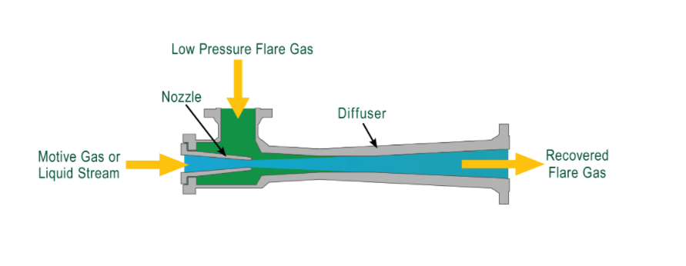
Figure 1 ejector parts
The motive chest is the initial part of the Ejector, since it is where the motive fluid enters. As in most scenarios, steam is used as the motive fluid, and this is also true for most equipment in general. The liquid employed must be vicious, even if any fluid with greater pressure than the Ejector's crushing pressure may be used.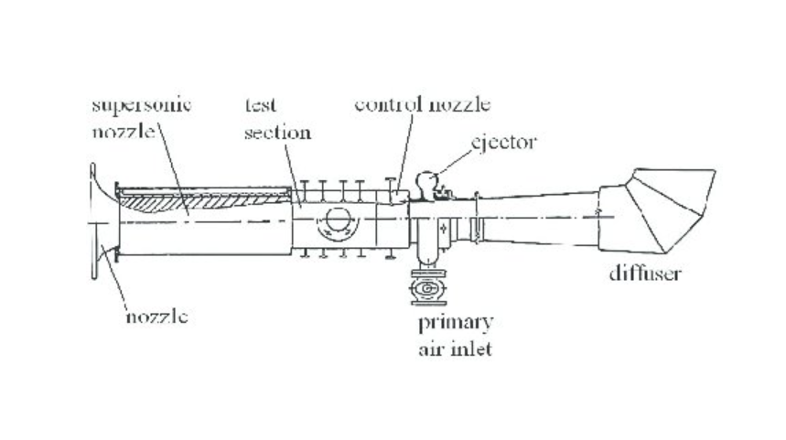
Figure 2 ejector parts

The motive nozzle is the second component. After entering the motive chest, the motive steam expands adiabatically through the converging-diverging motive nozzle, converting pressure to velocity (Fang et al., 2018). As the motive fluid rushes into the lower pressure zone of the suction pressure chambers, the pressure difference across the motive nozzle accelerates it (Galindo et al., 2021). A well-constructed converging-diverging nozzle efficiently converts a high-pressure motive to high-velocity steam leaving the nozzle's diverging portion. In reality, the engine gas fills the pressure zone below the suction area (Galindo et al., 2021). They cause the sectional vapour to increase due to the formation of a minor low-pressure zone. The manufacturer determines the position of the motive nozzle depending on your specific operating circumstances. Additionally, it is critical to the Ejector's functioning.
The sanctions chamber connects the nozzle to the chest ejector mechanically. The high-velocity mode stream/ steam combines with and enters the gas in the sanction chambers. The high-velocity model stream transfers momentum to the functional gases, accelerating the sectional and decelerating the motive gas to create a new mixed velocity diffuser. The stream of mixed gases enters the diffuser and is compressed and converted to pressure. Three segments comprise the diffuser: an inner converging segment, a middle segment, and a diverging external segment (Liddle & Sadorsky, 2017). The region and its discharges are shown schematically. When the inner converging section's cross-sectional area is lowered, the mixing velocity and pressure fall. Here, the gas flow is supersonic to subsonic. The diffuser flow is adjusted to provide a smooth transition from supersonic to subsonic flow, which raises the nozzle's pressure because pressure increases as velocity falls.
How Ejector works
Bernoulli's Principle shows that as a liquid's speed rises, its tension falls, as well as the other way around. An ejector changes pressure energy to rate by speeding up a high-pressure stream (the motive) through a spout. A low strain zone structures around the spout tip, when the speed is greatest. This is as often as possible alluded to as the attractions office of the Ejector. On the off chance that the tension here is not exactly the attractions liquid's strain along the edge bay or'suction branch,' the pull liquid will be entrained/sucked into the Ejector's body (Van Nguyen et al., 2020). The two liquid streams then, at that point, travel using the diffuser part of the Ejector, where their speed is brought down, and their strain is reestablished inferable from the wandering structure.

Because of the way that a part of the engine stream's energy is expected to 'play out procedures on the pull stream, the attractions stream's strain builds/decays as the rationale stream's tension falls. The release pressure is consequently equivalent to the distinction between the intention and attractions pressures.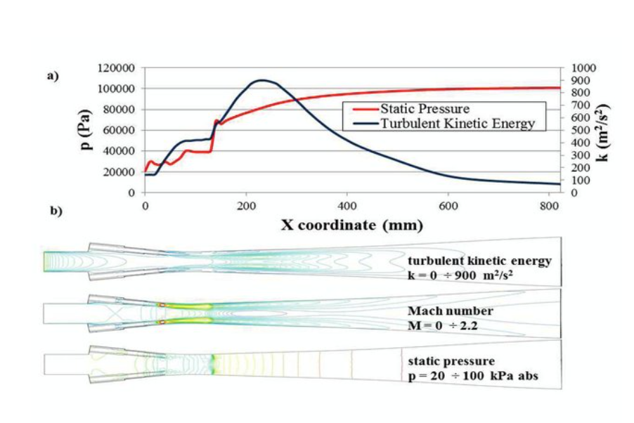
Figure 3 the flow through the mixing chamber and diffuser
Ejector applications
- • Transfer of water from one tank to another
- The Ejector may also start the siphon by creating a vacuum depression in the transfer circuit. • When the siphon is first started, a vacuum is formed. Chemists collect samples from chemical reactors using a sampling vacuum use this vacuum.
- Primary centrifugal pumps have the following features:
- Vacuum cleaner installation
Ejector in a refrigeration system application in detail and provide
For a long time, water was the primary refrigerant in ejector refrigeration systems. For example, the feasibility of developing and testing a 120–140°C steam jet refrigerator for small households is being explored theoretically and practically as part of this research project (Šarevski & Šarevski, 2016). Because it performs best at critical flow rates, the Ejector achieves the maximum possible coefficient of performance (COP) and entrainment ratio. To make things happen, a mixer is placed inside of the steam-ejector refrigerator's expulsion chamber. Water is demonstrated to be used as a cooling medium and as a power source for solar-powered ejector cooling systems. It is possible to get a performance coefficient of 0.3 with this system (COP) (Šarevski & Šarevski, 2016). For cooling, solar-powered steam jet ACs beat out typical vapour compression units, according to the findings of a recent experiment. Researchers are investigating if a steam jet refrigerator driven by sunlight arrived at the following conclusions: The Ejector's spindle regulates the main flow of material through it. The spindle position, boiler temperature and evaporation temperature, for example, are all taken into account when measuring ejector performance.
This research examines the efficiency of ejector refrigeration using the long-established constant area ejector flow model. Stable condensing and evaporation temperatures are more critical when comparing continuous generator temperatures to optimal CO2 generation than steady generator temperatures (Šarevski & Šarevski, 2016). Ejector refrigeration systems are powered by low-temperature heat sources, including solar, geothermal, and waste heat. Coolers' condensing and evaporating temperatures have a major influence on their condensing and evaporating temperature coefficient of performance when pushed by solar steam jet ejectors (COP). For this research, the end objective is to create an adjustable steam ejector with an intake spindle in the primary nozzle. Use a steam jet if at all feasible to cool the area by removing heat from it. Regarding ejector efficiency, the main nozzle's design and exit Mach number are critical factors to consider (Šarevski & Šarevski, 2016). These factors affect the overall performance of the system as a whole as well (COP). This study uses computational fluid dynamics to examine how the exit diameter and a throat diameter of various nozzle designs affect a steam ejector refrigeration cycle's efficiency (CFD).
The layout of refrigeration cycle without and without Ejector

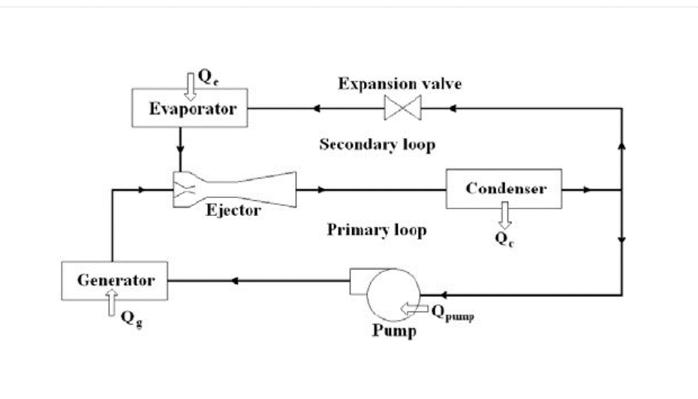
Figure 4 Layout of refrigeration cycle without and without Ejector
How does this Ejector reduce the amount of demand electricity and by how much
Effective cogeneration necessitates the utilization of both Rankine and ejector cooling cycles. This is crucial if you want your cogeneration system to perform well. The Rankine cycle's efficiency may be improved by using low-temperature heat sources, such as industrial waste heat or solar energy. This gadget may also be used as a power generator and a cooling system without using more points. Before gas is injected into the main nozzle, it is heated in the gas injector, inflated, and then cooled. You'll need to start with a low-grade energy vapour to accomplish the task correctly. To identify the relative relevance for determining the importance of various operational variables, we used experiments and simulations to explore the effects of different operating conditions on overall system performance, ejector entrainment ratios, and turbine power output. Comparisons of the results between HFE7100 and other refrigerants such as methanol, water, or even HFE7000 provide a more accurate picture of the findings. Due to the relative importance attributed to each of the three criteria stated below, an in-depth analysis has been undertaken on each one. After extensive computer simulations, it was discovered that factors like the ejector expansion ratio and temperature and heat sources like the condenser and evaporator influenced the turbine's power and overall thermal efficiency. Methanol had the highest thermal efficiency in the evaporator and condenser at 120°C (0.195), followed by ethanol and water (0.173) (Šarevski & Šarevski, 2016). Adjust the evaporator temperature and working fluid throughout the experiment to meet changing operational cooling demands. Because of this, it is possible to estimate exactly how much power the turbine will produce.

References
Abuan, B. E., & Berana, M. S. (2015). Ejector profile modelling for heat-driven ejector refrigeration system without involving shock. Volume 6B: Energy. https://doi.org/10.1115/imece2015-52521
Fang, D., Ren, Q., & Yu, Q. (2018). How elastic demand affects bidding strategy in electricity Market：An auction approach. https://doi.org/10.20944/preprints201811.0589.v1
Galindo, J., Dolz, V., Tiseira, A., & Ponce-Mora, A. (2021). Numerical assessment of the dynamic behavior of a solar-driven jet-ejector refrigeration system equipped with an adjustable jet-ejector. International Journal of Refrigeration, 121, 168-182. https://doi.org/10.1016/j.ijrefrig.2020.10.019
Liddle, B., & Sadorsky, P. (2017). How much does increasing non-fossil fuels in electricity generation reduce carbon dioxide emissions? Applied Energy, 197, 212-221. https://doi.org/10.1016/j.apenergy.2017.04.025
Van Nguyen, V., Varga, S., Soares, J., Dvorak, V., & Oliveira, A. C. (2020). Applying a variable geometry ejector in a solar ejector refrigeration system. International Journal of Refrigeration, 113, 187-195. https://doi.org/10.1016/j.ijrefrig.2020.01.018
Šarevski, M. N., & Šarevski, V. N. (2016). Undefined. Water (R718) Turbo Compressor and Ejector Refrigeration / Heat Pump Technology, 165-226. https://doi.org/10.1016/b978-0-08-100733-4.00006-8

