College of Engineering and Technology

Mechanical Engineering
Project Deliverable 1
GRASSHOPPER BEAM ENGINE
Academic Year: 2020 – 2021
Semester: Spring 2021
Course Code and Title: ME 352 machine design I
Prepared by:
Supervised by:
Dr.

Abstract

Since long time, the steam beam engine was first used at the time of industrialization. Thomas Newcomen, a blacksmith, managed in the early of the 1700s to develop the first truly promising steam engine to drive pumps to lift the water from mines in Cornwall. The efficiency of these engines was improved by several engineers like James Watt, Jonathan Hornblower, Arthur Woolf and William Murdoch. One of the different types of this engine is Grasshopper Beam Engine was developed by William Murdoch. In this paper, A brief history of this engine will be discussed, its design, its main component, material selection and the working theory. In this report, we will explain the optimal design of this machine, which leads to converting the alternating linear motion into a rotational movement, and the function of each piece of the device will be clarified and the materials that have been chosen in the manufacture of this piece as well as the method of manufacturing it.
Key words: Beam engine mechanism, Kinematic analysis, Rotational Motion, Simple Harmonic Motion, Piston, Cylinder.

Table of Contents
Abstract 1
List of figures 3
List of tables 3
Introduction 4
Design Concept Generation and Components’ Design 6
The base 6
The crankshaft 6
The beam 7
Crosshead 7
Moving leg 8
3.6. Cylinder and piston 8
Flywheel 9
Material selection 11
Stainless steel 11
Manufacturing procedure 13
Casting 13
Milling Machine 13
Drilling process 14
Kinematic analysis 15
Displacement analysis 15
Velocity analysis 18
Kinematic analysis 21
Kinetic analysis 21
References 24

List of figures
Figure 1 Steam beam engine version 4
Figure 2 William Murdochs' steam Engine model 5
Figure 3 the Marine engine. 5
Figure 4 crankshaft 6
Figure 5 beam part 7
Figure 6 moving leg part 8
Figure 7 piston and cylinder 9
Figure 8 flywheel 10
Figure 9 Casting Process 12
Figure 10 milling operation 13
Figure 11 drilling machine 13

List of tables
Table 1properties of mild steel 11
Table 2 properties of stainless steel 11

Introduction
There are many types of steam engines, including the radiating engine which used to drive water pumps where the thermal energy in the steam is converted to a kinetic energy. This thermal energy is developed to apply coal fuel boilers in which steam is produced through which steam is then pumped. As the piston rises, the beam moves and the pump rod lower, cold water is injected into. the cylinder to produce condensed water, and finally, a vacuum is formed, which pushes the piston down and raises the pump rod again in each cycle. Figure 1 shows a model of the steam beam engine and its main parts. (Frenken, 2004)
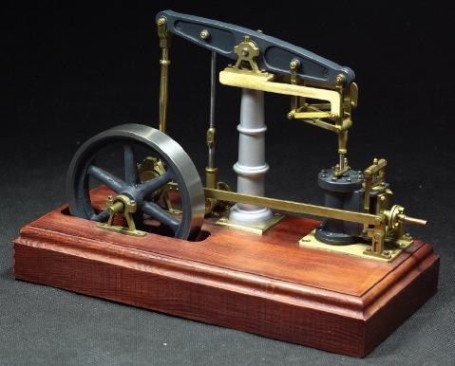
Figure 1 Steam beam engine version
The earliest recorded example of a Grasshopper Beam Engine was William Murdochs' steam Engine model (figure 2.) from 1784. In this model the beam is pivoted at one end, rather than the center of mechanism. The beam provided negligible mechanical benefit and looks to be used in place of a crosshead because it was effectively a connecting rod return engine. The American engineer Oliver Evans drew a high-pressure marine engine (figure 3.) in 1801 and in 1805 built the Oruktor Amphibolos, an amphibious excavator. (Thurston, 1899)
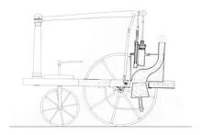
Figure 2 William Murdochs' steam Engine model
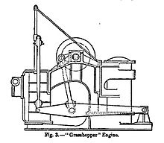
Figure 3 the Marine engine.
The advantage of this engine is that the working end of the beam can be connected directly to the piston rod of the engine, and in this way the engine is made much more compact, especially in terms of height, since the space that the usual swing arm connections between the beam take up and the cross-beam of the Piston rod. The bar length can also be reduced. While the beam is generally at least three times the total stroke length in the normal steam beam engine that of the Grasshopper is generally about 1 3/4 times the length. The stroke length and its weight are also proportionally less. The beam is guided in a straight line by a parallel movement device which is suitably modified for this special purpose, for which it is necessary that the anchored end is capable of side movement. This was generally made in the form of a rectangular frame fused with a lattice or crossed struts. Despite the weight of the Grasshopper beam is completely unbalanced, it is much lighter than the ordinary beams enable engines of this type to operate fairly satisfactory at higher speeds than the previous type. The compactness of the entire engine structure provided inherent rigidity as well as simplified assembly and installation using cuboid or brick. However, the engines were often sunk or raised in the floor to make room for an air pump and condenser under the bed and a race was made available to make room for the steering wheel.

Design Concept Generation and Components’ Design

The base
The base or frame is a component that is attached to the floor. Holds the entire machine assembly on top.

The crankshaft
Crankshaft is a mechanism of arms or levers to impart reciprocating motion to a rotating shaft. One end of the crank is attached to the shaft and the other end receives reciprocating motion from the hand, crank, etc.
The Shaft connects a lever to a crank or crankshaft in a steam beam engine. Together with the crank, it forms a simple mechanism that converts the reciprocating motion rotary motion into a rotary motion. A connecting rod can also convert a reciprocating motion into a rotary motion.
In figure 4. A clear understanding of how these working steps take place within the crankshaft
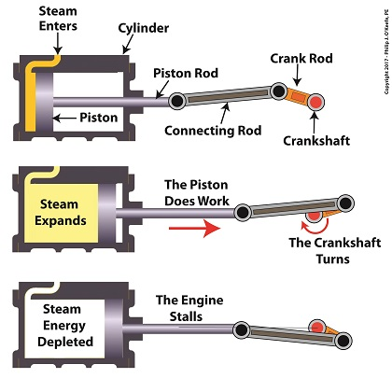
Figure 4 crankshaft

The beam
The beam is the main part of the engine that connects all the parts of the engine together. It’s obvious why this type of engine is called beam engine. During the reciprocating movement of the piston cylinder, the beam transfers the movement to the rest parts of the engine. In this type of engine, the beam is pivoted at one end, rather than the center of mechanism which leads to a longer stroke of the piston and a greater output of force.
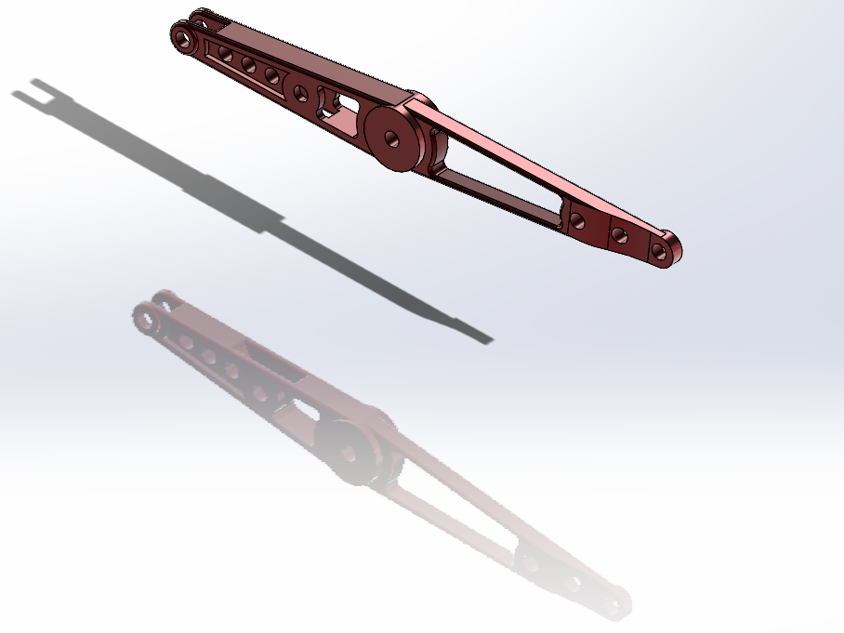
Figure 5 beam part

Crosshead
It moves between guides between the middle of the beam and the engine body which prevents the piston rod from getting bent due to excessive mechanical loads.

Moving leg
This part is connected between the beam and the engine base, it is connected to the beam at its fulcrum where it’s rotated.

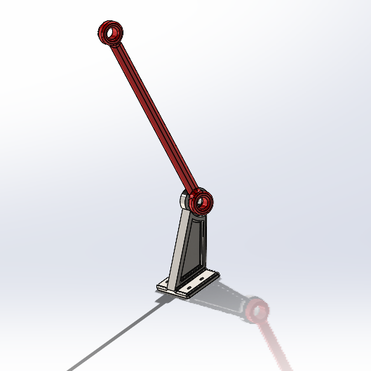
Figure 6 moving leg part

3.6. Cylinder and piston
It is made of cast brass and is bolted to the frame at one end. In the case of small engines, it is integrated into the frame. It forms a chamber in which the piston moves back and forward due to the action of steam. One end of the cylinder is closed by the center of a separate cap and the end is known as the cylinder cap end. The other end, known as the crankshaft end, carries the stuffing box through which the piston rod passes. The piston is made of Stainless Steel. Force is transmitted due to the pressure of the steam that acts on the crosshead through the piston. The piston rod runs through the cylinder head. Prevents steam from escaping from the cylinder into the atmosphere.
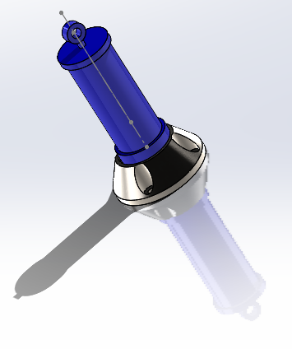
Figure 7 piston and cylinder

Flywheel
It has a unique advantage. It absorbs energy when supply exceeds demand, and releases energy when demand exceeds supply, thereby flattening power distribution and avoiding rapid fluctuations during rotation. Help the mechanism to overcome dead center positions.
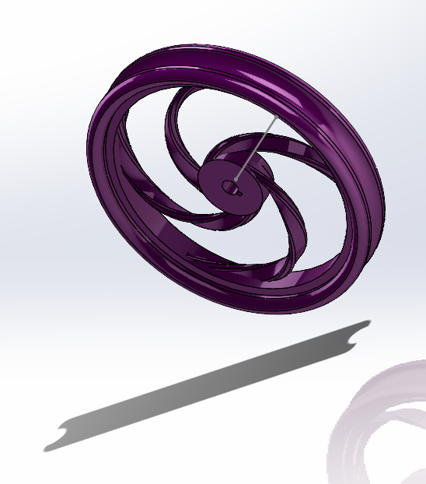
Figure 8 flywheel

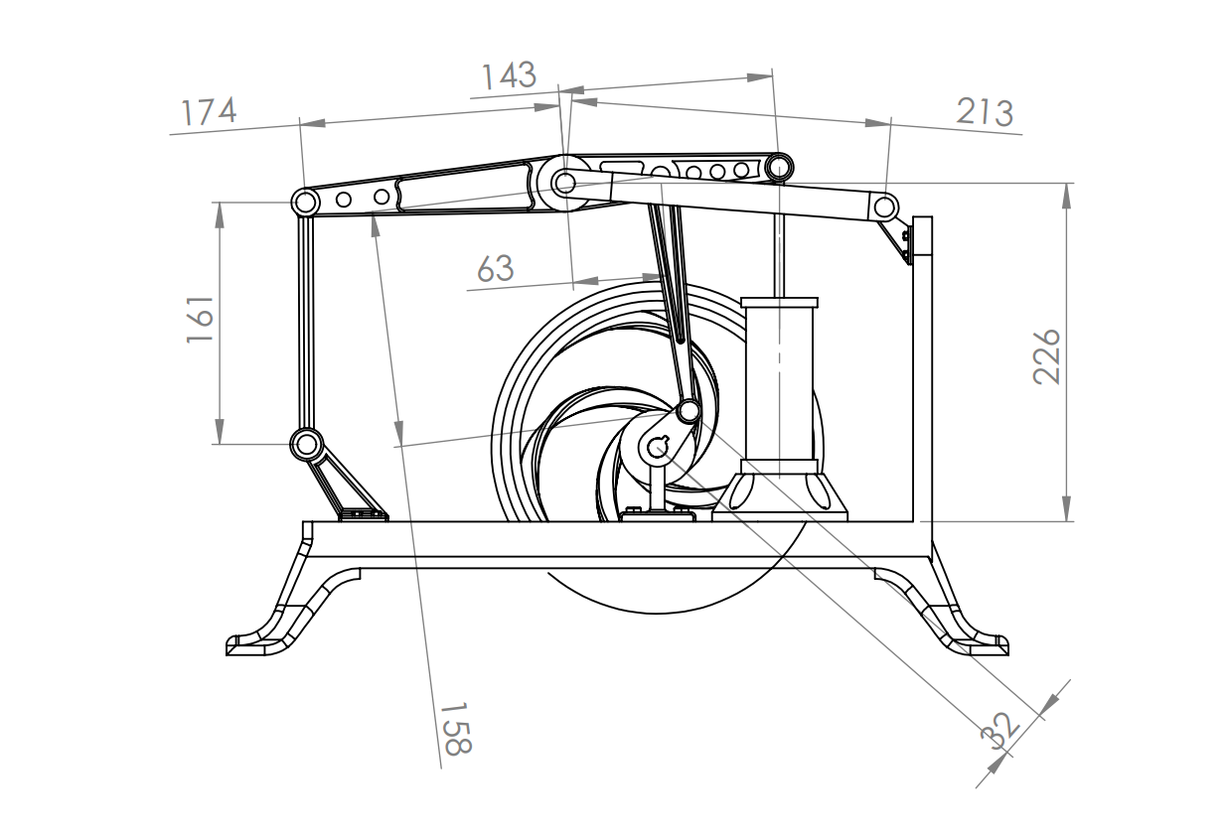
Figure 9 Design of mechanism

Material selection
Mild steel is the least expensive of all steels and the most widely used steel. Mild steel is used in almost all types of steel products and it is weldable, very hard and, although it rusts easily, very durable. It contains less than 2 % carbon. Mild steel can be magnetized and used in most projects that require a large amount of metal. The material used for the base and crank shaft is steel is mild steel.

Table 1properties of mild steel
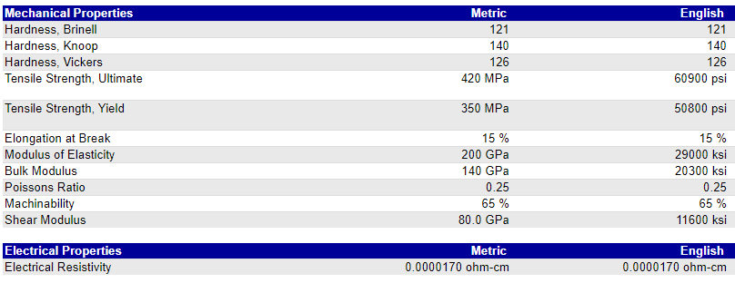

Stainless steel
Stainless steel has many desirable properties because of its chromium content, it is extremely resistant to corrosion, high strength and durability, its high and low temperature resistance, increased formability and easy fabrication.
Table 2 properties of stainless steel
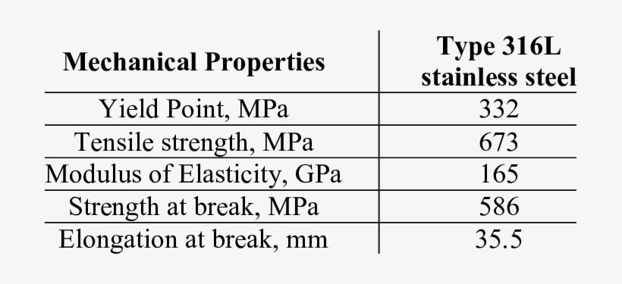

Manufacturing procedure

Casting
The casting process uses a wide range of metals, as it is an easy, simple and inexpensive method. Casting operations vary and there are some that are used for a one-time mold, and some of them are multi-use molds due to the quantity required for manufacturing. The casting process is based on converting the metal to a liquid state by raising its temperature to the melting temperature, and then this liquid becomes in molds that have been designed in a hollow form in the form of the piece to be manufactured. And then leave the mold with the molten metal in it until its temperature decreases and this molten metal turns into a solid piece of metal. Thus, the parts to be manufactured are obtained. This process is good for minerals that have a low melting point.
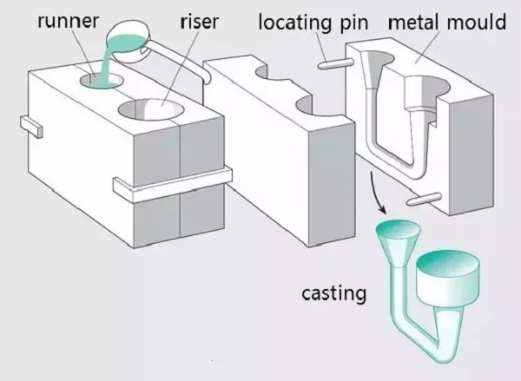

Figure 10 Casting Process

Milling Machine
This process is used to shape metal parts. By means of the grinding machine in this machine, the metal piece is fixed. Then the cutter moves at different angles to form the piece on the desired shape. In this machine, the metal piece moves up and down, and the cutter moves left and right, back and forward. This process is also used to remove excess parts and result from the casting process.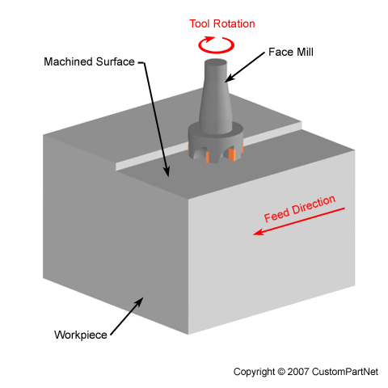
Figure 11 milling operation

Drilling process
This process is used to make holes in the metal pieces by means of the drill machine, and it is done by the drill that rotates and presses the metal pieces and that also presses this drill on the pieces and requires high pressure.
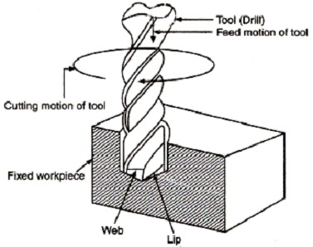
Figure 12 drilling machine

Kinematic analysis
In this part we will show displacement analysis, velocity analysis, and acceleration analysis for this mechanism by graphical method.

Displacement analysis
General position
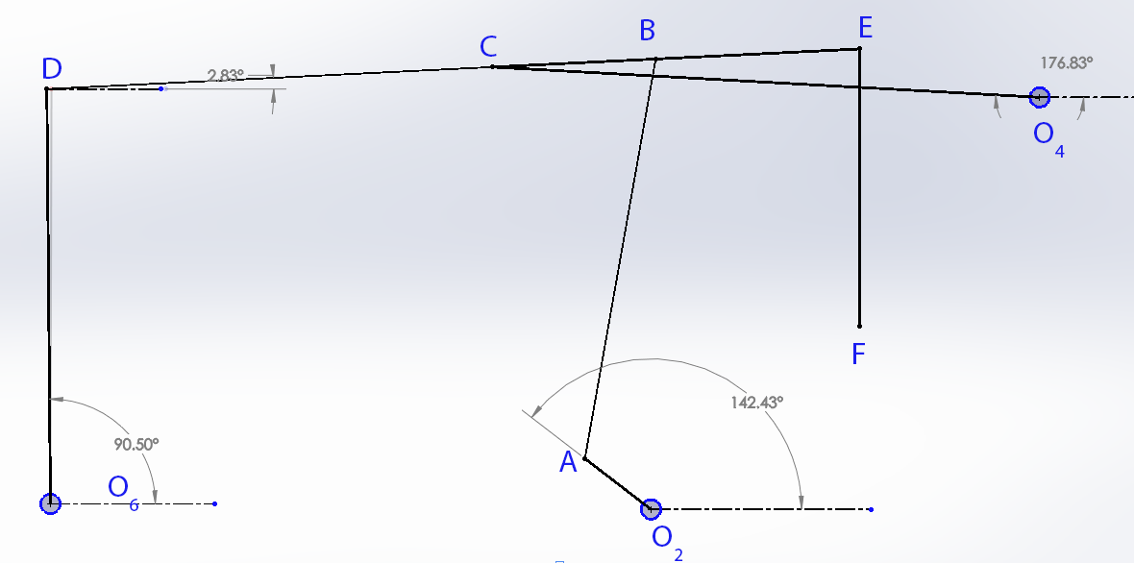

First critical position
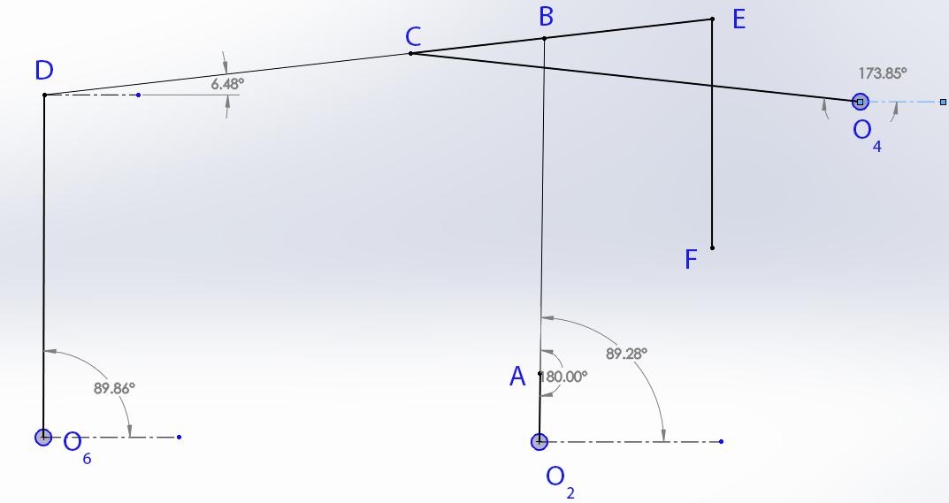
Second critical position

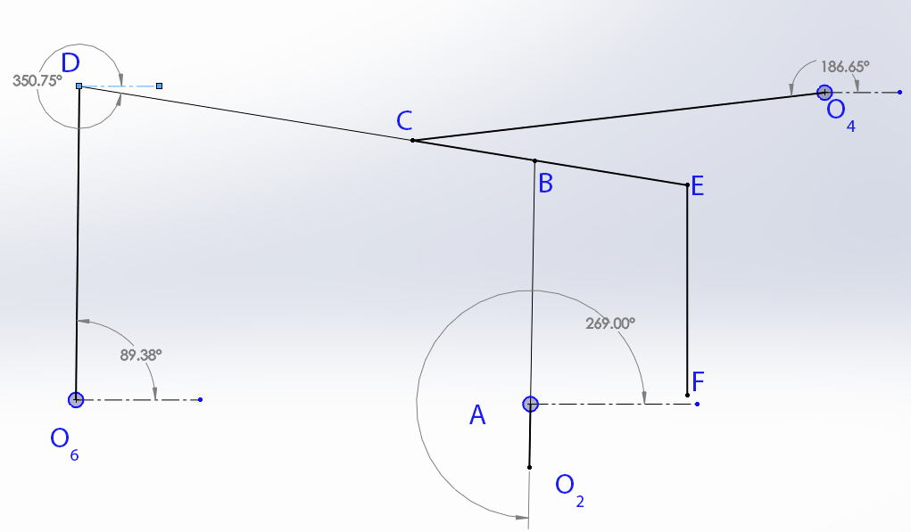

Displacement in links
link | displacement
OA | 180° CW
OC | 12.8° CCW
OD | 0.5° CCW
DE | 15.73° CW
FF' | 90 cm

Velocity analysis
Assume $ω_{OC}=1\frac{rad}{s}$
$$V=ωR=1*213=213\frac{cm}{s}$$
Scale 1:10
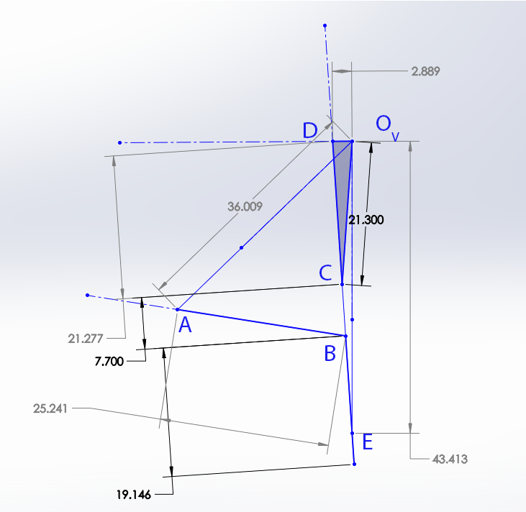

link | R cm | V cm/s | 𝜔 rad/s
OC | 213 | 213 | 1
DC | 174 | 212.77 | 1.222816
OD | 161 | 28.89 | 0.179441
CB | 63 | 77.03741 | 1.222816
BA | 158 | 252.41 | 1.597532
OA | 32 | 360.09 | 11.25281
OE | slider | 43.413 | slider

Acceleration
$$a_{n}=\frac{V^{2}}{R}$$
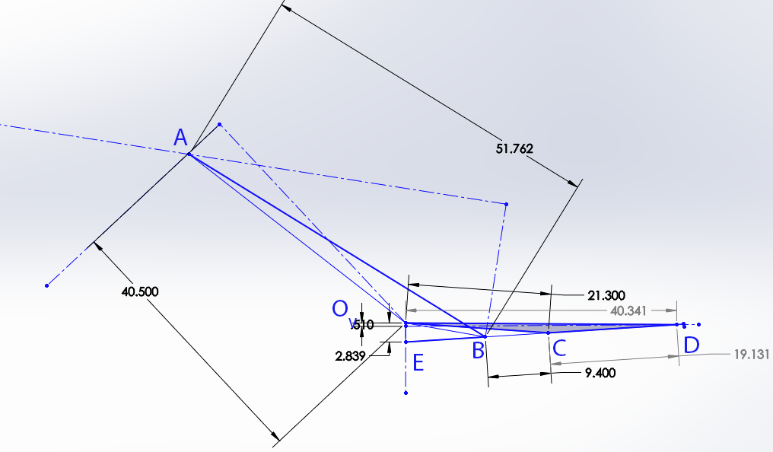
link | R cm | V cm/s | 𝜔 rad/s | a_{n} | a
OC | 213 | 213 | 1 | 213 | 1029
DC | 174 | 212.77 | 1.222816 | 260.1786 | 4015
OD | 161 | 28.89 | 0.179441 | 5.18405 | 4116
CB | 63 | 77.03741 | 1.222816 | 94.20259 | 5328
BA | 158 | 252.41 | 1.597532 | 205.143 | 4478
OA | 32 | 360.09 | 11.25281 | 405.654 | 8953
OE | slider | 43.413 | slider | slider | 4961

Kinematic analysis

Kinetic analysis
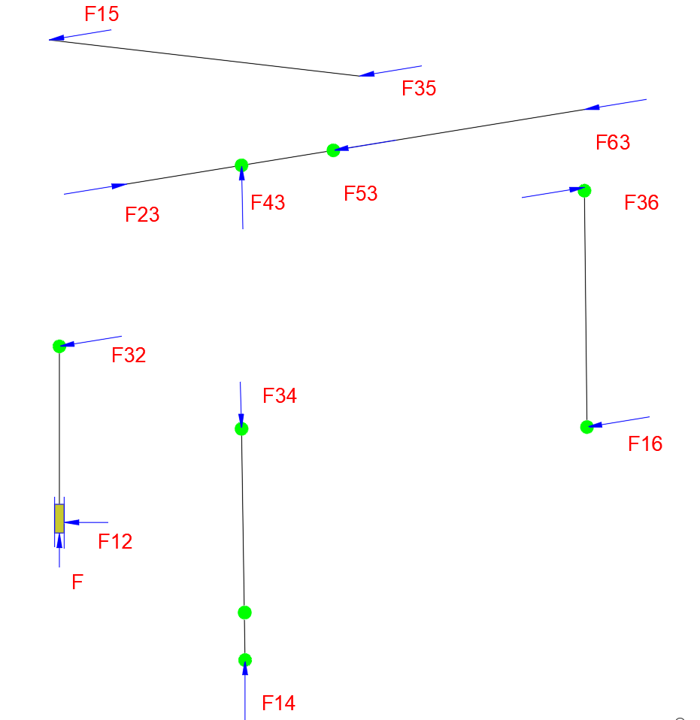
Figure 15 static force analysis
$$F=150 KN$$
For link 2
$$\sum{F=0}$$
$$F+F_{12}+F_{32}=0$$
$$Fj+F_{12}i-F_{32}\cos{12 i}-F_{32}\sin{12}j=0$$
For $i$
$$F_{12}-F_{32}\cos{12 }=0$$
For $j$
$$F=F_{32}\sin{12}$$
$$150=F_{32}\sin{12}$$

$$F_{32}=721 KN$$
$$F_{12}=705 KN$$
For link 3
$$\sum{F=0}$$
$$F_{43}=F_{23}=-F_{32}=-721 KN$$
$$F_{63}=721 KN$$
$$F_{53}=721 KN$$
For link 4
$$\sum{F=0}$$
$$F_{14}=F_{14}={-F}_{43}=-721 KN$$

For link 5
$$\sum{F=0}$$
$$F_{15}=F_{35}={-F}_{53}=-721 KN$$
For link 6
$$\sum{F=0}$$
$$F_{16}=F_{36}={-F}_{63}=-721 KN$$

Conclusion
We have done a study on this device and know its parts, how it works and the movement that each part performs in it, in order to convert the reciprocating movement resulting from the pressure of the steam into a rotational burning that is used. A study was conducted to find out the best materials that are used in the manufacture of those parts and the industrial processes that are used, and an analysis of displacement, velocity and acceleration was made.

References
Frenken, K. (2004). The early development of the steam engine: an evolutionary interpretation using complexity theory. Industrial And Corporate Change, 13(2), 419-450. doi: 10.1093/icc/dth017
Thurston, R. (1899). THEORY OF THE STEAM ENGINE. Science, 9(227), 659-659. doi: 10.1126/science.9.227.659
A model single cylinder Grasshopper beam engine,. (2018). Retrieved 23 April 2021, from https://www.christies.com/en/lot/lot-769604
Polly Model Engineering: Stationary Engine Kits - Anthony Mount Models. (2021). Retrieved 23 April 2021, from https://www.pollymodelengineering.co.uk/sections/stationary-engines/anthony-mount-models/easton-Andersons-Grasshopper-Beam-Engine.asp

