A calculator is permitted.
Use the following information for Questions 1–3:
The rate at which water flows into a tank, in gallons per hour, is given by a differentiable function R of time t. The table below gives the rate as measured at various times in an 8-hour time period.
t (hours) | 0 | 2 | 3 | 7 | 8
R(t) (gallons per hour) | 1.95 | 2.5 | 2.8 | 4 | 4.26
1.Use a trapezoidal sum with the four sub-intervals indicated by the data in the table to estimate 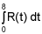. Using correct units, explain the meaning of your answer in terms of water flow. Give 3 decimal places in your answer.
The table gives the value of R(t) at times t₀=0, t₁=2, t₂=3, t₃=7, and t4=8. So the trapezoidal approximation for 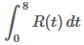 is:
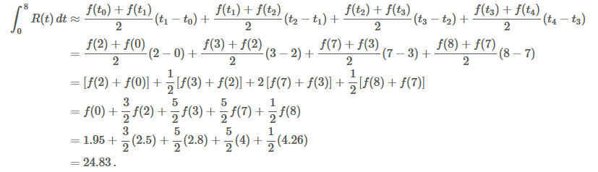
So 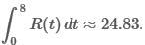. Since R(t) is measured in gallons per hour and the time variable t is measured in hours, it follows that approximately 24.83 gallons of water flow into the tank in the first 8 hours.

2. Is there some time t, 0 < t < 8, such that R′(t) = 0? Justify your answer.
So far as we can tell, R(t) could be an increasing function: for all the values of R(t) that we know, R(s)>R(t) whenever s>t. So it is possible that R′(t) is never zero. However, there is no way of ruling out the possibility that R′(t)=0 at some value of t..

3. The rate of water flow R(t) can be estimated by W(t) = ln(t2 + 7). Use W(t) to approximate the average rate of water flow during the 8-hour time period. Indicate units of measure.
The flow rate R(t) in gallons per minute can be approximated by the value W(t)=ln(t²+7). So the average flow rate over the first 8 hours can be approximated by the average value of W. We compute this average value as follows:
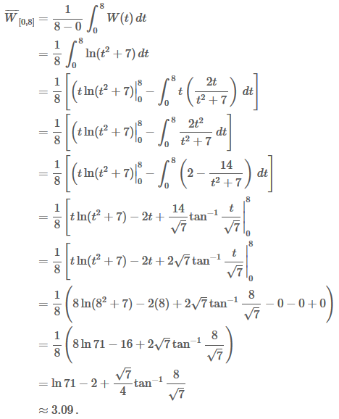
Since W(t) is given in gallons per hour, this means that the average flow rate over the first 8 hours is approximately 3.09 gallons per hour.
Use the following information for Questions 4 and 5.
f is a continuous function with a domain [−3, 9] such that
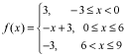
and let 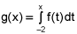.
4. On what interval is g increasing? Justify your answer.
Since, f(x)=g’(x); g’(x) is increasing
Where f(x) is possible, is g’(x)>0
i)For -2≤x<0, f(x)=3>0
ii) For 0≤x<6, f(x)=3-x. we have two sub-cases:
- For 0≤x<3, f9X)=3-x>0
- For 3<x≤6, f(x)=3-x<0, For x=3, f(x)=0
iii) For 6<x≤9, f(x)<0
Therefore, For -2≤x<3, f(x)>0 , and , so g(x) is increasing when -2≤x<3
5. For 0 ≤ x ≤ 6, express g(x) in terms of x. Do not include +C in your final answer.
