Respiratory and Intensive Care
Name
Institution
Course
Professor
Date

Respiratory and Intensive Care
For a long time, humidification of inhaled gases has been the standard of treatment in mechanical ventilation. A variety of studies from more than a century ago identified significant airway damage caused by dry gases throughout artificial ventilation. As a result, when the upper airway is bypassed, respiratory care facilities use external humidifiers to make up for the loss of natural humidification mechanisms.
Bubble Humidifiers
When a bubble humidifier whistles on its own, this indicates that the oxygen flow could be too high or an obstruction of the tubing. At times, bubble humidifiers exhibit excessive condensate, which causes obstruction to the small-bore delivery tubing connecting the humidifier output and the interface of the patient (Harb et al., 2020). In other cases, with prolonged use, there is a potential risk that the pressure relief valve becomes dysfunctional, leading to a build-up of excessive pressure (Harb et al., 2020). To troubleshoot, ensure the pressure relief valve opens, releasing the pressure from the bottle, and an audible alarm will be released. Once the flow obstruction clears, the pressure relief valve resumes functioning.
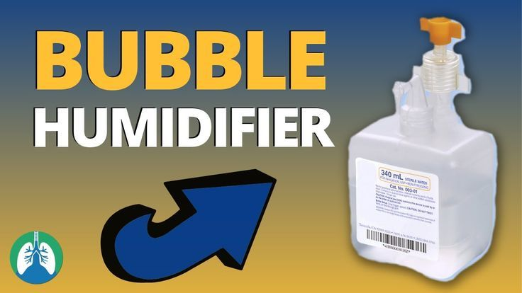
https://www.google.com/url?sa=i&url=https%3A%2F%2Fwww.pinterest.com%2Fpin%2F781937554035129617%2F&psig=AOvVaw0NZz6D_digU4NxFz9QrPCP&ust=1618038645397000&source=images&cd=vfe&ved=0CAIQjRxqFwoTCJDK3f_N8O8CFQAAAAAdAAAAABAD

Wick Humidifiers
A wick humidifier includes a reservoir with a porous material, a wick, which absorbs water and offers a larger area for air-water to combine for excellent evaporation. A proper function of a wick humidifier is seen when the inspired gas passes over the water surface and hydrophobic membrane (Harb et al., 2020). The vapor created passes through the wick, mixes with the dry inspired gas, and improves the water content. A properly functioning wick humidifier does not allow liquid water to cross the hydrophobic membrane (Harb et al., 2020).
Hand Held Nebulizer
When using a handheld nebulizer (HHN) on a patient, the device produces a sputtering sound to depict that the solution has been nebulized. After assembling the nebulizer as per the instructions provided by the manufacturer of the device, one should be positioned in a chair or a bed at greater than 45 degrees (Flecknell, 2015). Before beginning the treatment, a baseline respiratory assessment should be done. For verification that the equipment is working correctly, a flow rate of 6 to 10l should be achieved to offer sufficient misting in the nebulizer chamber (Flecknell, 2015).
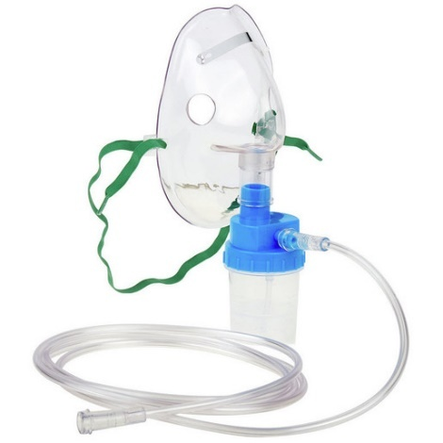
https://www.google.com/url?sa=i&url=https%3A%2F%2Fwww.boundtree.com%2FAirway-Oxygen-Delivery%2FNebulizers%2FHand-Held-Nebulizer-Kits%2Fp%2Fgroup005107&psig=AOvVaw2OOS8n0AQANHGlRZHqgudT&ust=1618039000016000&source=images&cd=vfe&ved=0CAIQjRxqFwoTCIjQg5XP8O
Large Volume Nebulizer
A large volume nebulizer may fail to produce enough mist when there is inadequate flow. If this occurs when the siphon tube is blocked or when the jet orifices are not correctly placed, the large volume nebulizer tends to produce less to no mist (Harb et al., 2020). In other cases, the large volume nebulizer may produce less mist when the device does not shut down appropriately, resulting in the production of dry inspired gas to the patient (Harb et al., 2020). Another reason leading to the production of less mist is prolonged usage of the device. Depending on the manufacturer, the filters in the compressor of the tool ought to be changed every 3-6 months to ensure the achievement of a fine mist with every use.
Change in Large Volume Nebulizer Therapy
When applying High-flow nasal cannula oxygen therapy using a large volume nebulizer, the Fi02 levels can change during therapy due to an error that commonly occurs when connecting the high-flowmeter to the oxygen outlet of the Airvo 2 (Diaz-Labato). When using HFNC, health practitioners must choose the flow and FiO2 that the patient needs. The Airvo 2's oxygen intake is on the right side of the unit (Diaz-Labato). This does not have a mixer, but it does warn the FiO2 that the patient is being administered according to the flow of O2 provided.
Mode of Operation of an Oxygen Concentrator
As an alternative to compressed gas cylinders, oxygen concentrators (also known as oxygen generators) may be used. They consume nitrogen and generate 90–95 percent oxygen from room air. Portable systems typically produce 4–10 l/min (Fig. 1.4), with more extensive equipment capable of providing multiple anesthetic machines generating up to 25 l/min (Harb et al., 2020). Regular cleaning of the air intake filter and occasional cleaning of the exterior with a mild sanitizing cleaning agent is recommended for home users. Technician-performed preventive maintenance is required at least every six months, which involves using a standardized oxygen analyzer to measure the oxygen concentration at both low and maximum flows, replacing the outer casing, and restoring it, cleaning the machine's interior, testing the batteries, and examining the internal filters(Harb et al., 2020.
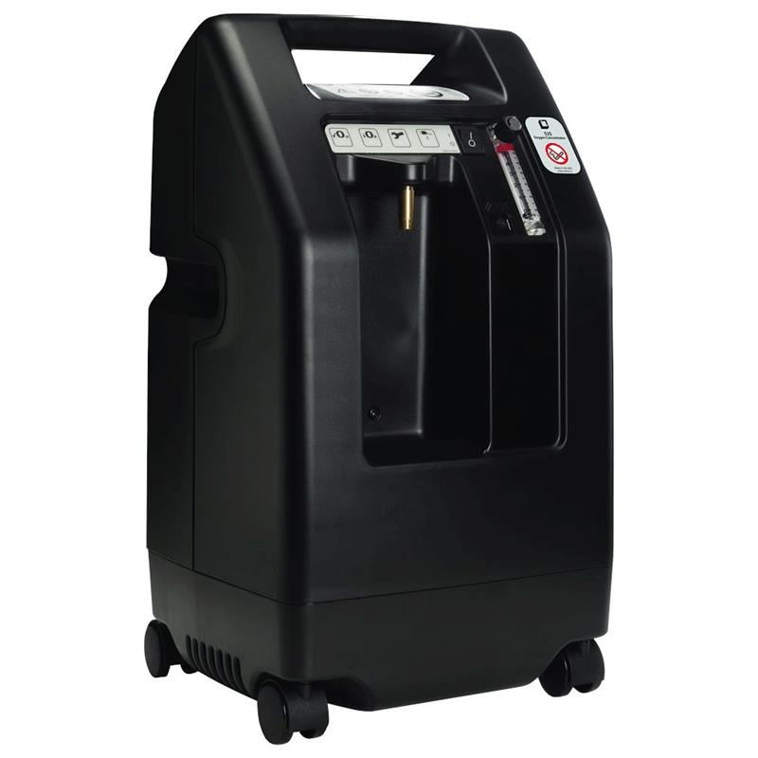
https://www.google.com/url?sa=i&url=https%3A%2F%2Fcopdstore.com%2Fproduct%2Fdevilbiss-5-liter-home-oxygen-concentrator%2F&psig=AOvVaw0BLpCesp45beE40KtFog0J&ust=1618039156071000&source=images&cd=vfe&ved=0CAIQjRxqFwoTCODU_eHP8O8CFQAAAAAdAAAAABAW
Active and passive humidification systems, in particular, have advanced quickly. As a result, the respiratory care and intensive care professional must have a basic understanding of the modes of operation of both of these instruments and their benefits and drawbacks.
References

Díaz-Lobato, S. (n.d.). Things to keep in mind in high flow therapy: As usual the devil is in the detail. Retrieved April 09, 2021, from https://clinmedjournals.org/articles/ijccem/international-journal-of-critical-care-and-emergency-medicine-ijccem-4-048.php?jid=ijccem
Flecknell, P. (2015, September 18). Basic principles of anaesthesia. Retrieved April 09, 2021, from https://www.sciencedirect.com/science/article/pii/B9780128000366000016
Harb, H. S., Saeed, H., Madney, Y. M., Abdelrahman, M. A., Osama, H., Esquinas, A. M., & Abdelrahim, M. E. (2020). Update efficacy of aerosol therapy with noninvasive ventilator approach (non-invasive ventilation and nasal high flow). Journal of Drug Delivery Science and Technology, 101922.

