Alyssa Alford
Human Sexuality
Love Maps DOA

My Love Map

I have always known my history of attraction, which is to males. My mom used to tell me when I was younger I had to go to the hospital to get stitches, I was probably around the age of four. I was crying and carrying on and the doctor came in, who was a fairly attractive man I’m told, I just laid back, stopped crying, and stared at him. I believe I first started to realize the manifestation of my attractions when I was about nine or ten. This was when my first real crush started and it was when two boys were fighting over me. I didn’t start thinking about sex right away, but I thought about kissing the boys a lot. I didn’t start dating until 7th grade so I was 13. I waited this long because my parents are the definition of helicopter parents. They played a big role in when I dated and when because I wasn’t allowed to see boys outside of school. Due to this restricted lifestyle, I was pretty rebellious and explored other ways to get boys attention, to put it lightly.
One of my earliest celebrity crushes, that I definitely remember was David Beckham. I know this set the path for my attraction to soccer players and most definitely the tattoos. The first in real life crush that I remember, was a guy named Drake. He was taller than all the other guys, but he also had a pretty sharp jaw line along with having hazel with flecks of green eyes. He was our quarterback in football back in middle school along with playing basketball.
I don’t really remember much of my other dating relationships because I was in some pretty bad places. I know I’ve blocked a lot of memories because they’re painful to bring up. I’ve been in several abusive relationships, physically and mentally, and a lot of my disgust personality triggers relate back to them.

Lust Triggers

Physical Inclusion
Attribute | Point Value
Scruff * | +3.5
Attribute | Point Value
Tattoos | +2
Attribute | Point Value
Booty * | +3
Attribute | Point Value
Jaw Line | +1
Attribute | Point Value
Height * | +1
Attribute | Point Value
Eyes * | +4

Cognitive/Personality Inclusion
Attribute | Point Value
Sarcastic * | +3
Attribute | Point Value
Sense of Humor | +2
Attribute | Point Value
Animal/Child lover | +4
Attribute | Point Value
Intelligent | +3
Attribute | Point Value
Protective * | +2
Attribute | Point Value
Understanding * | +5

Social/Cultural Inclusion
Attribute | Point Value
Soccer Players | +4
Attribute | Point Value
Golfers * | +2
Attribute | Point Value
Artists | +2
Attribute | Point Value
Unbiased with religion | +1
Attribute | Point Value
Gamer nerd | +2
Attribute | Point Value
Bilingual * | +3

Disgust Triggers

Physical Exclusion
Attribute | Point Value
Crooked Teeth * | -2
Attribute | Point Value
Body odor | -2
Attribute | Point Value
Body Hair * | -3
Attribute | Point Value
Dad bod * | -4
Attribute | Point Value
Long hair * | -5
Attribute | Point Value
Voice * | -3.5

Cognitive/Personality Exclusion
Attribute | Point Value
Disrespectful | -4
Attribute | Point Value
Introvert | -2
Attribute | Point Value
Arrogant | -2
Attribute | Point Value
Insecure * | -2
Attribute | Point Value
Noncommittal | -3.5
Attribute | Point Value
Crass * | -4

Social/Cultural Exclusion
Attribute | Point Value
Meatheads * | -5
Attribute | Point Value
African American | -2
Attribute | Point Value
Overly religious | -4
Attribute | Point Value
Frat douches * | -5
Attribute | Point Value
Band | -2
Attribute | Point Value
Non-Athletic | -3

Unique Physical Lust Triggers

Scruff
One of my definite triggers is scruff, I decided this was a unique trigger because of what I call scruff. I don’t just consider the 5 o’clock shadow a part of scruff. I don’t include a full beard though. My trigger is hair on the chin and right under the lip together. I sometimes don’t like a mustache. (Figures 1. 2. 3.) I know I like scruff because it gives a sense of masculinity that some of the men I date lack because they have a baby face of the sort.
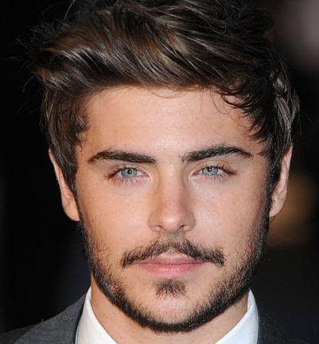
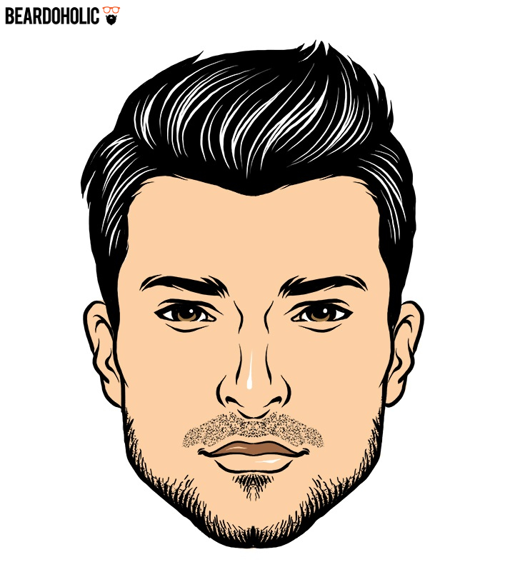
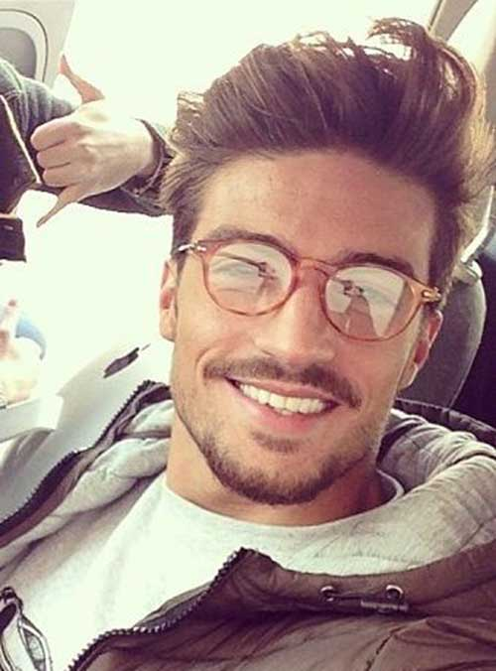

Figure 1 Figure 2 Figure 3

Booty
I love a man with a good booty, but not like, a massive booty. I don’t want to compete with him in who has the bigger, better booty. (Figures 4. 5.) This is one of the reasons my social trigger is soccer players. They have a very definite booty along with a very good looking body. I know David Beckham shaped a lot of my physical triggers because he legitimately has the nicest booty I have ever seen on a man. I feel like this is unique to me, because while a man doesn’t have to have a booty for me to date him, it is a very wanted characteristic. This is completely opposite, in terms of masculinity, then the scruff aspect. Most men don’t acknowledge they have a nice butt because it’s a fairly feminine characteristic.
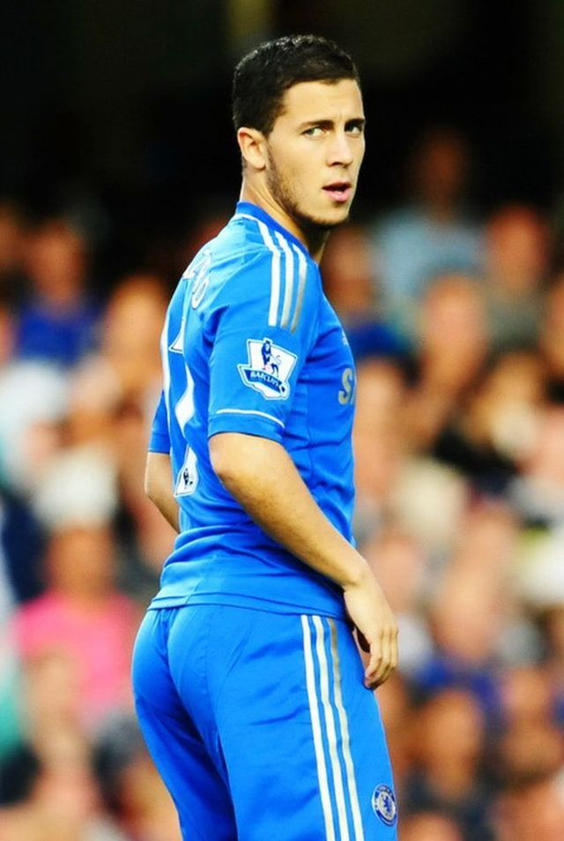
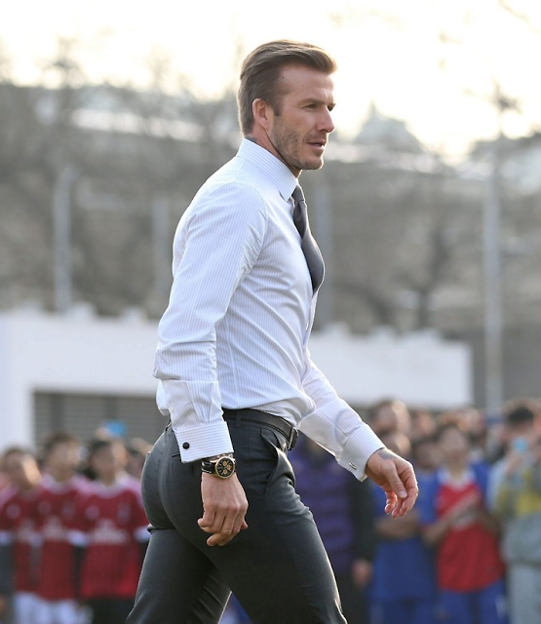

Figure 4 Figure 5

Height
I decided that height was a unique trigger to me, because I’m opposite of most people. I don’t think height is a big turn on, sure I like tall guys, but I wouldn’t not date a shorter guy. Granted, I am a 5’4 so most guys are taller than me, but I would be comfortable dating a guy as tall or even a little shorter than me. For me, I like shorter guys, I don’t usually go for the 6 foot and up because honestly, I’m tired of being towered over by everyone. My entire family is tall, so I like having someone who relates with being short and having to figure out unique ways to reach the top shelf at the supermarket also.

Eyes
I knew before starting this project, that I really have a thing for eyes. I knew I liked golden and green eyes especially on tan or darker skinned men. What I realized when looking at pictures, is I’m attracted to a certain eye shape also. (Figure 6. 7. 8.) It’s a kind of squinted, narrow, piercing eye that makes me melt. Also, if their eyebrows are set low on their bow bone and drop towards their eyes, that is something I really like, as shown in Figure 9.
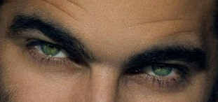
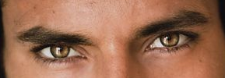
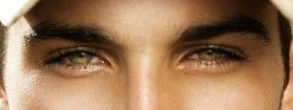

Figure 6 Figure 7 Figure 8
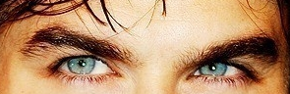

Figure 9

Unique Cognitive/Personality Lust Triggers

Sarcastic
Most people think of sarcasm as a negative, but I like a guy that can snap back to my sarcasm. I don’t mean like really rude sarcasm where they mean it when they say it, but jokingly sarcastic. This is a personality turn on because it gives the sense of humor more depth and I’m an extremely sarcastic person. If a guy can handle my sarcasm and dish it back out that is a win-win in my opinion.
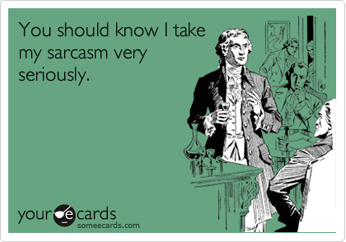
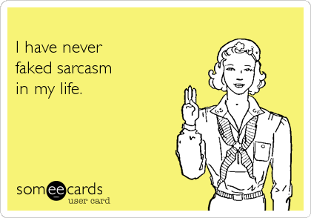

Protective
I like the protective trait because I like a person that cares about me, but not someone who is overly jealous and overly controlling. If a person shows they care about me, even in such a small way of making sure I made it home safe, it is a major turn on. I feel this is a rare thing to find in men, because they have the notion in their heads that women like men who don’t show they care.
Understanding
So, this is the biggest and most important trigger I have. This would outweigh most of my disgust triggers. Understanding is very important to me because I have a genetic condition called Ehlers Danlos Syndrome. It is a connective tissue disorder and while I do not have it as bad as others, I still struggle with it daily. I am in chronic pain and also might not be able to carry a baby to full term. If a guy is unable to understand, that sometimes, no matter how much I would like to do something, sometimes I just can’t. I chose the word understanding, instead of sympathetic, because I don’t like when I receive sympathy. This is due to the fact; I don’t want pity or to be treated any different. When a man is able to understand, and realize my issues and not just push them to the side, it is an amazing thing.


Unique Social/Cultural Lust Triggers

Golfers
So, I know this is unique because myself being a golfer is pretty unique for a girl. I tend to lean towards dating golfers because usually they are fairly intelligent along with having a decent amount of money. These guys are able to hold conversations and usually have a good handle on their anger, because let’s be honest. Golf is long, three hours or more, and very frustrating. If a guy is able to handle rounds of golf, he’s able to handle me.
Bilingual
Honestly, I don’t even know why this is such a turn on, because my boyfriend speaks Arabic and I can’t understand a word he says but I love it. I have a feeling it’s because men wo or bilingual or even know more than two languages are smart enough to learn languages especially when English isn’t there first language is a good trait. It will help them later on in life and also, myself being bilingual, I like learning about other cultures and how they speak.

Unique Physical Disgust Triggers

Crooked Teeth
I absolutely can’t do crooked, yellow teeth. I feel that teeth are a good reflection of your overall caring of yourself. If you can’t take care of your teeth, one of the first things people see, what’s to say you take care of the rest of your body. Although, if the teeth are crooked but white or well taken care of that is an exception. You can’t change the genetics that cause your crooked teeth.

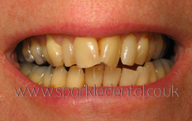

Body Hair
I like my men with as little body hair as possible because too much body hair is disgusting to me. (Figure 10.) I really hate stray hairs, even if they’re my own, so I can’t even imagine a guy’s body shedding also. That being said, I am okay with a guy having a lot of arm and leg hair, but also having a neat happy trail like figure 11 shows.
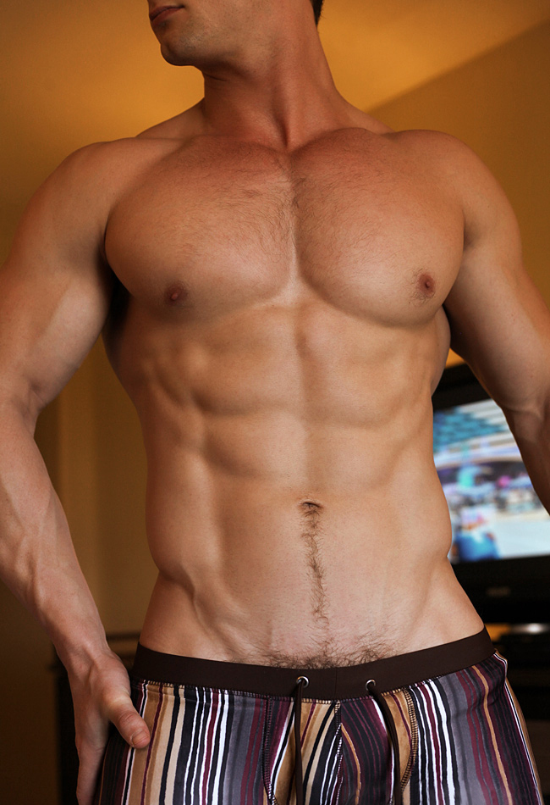
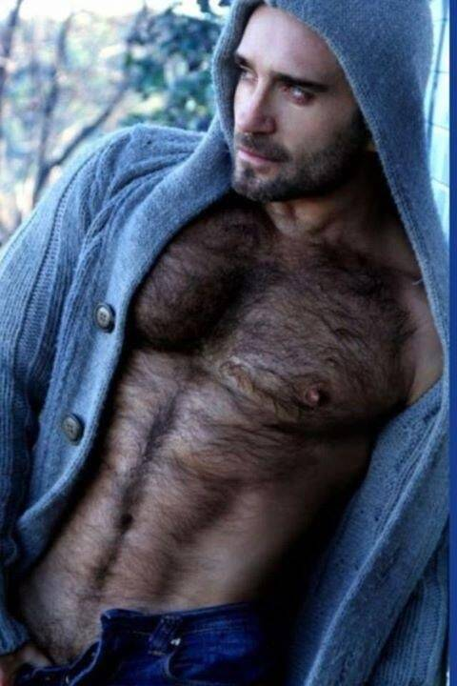

Figure 10 Figure 11

Dad Bod
I believe that dad bod and beer belly are the same thing, but in my opinion a beer belly is a tight, bigger stomach and a dad bod is a saggy bigger stomach. Granted I don’t want either, but a dad bod is such a turn off because allowing your body to become so out of shape this young, what about when you get older. (Figure 12. 13).
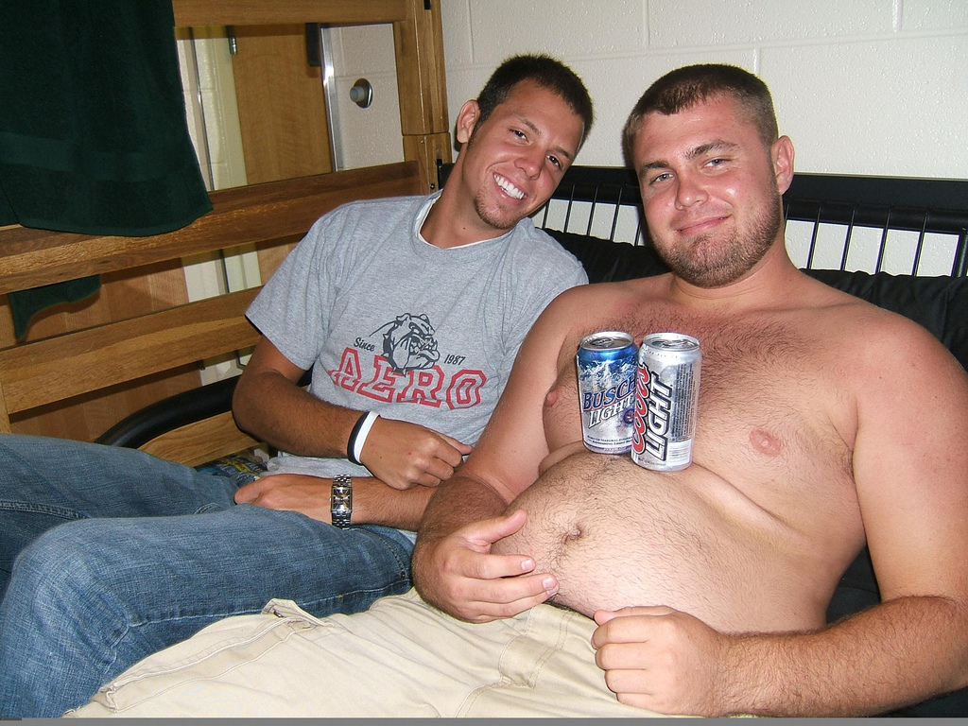
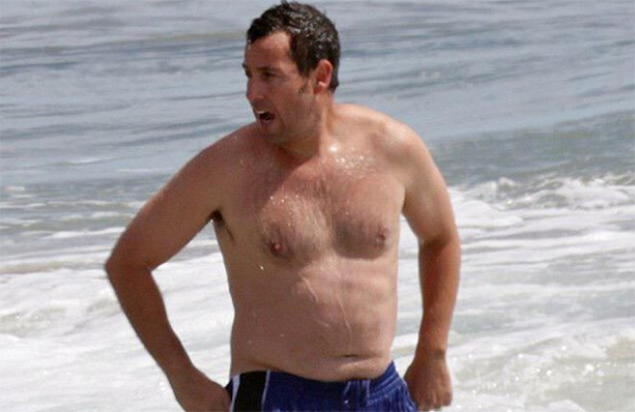

Figure 12 Figure 13

Long Hair
Hair longer than a guy’s face is a turn off due to the fact it is just too feminine. (Figure 14). I love a guy with a good pompadour going on though like figures 15 and 16. Having long hair is such a turn off that I can’t even imagine the guy with short hair because it just looks wrong.
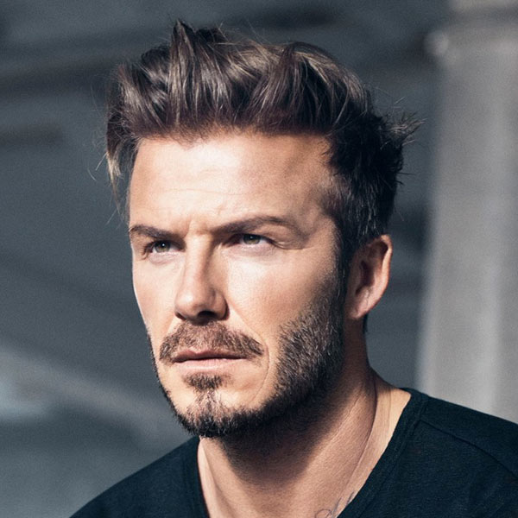

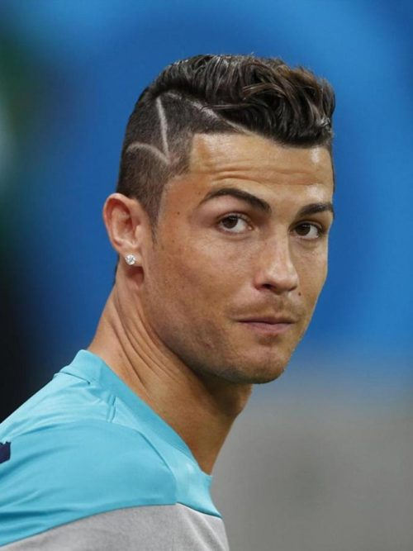

Figure 14 Figure 15 Figure 16

Voice
I feel this is a unique trait because while a lot of women can agree we don’t like a high pitched male voice, they can’t say the same for a deeper voice. I find a deeper voice absolutely scary, I like a voice that’s similar to mine. I feel like my voice isn’t very high pitched for a female and I also use a lot of emotion when I speak. I look for emotions in a guy’s voice when we talk because a monotone voice to me equals disinterest in life and in the conversation.

Unique Cognitive/Personality Lust Triggers

Insecure
A man who is insecure in either in either his looks or his personality, kind of goes with introvert. I don’t want a man to be cocky thinking he’s hot shit, but I like a man who knows that he’s got a good personality or is good looking. I like my men similar to me, and because I’m not unaware of my own looks I want a guy who is similar.
Crass
Crass is a unique one for me because I like the way a person holds themselves and also how they conduct themselves around other people. It is one thing to not care how you sound in the privacy of your own home or look, but it’s not okay to be unrefined in public. This relates with intelligence, but my definition of intelligence is trying to further your life or doing the best you can in life for your future.

Unique Social/Cultural Disgust Triggers

Meatheads
I think these men are absolutely disgusting. In my opinion a meathead is someone who spends all of their waking time working out and building muscles. Honestly large muscles, especially leg muscles, scare me because of my past relationships with abusive men. If my past exes who were extremely lanky, could hurt me, I can’t even let myself be in the position to be dating someone with that much testosterone. (Figures 17. 18)
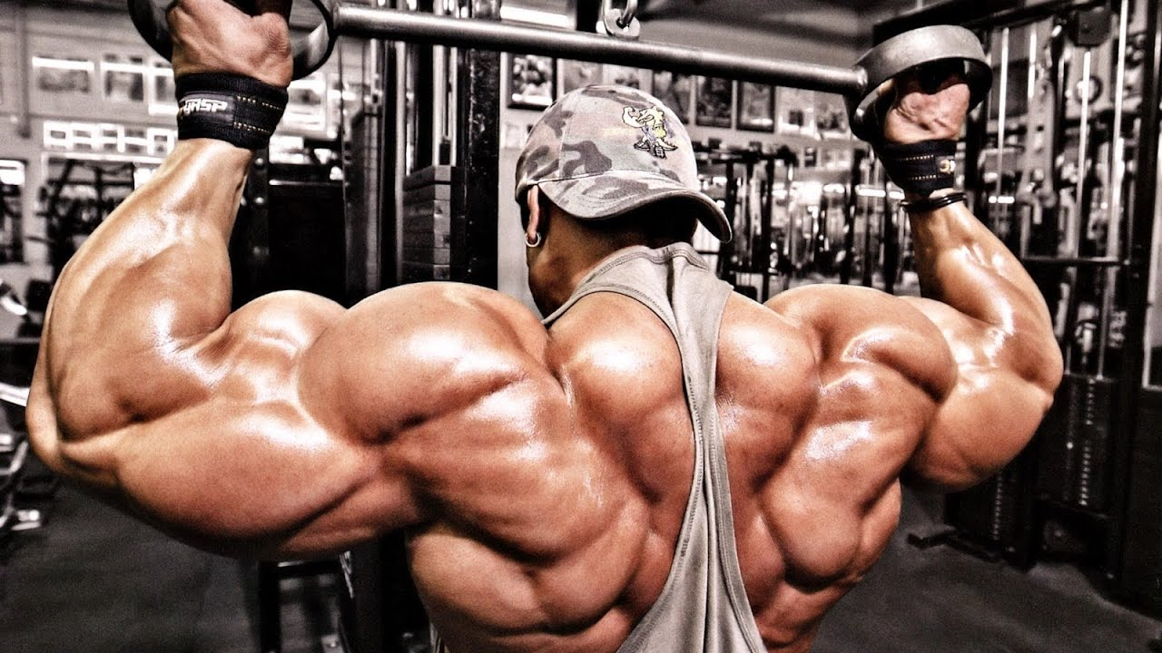
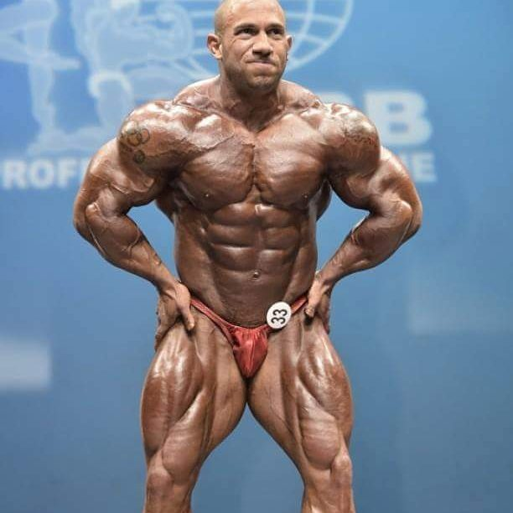

Figure 18

Figure 17

Frat Douches
This also goes along with one of my other disgust traits of arrogance. I dislike the fraternity guys that believe they are immune to everything and can get any girl they want with or without the girl’s consent. A majority of these frat guys think they’re better than everyone else and I hate that. I already have a hard-enough time being treated normal, that I don’t want to be treated like I’m a lesser human because I’m not coming from a lot of money. (Figures 19. 20).
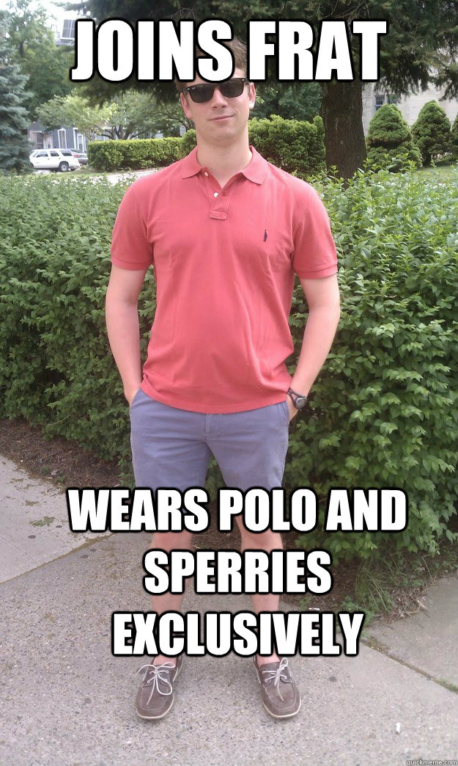
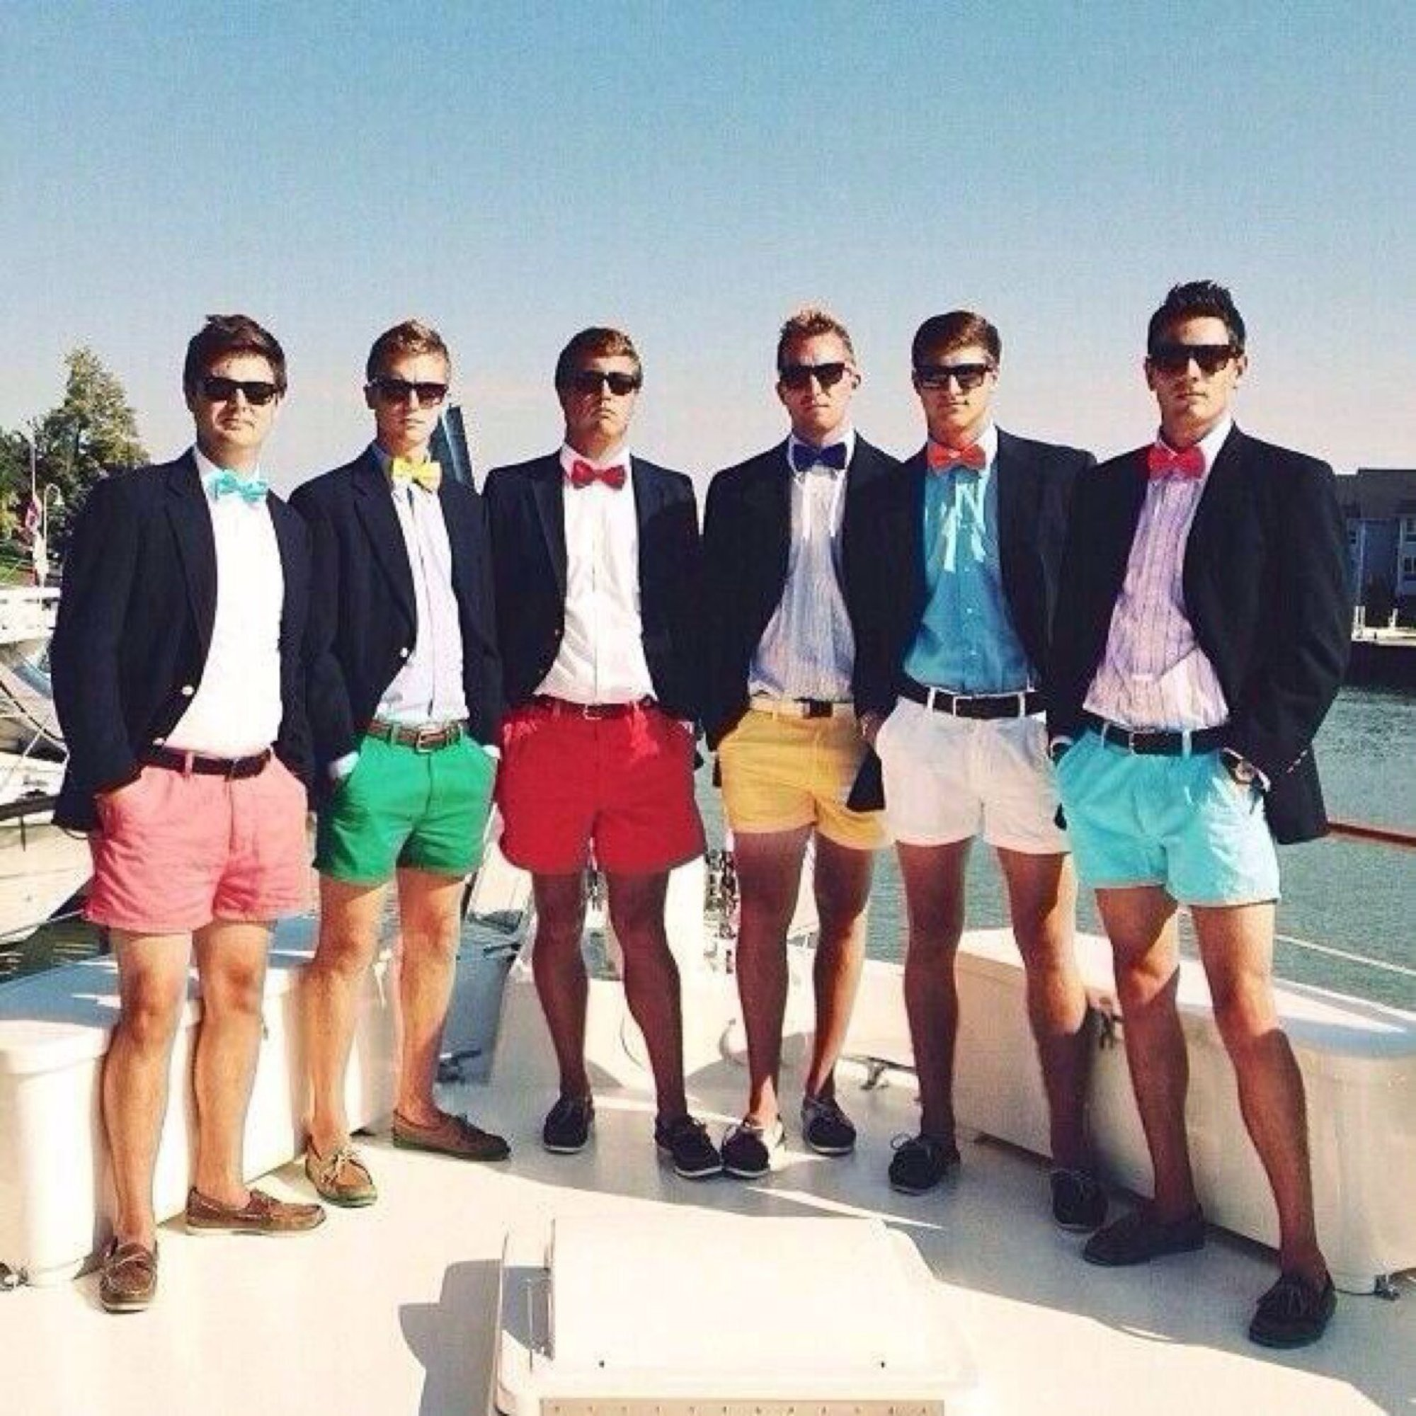

Figure 19 Figure 20
Conclusion

