Name
Professor’s Name
Course
Date of Submission
Compare Timber and Steel in Structure
Introduction
The most commonly used materials in the construction of structures are steel, wood, and concrete. The oldest used material is wood i.e., timber, and it was initially used by the early settlers in North America to build log cabins after some time concrete became available. Steel is the latest of the three materials. This paper will compare the use of steel and timber in buildings by analyzing the environmental, economic, and social aspects extensively and the advantages and disadvantages of the two.
Environmental Aspect
A structures’ life cycle begins with extraction of raw materials to be used in its construction. Compared to steel, the environmental impacts of timber at this initial stage are relatively low. Steel is an alloy comprising of mainly iron and contains a carbon content which varies with the grade. The main ingredient of steel is iron ore, which is typically extracted via open-pit mining and then subjected to very high temperatures. Open-pit mining is disastrous to the environment since critical minerals such as iron usually are available in little concentrations, therefore increasing the quantity of ore required. The open-pit mining process has negative environmental impacts in all its steps.
To start with, hard rock mining leads to the exposure of rocks that have lain underground for years to geological eras. Crushing of these rocks emits metallic dust and radioactive elements which are unfriendly to the environment. The crushed rocks are then separated during which tailings are produced and comprise of radioactive and toxic elements that can leak into the bedrock if they are not appropriately contained (Monjenzi et al. 205-216). The separated iron is then transported to blast furnace and heated at extremely high temperatures with coke or charcoal, thus high carbon emission to the environment. The melted iron forms metals, which are generally the basis of steel. Unlike steel, timber is extracted from trees that occur naturally and thus results in less carbon emission. Most timber companies use woody biomass such as sawdust and bark to fuel their operations while steel industries use fossil fuels. However, harvesting of timber may lead to unwanted changes in the ecosystem and depletion of forest cover as a result of deforestation, which reduces the quantity of green leaves responsible for converting the carbon monoxide in the atmosphere into oxygen (Anejo 58-63).
Another essential step in a structure’s life cycle is its demolition. If raw material cannot be recycled, it is not sustainable. Steel can be recycled but would require massive heat to be melted into new material. The heat energy that is needed to recycle steel is obtained by the burning of fossil fuels (Guggemos et al. 93-101). Therefore, the recycling of steel also hurts the environment. The timber, on the other hand, requires little amounts of energy to be recycled. Reclaimed timber i.e., Lumber extracted from old structures, can even be removed underwater if it has not rotted away. To some extent reclaimed wood is even better than new wood since it can be made taller than the usual tree height, does not require time to shrink into size by drying out and is cheaper than new wood (Hill et al. 215-219). The graph below shows how both timber and steel structures affect the environment.
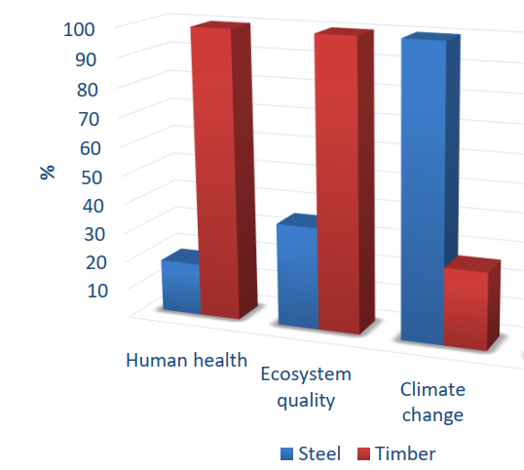
Figure 1: Environmental impacts of timber and steel
From the graph, steel impacts climate change more than timber due to the emissions involved in its production. It is also evident that timber is more sustainable ecologically than steel since it occurs naturally. Timber is also better in terms of sustaining human health since it emissions are minimal compared to steel.
Economic and Social Aspect
There are broadly three stages in the life cycle of a structure that accrue costs i.e., construction, maintenance, and recycling. To properly consider the construction cost, one must take into consideration the cost of acquiring the raw materials, transportation costs, and the labor incurred in the construction process. By choosing based on only the initial cost of raw materials, a timber structure would seem more cost-efficient since its naturally occurring and thus relatively cheaper to acquire compared to steel. Recycling timber is also less expensive than recycling steel, as explained above. Using these considerations, wood structures are more economical to construct and recycle compared to steel. However, determining the overall cost of a building is tricky as it requires evaluating the whole life cycle incorporating monetary factors and environmental factors (Smith and Tobias 141-149).
The social aspect refers to the various forces within a community. For example, in a community prone to fires due to factors such as the geographical location, a steel structure may preferable to a timber structure. Whereas in severely cold regions, timber structures may be preferred due to the natural insulation properties of timber. Different social aspects may broadly impact the choice between steel structures and timber structures (Abeysundra et al. 2141-2149).
Advantages and Disadvantages
Comparing the two materials, each one of them as some advantage over the other. This essay will first analyze the advantages of timber over steel i.e., the disadvantages of steel compared to wood. First, as stated earlier, timber is natural; as such, unlike steel, it does not emit chemical fumes, is not toxic, and is safer to work with. Second, timber is ecology-friendly and sustainable. The process of recycling wood is eco-friendly and cheaper, unlike the recycling of steel. Third, the production of timber requires minimal energy. The energy needed to produce timber is lower than the energy needed to provide steel. Fourth, unlike steel, timber has natural insulation properties. It is excellent for use on windows, floors, and doors. Frames made of timber provide more room for insulation than those made of steel. Lastly, the time it takes to build a timber house can be shorter compared to a steel house of the same design. This is because timber frames can be modulated, pre-cut, or even built entirely away from the construction site, which is impossible with steel frames (Kremer and Symmons 138-147). Figure one below shows an example of a timber structure.
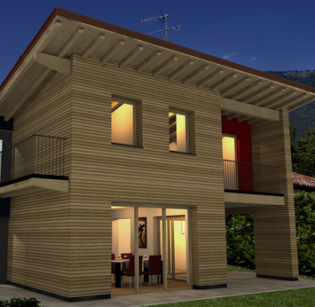
Figure 2: Timber Structure
Steel has various advantages over timber i.e., disadvantages of timber compared to steel. First, steel frames are lighter than wood frames due to their design. This results in a more straightforward foundation of a building, lower shipping costs, and a general reduction in the overall budget of constructing the building. Second, compared to wood, steel is more versatile. It can be molded into any shape and can generate shingle-Esque roof patterns. This versatility is what allows for the construction of skyscrapers. Third, the aesthetic appeal of steel building is better than that of timber buildings. Steel will enable architects to express their creativity more than timber does. It allows for emphasis on slenderness, transparency, and grace; for example, the aesthetic appeal of figure two shown below, which is a steel structure that cannot be accomplished using timber. It can even be bent to emphasize the aesthetic appeal of the building. Fourth, steel is stronger than wood. Steel is very strong; the strength of the steel used in buildings today is higher than that of steel used for construction purposes ten years ago, indicating an upward trend (Sadeghi and Barati 1151-1159). It can, therefore, withstand strong winds, pest infestations, and even seismic activities. Lastly, steel is modifiable, unlike timber. Steel structures can be modified in a future date in terms of vertical expansions, new applications, and owner's desires, unlike timber framing systems.

Figure 3: Steel Structure

Conclusion
As I sum up, timber and steel structures differ in so many ways, as discussed. However, one cannot distinctly say that one is better than the other since they both have unique features that make each of them better than the other in one way.

References
Hill, Callum Aidan Stephen, and J. Dibdiakova. "The environmental impact of wood compared to other building materials." International Wood Products Journal 7.4 (2016): 215-219.
Mallo, Maria Fernanda Laguarda, and Omar A. Espinoza. "Cross-Laminated Timber vs. Concrete/steel: Cost comparison using a case study." 2016 World Conference on Timber Engineering, WCTE 2016. Vienna University of Technology, 2016.
Ramesh, Talakonukula, Ravi Prakash, and K. K. Shukla. "Life cycle energy analysis of buildings: An overview." Energy and buildings 42.10 (2010): 1592-1600.
Sadeghi, J., and P. Barati. "Comparisons of the mechanical properties of timber, steel, and concrete sleepers." Structure and Infrastructure Engineering 8.12 (2012): 1151-1159.

