Data Analysis on Child Poverty
Student’s Name
Institutional Affiliation

Table by County
Location | Data Type | 2013 | 2014 | 2015 | 2016 | 2017
Texas | Number | 1,739,298 | 1,721,843 | 1,634,149 | 1,616,085 | 1,525,944
Texas | Percent | 25.0% | 24.5% | 22.9% | 22.4% | 21.0%
Bexar | Number | 112,621 | 126,381 | 107,996 | 108,689 | 110,667
Bexar | Percent | 23.9% | 26.4% | 22.2% | 22.0% | 22.2%
Dallas | Number | 195,950 | 193,884 | 179,175 | 169,288 | 151,187
Dallas | Percent | 29.5% | 29.0% | 26.5% | 24.9% | 22.1%
Denton | Number | 20,967 | 19,102 | 18,003 | 18,943 | 16,283
Denton | Percent | 11.0% | 9.8% | 9.0% | 9.3% | 7.8%
El Paso | Number | 73,737 | 74,090 | 67,912 | 72,477 | 67,757
El Paso | Percent | 31.2% | 31.7% | 29.4% | 31.4% | 29.6%
Harris | Number | 312,784 | 299,274 | 306,724 | 299,330 | 286,551
Harris | Percent | 26.7% | 25.1% | 25.3% | 24.4% | 23.2%
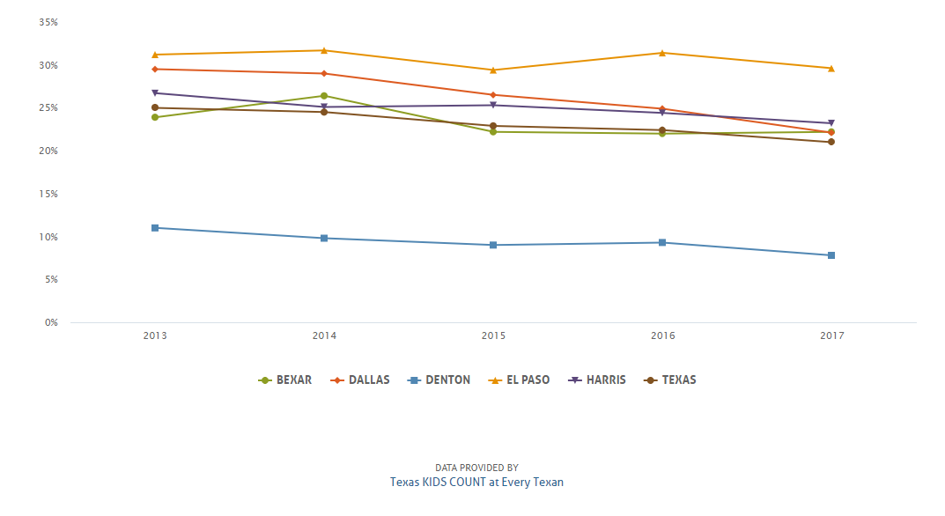
Trends for 2013 – 2017
Line Graph For 2013

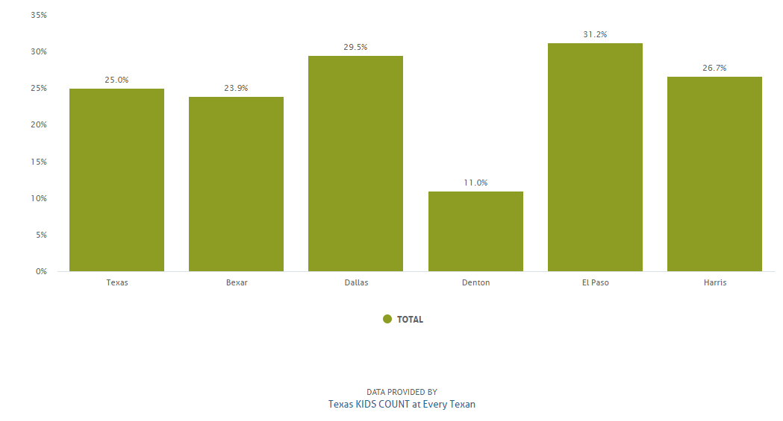

Line Graph For 2014

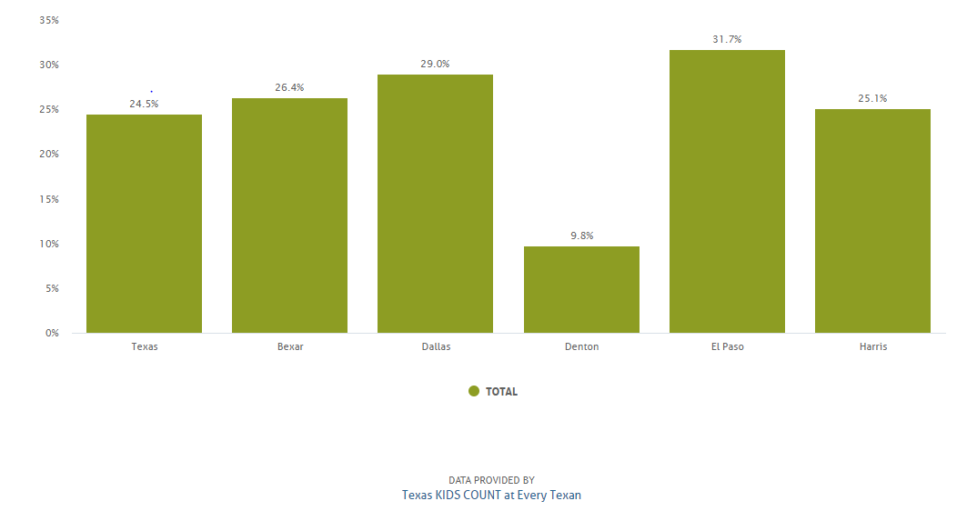
Line Graph For 2015

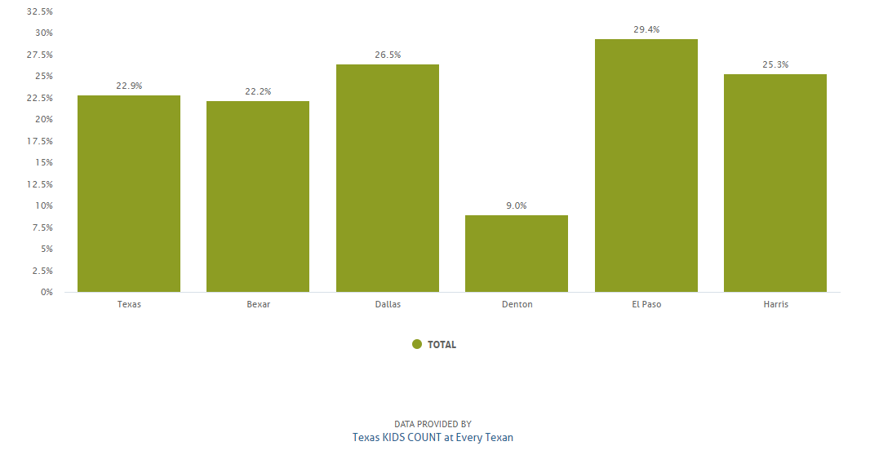
Line Graph For 2016

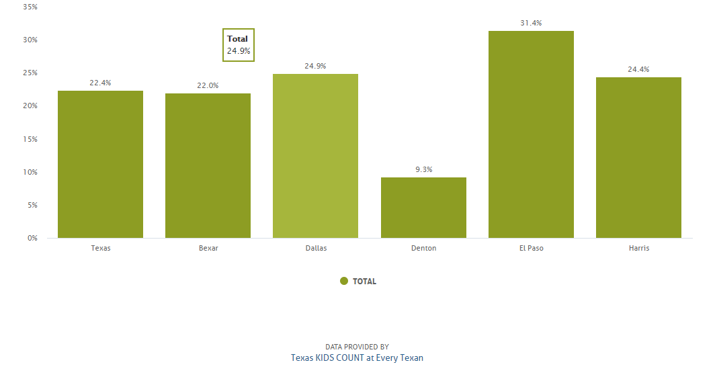

Line Graph For 2017

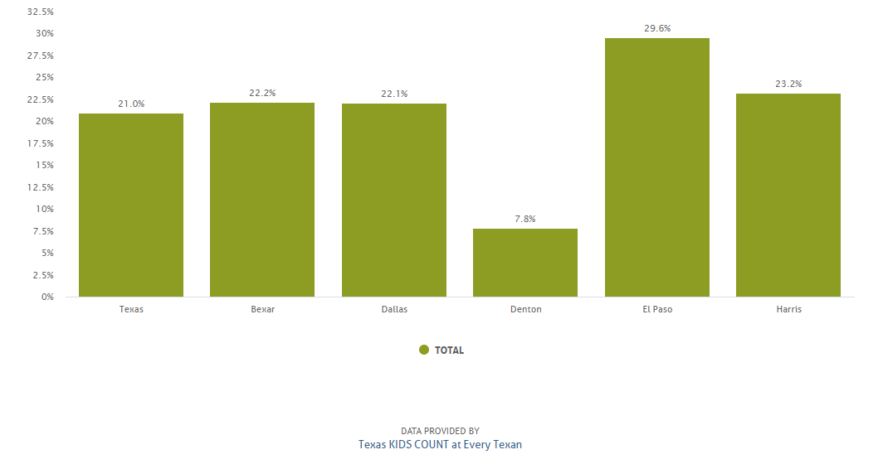

Reference
Texas KIDS COUNT at Ever Texan: https://datacenter.kidscount.org/data/line/3065-poverty-0-17?loc=45&loct=5#5/6529,6571,6575,6585,6615/true/1729,37,871,870,573,869,36,868,867,133/asc/any/8191

