Cutting down Trees
Institution
Name
Course

Cutting down of trees is referred to as deforestation. The process of deforestation entails cutting down and burning the trees in the forest and converting the pieces of land to other uses such as agriculture or for some other industrial purposes. The nature of trees has changed over time; there has been replacing of slow-growing indigenous trees with other fast-growing woods. This simply means that the precious eco-system of the forest has changed to less bio-diverse eco-systems such as cropland, pasture, and removal of rainforest (Kreike, 2010). However, about thirty percent of the earth's surface is still covered by forests. Cutting down trees is associated with desertification, climate changes, loss of topsoil, and many other social effects.
There are two main problems that are associated with deforestation (cutting down of trees). Trees are well known to be absorbing carbon IV oxide which helps in controlling the effect of global warming. Carbon IV oxide is said to be one of the factors or gases that are associated with causing global warming. Thus, since trees use carbon IV oxide during the photosynthesis process, they help in reducing its volume within the atmosphere which on the other hand help in slowing down the greenhouse effect (Kreike, 2010).
Additionally, the other problem is that trees are often cleared and burned down. The wood that is got from the cut-down trees is simply destroyed and not used for any positive use. When the wood is burnt, it emits carbon into the surrounding which in turn turns to be harmful to the environment. Cutting down of trees leads to the reduction of trees that would have otherwise been used for absorbing carbon IV oxide. Due to the devastating effects of cutting down trees, Rainforest Action Network (RAN) has been campaigning for the forests, their populaces and the natural systems which sustain life (Linde, 2011). These campaigns can be channeled through education, grassroots organizing, and non-violent direct action. RAN organization has estimated that about ninety percent of the rainforest to have already gone.
Causes of Deforestation (cutting down of trees)
Deforestation is mainly caused by urbanization, overpopulation, change in climate and globalization. Trees have been cut down simply for construction purpose, agriculture (cleared for to create space for growing crops), and are also used as firewood for cooking.
Overpopulation
There has been an increase in the number of people around the world. Due to the increasing number of people (overpopulation), there is a need to have more forest areas cleared for establishing housing and settlements. Also, large tracks of forest have resulted in being cut down for the building more roads and highways in order to accommodate the increasing number of people driving (Linde, 2011). On the other hand, due to the increasing population, there has been an increasing need to produce more food-resulting in cutting down of trees to pace the way for agriculture. Also, there is a rise in the demand for furniture, thus making the logging industries increase their activity of cutting down trees to meet the increasing demand. All these are as a direct impact of the increasing number of people.
Agriculture Expansion and Livestock Ranching
The agricultural sector has been expanding, thus causing cutting down of trees to pave the way for plantations. Due to the increasing demand for agricultural products such as palm oil and soybeans has been acting as the driving force towards deforestation. Additionally, those who have an interest in keeping many livestock, they have resulted in clearing the forest by using slash and burn techniques (Kreike, 2010). Unfortunately, the farmers have resulted in using the soils until it is completely degraded and they end up repeating a similar process in a different patch of woodland. Ultimately, the area will reforest, but it might take many years to return to its initial condition. On the other hand, cattle ranching and deforestation are strongest in Latin America. Over the past four decades, forest area has declined by about an astounding forty percent (Tchatchou, (n.d.)). During the same period, areas containing pasture and the population of the livestock has also increased by almost the same rate.
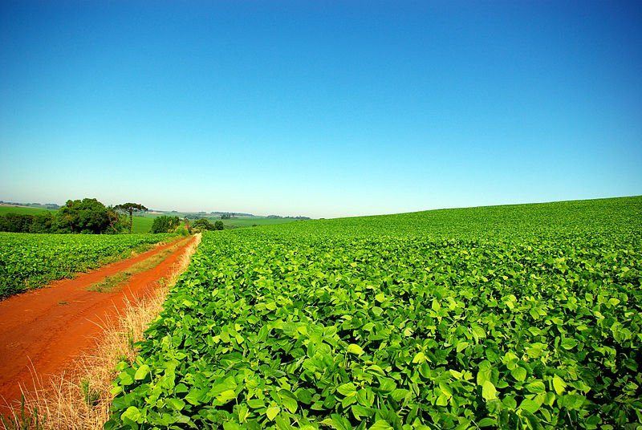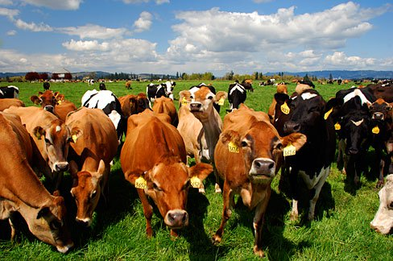
https://7gigzxopz0uiqxo1-zippykid.netdna-ssl.com/wpcontent/uploads/2013/08/SoyPlantation2.jpg
Climate Change
Forests are seen as the lungs of the planet. All plants take in carbon dioxide and in return release oxygen. Trees have been claimed to be converting more carbon dioxide than a regular plant, though. Forest loss is often due to climate change (Tchatchou, (n.d.)). Tropical rainforests are extremely humid and release water vapor alongside oxygen. When the rainforests are cut down, the level of humid within the atmosphere decreases thus causing the other plants to dry out.

Urbanization and Globalization
When a country is going through urbanization, there arises the need to cut down trees for the use of building materials, paper products, and furniture. Due to the expanding population within the urban areas, forests are cleared to give way for the construction of roads and building that will accommodate the increasing number of people within the area (Linde, 2011). Additionally, globalization has also caused cutting down of trees due to the increasing number of industries and factories. The running industries and factories emit carbon dioxide which has the greenhouse effect.
Logging and Development of Infrastructure
Logging is one of the major causes of deforestation. People cut down trees to obtain logs for commercial purposes. Once, the trees have been cut down they rob those who depend on the forest as their source for livelihoods. On the other hand, construction of infrastructure such as roads, railways and airports lead to deforestation. Trees are cut down to pave way for an entry to previously remote area.
Effects of Deforestation (cutting down of trees)
The state of the environment is getting worsened by the effects of cutting down trees such social effects, biodiversity effects, and soil erosion.
Soil Erosion
When bushes are burned, and trees are cut down, the immediate effect includes washing away of soil. Once deforestation has been effected, there are no trees that can hold together the soil and thus the mud just slides whenever rain pours (Campari, 2005). Also, due to the much amounts of water, large amounts of nutrients are leached. Erosion also causes contaminants in the soil to leach into the water supply which affects the quality of the water used for drinking. In addition, due to the washing away of soil by rainwater, nearly 80% of the tropical forest soil is now infertile, and thus there will be continued bad effects to the animals and other living things.
Biodiversity
The tropical forests cover about seven percent of the earth's dry land. However, it provides inhabitant for around half of all the species found on earth. Many of these species are so specialized to microhabitats within the tropical rainforest that they can only be found in small areas. Thus, due to their specialization, they are prone to extinction. When an area is totally deforested, the plants and animals in the fragments of forest which remain also becomes increasingly vulnerable, and sometimes are prone to extinction (Kägi, 2000). The edges of the areas that remain forested dries out and are hard hit by hot winds whereby even the mature trees end up dying. Additionally, due to the cutting down trees, the forest canopy is thinned out thus allowing sun rays that were blocked by the canopy hit hard on the ground causing there to be experienced high swings of temperature. Thus, due to cutting down trees, many animals, insects, and plants lose their natural habitats and may then become endangered and even go extinct.
Social Impacts of Cutting down Trees (Deforestation)
Cutting down trees has so many social effects on the community. It affects not only the people but also the plants, animals and the environment around. The Indigenous people who consider the forests as their primary habitats are rendered homeless when trees are cut down. This has been seeing mostly in the areas that are underdeveloped since there are so many people who use the forest as their primary habitat (Kägi, 2000). Once the trees have been cut down, the people living in these areas are normally forced to move from their original areas. They then move from the deforested areas and start seeking shelter elsewhere.
People and animals living in the rainforest normally rely on the natural environment. They depend on their natural environment for their basic things such as food, water, shelter among others (Campari, 2005). Once the trees are cut down, the natural setting is thus disturbed, and those living in the affected areas either animals or people normally move to other places in search of a conducive atmosphere.
In conclusion, cutting down trees is associated with desertification, climate changes, loss of topsoil, and many other social effects. On the other hand, deforestation is mainly caused by urbanization, overpopulation, change in climate and globalization. There are two main problems that are associated with deforestation (cutting down of trees). Trees are well known to be absorbing carbon IV oxide which helps in controlling the effect of global warming. Carbon IV oxide is said to be one of the factors or gases that are associated with causing global warming. Trees have been cut down simply for construction purpose, agriculture (cleared for to create space for growing crops), and are also used as firewood for cooking (Kägi, 2000). Additionally, due to cutting down trees, there has been accompanying effects which include; soil erosion, loss of biodiversity, and other social effects. Once deforestation has been effected, there are no trees that can hold together the soil and thus the mud just slides whenever rain pours (Campari, 2005). Also, due to the much amounts of water, large amounts of nutrients are leached. Cutting down trees has so many social effects on the community. It affects not only the people but also the plants, animals and the environment around. The Indigenous people who consider the forests as their primary habitats are rendered homeless when trees are cut down. This has been seeing mostly in the areas that are underdeveloped since there are so many people who use the forest as their primary habitat (Kägi, 2000).

References
Campari, J. S. (2005). The economics of deforestation in the Amazon: Dispelling the myths. Cheltenham, U.K: E. Elgar.
Kägi, W. (2000). Economics of Climate Change: The Contribution of Forestry Projects. Dordrecht: Springer Netherlands
Kreike, E. (2010). Deforestation and reforestation in Namibia: The global consequences of local contradictions. Leiden: Brill.
Linde, B. M. (2011). Deforestation and desertification. Pelham, NY: Benchmark Education Co.
Tchatchou, B., & JSTOR. (n.d.). Deforestation and forest degradation in the Congo Basin: State of knowledge, current causes and perspectives. Place of publication not identified: publisher not identified.

