Essay 1
First Draft Due:
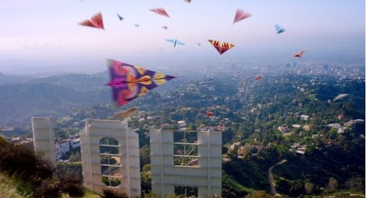
Second Draft Due:

Key Moves
Scholarly essay writing typically calls for two key moves: adding to a conversation started by a text/author and analysis. Both moves set scholarly writing apart from other styles of writing. In the college environment, your readers (professors, fellow students, folks curious about the world) look for these features because they want to learn something from you.

“Adding to a conversation” really means that it’s your job to further explore ideas, concepts, questions, or terms raised by another writer. In other words, your readers are looking to you to read other texts for interesting ideas or tensions. As you encounter those ideas or tensions, your task is to explore those ideas or tensions further through your own writing. This work usually calls for your own examples, claims, and analysis as you test, complicate, or add to the ideas raised by another writer. By doing this work, you’re in the driver’s seat developing your own insights for readers.

What exactly is analysis? These are moments where you open up meaning for readers, based on evidence from your subject, beyond an opinion-only reaction. It’s the stuff that makes your writing interesting and insightful.

The overall goal is not to have a final word on a subject. Rather, it is to open up further discussion and meaning - a mode of intellectual exchange (which is really why we’re here!).
Adding to the conversation
The Assignment
For our first essay, we’ll use Deepak Narang Sawhney’s essay “Journey Beyond the Stars” as our starting point. His essay tracks a lot of tensions and perceptions about Los Angeles, but one of his main points seems to be that LA is portrayed in specific ways through mainstream or commercial texts. He writes, “[t]hough a common dialogue, collective vision, and shared perspective may not be present in contemporary Los Angeles, the city nevertheless sells itself extremely well” (7). Later, Sawhney comments, “[t]he question of how we begin to understand this dynamic, contradictory city preoccupies countless films, journals, articles, books, websites, and radio programs. Eager participants of mass consumption, whose insatiable appetite devours everything that is L.A., are fed analytical and scripted perspectives on what it is that makes Los Angeles unique” (7-8). With these claims (and many questions) Sawhney raises, he gives us something to consider: what exactly are the current, commercial perceptions of L.A. being put forth?
Analysis of one “commercial”/mainstream example

This is where you come in. Select one sample “text” to analyze in-depth as you develop your essay. This example can be a scene from a film, an ad, a tourist guidebook, a magazine, an episode from a TV show, or any other representation of L.A. that constructs a dominate/commercial/common perception of the city or its people. As you compose your essay, your goal is to analyze how exactly the city is packaged or “sold” through that commercial/mainstream text. In other words, you’ll be looking into the details of that example to see how L.A. is portrayed. It may be subtle and background or very up-front, in-your-face. As Sawhney claims, it may also be an extreme “utopia” or “dystopia” portrayal. Whatever the case, it’s your task to investigate Sawhney’s claims through the lens of one specific example (of your choice).

As you continue your discussion, unpack for readers what it looks like when you offer an “anti-commercial” or non-mainstream look into Los Angeles. For that angle, choose one of the recent class readings to discuss in depth. The choices are:
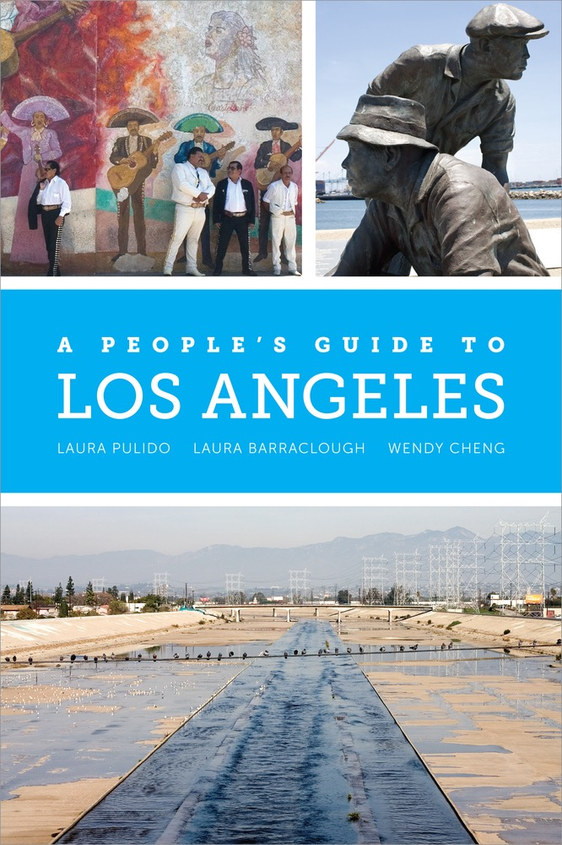
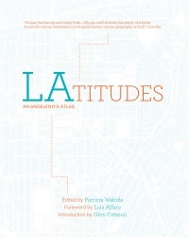
Analysis of the “anti-commercial” - one selected class reading
  - “Naming Los Angeles” (Woo)
  - “Freeway Jam” (Ulin)
  - Introduction to A People’s Guide (Pulido, et. al. )
  - A People’s Guide: “South Los Angeles” (Pulido, et. al.)

Include an analysis of one of the above readings. Consider: How does this text offer an alternative portrayal of Los Angeles? Why might this text or it’s content be important to notice?
Answering
“so what?”

The “so what?” question is always a good prompt as you write. It’s especially useful as you move to a conclusion. Think about what you want readers to take away by the end of your discussion.
Return to Sawhney’s guiding questions in his concluding paragraphs. He asks, “In a city where it is often difficult to separate myth from reality, fact from hype, where do we start to find a middle zone of engagement?” (13). What do you think? What should people notice about the ways texts (in all forms) filter our perceptions of a place?

As you consider this in your conclusion, let readers know what’s been gained by your discussion. What insights do you want to leave with your readers regarding this subject?

The Details
Integrating Sources

This essay assignment will get us into some of the main practices of strong source integration. Early on in your essay, you’ll want to briefly summarize Sawhney’s essay for your readers. Letting your readers know about his claims will help you set up your angle of analysis - that is, an exploration into what exactly he’s referencing. The practice of summary (all in your own words), paraphrase (with a citation), and directly quoting (with a citation) are all moves to showcase as you tell readers about Sawhney’s essay.

Your other source material will be the chosen texts you are analyzing. With those sources, you’ll want to make the same moves of brief summary, zooming on details, quoting before you break into your analysis.
Developing a Thesis

A scholarly essay (at least in the U.S.) is guided by a thesis. Early on, it’s the place where you offer readers your main claim or guiding idea for the essay. For this essay, you’ll want to set up an initial working thesis for your readers. Your initial thesis should be a claim or idea that requires further exploration and analysis. Throughout the essay, you will be developing, deepening, and refining this thesis. In this project, the thesis should be a carefully worded claim about the examples you are analyzing, the ways L.A. is portrayed by mainstream texts in general, or an idea about the ways texts assert power and control over people’s perceptions of a place. This thesis statement helps readers see the subject and scope of your discussion.
An Early Decision Point

It’s up to you how to introduce your topic. Would it make sense to let readers know about Sawhney’s text first, then move to your thesis and discussion? Perhaps you would rather start discussing part of your example text, move to your thesis, then bring in the context of the Sawhney essay to set up your analysis/discussion.

To help you make this decision, try doing a rough outline of your essay. What will be the best way to introduce your topic, Sawhney, and your first example? How might you structure the development of your examples? Where will it lead for a concluding claim/insight by the end of your discussion?

Assignment Requirements:

- Your essay should be a minimum of 4 full double-spaced pages with 1” side margins, 1” header and footer margins, Times New Roman, 12 pt font.

- Early on in your draft, you should form a working thesis to give your readers a main claim or guiding idea which will be developed throughout. By the end of the essay, this thesis should be developed into a complex claim about how texts provide a lens that filters, represents, or asserts power, and thus affects our understanding of L.A.

- Your essay must bring in Sawhney’s essay, “Journey Beyond the Stars,” accurately summarizing in a way that is understandable to a reader who is not familiar with the text but making sure that the summary does not take over the essay. To go with that summary, offer a good mix of paraphrases and direct quotes (with MLA style citations) to help readers see exactly what Sawhney says in his essay.

- To add to the conversation started by Sawhney, your essay should attempt to engage in analysis of your chosen example to unpack how L.A. is portrayed in a mainstream or commercial way in that text. Adding to that discussion, bring in one of our recent class readings (Woo, Ulin, or Pulido) to discuss how that text moves beyond typical, commercial, mainstream portrayals of the city.

- Give careful consideration to your final thesis (or your answer to “so what?”) as you move to a conclusion. Make sure that it is clear what has been gained by your discussion and what insights you want to leave with readers. Remember that specifics are much more rewarding than general platitudes or preachy/teachy conclusions. Detail exactly what you’ve noticed about the portrayals of L.A. in your example texts and why that’s worth noticing as you reconsider (or push beyond) Sawhney’s points.

- Cite all sources in MLA format (in text), in addition to a Works Cited page. Use Purdue OWL (linked on Canvas) to look up proper MLA in-text citations and Works Cited formatting.

- Proofread for mistakes and edit for clarity. Consider paragraph organization and appropriate transitions to lead your reader through your discussion.

