Directions
There are two parts to this assignment. The first half of this assignment is graded on satisfying the Microsoft Word document or software portion of the assignment. The other half is finding and entering the data requested into the Microsoft Word document.
Part I: You may use the attached Assignment 02: Cells and Cost of Living Template to complete this assignment.
OR
Open the Microsoft Word Document you created for the "Assignment 01" and use the SAVE AS feature to save a new copy of this document named LastName.FirstName.CS1300.Assignment02. You may want to change your view to "landscape" to fit all of your columns in one view (Go to Page Layout - Orientation - Landscape). Add five (5) new columns to the right of the existing columns (Right Click on the table in the "SD Hourly" Column - Select Insert - Insert Columns to the Right - do this 5 times): “Sioux Falls CoL”; City 1 COL; “City 2 COL”; “Comparison City 1”; and Comparison City 2” (format: currency; no decimal points) (note: you’ll change these labels when you collect your data in part two).
Part II: This part of the assignment is where you locate the data to enter into your Word Document. You will need to access the following two websites: 1) Sperling’s Best Places: (COL); and 2) NerdWallet's Cost of Living Calculator (COMP) AND you will need the MEDIAN SALARY data from Week 01 (if you do not have this data, use $40,000 for your comparison salary amount).
Using the COL website, you are going to find the cost of living data for Pierre, South Dakota, and two other locations of your choice. First, click on the Sperling’s Best Places website. This should take you directly to the page for Pierre, South Dakota. Find the number listed for the overall cost of living comparison; you should see a number of “94.9” for that piece of data. Collect this data so you can enter it into your Microsoft Word Document.
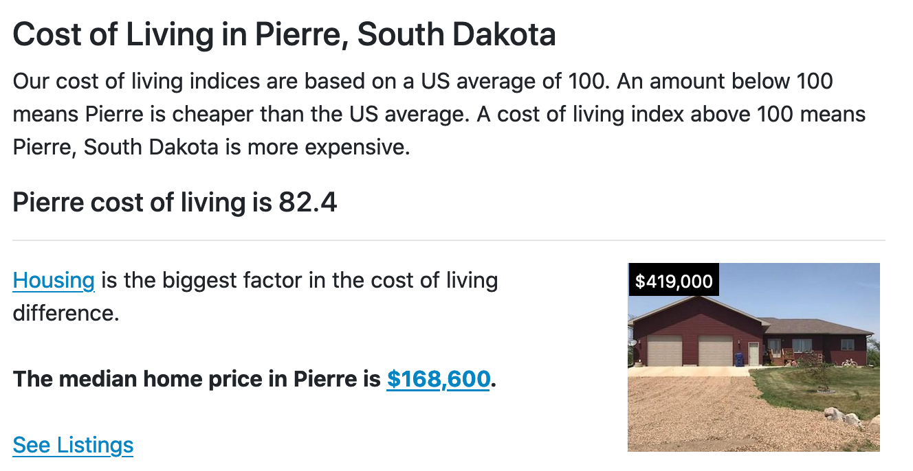
Next using the search window above, find the overall cost of living for two other cities of your choice. Collect this data to enter into your Microsoft Word document.
Now, go to the NerdWallet's Cost of Living Calculator and
1) Enter the median salary from South Dakota for an occupation of your choice (USE the data from Assignment 01) for your initial city. HINT: use the same cities you looked at before for the cost of living!
2) Enter "Pierre, SD" under the "I currently live in" dropdown menu.
3) Enter a second city of your choice for which to find the comparable salary (this will be “Comparison Salary 1).
See the screenshot for assistance:
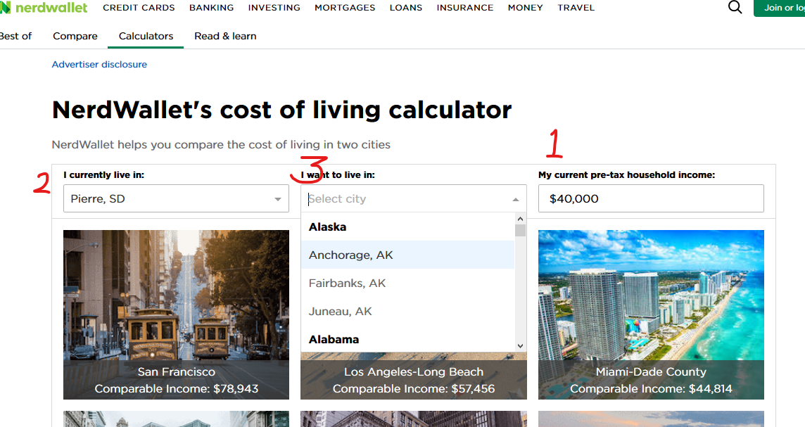
Complete this process for Pierre, South Dakota and another comparison city (this will be the “Comparison City 2” data for your worksheet.) Last, enter this data into the appropriate columns in your worksheet. You only need to enter the salary data once and then you may COPY the cells to the rest of the column. Remember to rename your columns so that, for example, “Comparison City 1” will become “Springfield, MO: Comparison City 1.”
Submit this assignment to the dropbox "Assignment 02: Cells and Cost of Living." This assignment is worth 50 points and will be graded according to the scoring guide below.

