The following data represents daylight temperature that I collected consecutively.
29.5, 36.4, 28.1, 30.9, 37.6, 36.4, 29.8, 36.8, 32.0, 33.5
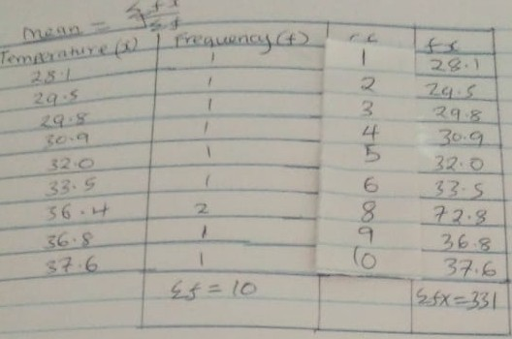

Mean= (sum of fx/sum of f) =331/10
=33.1°C

Mode is regarded as the most. It is the number with the highest frequency.
Mode=36.4°C
Median=n/2 = (10/2) th position and (10/2+1)
=(5th+6th)/2
= (32.0+33.5)/2
=32.75°C
Midrange=(32.0°C-33.5°C)

