Students will be applying the cognitive learning theory constructivism based off Jean Piaget's theory of schemas.
Select a picture from the following images. Select only ONE. Determine a topic picture that could be turned into something you teach a person. For example, you could select the sailboat and what you teach is how to sail. Take it one step further and explain how you would teach it using one of the conditions and examples about schemata from the table found in the article by Clark (2018), Learning Theories: Cognitivism. Radiologic Technology, 90(2), 176–179. (Located here). See the table on page 178 of the article. Students must clearly list the concept from the table that you are using to illustrate the cognitivism. Please look at how cognitivism is defined and don't confuse it with one of the conditions that can be used to engage someone in the information process. Please clearly let your reader know which concept is being used.
Please underline, color code, or bold the concept you are using from the table in the article listed here.

 |  |  | 
Image: Rope | Image: Sail boat | Image: hamburger | Image: lightening

 |  | 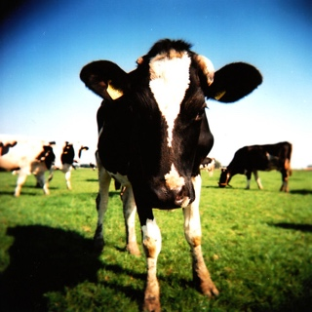 | 
Image: Auto Accident | Image: girl | Image: Cows | Image: Stoneheadge

Here is the book to use as a reference. Only in-text citations. APA FORMAT 7TH EDITION
Helena Seli - Motivation and Learning Strategies for College Success_ A Focus on Self-Regulated Learning-Routledge (2020).pdf

