Clearly use one concept from the assigned reading and explain what types of influences you believe best explain the person's behavior. Underline or bold the chosen concept.

Journal Instructions
Part 1: Print out the following picture of the three men or show the picture here to four different people and ask them what their first impression is of the men. Do not tell them beforehand who the men are. After they reply, tell the four people who the men are. Ask why they think their impressions were wrong. Upon knowing who the men are, did it change their impression of them? Explain your findings as a whole.
First man: Ted Bundy
Second man: Ingvar Kamprad, founder of IKEA
Third man: Christopher Langan: highest IQ reported

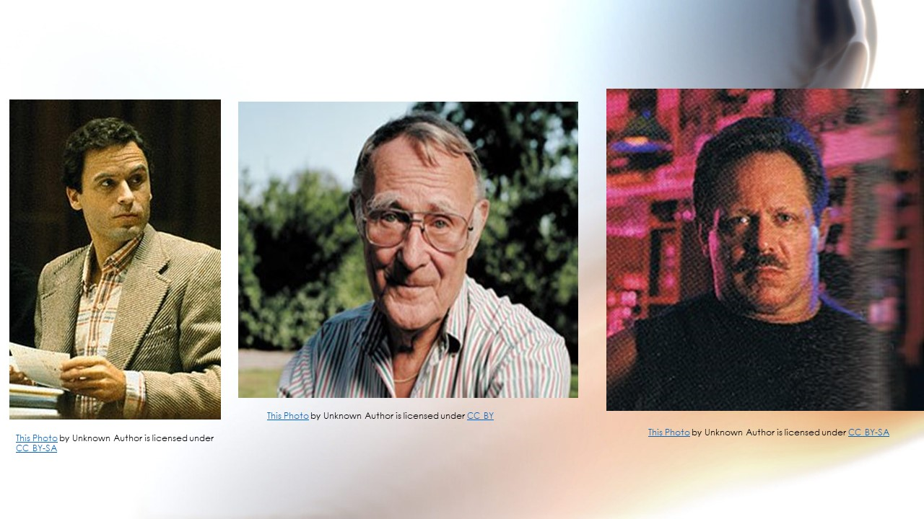
Part 2: Explain in a well-thought paragraph using the terminology of first impressions and thin slicing why do people hold on to their first impressions and what might be an implication of doing that in some area, such as in relationships, work, school, or another social event?

Here is the book to use as a reference. Only intext citations. No direct quotyes. APA format 7th edition
Elliot Aronson, Timothy D. Wilson, Robin M. Akert, Samuel R. Sommers - Social Psychology-Pearson (2015)

