Students are to fill in the chart by explaining the purpose, strength, and weaknesses of the three commonly used research methods of descriptive, correlation, and experiment.
Once you select Submit Assignment, the box should open to where you can type in the table here. If you experience technical difficulties doing that, you can copy and paste the table into a Word document, complete it, and the copy it to this page.
Main Research Methods | Purpose | Strength | Weakness
a.
descriptive:

b.
correlational

c.
experiment

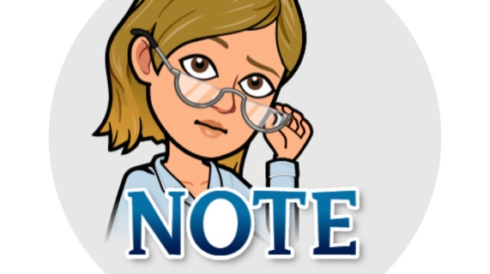

This information you gather for this assignment should be used for the Research Project in the Signature Assignment. Please look for any feedback in your gradebook pertaining to this assignment prior to completing it in the e-Portfolio.

