PART 1 – INFANCY AND EARLY CHILDHOOD
The year of 1925 was one of drought and flooding rains in Australia. It depended where you lived. It was also the year of birth for some famous Australians—Don Chipp, Ruth Cracknell and Norm McDonald amongst them. But as Mavis bent over the bassinet of her second daughter, Alice, none of this was important. It had been a difficult birth in the small country town of Echuca, home of the paddle steamers. Henry, Alice’s partner of four years, was away upstream and may or may not have
been stranded with the drop in the river level. He wouldn’t be back for weeks. Alice wouldn’t feed easily like her older brother Raymond had, and Mavis was quickly becoming frustrated and tired. The child wouldn’t die, but it seemed like she didn’t want to live properly either. The doctor and the midwife gave advice, but nothing seemed to work, though feeding her goat’s milk helped a bit—when it was available.
Mavis often left Alice and Raymond with the neighbours. She had to work and mainly did cleaning and housekeeping around the district. When Alice was about 7 months old Henry came home, stayed briefly, and was gone again—down river this time to Adelaide for cargo delivery and pick-up. He wasn’t so interested in his children. Alice met most of the normal milestones, though slowly, over the first 12 months of her life. At about 16 months she began to walk, but verbalised little and was a crotchety, withdrawn child. By 18 months, she showed a preference to play outside, though mostly on her own. Her companions were the dogs in the neighbourhood. The local adults all knew her from her wanderings about. There was talk that Mavis had rejected the child and that Henry had left for good, preferring a woman he’d met in Adelaide. A younger sister had been born, but died within a month. Mavis appeared unmoved by the event.
At 3 years, Alice found her voice, but spoke only when directly addressed. She had been ill with mumps and Mavis suspected she was deaf, but said nothing. Raymond, now 5 years old was at school. He was quick and had a sense of humour that made him loveable to the teachers and popular with his peers. He had noticed that Alice only answered when she had direct eye contact with the person speaking to her. He had learnt to touch her arm when wanting to communicate with her. And he brought her books from school as he saw her interest in learning to read. Mavis noticed this too, and packed her off to school with Raymond when Alice was 41⁄2. The few students and teachers at the local school didn’t seem to mind and Alice just played quietly in the background absorbing everything that went on around her.
Late in 1929 Mavis met another man—a farmer visiting from out of town. He proposed marriage and Mavis packed up their few belongings and left the tiny cottage in which she had lived for the last 7 years. The children stayed in Echuca. This was ostensibly so they could continue to attend school and neighbours agreed to take them in as company for their son aged 7 years. It was evident, too, that Mavis’ new partner didn’t want the kids, and Mavis, herself, was ambivalent. She had started the de facto relationship with Henry and had Raymond at the age of 17. At the age of 24 years, she wanted a very different life and being the wife of a grazier offered her a position in the local rural society. All she needed was the marriage to Edward, and a life away from Henry’s kids. When Edward proposed
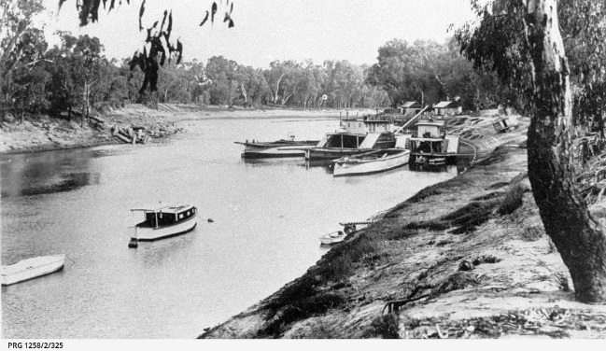
LIFE COURSE DEVELOPMENT – ASSESSMENT 4 (ALICE)
they take on one of the family properties at Yarrawonga she readily agreed to the move. It was a chance to start again.
Alice appeared to attach to the neighbours, the Mackeys, more strongly than to Mavis, and was very close to Raymond.
Points to consider
- Discuss issues of attachment in relation to Alice.
- Describe, using referencing, your concerns about Alice’s emotional, social, physical and
cognitive development
LIFE COURSE DEVELOPMENT – ASSESSMENT 4 (ALICE)

PART 2 - MIDDLE CHILDHOOD TO ADOLESCENCE
When Alice was 9 years old and Raymond nearly 11, the Mackeys needed to move from Echuca to Melbourne. They had had the two children in their care, together with their own son, Neil, for nearly four years and had long lost touch with Mavis, and with Henry who was said to be working in Adelaide. There were only two choices—to place the children at St Aiden’s in
Bendigo or take them to Melbourne too. Frank Mackey had had a promotion in the bank and, now in his mid-30s, was ambitious to further his career and qualifications in finance and management. Vera Mackey was happy to keep the three children together, though in times of stress her husband grumbled about the expense. She was not keen on placing the children at St Aiden’s because she had visited the children’s home on one occasion and found it a daunting experience.
In January 1934, the family moved to Hawthorn. It was the Melbourne Centenary and the Duke of Gloucester was to give the opening Speech at the celebrations. The Shrine of Remembrance was completed and Mary Poppins was published. The three children were enrolled in Auburn Central School and, while the boys settled in quickly, Alice found it more difficult. Her deafness was now quite evident and more difficult for the teacher in a class of 30 children to manage. It was hard for Alice to make friends in the strange new routine of Grade 3 and, as the Mackeys were renting a house whilst their bank home was built, she was not allowed to have pets. The dogs she had played with for years in Echuca had been left behind.
Alice only just managed to keep up with her school work over the first year in Hawthorn. Then, just after she had turned 10, Alice took Mrs Mackey’s new bicycle and tried to ride it down the street. She didn’t see or hear the car coming at the cross road and was knocked over. Sometime later an ambulance arrived and she was taken to hospital. Alice sustained a head injury and many broken bones. Her stay in hospital was a long one and she missed most of the year of schooling. When she returned, she was placed in Grade 4 again with a new group of children. She was unable to play physical games due to her limping gait and spent long hours in the little library or sitting apart in the playground. Raymond was no longer able to keep an eye on her as he had started at high school. Alice’s mood and interest in school deteriorated.
In Grade 5, Alice had a new, young teacher who was keen to engage with Alice. The Principal had suggested that Alice would be unlikely to continue into secondary schooling and Miss Bolton was ready to prove him wrong as she had a brother would was deaf and the same thing had been said about him. With some special attention he had proved everyone wrong and was now doing a skilled trade to considerable acclaim. Alice, who turned 12 in Grade 5, came ‘alive’ with more individual attention and Miss Bolton introduced her to a range of activities that filled her time at school and at home. Alice had considerable ability in art and design, often using her knowledge of nature and animals in her work. Vera Mackey was relieved to find Alice happier at home than the last couple of years and, as the family were now in their bank home, Alice was able to have a puppy of her own. Alice was also fitted with a hearing aide for the first time, though she avoided wearing it unless at school.
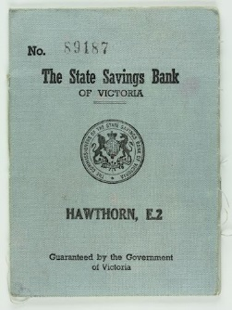
LIFE COURSE DEVELOPMENT – ASSESSMENT 4 (ALICE)
Points to consider
- What are the factors that are contributing to Alice being vulnerable?
- What factors might contribute to Alice developing or displaying resilience?
- How might Alice’s social, cognitive, emotional and physical development be affected by the
accident?
LIFE COURSE DEVELOPMENT – ASSESSMENT 4 (ALICE)

PART 3 - ADOLESCENCE TO ADULTHOOD
In Grade 6, Alice continued to make rapid progress in her academic work and in her art work. Miss Bolton continued to spend time with Alice whose limp was now not so pronounced and had made friends with two other girls, Elizabeth and Marjory, who had come to the school. One of the girls had had polio and had been left with spasticity, the other was a girl who was living with her aunt and uncle because of being abandoned by her mother. The three girls were able to share a close understanding of what it was like to be different to one’s peers.
It was 1938 and Raymond had decided he wanted to go to university to do engineering. The Mackeys were slightly in awe of Raymond’s energy and determination. They couldn’t afford to pay for his education so
Raymond was working to gain a scholarship and was already saving the earnings from his weekend job to pay for the four year course. Alice had grown closer to Raymond than previously and admired his sense of focus and commitment to his future.
Miss Bolton took Alice to Swinburne in Hawthorn at the end of 1938 and it was arranged that Alice would commence there in 1939 and take subjects in the art and design stream for her secondary education. Only Elizabeth went with her to Swinburne. Marjory went with her uncle and aunt to Seymour as her uncle was in the defence forces and said it was likely war would be declared that year. It was. That made Alice worry that Raymond might decide to join up instead of continuing with his plan to do engineering. Mr Mackey wanted to, but was too old. He talked a lot about the responsibility of young men, but the age for recruitment was set at 20 years and Raymond had several years in which to continue his education. At 18 years, Raymond won a scholarship to university and commenced his engineering course. Alice was doing exceptionally well in her art and design subjects and was now employed for two afternoons a week and Saturday mornings at a printing and publishing business in Camberwell. She had begun to pay towards her board with the Mackeys. Their son, Neil, was also doing well in his studies and was planning to do accountancy.
When Alice was 16, she met William who was doing carpentry at Swinburne. They met up whenever they could. William was possessive and, at 17 years, was already inclined to drink alcohol and smoke. While Alice was fascinated with his apparent worldliness, the Mackeys were concerned that he might be inclined to bullying behaviour and tried to dissuade Alice from getting too attached to him. Raymond was also wary of William, but this made Alice feel rebellious and defensive. When William decided he had found another girlfriend, Alice was distressed and again became withdrawn for a period, but some months later met a friend of Raymond’s called Greg to whom she became very attached.
In 1944, Raymond graduated with his engineering degree with honours and joined the military engineering division where he was involved in special projects. Alice was now nearly 20 and was working full time in a publishing house, but also developing her art and design work and planning her first exhibition. She and Greg had decided to live together in spite of objections from the Mackeys. Greg had also graduated in engineering and was now employed by the government in civil
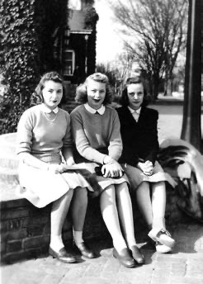
LIFE COURSE DEVELOPMENT – ASSESSMENT 4 (ALICE)
engineering developments. They rented part of a house in Hawthorn and planned to marry as soon as they were financially secure and able to get a house of their own.
In 1948, Alice became pregnant and miscarried. The same thing happened in 1949. Alice became depressed and moody. She ceased to do her art work and talked of leaving her job. Greg decided they should get married and get a home of their own. He thought this would give Alice greater security and help her to feel happier.
In 1950, they moved into a small weather board house and Alice became pregnant again. During her pregnancy she wanted to make contact with her birth mother and father and, while Greg found this alarming, he supported her efforts. Alice discovered her mother was still at Yarrawonga, and that her father had died in Adelaide some years previously in a work accident. Her mother, Mavis declined contact with Alice sending a letter that suggested that Alice had been an unloving child and it was “too late to mend bridges”. Alice
made no further mention of her family background and instead, to Greg’s relief, focussed on the birth of their child—a health boy they named Michael. Greg’s family were very supportive as were the Mackeys.
Points to consider
- The nature of Alice’s relationships with significant people in her life. How are they changing, but also how do they reflect continuity in Alice’s development?
- What social pressures would have influenced Alice through her adolescence and early adulthood?
- What risk and protective factors are at play for Alice?
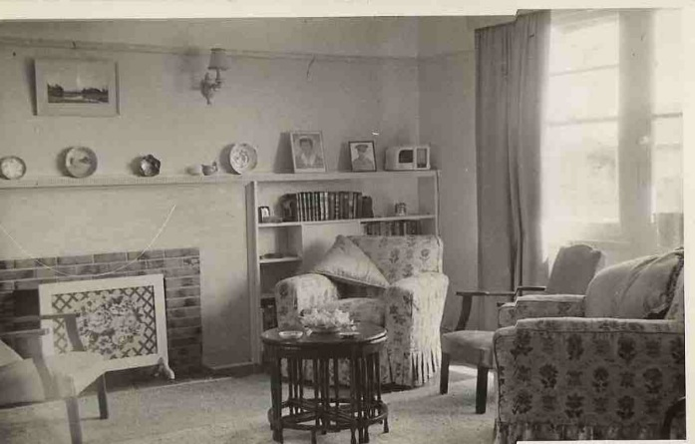
LIFE COURSE DEVELOPMENT – ASSESSMENT 4 (ALICE)

PART 4 - ADULTHOOD TO OLD AGE
Between 1955 and 1965, Alice and Greg had four children. It was a decade in which Margaret Court won at tennis, Betty Cuthbert won races, and Dawn Fraser and Murray Rose swam in the Olympics. Greg had been promoted and was a senior engineer. He had travelled overseas on several occasions and was considering taking up a lecturing position at the University of Melbourne. Alice was busy with the children, but was also doing her art work again and had sold a number of designs to fabric manufacturers as well as having two exhibitions. They had bought a house in Hawthorn that had been renovated and the children were all reaching their milestones and developing individual attributes and interests. Alice heard during this decade that her mother had died suddenly and she was also involved in supporting Frank Mackey as Vera Mackey had been diagnosed with cancer.
Australia had emerged from the post war years with new opportunities. Greg had developed an interest in the engineering of prosthetics for returned service personnel and began some pioneering work in this field. Raymond had left the defence forces and was running his own business. He had never married and, with his passion for engineering and with Greg’s encouragement, he was considering expanding his business to include prosthetics research and development.
Alice had learned to drive and Greg had bought her a car. They had a TV, modern household appliances and a housekeeper who came several times each week. Alice’s deafness was now assisted with the latest hearing-aide technology and Alice was able to enjoy the wide friendship network she and Greg had developed. It included people who had migrated to Australia after the war—people from Hungary, Germany, Italy, Poland and Greece. Many were artists and musicians and Alice encouraged her children to learn to play musical instruments.
During the 1970s, Greg became an academic and Alice took on a part time teaching position at Swinburne in the Art Department. One of their children had been diagnosed with leukaemia and died in 1973 aged 11 years. Alice was again very depressed and treatment with LSD was suggested, but Greg was opposed to this approach. Alice slowly recovered, but the death of Vera Mackey the following year caused her to again suffer depression. This was to become a pattern in Alice’s adulthood and when Raymond died of smoking related disease in 1979 Alice’s depression was so severe as to warrant hospitalisation.
In 1980, Alice was in better health. She had turned 55 and finished menopause. Their eldest daughter was married and had gone to live overseas with her husband and their second child was finishing university. Their third child was studying medicine at university and the youngest was about to finish schooling and commence engineering like his father. With the turbulence of their children’s teen and early adulthood years behind Alice and
Greg, they were able to contemplate retirement and the kind of lifestyle they might develop.
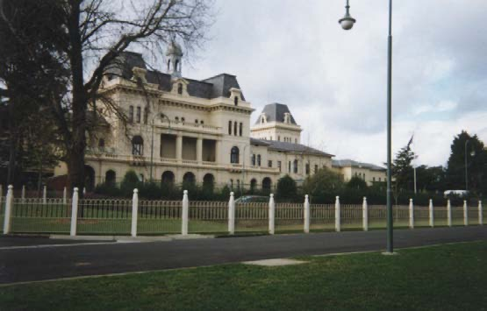
LIFE COURSE DEVELOPMENT – ASSESSMENT 4 (ALICE)
In their 60s, Alice and Greg decided to travel extensively and on returning Alice resumed her art and design work with renewed passion. Greg decided to stay on at the University in his research role rather than retire and together they enjoyed grandchildren and family occasions. Alice was finding difficulty with movement now—a long-term result of the accident when she was a child—and her hearing suddenly deteriorated to the point of almost total deafness. This put strain on her relationships with family and friends, and as she moved into her late 70s, Alice became increasingly withdrawn and solitary.
Greg died suddenly of heart disease in 1999 and Alice, strangely, appeared unmoved. She did not relapse into depression, but continued her reclusive lifestyle. She seldom saw members of her family and spent long hours immersed in her art work. In 2006, Alice’s children became concerned about her health and moved her into an Aged Care facility, but she deteriorated quickly away from her familiar home, was unable to communicate and refused to eat. Alice died in 2007 aged 82.
Points to consider
- What are the common elements to Alice’s development across her life span?
- What were the key transitions she experienced and what have been her responses?
- How have her early experiences of growing up affected her adult and later life? Include here
reference to her disabilities.
- What are your key learnings from studying Alice and her life story?

Marking Guide
1 | Demonstrated identification and understanding of the developmental issues evident in the case study. These should be considered in relation to the physical, cognitive, emotional and social aspects of development across the life course. | 20
2 | Demonstrated understanding of the concepts discussed throughout the subject as they apply to the chosen case study. This is likely to include consideration of factors such as attachment, vulnerability, trauma, risk, and resilience. | 20
3 | Application of appropriate theories to the developmental issues raised in the case study. Also consider links between theories (e.g., Harms; Bronfenbrenner). | 20
4 | Demonstrated capacity to identify the issues of change and continuity across the life course of an individual. Particular attention should be given to the impacts of life transitions identified in the case study. | 20
5 | Clarity of the logic, arguments, discussion and critique using appropriate professional language and English expression. Appropriate use of in-text citations and accurate APA referencing. | 20

