Literature Review Task 3
Database Searches

Resources for Additional Assistance:
- Pp. 81–89 in Chapter 2 of Educational Research by L. R. Gay, G. E. Mills, and P. Airasian
- Chapter 2 of The Literature Review: Six Steps to Success by L. A. Machi and B. T. McEvoy
____________________________________________________________________________________________________________________________________________________________________________________________________________________________________________________________________________________________________________

STEP #1: Select your databases according to your topic.
ERIC
Psychinfo

STEP #2: Record your search strategy (or strategies). (KEYWORDS, the Boolean operators, and fields that you will search).
- Analyze the brain after behavior issues
- And seek evidence
- Evaluate, verifiable information to translate
STEP #3: Perform your searches.
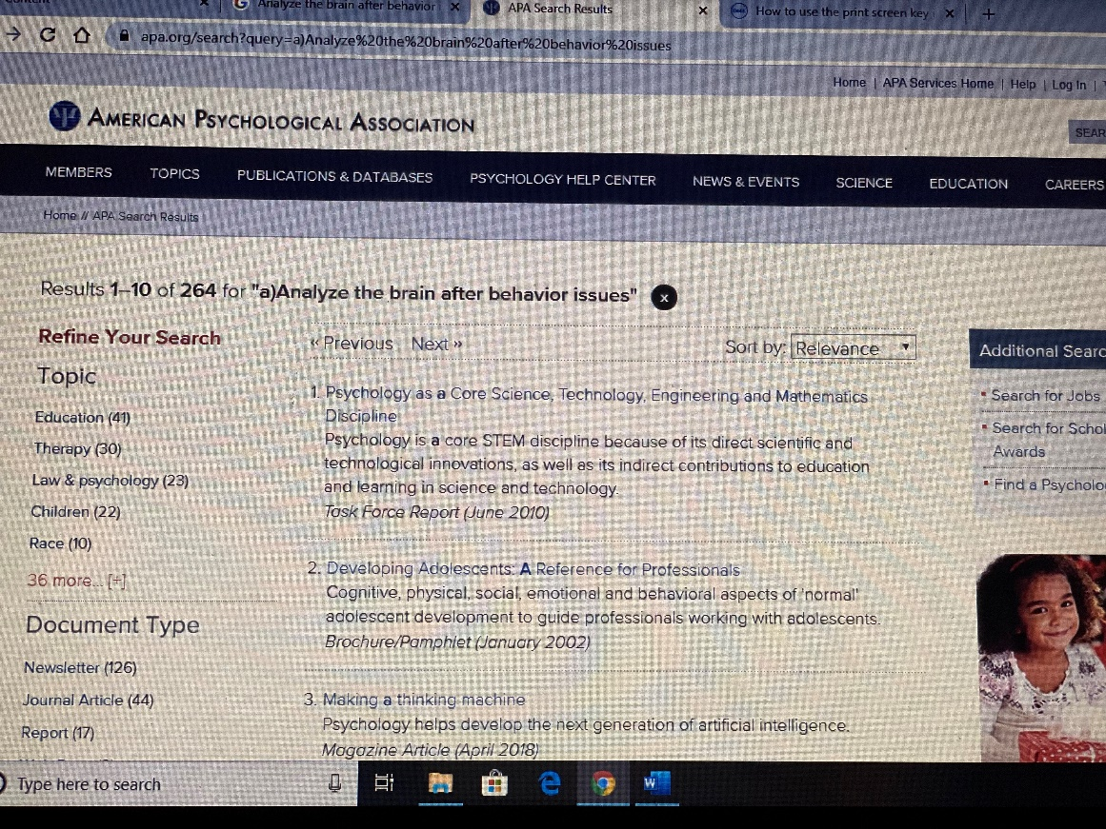
STEP #4: Write a paragraph(s) documenting your search.

I searched Psycinfo databases. I used the following keyword search strategy: Analyze the brain after behavior issues. The search resulted in 264 hits.

