Nomenclature
Use the built-in hidden table, enter variables with Arabic letters in alphabetical order
Greek Letters
Similar to above table, enter Greek variables in alphabetical order
Acronyms and Abbreviations
Similar to above table, enter any acronyms in alphabetical order

Abstract
[No more than 100 words, structure this as an executive summary of the work done.]

Introduction
No more than 250 words for the INDIVIDUAL Version, or 400 words for the GROUP Version. Introduce the project/task, treat this portion as a ‘Problem Statement’. Follow up with a brief literature review on (i) the application of the engine covered in your respective project, and (ii) discuss some research efforts into shaft balancing and improving engine balance.

A minimum of 10 journal paper/conference proceedings sources are needed for the INDVIDUAL Version and 15 for the GROUP Version. Google Scholar are excellent resources to easily find journal papers on any topic. Use the ‘References’ tab in MS Word to include your references in the document.

Methodology
Outline the approach used for analyzing the engine. DO NOT show the derivations here, only discuss the implemented ‘tools’ (e.g. Newton’s law/analytical methods for the equations of motion, the software package MATLAB/Excel/MathCad/Julia/… and general approach used for calculations and θ₁-history/graph development). You can cite the course notes and textbook in this section only (but NOT within the Introduction section). No more than 200 words in this entire section.

Analytical methods

$${\overset{⃑}{F}}_{OOB, rot}=\sum_{i=1}^{q}{m_{i}r_{i}ω^{2}∡θ_{i}}$$ | (5)
A sample equation is provided above this text, note that this sample is already formatted and was fully generated in MS Word. The equation editor can be found under the ‘Insert’ tab. If you copy/paste this table throughout the document, you can modify the equation text or ‘internal content’ and the number will automatically update. This is also applicable to Figures and Tables since they are also automatically numbered objects.
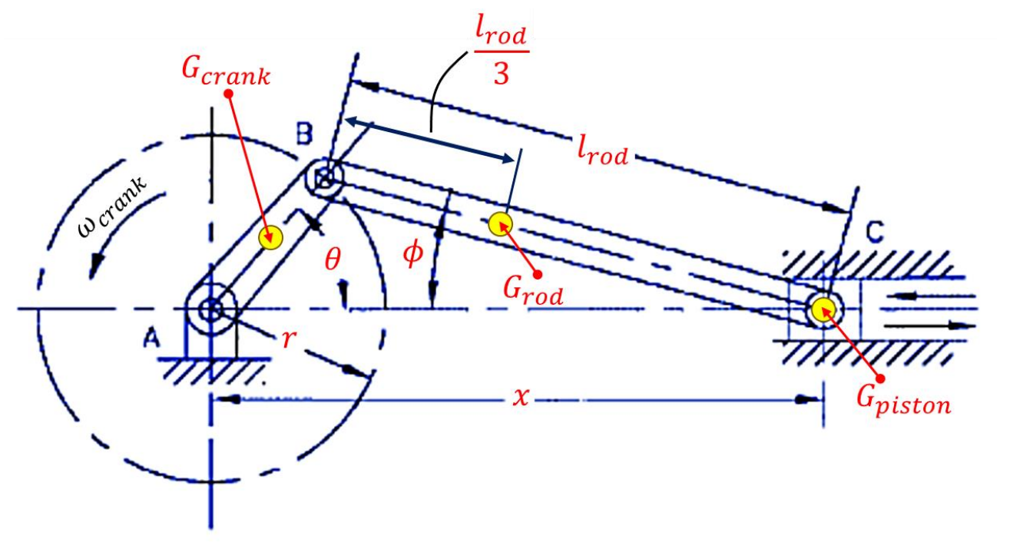
Figure 1: Schematic of a representative slide/crank mechanism [BE MINDFUL OF WHICH ENGINE YOU SELECTED FOR THIS FIGURE].

Generation of θ₁-history solutions

(a) | (b)
Figure 2:

Template for a generic 2-part Figure. You will notice that Figure 1 is also contained within a table where the outline has been hidden for presentation purposes. I recommend using this format because it is easier to keep a Figure and its Caption together, you can also quickly copy/paste Figures throughout the document and modify them easily preserve the automated numbering.

Rather that typing ‘Figure 2’ or ‘Table 3’, etc., you can use cross-referencing which benefits from the automated numbering which is introduced in this document. For example, rather than manually typing ‘Figure 2’ you can access cross-referencing in the ‘References’ tab on the main ribbon by selecting ‘Cross-reference’. Insert the appropriate reference (Figure 2, Only label and number) and the text ‘Figure 2’ will appear. If you add more Figures within the document before the (previous) Figure 2, or if you move the (previous) Figure 2 somewhere further in the document, the text in your document will automatically update and you will not have to keep track this.

Analytical modelling
Briefly outline the necessary core equations (acceleration, out-of-balance forces, etc.), assumptions, and derivation of force summations, and any other relevant points. No more than 200 words in this entire section.

Representative slider/crank mechanism

[Insert name of engine] lumped parameter model

Consistent to the tutorials and exams, the table provided below is mandatory, modify the contents of the rows and columns, and add/subtract cells, per the engine you have chosen (recall that the INDIVIDUAL Version does not call for moments and hence the ‘delta’ column will not be needed for this case).
Table 1: Index of key parameters for the [specify engine].
i | m_{i} [kg] | r_{i} [m] | m_{i}r_{i}ω² [N] | θ_{i} [deg] | δ_{i} [m], from [DATUM]
1
2
…

Discussions
Consistent to the rest of the report, modify, add/subtract and alter the subheadings as you see fit, and as needed for your specific project. Present your graphs of the θ₁-history solutions in a clear/legible manner (e.g. with gridlines, fully labelled axes and legends) and concisely interpret the findings in your written discussion. No more than 250 words for the INDIVIDUAL Version and 400 words for the GROUP Version.

Piston kinematics

Out-of-balance forces [and moments, if applicable]

Dynamic rotating forces

Dynamic, primary reciprocating forces

Dynamic, secondary reciprocating forces

Total out-of-balance forces [and moments, if applicable]

Conclusions
The impetus of this study was to analyze [complete the statement, per your version of the project]. A lumped parameter modelled was generated by [discuss] and time-history solutions were generated utilizing [discuss] software package. The key findings are summarized as follows:
- First key point.
- Second key point.
- Third key point.
- Fourth key point.
- Fifth key point.
Summarize the most important findings in a series of numbered statements directly above these instructions, up to 4 statements for the INDIVIDUAL Version and up to 6 points for the GROUP Version. Include some quantitative details in these points (e.g. peak acceleration, max/min forces, magnitude of rotating versus reciprocating force, etc.). No more than 2 sentences per numbered statement.

References
There are no sources in the current document.
If you use the automated system in MS Word, Scopus or a similar tool this section will automatically populate itself.

