Your Name
Supervisor Name
Course Name
Due Date

How Technology, Delivery Services, and Ecommerce Are Changing Grocery Shopping
Introduction
Background
The world has observed changes in how issues concerning economics, politics, transportation, business management, communication, and technological developments are handled. These changes have been attributed to globalization which has forced organizations, especially business oriented ones, to make decisions from a global perspective (Huh and Park, 2021). Factors that drive globalization include financial factors through financial deregulation and liberalization, market or economic factors which is the reduction of barriers to trade and investments, political factors which is the government policies designed to enhance trade and commerce, social factors that make cultures across the world to merge and have significant similarities, and technological factors in terms of transport and communication (Naz and Ahmed, 134). Technology is thought to be the main contributor to globalization and hence most of the effects of globalization on business management are attributed to it coupled with the increase in internet use across the world as it allows access to (Maurseth and Medin, 5). The developments in technology brought about the aspect of ecommerce and delivery services to complement it.
There has been a steady penetration of ecommerce businesses in most sectors which has changed the way individuals shop for goods and services which has led to ecommerce taking increased share of total retail sales (Bauerová et al, 1). The changes include expansion of product range available to consumers, competition stimulation, and emphasizing on shopping convenience (Saphores and Xu, 1).
Grocery shopping is one of the areas where this ecommerce penetration has lagged behind. Currently, there are very minimal recorded permanent expansion of ecommerce to grocery stores in countries across the world (Bauerová et al, 1). For example, in the United States, in spite the penetration levels of online purchasing practices, only 16% of adults had purchased groceries online (Saphores and Xu, 4). There is a gap in explaining the reasons behind this lag in ecommerce for groceries and the difference between the growth rates in different countries in the world (Bauerová et al, 1). Understanding the factors at play will help businesses to position themselves to take advantage of the unpenetrated market by enhancing marketing strategies for online groceries shopping. This especially motivated by the situation brought about by the 2019 pandemic where lockdowns and quarantines were effected in most regions across the world forcing consumers to order online. In the space of three months, adoption of online grocery shopping was catapulted 10 years into the future and this is likely to be the new normal going forward (Gutt, p. 3)
This work seeks to meet to goals. First is to answer the research question of how technology, delivery services, and ecommerce is changing the way consumers shop for and buy groceries? This will incorporate the effects of the pandemic in terms of how it has necessitated the use of online shopping and how consumers perceive the experience of online shopping. Secondly, this work aims to develop a marketing strategy based on the findings from the first objective.
Methodology
This work made use of a mixed research approach from two perspectives. First, it makes use of primary and secondary data in attempt to answer the research question and meet the second objectives. The primary data was collected by means of a survey on grocery shoppers which was done through online survey tool, SurveyMonkey and physical interviews. The respondents were reached through online and physical communities in the researcher’s neighbourhood. The secondary data was obtained from past research conducted to answer different research questions but were deemed necessary in meeting the objectives set here. Second, the data and information collected entailed both qualitative and quantitative data which is an ideal method for allowing a more comprehensive and synergistic data utilization to effectively answer research questions and meet study objectives.
Findings
Secondary Sources
The developments made in information communication technologies has shaped the retail landscape thus creating opportunities (Nasir and Kurtuluş, 1508). Shoppers always have mobile devices in their hands which has influenced both in-store and off-store shopping behaviors as shopper expect to be informed in real time despite the location and time (Nasir and Kurtuluş, 1509). The change here is mostly firms finding cost-effective and creative ways to assist the customers to enhance convenience in the shopping experience. Nasir and Kurtuluş (1518) found that about 34% of shoppers very often use their mobile phones while in store to search product information, assessing reviews online, and compare prices.
Table 1
Product category based difference test with regard to in-store mobile technology usage for product and price search (Nasir and Kurtuluş, 1521)
Factor 2 | Mean Difference | Sig
Apparel | -6.17* | 0.000
Home | -1.13* | 0.000
Electronics | -1.94* | 0.000
Books | -0.78* | 0.000
a. * Significant at the 0.001 level.
From Table 1, there is statistical significance difference at the 0.1% level in terms of in-store mobile technology usage for product and information search. Compared to apparel, home products, electronics, and books, consumers are less likely to use their phones while in-stores when shopping for groceries. This confirms the lag in technology use in grocery shopping. In terms of attitude, the respondents agree that in-store mobile technology utilization is useful, offers economical shopping, increases convenience, and uses less time (Nasir and Kurtuluş, 1521). On the flip side, they are not much likely to purchase products online even when they find dealers offering lower prices and free delivery (Nasir and Kurtuluş, 1521).
Online grocery shopping has evolved from a grocery channel to a grocery interaction point between consumers and retailers. Older shoppers are adopting to the options of online grocery shopping while the younger ones are exploring a future that differs from the norm. Despite the shoppers currently using a wider variety of retailers to shop well, they trust that each one of them will support their wellness goals. The findings also indicate that by 2018, 34% of grocery shoppers in the United States were doing it online. On average online grocery shoppers spent $127 per week while the typical shoppers spent $109 weekly while making one purchase per month and weekly respectively (Bryk, p. 12).
Popular technology helpers like voice features, smart home, and on-demand delivery have enhanced a steady growth in the number of online grocery shoppers (Bryk, p. 4). Prior to the 2019 pandemic, online shopping was mainly motivated by convenience. The increase in number of online shoppers in the midst of the pandemic forced companies to increase their capacity to handle the increased demands, for example, Amazon increased their delivery capacity by about 160% (Bryk, p. 5). Technology is also changing grocery shopping by using digital tools to create shopping lists, using digital coupons to search for offers and compare prices, the grocery store Apps whose download increased by almost 50% in the period 2017-2018, smartphones use in shopping, easily accessible information hence shoppers make informed choices, and easier ways of paying for product. The technology features like grocery store application and store websites have allowed for integrated versions of online and in-store purchases referred to as buy-online/ pick-up-in-store option which reduces the time spent physically shopping (Gutt, p. 4).
On factors that may pull grocery shoppers towards he online option, there are various identified. According to consumers’ perceptions, half of grocery stores have not figured out how to utilize technology in retailing like other sectors (Bandoim, p. 2). This may be attributed to the general slow adoption of technology in grocery retail and hence requires companies to fast-track their capacity building to handle increased online traffic due to the steady growth and the pandemic. About 89% of grocery shoppers require stores to comprehend how to make shopping more efficient through improving layout (92%) (Bandoim, p. 2). Shoppers use the ability to support their healthy eating goals as a criterion for assessing food retailers. Therefore, retailers need to consider how to address these concerns in order to effectively capture the increased online grocery shoppers even post the pandemic.
Primary Source
From the survey conducted, 84% of the respondents claimed to have shopped for groceries online during the pandemic period while only 43% claimed to have shopped for groceries online before the pandemic. A total of 57% of the respondents shopped online before the pandemic or intended to continue shopping for groceries online even post the pandemic, who will be referred as online shoppers going forward. As shown on Fig. 1, 56% of all the respondents were female while 44% were male. Out of the online shoppers, 49% were female while 51% were male as opposed to 59% female and 41% male for non-online shoppers. This indicates that online shopping bridges the gender divide.
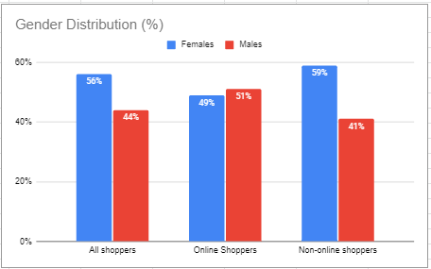
Fig. 1. Distribution of shoppers across gender and shopping category.
Comparing the percentage of respondents on different demographics on the basis of out of the total that are online shoppers and non-online shoppers, the findings were as follows; 55% of online shoppers and 41% of non-online shoppers had at least a college degree, 37% of online shoppers and 24% of non-online shoppers had a family, 69% of online shoppers and 53% of non-online shoppers were employed, and the average annual salary was about $76400 for employed online shoppers and $64,500 for employed non-online shoppers.
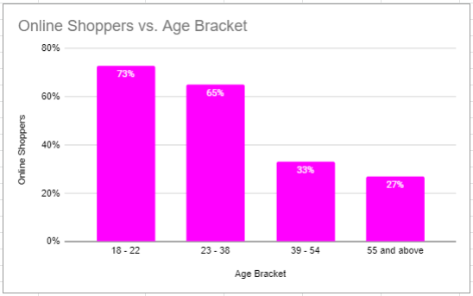
Fig. 2. Percentage of online shoppers across different age categories.
The findings indicate that the for a given age group, the percentage of online shoppers reduces with increase in age. The online shoppers for the different age groups were 73 percent for respondents aged 18 to 22 years, 65% for respondents aged 23 to 38 years, 33% for respondents aged 39 to 54 years, and 27% for respondents aged 55 years and above. This implies that the percentage of online grocery shoppers will increase in future. The findings also indicate that about 79.4% of online shoppers engage in some form of pre-shopping activities while 72.8% of non-online shoppers do the same. The pre-shopping activates mentioned by the respondents included checking for how much food remained, creating a shopping list, checking recipes for requirements, planning for meals, and creating different lists for different stores on the basis of price comparisons as displayed on Table 2 below. This implies that online shoppers are keen planners who mind about prices. In addition, online shoppers equally use a mix of both digital and traditional methods when listing (24% digital and 63% paper) compared to non-online shoppers (7% digital and 88% paper). Querying on the reasons for not adopting technological developments when listing, some of the dominant themes were that the available tools were not user friendly and most stores did not have customized websites and/ or applications to increase convenience in the shopping experience.
Table 1
Pre-shopping activities by online shoppers
Pre-shopping activity | Percent of count
Checking for remaining food | 81%
Shopping list | 78%
Check recipes | 49%
Meal planning | 39%
Price comparison | 34%

The findings also indicate that on average, online shoppers are more tech savvy compared to non-online shoppers. About 47% of online grocery shoppers were tech savvy compared to 23% of the non-online shoppers. Tech savvy in this case being defined by the frequency of engagement in checking retailers’ offerings online, using store mobile applications, searching online for product information and discounts, have multiple grocery-related applications, and search for reviews.
Out of the respondents classified as online shoppers, 52% of them claimed to have supplemented the online shopping with occasional visits to the off-line grocery stores. When questioned about the technology-based activities they engage in while in-store; 86.5% of the respondents use their smartphone in some way while in the store, 52% of the respondents use digital coupons, 51% of the respondents check specials at their primary stores on a weekly basis, 41% of the respondents check for recipes, 27% use in-store item locator, 27% use QR codes to compare prices and learn about the nutritional contents, and 33% read reviews of products and brands.
When questioned about the disadvantages of online shopping that reduce their willingness to shop online, the study found out that; inability to choose own products (32%), lack of ease in returns (27%), higher prices (26%), delivery inefficiencies (22%), products not fresh (21%), denies opportunity to get out of the house (17%), uses more time (12%), and is more complicated (8%).
Recommendations
The study findings point at an increasing online grocery market and companies must equip themselves to handle this increase in order to maintain competitive advantage. The study presents interesting findings concerning how technology shape the grocery market and further how ecommerce can better be improved. In this sections, recommendations are provided in form of a marketing strategy.
Product
From the findings, there are a number of issues concerning the product for online grocery shopping that have been raised by the consumers. These issues must be addressed when planning for the product in the marketing strategy since the grocery retail business has very little differentiation across different vendors as is the case for most retails goods. The consumers’ wellness goals have been clearly identified as important. Although the online shoppers currently using a wider variety of retailers to shop well, they trust that each one of them will support their wellness goals. This means that retailers have to be familiar with different wellness and healthy eating habits of their consumers and work towards facilitating such. For example, some consumers prefer to consume pure organic meals and hence retailers must strive to know the source of the food they are selling to consumers.
About 21% of the respondent mentioned products not being fresh as a discouragement to online shopping. Therefore, retailers must put in more effort to ensure that the products sent out to consumers are always fresh, factoring in time of delivery for the case of highly perishable goods and ensure that the transportation means maintains the freshness. Apart from the product in itself, how technology is used to present the product is also very important. For example, since 49% of online shoppers have a habit of checking recipes before shopping for groceries, companies can strategies to have ease of getting products by having a recipe category where a consumer chooses different recipes and the ingredients are all selected at one go instead of consumers choosing item by item.
Finally, there is still a significant number of consumers who prefer in-store grocery shopping while more than half of the online grocery shoppers still supplemented with in-store shopping. Since most of them are tech savvy and even the in-store shoppers have cell phones and prefer convenient shopping, companies must make effort to technologically equip their stores for in-store technology use. This includes digital price scanning, store layout, and payment methods that move away from cash and payments to avoid physical contact in the wake of the pandemic.
Place
Prior to the pandemic, only34% of grocery shoppers did so online. With the boost brought by the pandemic, the survey projects that 57% of grocery shoppers will continue shopping online post the pandemic. Further, there are 42% of the projected online shoppers who will still supplement online shopping by occasionally visiting the physical grocery stores. Therefore, this requires that firms in the grocery business use a proper mix of distribution channels to optimize their share of the grocery market.
The physical in-store channel must be incorporated since consumers need vendors they can trust and having a physical location enhances that trust. Online shopping is necessary to cover for the online shoppers. Ecommerce can be used for the set of shoppers who execute their shopping completely online. Here, technology will play a vital role through creation of efficient websites, store applications, and digital coupons for discounting. Since convenience is a key factor for both online and non-online grocery shoppers when they visit the physical stores, companies can consider versions that merge the two aspects of shopping like the buy-online/ pick-up-in-store option which reduces the time spent physically shopping (Gutt, p. 4). This option caters for the shoppers who are concerned with not handpicking the products personally or the goods being damaged during delivery since when they pick the items they can quickly replace the ones that are not appealing to the consumers.
Price
Grocery shopping being an area where the products cannot be significantly differentiated form those of competitors, there is little room for charging higher prices. Nasir and Kurtuluş (1518) found that about 34% of shoppers very often use their mobile phones while in store for activities like price comparison. On the flip side, they are not much likely to purchase products online even when they find dealers offering lower prices and free delivery once the consumers are in-store (Nasir and Kurtuluş, 1521). However, the survey established that both online and in-store grocery shoppers do some form of price comparison before shopping. About 26% of the respondents in the survey quoted higher prices as a discouragement from online shopping which is justified by the finding that online grocery shoppers spend more compared to the non-online grocery shoppers.
The implication is that the grocery shoppers are price sensitive and therefore economy pricing makes the most sense in this case. Here, businesses will be looking to minimize costs linked to production or the cost of goods sold to enable for lower selling prices. In addition, the retailers will be out to sell in large numbers on a small profit margin and take advantage of economies of scale. This will involve promoting for bulk purchases to reduce the costs of packaging and delivery. Looking at Fig. 3, Bryk (p. 13) established that across the UK and Europe, consumers who moved across brands were influenced by lower prices compared to previous years before the pandemic. This pricing strategy then also works as a strategy for pulling grocery shoppers who are looking to change retailers.
Promotion
Following the choice of the pricing strategy as economy pricing, there is an overarching goals for such grocery retailers to reduce the total costs of goods sold to allow offering of lower prices to consumers. Therefore, the promotional choices must prioritize the ones that will optimize on costs. Since there exist physical locations form the strategies, point of sale advertisement will be vital as the consumers will get to know of the discounts, other channels of distribution that exists, ease of using these online channels, and the convenience it brings to them when they visit the store. Most grocery items are also perishable and therefore it means that due to delivery constraints, most targeted clients for both online and in-store will be within the localities. Therefore, using social media for advertising will be ideal for grocery retailers since they are relatively low cost compared to other advertisement means. In addition, customers will be keen on how the business impacts on their community and therefore, apart from championing trust built on offering natural and purely organic products, addressing the possible adverse effects of the business like environmental pollution (Fig. 4) will help earn the trust of the host communities.
Conclusion
The The world has observed changes in how issues concerning economics, politics, transportation, business management, communication, and technological developments are handled. Technology has been on the forefront in supporting these changes. The grocery industry has lagged behind for many years in terms of adopting technology but the 2019 pandemic catapulted its growth due to the lockdown and quarantines effected by different governments across the world. This work sought to establish how technology, delivery services, and ecommerce has affected grocery shopping and further recommend a marketing strategy for the industry.
From the findings, the researcher suggests offering fresh products at all times and using technologies to enhance the offering by one click selection of items based on recipes. A proper mix of distribution channels is found necessary; physical stores, ecommerce, and a mixture of online purchasing and physical collection. Grocery shoppers are found to be price sensitive and the product is categorized as minimum differentiation hence economy pricing is reminded where retailers will target minimizing the cost of goods sold. The findings further imply using less costly means of advertising focused on building trust through assuring consumers on the source of food and alleviating the effects of their business on the environment.

Works Cited
Bandoim, Lana. “Can Grocery Stores Embrace Change And Technology?” Forbes, 29 May 2019, www.forbes.com/sites/lanabandoim/2019/05/28/can-grocery-stores-embrace-change-and-technology/?sh=20dcf61673a0.
Bauerová, Radka, and Martin Klepek. The theoretical framework for the application of the TAM in online grocery shopping. No. 0044. 2017.
Bryk, Kristen. “How a Global Pandemic Changed the E-Grocery Industry Forever.” Factor-a, 17 Mar. 2021, www.factor-a.com/shift-to-online-grocery-shopping.
Enache, Maria Cristina. "E-commerce Trends." Annals of the University Dunarea de Jos of Galati: Fascicle: I, Economics & Applied Informatics 24.2 (2018).
Gutt, Loran. “Technology Changes How We Grocery Shop.” Food Logistics, Food Logistics, 11 Mar. 2021, www.foodlogistics.com/technology/software-solutions/article/21271093/bazaarvoice-technology-changes-how-we-grocery-shop
Huh, Hyeon‐Seung, and Cyn‐Young Park. "A new index of globalisation: Measuring impacts of integration on economic growth and income inequality." The World Economy 44.2 (2021): 409-443.
Li, Charlene, Miranda Mirosa, and Phil Bremer. "Review of Online Food Delivery Platforms and their Impacts on Sustainability." Sustainability 12.14 (2020): 5528.
Maurseth, P. B., & Medin, H. (2019). Internet use, intermediaries and international trade.
Nasir, Süphan, and Kurtuluş, Bengi. “Technology Is Transforming Shopping Behaviour: In-Store Mobile Technology Usage.” Business Science Reference. (2018). DOI: 10.4018/978-1-5225-2599-8.ch071
Naz, Ayesha, and Eatzaz Ahmad. "Driving Factors of Globalization: An Empirical Analysis of the Developed and Developing Countries." Business and Economic Review 10.1 (2018): 133-157.
Saphores, Jean-Daniel, and Lu Xu. "E-shopping changes and the state of E-grocery shopping in the US-Evidence from national travel and time use surveys." Research in Transportation Economics (2020): 100864.

Appendix
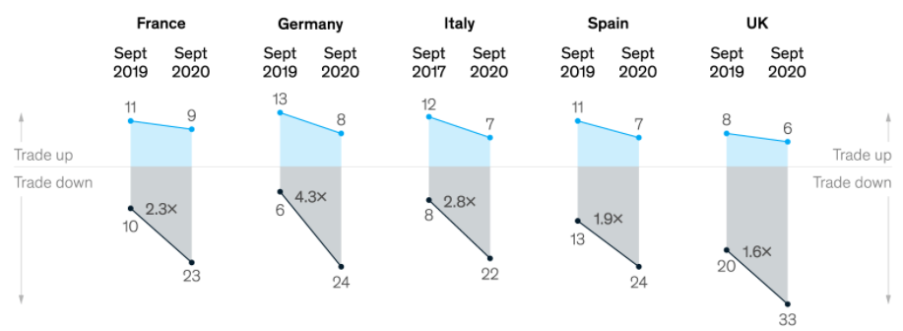
Fig. 3. Consumer trade-off behaviours (Bryk, p. 13)
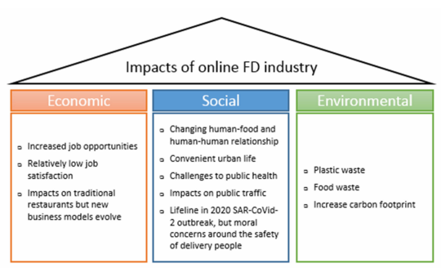
Fig. 4. Message house of impacts of online (Li, 6)

