Experiment-3 HOOKE’S LAW – USING PHET
3-22-2020

OBJECTIVES
To find the spring constant of a vertically hanging spring.

EQUIPMENT
PhET Masses and Springs Lab: https://phet.colorado.edu/en/simulation/masses-and-springs-basics
You can also get to the simulation by entering in your browser: Phet, then select Physics. Then select masses and Springs “Basic” simulation.

THEORY
Whenever a restoring force is created due to displacement of a body from its mean (equilibrium) position, the restoring force tries to bring the body back to the original (mean) position. A linear restoring force may be expressed mathematically by the equation
F = -k Δx (1)
where F is the force (N), Δx (m) is the displacement from the equilibrium point, and k (N/m) is a proportionality constant. The minus sign expresses the restoring nature of the force by indicating that the direction of F is always opposite to the displacement Δx from equilibrium. In our case, the force will be the weight hanging from the spring.

SPRING-MASS SYSTEM
This consists of a light spring, to which a mass is attached, such that the mass can move freely. In our case, we will hang the spring vertically.  Ideally, the elongation of a spring is proportional to the stretching force. Therefore, if a mass is hung on a spring, the spring will be stretched by an amount proportional to the weight of the mass. An equilibrium position will be reached at which the spring pulls up on the mass with a force just equal to the mass's weight. If X is the equilibrium position, then when the mass is pulled lower than X by a displacement Δx, there is a restoring force F = -k Δx, which pulls the mass towards the equilibrium position. | Figure 1: Spring-Mass System
 | 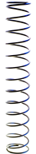  X | 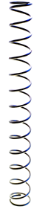  X + ΔX

PROCEDURE

SPRING-MASS SYSTEM
Open the simulation: Mass and Spring - Basics in PhET. Select “LAB”.
1- Select Spring Strength (related to spring constant) at a position close to the left end, i.e. close to “Small”. Select on right hand top corner: Unstretched Position and Resting Position.
2- Attach the mass to the spring. The spring will start oscillating up and down. You need to stop it by clicking on it when it is in the Resting Position. Set the mass to 50 g and measure the distance between the Unstretched Position (blue line) and the Resting Position (Green Line) by using the ruler. Repeat after increasing the mass in 25 g increments till it reaches the maximum available value. Fill up this data in Table 1.
3- Plot a graph with force (= mg) on the y-axis and elongation on the x-axis. The slope of the line is the spring constant, k, of the spring. Attach the graph with your report
4- Attach each of the three colored masses with ‘?’ on them, one at a time, and by noting the distance that the spring stretches, calculate their masses.
5- Repeat steps1 to 4, with the Spring Strength set to a point closer to the “Large” strength.

CALCULATIONS
1- Use the data of procedure 7 to find the elongation of the spring for each of the masses, and plot the weight (not mass) on the y-axis versus the elongation on the x-axis. Use linear least square fit to fit a straight line to the data. The slope of this line is the spring constant k.

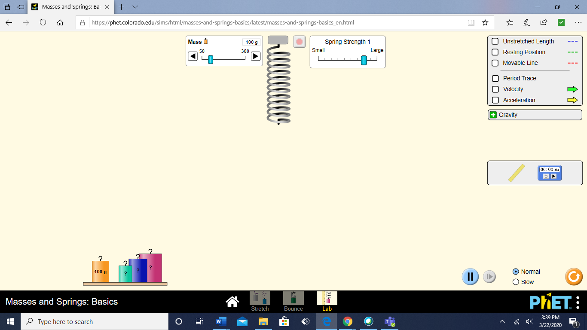

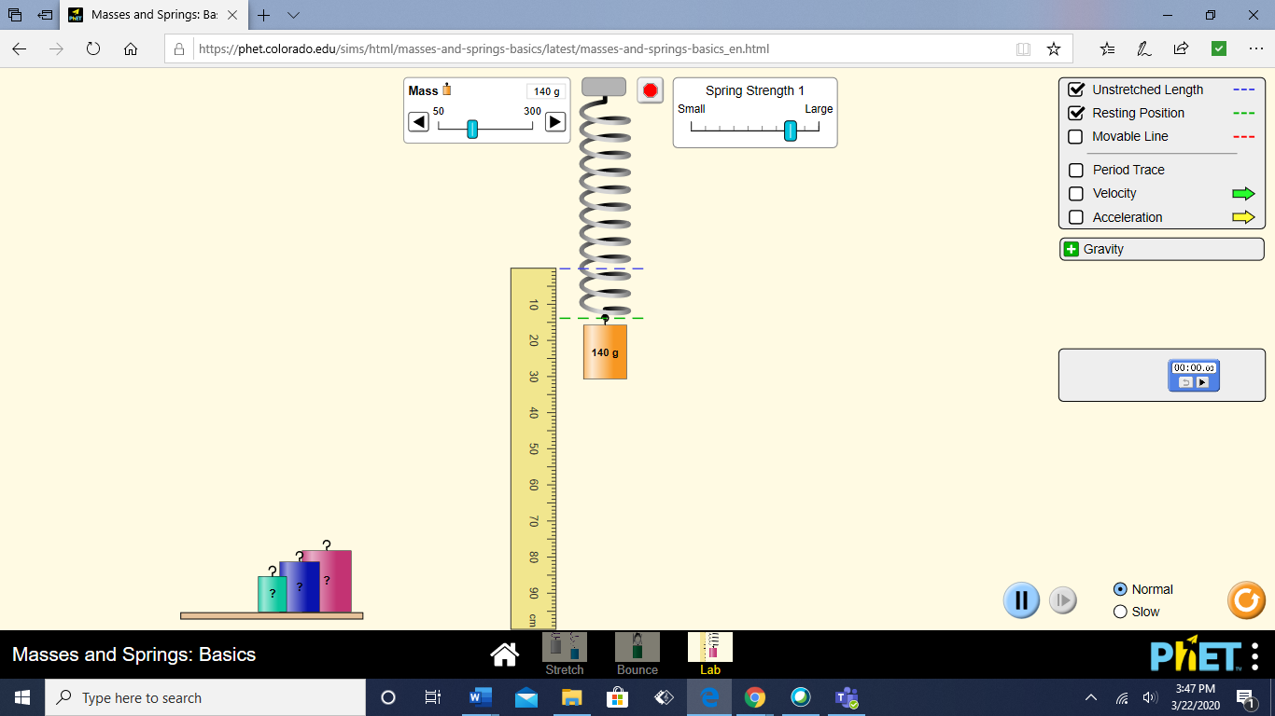

DATA: SPRING-MASS SYSTEM

Table 1: Spring Strength: ___________

Mass suspended from the spring  ( kg ) | Force stretching the spring  ( N ) | Elongation, ΔX  ( m )
0.0 | 0.0 | 0.0
Force constant k of the spring: ______________ (attach graph)

Unknown masses: Light Blue: __________ Dark Blue: ____________ Pink: ____________

Table 2: Spring Strength: ___________

Mass suspended from the spring  ( kg ) | Force stretching the spring  ( N ) | Elongation, ΔX  ( m )
0.0 | 0.0 | 0.0
Force constant k of the spring: ______________ (attach graph)

Unknown masses: Light Blue: __________ Dark Blue: ____________ Pink: ____________

