ECONOMICS
STUDENT’S NAME
INSTITUTIONAL AFFILIATION COURSE
DATE
1)i) consumer surplus = ½ × (90-24) ×48 =$384
ii) producer surplus = ½ × (24-6) ×48 =$432
iii) Total surplus = 384+432 = $816
b) This will result in an increased demand in the economy leading to;
i) an upward pressure pushing it to $28.
ii) New consumer surplus = ½ × (48-28) × 32 = $320 consumer surplus will go down by $64.
iii) The new producer surplus will = ½ × (18 -6) × 32 =$192, leading to a decrease in producer surplus by $240.
Computing the new total surplus, we get;
320 +192 =$512 which is less by $304 (816-512).
C) i) price ceiling is not binding as the new price is the equilibrium price at which Demand = supply and there is no is no excess demand or supply.
ii) Quantity buyers wish to purchase at 48 while quantity sellers wish to sell at the same price.
Yes, the market clears as demand equals supply.
iii) New consumer surplus = ½ × (40-24) × 48 = $384. Comparing the value to that of part b) consumer surplus increases by $64.
iv) New producer surplus = ½ × (24-6) ×48
=$432. Comparing this to part b) producer surplus increases by $240.
(v) Now total surplus = 432+ 384 =816
Increase in Total surplus= 816- 512= $ 304
vi) More efficient or willingness to pay equals ability and willingness to sell.
a)
QL | QT | TVC | TFC | TC | MC | AFC | AVC | ATC
0 | 0 | 0 | 500 | 500 | 500 | 500 | 500 | 500
1 | 20 | 2000 | 500 | 2500 | 2000 | 500 | 2000 | 2500
2 | 80 | 4000 | 500 | 4500 | 2000 | 250 | 2000 | 2250
3 | 130 | 6000 | 500 | 6500 | 2000 | 166.67 | 2000 | 2166.67
4 | 170 | 8000 | 500 | 8500 | 2000 | 125 | 2000 | 2125
5 | 200 | 10000 | 500 | 10500 | 2000 | 100 | 2000 | 2100
6 | 220 | 12000 | 500 | 12500 | 2000 | 83.3 | 2000 | 2083.33

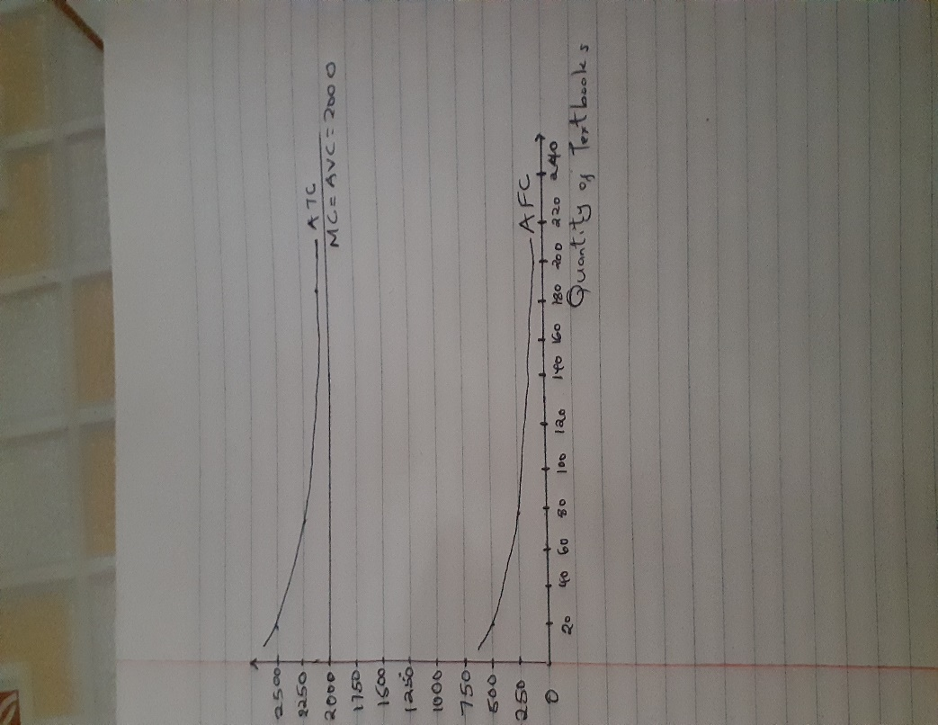
c) When Ql =4; TC= 8500
Total Revenue =Price×Quantity= P.Qt =170P
Profit =Total revenue- Total Cost= 170P-8500
= 170(P-50)
d) ATC is minimum when MC=ATC
Possible output level, Qt= 220
Total Cost (TC) =Total Fixed Cost (TFC) + Total variable Cost (TVC)
TFC= 500
Wage of labor = 2000
MC =TCn-1
Average Variable Cost (AVC)= TVC/Q
Average Fixed Cost (AFC)= TFC/Q
Average Total Cost (ATC) = TC/Q

