
PROBLEM 1
To calculate the real salary, we take nominal salary and divide it by CPI then multiply by 100%
Real salary = (nominal salary/ CPI) *100%
The real salary of the three employees can be calculated as follows:
Ahmed = (7200/83) *100
= 8675 KD
May = (12600/103) *100
= 12233 KD
Abdullah = (16800/135) *100
= 12444 KD
Ordering the workers according to the real salary from the highest to the lowest we get
Abdullah, May, Ahmed. Abdullah earned the highest followed by May and then Ahmed.

PROBLEM 2
1.
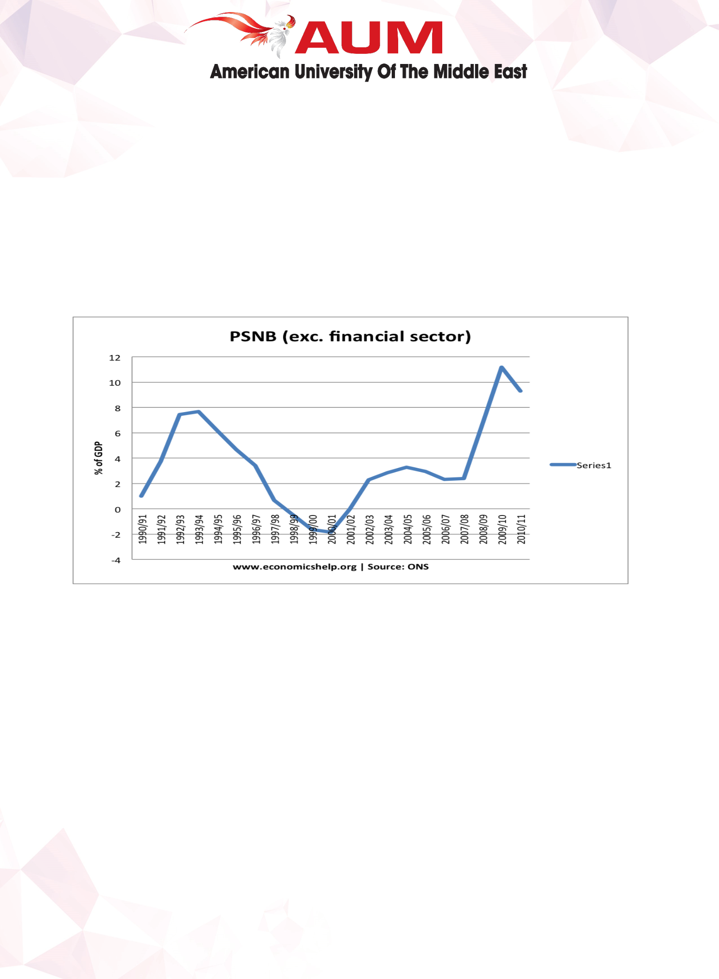
Expansion phase
Recession phase
Expansion phase
Expansion phase
Recession phase
Recession phase

2. Expansion economic phase is characterized by the growth macroeconomic indicators like the increase in the per capita income, increased domestic product, increased rate of employment thus reduced unemployment levels and better equity markets performance. During the expansion phase, the output generated by the economy increases significantly and the country experiences efficiency in its production. Increased gross product translates to better living standards as the income per capita also increases. The country makes good use of its labor force thus the rate of unemployment decreases significantly. Since the companies are making profits during this phase, the price of shares and equity increases greatly thus good performance of the equity markets. The level of investments and savings rises as the amount of disposable income also rises. The number of individuals living under the poverty line reduces as dependents decrease in number with more people securing employment opportunities.
Economic contraction is a common feature in recession period. The macroeconomic indicators of recession are decreased amount of gross domestic product, reduced amount of income per head, decreased number of job opportunities thus high levels of unemployment and minimal to zero savings and investments. The equity markets perform poorly during this phase and few individuals are willing to invest their shares or stock in companies.
3. The end of the expansion period results in gradual decrease of the gross domestic product to minimal levels called the basin, reduction of the income per head, gradual job loss by individuals thus increase in unemployment rates, decrease in level of savings and thus investment besides poor performance of share markets.

4. Inflation rate is the extent to which consumers are made worse off due to commodity price increase while income remains constant. A rise in price reduces the purchasing power of consumers as they reduce the consumption basket number of items. When inflation occurs, consumers obtain less goods with the same amount of money they used to spend initially. Inflation, thus, reduces the utility of consumers as they are made to have limited options to choose from.
PROBLEM 3
- The rate of unemployment = number of people in Kuwait who are unemployed/ country’s labor force
Number of people who are unemployed = labor force – employed people
= 1,263,000 – 1,157,000
= 106,000
Rate of Unemployment in Kuwait = (106,000/1263000) *100%
= 8.4%

- The number of people in Kuwait who are not in the labor force = people of working age less people in labor force
= 1,478,000 – 1,263,000
= 215,000

- Employment population ratio = number of people who are employed/ number in working age
= (1,157,000/1,478,000) * 100%
= 78.3%

- Labor force participation rate = (number in labor force / number in working age) * 100%
= (1,263,000/1,478,000) *100%
= 85.5%
PROBLEM 4
- Pencil CPI in 2015 = (pencil cost in 2015/pencil cost in 2010) * 100%
= ((6*14)/ (6*12)) *100%
= 116.7
Tablet CPI in 2015 = (tablet basket cost in 2015/tablet basket cost in 2010) * 100%
= ((10*12)/ (10*15)) *100%
= 80
Sunglasses CPI in 2015 = (sunglasses basket cost in 2015/sunglasses basket cost in 2010) * 100%
= ((12*150)/ (12*180)) *100%
= 83.3

Pencil CPI in 2016 = (pencil cost in 2016/ pencil cost in 2010) * 100%
= ((6*14)/ (6*12)) *100%
= 116.7
Tablets CPI in 2016 = (tablet basket cost in 2016/ tablet basket cost in 2010) * 100%
= ((10*12)/ (10*15)) *100%
= 80
Sunglasses CPI in 2016 = (sunglasses basket cost in 2016/ sunglasses basket cost in 2010) * 100%
= ((12*130)/ (12*180)) *100%
= 72.2

- The inflation rate for each item in 2016 can be calculated as:

pencil= ((116.7-116.7)/116.7) *100% = 0%
The price of pencils did not change between 2015 and 2016.

Tablets = ((80-80)/80) *100% = 0%
The price of tablets did not change between 2015 and 2016

Sunglasses = ((72.2-83.3)/72.2) *100% = -15.4%

The cost of sunglasses reduced by 15.4% between 2015 to 2016

