ECONOMICS
Question 7
a)

b)
At Equilibrium price= Quantity demanded= Quantity supplied:
10+ Q = 100 – Q
Q+Q = 100 – 10
2Q = 90
Therefore,
Q_{e} = 45
P = 10 + Q = 100 – Q
But Q = 45, hence
P_{e}= (10+45) = (100-45) = 55
Equilibrium price and Quantity are 55 and 45 respectively.
c)
Total Revenue = Equilibrium Quantity * Equilibrium price
= ( 45 units)* (55units)
= 2475 units
d)
Consumer Surplus = Area above equilibrium point but below demands curve = triangular
= 0.5 (base * height)
= 0.5(45*45)
= 1012.5
e) Producer Surplus = Area above supply curve but below equilibrium price point= Triangular
= 0.5 (base * height) = Base = 55-10 = 45 and Height = 45
= 0.5(45*45)
= 1012.5
f) The total Surplus = Consumer surplus+ Producer Surplus
= (1012.5 + 1012.5) = 2(1012.5)
= 2025

Question 8
- Demand: P= 100 – (1/2)Q
Supply: P= 10+ (13/10)Q
At equilibrium, Demand equals supply, hence;
100 – (1/2)Q = 10+ (13/10)Q
100 – 10 = (13/10 +1/2) Q
90/1.8 = 1.8Q/1.8
Q_{e} = 50

P_{e} = 100 – (1/2) Q but Q = 50, hence
P_{e =} 100 - 0.5* 50
= 100- 25
P_{e} = 75

b)
Total revenue for farmers is equal to price times quantity.
($75 per unit of corn) *(50 units of corn) = $3750.

c) When the price of corn is $80 per unit of corn, consumers will purchase 40 units of corn. Use the demand curve to find this quantity: P = 100 – (1/2)(Q) or 80 = 100 – (1/2)Q or Q = 40 units of corn.
d) When the price of corn is $80 per unit of corn, suppliers will supply 54 units of corn. Use the supply curve to find this quantity: P = 10 – (13/10)Q or 80 = 10 – (13/10)Q or Q = 54 units of corn (this is rounded). Since consumers consume 40 units, this means that the government will purchase the surplus of 14 units.
e) The cost to the government is equal to the (price per unit of corn)(units of corn purchased by the government) + (units of corn purchased by the government)(storage costs per unit of corn). Or, the cost to the government is equal to ($80 per unit of corn)(14 units) + (14 units)($10 per unit of corn) = $1260.
f)
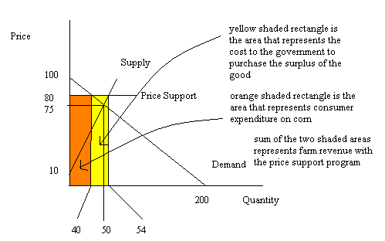
g. With a price guarantee of $80 per unit of corn consumers will purchase 54 units of corn. To see this recall that if the guaranteed price of corn is $80 per unit then suppliers will be willing to produce 54 units. With the price guarantee program the farmers will then sell all of this corn for whatever price they must in order to sell 54 units. Thus, consumers will buy the entire 54 units of corn.
h. With the price guarantee suppliers produce 54 units of corn. Consumers are only willing to pay $73 per unit of corn for this amount. To see this, use the demand curve: P = 100 – (1/2) Q where Q = 54. Thus, P = 100 – (1/2) (54) = $73 per unit of corn. The total expenditure on corn made by consumers is ($73 per unit of corn) (54 units of corn) = $3942.
i) With a price guarantee program the government does not buy any of the good. There are no storage costs since the government has not purchased the good.
j) The cost to the government is the difference in the guaranteed price of $80 per unit of corn minus the price the corn actually sells for ($73 per unit of corn) times the number of units of corn sold. Thus, the cost to the government is ($80 per unit of corn - $73 per unit of corn) (54 units of corn) = $378. There are no storage costs.
k.)
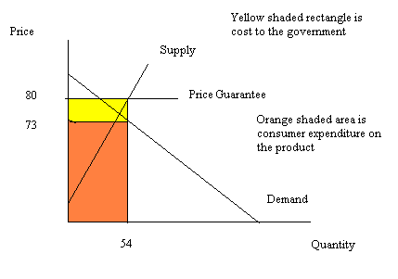

Question 9.

.
- How big an excise tax will the government need to implement in order to reduce consumption to 50,000drinks?
From the information given;
Demand: Q = -50000P + 150000
Supply: Q = 50000P
To find the price consumers must pay in order to demand only 5000 drinks use the demand equation and substitute Q = 50000 into that equation. Thus, 50000 = -50000P +150000 or P = $2.
Thus, the government will impose an excise tax of $2 to reduce consumption of drinks to 50000 drinks.

Use the supply and demand curves to find the equilibrium price and quantity:
-50000P + 150000 = 50000P
150000= 100000P or P = $1.5
Q = 50000(1.5) = 75000 drinks

To calculate the producer surplus, we first need to determine the y-intercept of the supply curve: so, use the supply curve and set Q = 0 to find this y-intercept. Thus, 0 = 50000P or P = $0. Producer surplus is thus equal to (1/2) (($1.5 /drink- $0/drink) (75000 drinks) = $56250

Deadweight loss from this quantity control program = (1/2)($3/drink - $1.5/drink)(75000 drinks – 50000 drinks) = $18750.

Question 10. [Textbook Chapter 9] (1 mark)
- To find the equilibrium price and quantity simply use the demand and supply curves. Thus, 1000– (1/5) Q = 200 + (1/15) Q and solving for Q, we get Q = 3000 units. Using this quantity in either the demand or the supply equations we can find the price: P = $400.

b.
If the world price is $300 per unit of bananas and this economy opens to trade, then at $300 domestic demanders will demand 3500 units of bananas. At $300, domestic suppliers will supply 1500 units of bananas. The less supply of 2000 units of bananas will be imported.

c.
Consume surplus when the banana market was closed to trade was equal to (1/2)($1000/unit of bananas - $400/unit of bananas)(3000 units of bananas) = $900000. CS when the banana market is open to trade is equal to (1/2)($1000/unit of bananas - $300/unit of bananas)(3500 units of bananas) = $1225000. The benefit is consumer surplus when the banana market opens to trade is equal to $325000.

d.
When the world price is $300 per unit of bananas domestic demanders will demand 3500 units of bananas while domestic suppliers will supply 1500 unit of bananas. The excess demand for bananas of 2000 units will be met by importing 2000 units of bananas into this small economy.

e..
With the tariff the price of bananas rises to $1250. At this price 1500 units of bananas will be supplied domestically and 1000 units of bananas will be demanded domestically. The small country will therefore import 1000 units of bananas and collect a tariff of $1.25/unit of bananas on these imports. Tariff revenue is therefore equal to ($1.25/unit of bananas)(1000 units of bananas) = $1250 Deadweight loss is equal to (1/2)($1250/unit of bananas - $400/unit of bananas)(3000 units of bananas – 300 unit of bananas) + (1/2)($1250/unit of bananas - $1000/unit of bananas)(1000 units of bananas – 300 units of bananas) = $125000.

f.
With the tariff the small economy imported 1000 units of bananas. If the quota was set at 1000 units of bananas then the quota would have the same impact as a tariff of $1250/unit of bananas on consumer surplus, producer surplus, and deadweight loss.

g.

When an economy opens to trade in a market typically either the world price is greater than or less than the domestic equilibrium price. If the world price is greater than the domestic equilibrium price then the economy that has opened its market to trade will export the good: domestic producers will benefit while domestic consumers will be hurt from this trade. If the world price is less than the domestic equilibrium price then the economy that has opened its market to trade will import the good: domestic producers will be hurt while domestic consumers will benefit from this trade which is the case in e) above, where importer benefits from importing to meet demand.

Question 11.

a) (I) The resultant allocation of resources to highway construction rather than some other use.
(ii) Air pollution
(iii) Cost associated with health issues of those with respiratory illnesses due to air pollution.
(iv) Externality costs of accidents.
b)
The marginal social cost of the gasoline curve will be located to the left of the supply curve. This is due to the fact that the marginal cost of gasoline includes so many costs which are not included currently in the market supply curve.
c) At Equilibrium,
Quantity supplied = Quantity demanded
Demand: 50,000 – 5000P
Supply: 20,000P
= 50000 – 5000P = 20000P
= 25000P/25000 = 50000/25000
= P(Equilibrium price) = $2

Q(Equilibrium quality) = 50000 – 5000P but P =2;
= 50000 -5000(2)
=40000 gallons of gasoline
d)
To compute the externality cost per gallon of gasoline, then we use the information that if the market should ideally result in the consumption of 20000 gallons of gasoline. Using the two equations, Supply and Demand, we find that producers are willing to supply 20000 gallons for a price of $1 per gallon, usin supply equation.
Using the demand equation with the same 20000 gallons of gasoline, we find that demanders are willing to demand 20,000 gallons for a price of $6 per gallon.
The externality cost per gallon therefore will be $(6 -1), which is $5 per gallon.
e)
The imposition of excise tax by the government, if by $5 per gallons of gasoline, then this would cause the supply curve to shift to left by the amount of the externality cost per gallon of gasoline. The market would then provide the socially optimal amount of the good with this tax, being 20000 gallons of gasoline sold for a price of $6 per gallon.

