Campus: Bundoora
Lecturer: Debbie Showers
Group: Wednesday 2pm
EDU2CAA Curriculum and Assessment
Assessment Task 1A
RAJVI DHUNDOO (19914702)

Assessment is the ongoing process of; gathering, analysing and interpreting evidence; reflecting on findings and making informed and consistent judgements to improve student learning (Department of Education, 2019). The purpose of assessment is to accurately test subjects (Students, sports players etc) in their understanding on any given task or topic, so they can demonstrate to assessors their level of knowledge and understanding of set tasks or topics. There are many different types of assessment, however, the most common ones are Formative and Summative Assessment. Both work samples provided by Tilly and Debra are examples of the formative assessment.
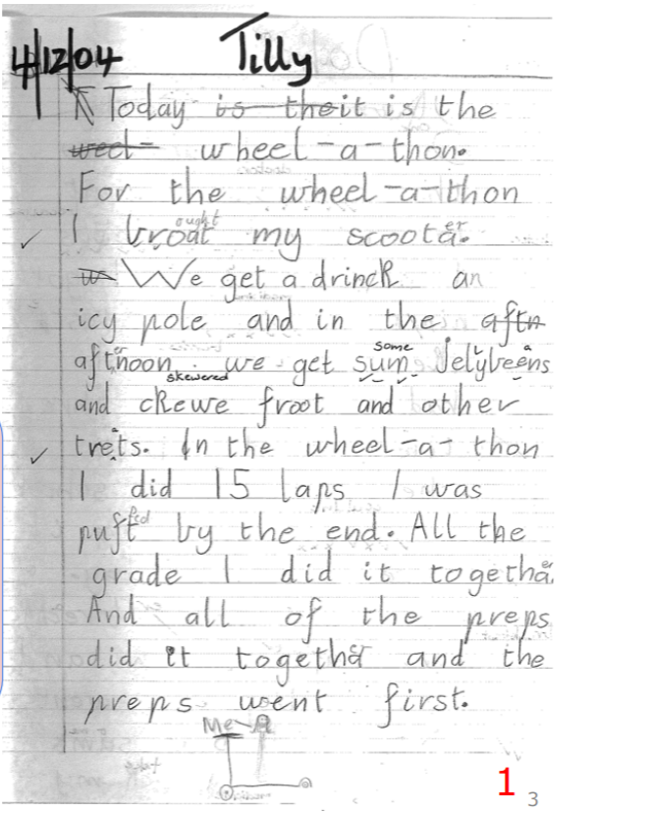
The first sample is a written piece that clearly portraits an example of a formative assessment. According to Brady (2018), formative assessment is the provided feedback to students about the progress they are making in learning new concepts, skills and attitudes. It can take place during the teaching/ learning process or as structured feedback on work samples submitted by students. Such feedback can assist students to improve their learning and can also help teachers to develop new and more effective ways of teaching. In Tilly’s writing piece, the teacher has provided feedback about their progress by ticking what is right and writing over the top of the word that had been spelt wrong.
The Victorian Curriculum and Assessment Authority (VCAA) claims that at Level 1, students must be able to ‘recognise that different types of punctuation, including full stops, question marks and exclamation marks, signal sentences that make statements ask questions, express emotion or give commands.’ Tilly has shown that she is able to recognise when to use the appropriate punctuations in her writing. She was able to place a full stop wherever needed in her writing piece. The VCAA also implies that students need to have an ‘understanding how to use visual memory to write high-frequency words, and that some high frequency words have regular and irregular components.’ Tilly has successfully achieved this requirement for the Level 1 Phonics and Word Knowledge sub-strand. As shown in the picture above, the learner wrote “weel” and crossed out the word and spelt it the correct way next to it. It can also be seen on the 6th line that she made a mistake and crossed it out and had a second attempt at writing the word.

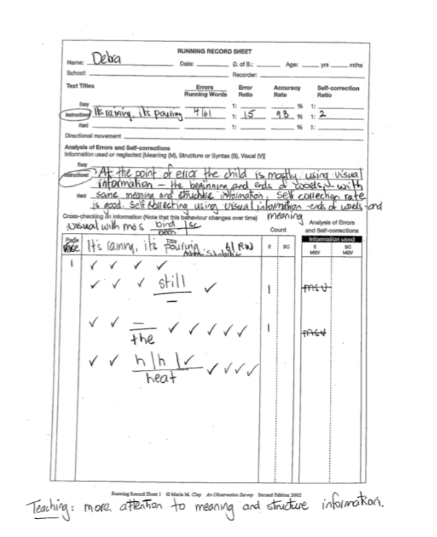
The second sample is a running record that is also another example of formative assessment. Brady (2018), indicates that summative assessment takes place at the end of a unit of work, a subject or a course, and designates the extent to which expected learning outcomes have been achieved. However, running records are often used at the beginning of the year where the teacher works individually with each student and access their reading aloud to get an idea of what reading level they are at. The teacher then decides to use subsequent running records to track their student progress throughout the year. A teacher might also decide to access an emergent reader every two to four weeks and a fluent reader every eight to ten weeks.
The sample provided is clearly showing that Debra has exceeded the Level 1 Reading Mode. All the ticks represent the achievement of knowing every word in Debra’s running record. This also shows that the text was too easy for her and that she might be performing at a Level 2 at reading.
These two samples have both been examples of formative assessment and have been of students working at a level 1 and perhaps working steadily towards Level 2. Both assessments link to the ‘Assessment for learning’ and ‘Assessment as learning.’ Assessment for learning occurs when teachers use inferences about student progress to inform their teaching. (Department of Education, 2019). Tilly’s teacher will now have to implement different ways of teaching her students in order to cater for every students’ learning. Assessment as learning occurs when students reflect on and monitor their progress to inform their future learning goals. (Department of Education, 2019). This is where Tilly’s and Debra’s teacher will set goals with their students and work towards achieving them together. Finally, assessment of learning which occurs when teachers use evidence of student learning to make judgements on student achievement against goals and standards. (Department of Education, 2019) will take place at the end of the unit when students will be assessed on the whole subject.

References

State of Victoria, Department of Education and Training (2019) Teaching Resources: Assessment. Retrieved from: https://www.education.vic.gov.au/school/teachers/teachingresources/practice/Pages/assessment.aspx

L Brady., K, Kennedy (2018) Assessment and Reporting: Celebrating Student Achievement. Victoria: Pearson Melbourne

Victorian Curriculum and Assessment Authority (2019) Victorian Curriculum Foundation – 10: English Curriculum. Victoria State Government. Retrieved from: https://victoriancurriculum.vcaa.vic.edu.au/english/curriculum/f-10

