PART A

WAVELENGHT AND THE EMMISION OF PHOTOELECTRONS

QUESTION 1; changing the value less than the value I found the metal target started to emit electrons. Moving away from the ir region.
Question 2moving away further for other metals the electrons were emitted.
Its shows that the lesser the wavelength the more strong its in terms of emitting electrons
Question3;the general statement is that the further you move away from the uv region the more strong the wavelength is in terms of removing electrons from the metal tangent.
I have also found that the light in the IR region which is more strong as compared to that found in uv has no power to dislodge the elect
METAL | WAVELENGHT |  | threshold frequency |  | energy
SODIUM( | 386Nm |  | 7.7E5HZ |  | 5.082E^-29
zinc | 248nm |  | 1.2E6HZ |  | 1.81E^-29
copper | 226nm |  | 1.3E6HZ |  | 8.14E^-28
platinum | 177nm |  | 1.6E6HZ |  | 1.060E^-27

SAMPLE CALCULATION OF FREQUENCY
We know that
Speed of light=frequency *wavelength
C=f*labda
Frequency=speed of light divided by wavelength
Example
3.0e^8/386=7.7E5hz

Calculating energy
E=hf
Where h is the planks constant which is equal to 6.626E^-34
Example energy of photon of platinum will be
1.6E6*6.626*10^-34=1.060E-27
Part b
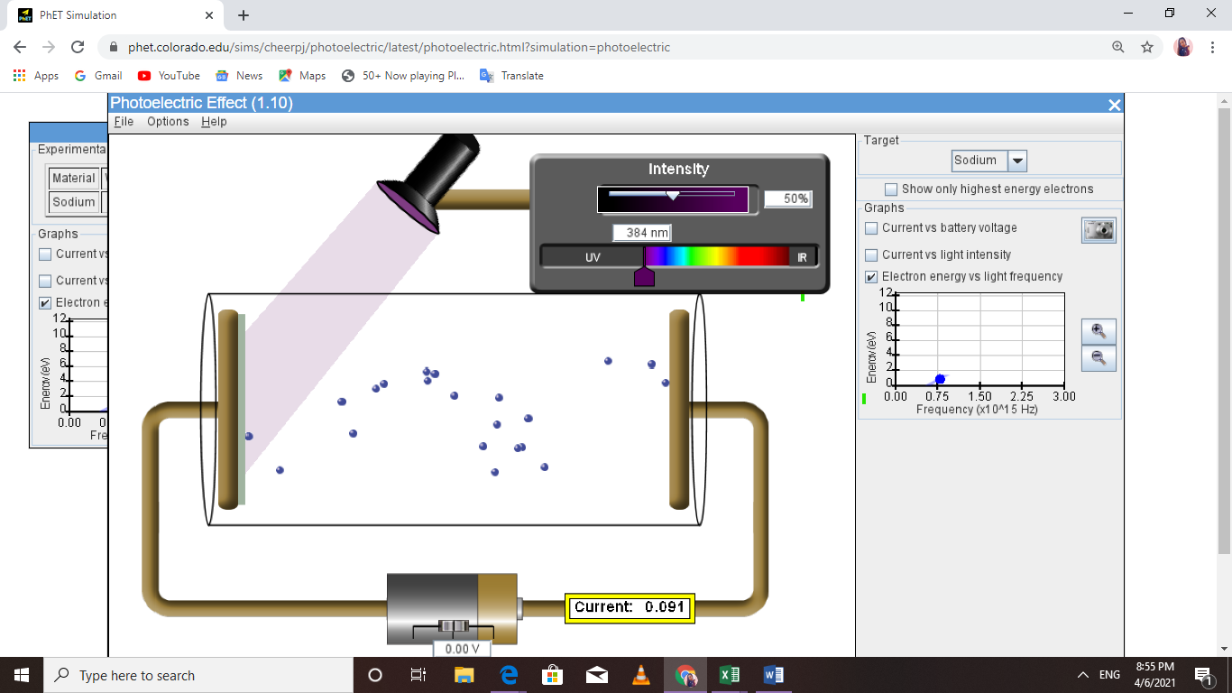

JCF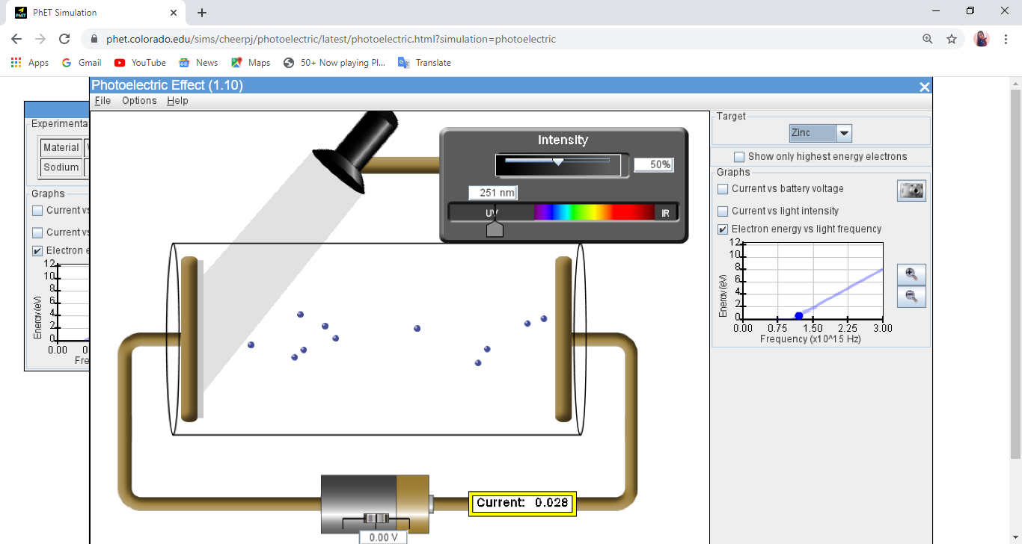

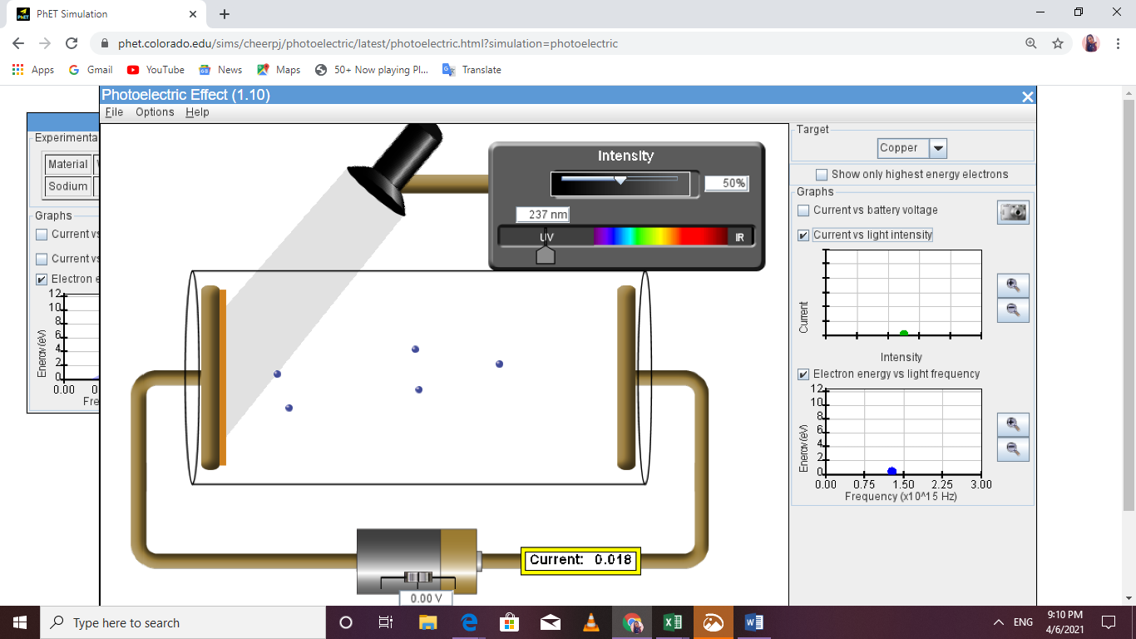

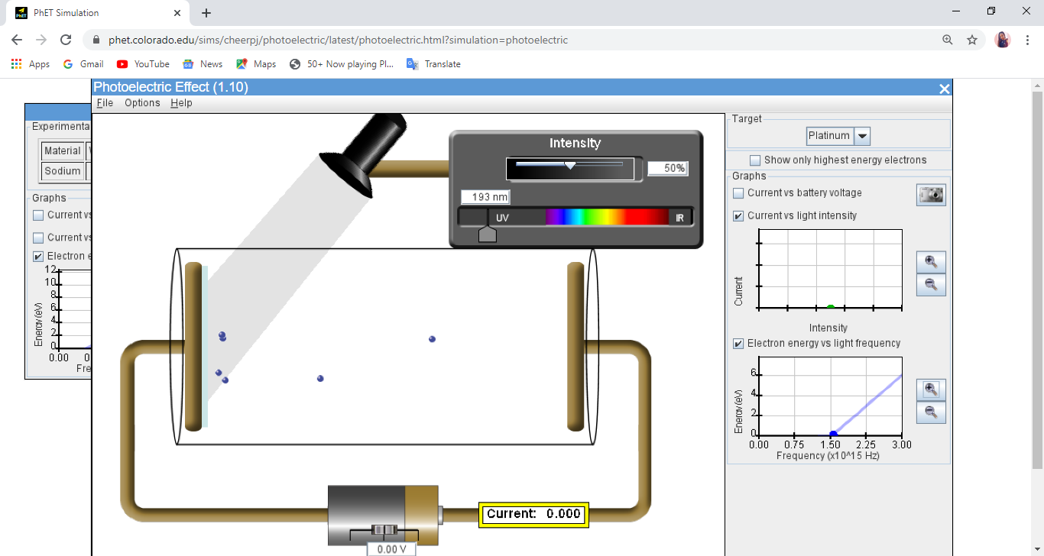

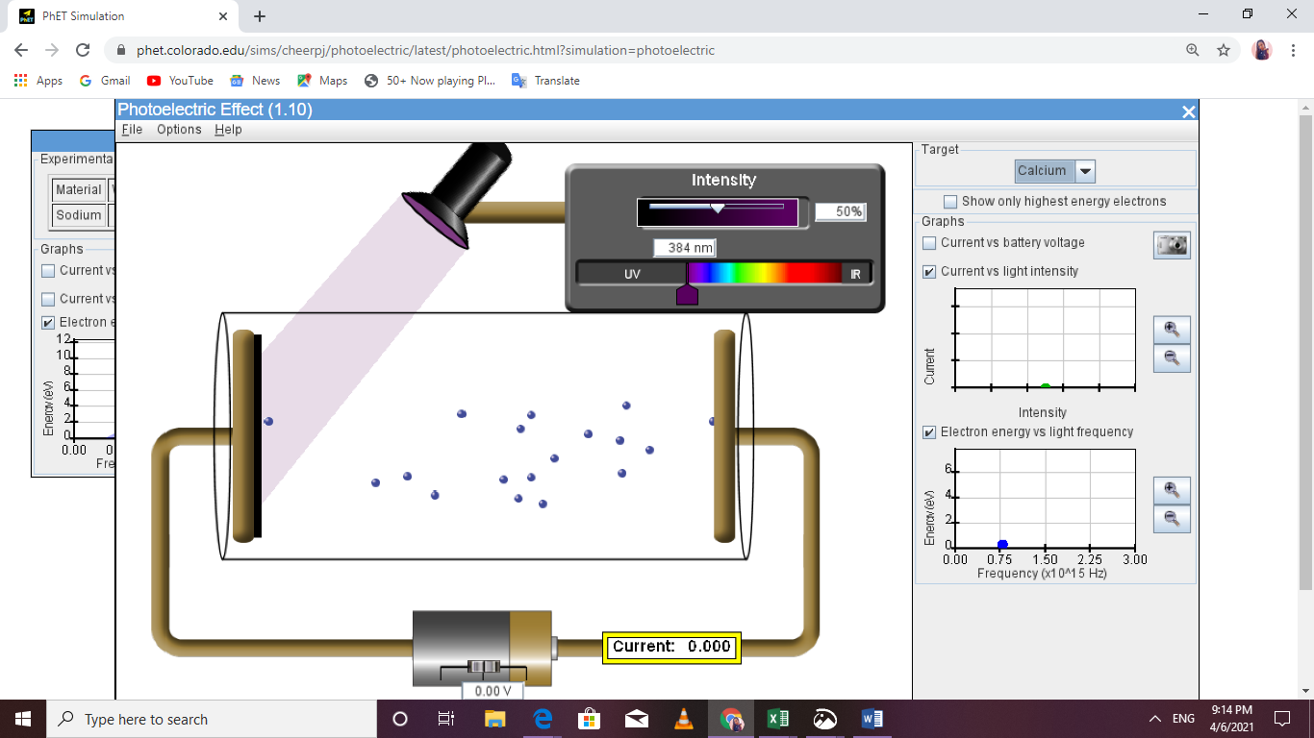

 | Frequency,threshold | E=hf
sodium | 0.78*10^15hz | 5.16E-19
copper | 1.00*10^15hz | 6.63E-19
platinum | 1.50*10^15hz | 9.94E-19
copper | 0.78*10^15hz | 5.168E-19

The values are closely related to the above values of photoelectric emission. This shows that the energy a photon requires to be emitted is almost the same to that, that it contains. A mathematical equation is as follows
E=hf-h*Threshold frequency or fnot

PART C

Increasing the intensity of light INCREASES the power of the light intensity to dislodge electrons.
The number of electrons coming out INCREASED EVENTUALLY increasing the intensity leads to an increase in number of electrons

intensity | Current(Ma)
10% | 0.000
20% | 0.000
30% | 0.015
40% | 0.021

50% | 0.026
60% | 0.032
70% | 0.036
80% | 0.042
90% | 0.047
100% | 0.52

Yes there is a relationship increasing the light intensity increases the number of electrons coming out thus having a direct effect on photoelectric emission. An increase in intensity dislodges more electrons .
Increasing the wavelength leads to a decrease in number of electrons and eventually stopping coming out ie its power to dislodge electrons reduces.

The type of light affects the amount of photons being dislodged. We have seen that in our experiment that the light that lies in the infrared radiation region cannot dislodge electrons but that of uv can dislodge electrons

Because an electron behaves both as a photon and a wave in nature. It has to absorb some energy for it to be dislodged.
It has to gain some energy or to be quantized so that it can get excited and move to the next energy level and radiate some energy which will result to photoelectric emmmison

