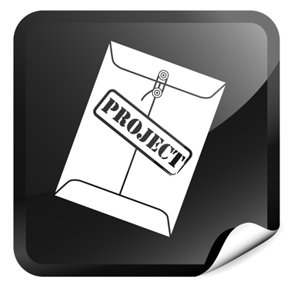
Project 2
Evaluation 32
Multicultural Literature (ENGH 015 062)
Be sure to include ALL pages of this project (including the directions and the assignment) when you send the project to your teacher for grading. Don’t forget to put your name and I.D. number at the top of this page!
This project consists of two parts, each worth 50 points for a total of 100 points. Note that grammar, spelling, and proper citation of sources are important for this project. Refer to the appendix in this syllabus for guidelines on writing conventions.

Part A
This portion of the assignment will involve examining a piece of literature more closely and looking at how the author’s life and beliefs are reflected in the writing. Writers write about what they know and observe. The time and place in which an author lives influences the works that he or she creates. Many authors intentionally include details about the time and place in which they lived as a form of social commentary.
First, you will select a piece of literature that you have read in either Unit 2 or Unit 3. Then, you will examine how the writer is reflected through that piece of writing. How does the author communicate his or her view of the world through the piece of writing? Look at how the piece of writing portrays the setting, the characters, and the theme. Examine the writing style. Look for a stance on a topic based on the time and place in which the author lived and compare it to where and when the story is set. Observe how the author's own experiences are reflected in the writing. Decide whether or not the writer is using the story as a vehicle for social commentary. If so, what is the author's stance on the social issues of the time? How is this idea communicated to the reader?
1. Research the period in which the story is set to learn more about the historical background and why it is important. Use the author information in the textbook and lessons as a place to start. How is the time period reflected in the story?
2. Review the information provided about the author in the textbook and lessons. Go beyond this information to learn more about the particular author that you have selected. What did you learn about the background of the author that is reflected in his or her writing?
3. Examine the characters, setting, plot, and theme of the story to draw some conclusions about how the story reflects the information about the author's purpose and background. Find specific evidence from the story to support your ideas. What evidence in the story did you find that shows the author's purpose and background?
4. Write a well-developed essay that analyzes how the author's purpose and background are reflected in the story. A brief summary of the story will be part of the essay. However, the essay is to be an analysis of the author’s background and purpose, not just a summary of the story. Be sure that all of the questions above are addressed in your essay.

Follow these guidelines for organizing your essay:
Thesis Statement
Develop a thesis statement, which will be the basis for your essay. The thesis statement will answer these questions:
- What is the subject of my essay?
- What is my opinion on this subject?
Your thesis statement must include:
- the name of the author
- the name of the work about which you are writing
- a statement that is a clear response to the questions being asked
Introduction
The introduction to your essay will include your thesis statement, an attention getter or a hook to get the reader interested in the topic, and general background information necessary to inform the reader and provide a context for the remainder of the paper.
Main Body
Your essay must include information about the author's background, the time period, and specific evidence from the story to prove the thesis and answer the questions.
- Ensure each point is given a new paragraph.
- Write a well-developed topic sentence for each body paragraph that covers one topic and supports the thesis.
- Explain the topic and use evidence from the text or your outside sources to support the topic.
- Write a concluding sentence to finalize your discussion of that topic.
- Use transitional words or phrases at the start of each paragraph and within the paragraph that will guide the reader through the paper and show how each topic relates to the previous paragraph or topic. A few examples of transitional words are “however,” “in addition,” “for this reason,” “nevertheless,” and “moreover.”
Conclusion
The concluding paragraph for your essay should wrap up and draw the essay to a close. You should restate your main points in a new and refreshing way. Then, you should draw the essay to a graceful conclusion by finalizing your thoughts on the topic.
Review
My Thesis:
- Does it directly respond to the assigned topic?
- Is it an opinionated statement?
- Do I introduce the writer and the title of the piece of writing?
- Does my paper cover everything that I promised I would in my thesis? (If not, revise the thesis or develop the body portion of the essay.)
My Topic Sentences:
- Are each of my topic sentences broad topic statements?
- Does each statement relate directly to the thesis?
My Evidence:
- Do I have enough evidence to prove each of my topic sentences?
- Is my evidence specific?
- Have I cited direct quotations? Be sure to create in-text citations as well as a bibliography page for your sources. Use MLA formatting for these citations. (Review the formatting page in the appendix of this course.)
My Conclusion:
- Have I restated my overall point and made a final statement about what my essay shows?
Editing and Proofreading
Print a hard copy of your draft. Read it aloud and check for the following:
- no skipped words
- complete sentences
- correct spelling
- correct words (for example “there” or “their”)
- appropriate use of apostrophes
- appropriate use of commas
- appropriate use of semicolons
- appropriate use of colons
- appropriate use of quotation marks
The paper will be at least 600 words in length (two typed, double-spaced pages) and will be worth 50 points. The essay will be scored according to the criteria in the following rubrics.

Structure | 5 | 4 | 3 | 2 | 0
Focus on Assigned Topic  (5 points possible) | Thesis is engaging and specific; goes beyond the obvious. Thesis directs the topic and purpose. | Thesis is specific and directs the topic and purpose. | Thesis announces the topic and purpose | Thesis is incomplete. | No attempt has been made to relate information to the assigned topic.
Introduction  (5 points possible) | Effective hook/attention getter provides unexpected yet appropriate background information. | Effective hook/attention getter with relevant, controlled background information. | Uses weak hook/attention getter and/or background information lacks control. | The introduction is vague and incomplete. | Introduction is lacking. No attempt has been made to connect the details.
Main Ideas  (5 points possible) | Main ideas stand out and are varied and original.  All of the topics are covered. | Main ideas are evident.  Most topics are covered. | Main ideas are repetitive, random, and/or lack focus.  One or more of the topics is missing. | Main ideas are difficult to determine, disconnected, or irrelevant. Only one topic is covered. | Main ideas are not evident.  The topics are not addressed in the essay.
Supporting Details  (5 points possible) | A variety of supporting details and examples explore and enhance the main ideas. | Relevant details and examples support main ideas. | Limited or repetitive details are listed that support the main ideas. | Supporting details are consistently irrelevant. | No supporting details are included.
Order and Development of Ideas  (5 points possible) | Sequencing is intentional and emphasizes the strengths of the paper.  Provides clear and well-focused explanations to develop each idea. Reasoning is logical and sound. | Sequence parallels introduction / thesis. Supporting details are present where they fit.  Explanation is generally clear and focused.  Each idea is developed. Reasoning is usually logical and convincing. | Misplaces order of some paragraphs and/or supporting details in paragraphs.  Explanation is somewhat clear but limited. Somewhat focused but contains some digressions from the topic. Reasoning is unclear. | Order of paragraphs seems random and similar details are not grouped together.  Explanation is limited and unclear in places. Not all topics are addressed. Reasoning is not logical or clear. | No attempt at order is apparent.  No attempt is made to explain the ideas.
Quotations  (5 points possible) | At least one valid quotation is used in each body paragraph. It is relevant and well placed.  MLA citations used correctly.  Works Cited page done correctly. | At least one quotation is used in each body paragraph.  Follows MLA format with few errors.  Works Cited page is used with few errors. | Quotations are used in some body paragraphs but not all of them.  Follows MLA format with some errors.  Works Cited page contains many errors. | Quotations are misplaced or not used appropriately in body paragraphs.  Does not use MLA format. Missing needed citations.  Works Cited page incomplete. | No quotations are included.  No Works Cited page included.
Conclusion  (5 points possible) | Provides resolution/closure by revisiting the hook and/or major details with fresh phrasing. | Links the conclusion directly to the introduction without complete repetition; may incorporate hook. | Conclusion is ineffective, awkward or merely repeats the introduction, thesis, and main ideas. | The conclusion is weak or incomplete. | Conclusion is lacking.

Conventions | 5 | 4 | 3 | 2 | 0
Vocabulary  Accuracy/ Word Choice  (5 points possible) | Vocabulary is precise, vivid, and natural.  Enhances the intended message. | Vocabulary is accurate and active. Contributes to the intended message. | Vocabulary is mostly accurate, but ordinary. Contributes to the message in a limited way. | Vocabulary is used inaccurately, detracting from the message. | Words do not make sense as they are used. Reader is confused.
Spelling and Punctuation  (5 points possible) | Almost all words are spelled correctly.  Almost no errors in English usage or grammar.  Almost no errors in punctuation. Almost no errors in capitalization. | Some spelling errors, but are not enough to impede understanding. Some errors in usage or grammar, but not enough to impede understanding.  Contains some errors in punctuation, but are not enough to impede understanding. Contains a few errors in capitalization. | Some spelling errors may impede understanding. Errors in usage or grammar impede understanding at times.  Errors in punctuation may impede understanding at times.  Errors in capitalization may intrude on understanding. | Numerous spelling errors impede understanding. Contains numerous errors in grammar or usage.  Errors in punctuation impede understanding. Contains numerous errors in capitalization. | Misspells most common and complex words. Punctuation is lacking.
Sentence Fluency and Paragraphing  (5 points possible) | Sentences are smooth and easy to read.  Varied in length and structure throughout. Writing demonstrates a solid use of paragraphing. | Sentences are easy to read and varied in length and structure at times. Paragraphing is generally used correctly. | Sentences are sometimes awkward.  Limited or repetitious sentence structures, length, and beginnings. Paragraphs are attempted. | Sentences contain a lack of fluency and are difficult to read. Choppy or run together sentences create a distraction to the reader. Paragraphs are lacking. | No paragraphing is used. Uses only fragments and run-ons throughout.
Total Score out of 50 Points:

Part B
In Lessons 5 and 6, we discussed the hero's quest and the characteristics of the archetypal hero or heroine. Review the diagram below and the information in the lessons about the traits of a literary hero.

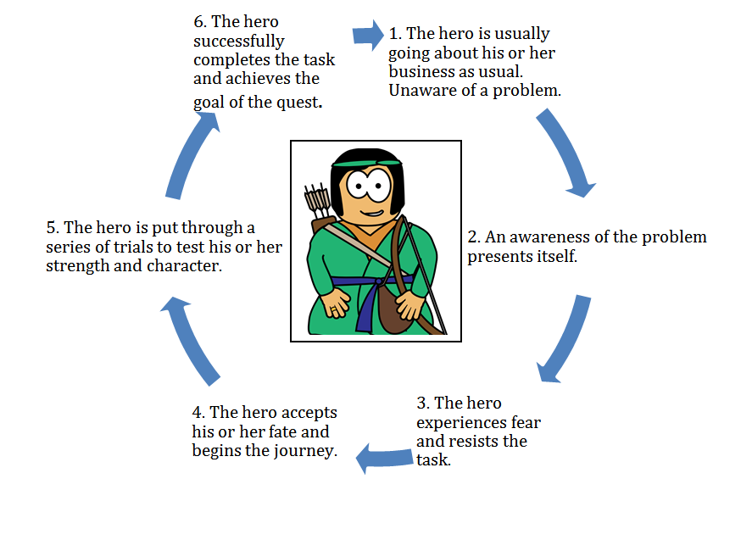
Using the information about a hero’s journey and the traits of a hero, write an original story about a hero who has all of these traits and follows the path of a typical hero's journey. Be sure that your story has all of the necessary elements of a story. It must have a specific setting, a protagonist (the hero or heroine), an antagonist (the villain or someone or something that keeps the hero from reaching his or her goal), and a plot that illustrates all of the aspects of the traditional hero's journey.
The paper will be at least 600 words in length (two typed, double-spaced pages) and will be worth 50 points. The story will be scored according to the criteria on the following rubrics.

Structure | 5 | 4 | 3 | 2 | 0
Focus on Assigned Topic  (5 points possible) | Entire story is related to the assigned topic. Reader clearly understands topic. | Most of the story is related to the assigned topic. The story wanders off at one point, but the reader can still understand topic. | Some of the story is related to the assigned topic. Reader does not learn much about the topic. | Little attempt has been made to relate the story to the assigned topic. | No attempt has been made to relate the story to the assigned topic.
Organization  (5 points possible) | The story is very well organized. One idea or scene follows another in a logical sequence. Clear transitions are used. | The story is pretty well organized. One idea or scene may seem out of place.  Clear transitions are used. | The story is a little hard to follow.  The transitions are sometimes not clear. | Ideas and scenes seem to be randomly arranged. | Organization is lacking. No attempt has been made to connect the details.
Setting  (5 points possible) | Many vivid, descriptive words are used to tell when and where the story took place. | Some vivid, descriptive words are used to tell the audience when and where the story took place. | The reader can figure out when and where the story took place, but the author didn't supply much detail. | The reader has trouble figuring out when and where the story took place. | Setting is not included in the story.
Problem/ Conflict  (5 points possible) | Very easy for the reader to understand the problem the main characters face and why it is a problem. | Fairly easy for the reader to understand the problem the main characters face and why it is a problem. | Fairly easy for the reader to understand the problem the main characters face, but it is not clear why it is a problem. | It is not clear what problem the main characters face. | The conflict is not present in the story.
Characters  (5 points possible) | Main characters are named and clearly described in text.  Most readers could describe the characters accurately. | Main characters are named and described.  Most readers would have some idea of what the characters looked like. | Main characters are named.  The reader knows very little about the characters. | It is hard to tell who the main characters are. | Character description is lacking.
Hero’s Journey  (5 points possible) | The plot is well focused and clearly follows the pattern of the hero’s journey. | Follows the pattern of the hero’s journey. It is not exceptionally clear. | Follows some of the pattern of the hero’s journey, but not all of it. | Hard to recognize the pattern of the hero’s journey. | No attempt is made to follow the hero’s journey pattern.
Resolution  (5 points possible) | Solution to the character's problem is logical and easily understood.  No loose ends. | Solution to the character's problem is easy to understand.  It is somewhat logical.  A few loose ends. | Solution to the character's problem is a little hard to understand.  Many loose ends. | Solution is attempted, but it is hard to understand. | The story has no conclusion or resolution.

Conventions | 5 | 4 | 3 | 2 | 0
Vocabulary  Accuracy / Word Choice  (5 points possible) | Vocabulary is precise, vivid, and natural.  Enhances the intended message. | Vocabulary is accurate and active. Contributes to the intended message. | Vocabulary is mostly accurate, but ordinary. Contributes to the message in a limited way. | Vocabulary is used inaccurately, detracting from the message. | Words do not make sense as they are used. Reader is confused.
Spelling and Punctuation  (5 points possible) | Almost all words are spelled correctly.  Almost no errors in English usage or grammar.  Almost no errors in punctuation. Almost no errors in capitalization. | Some spelling errors, but are not enough to impede understanding. Some errors in usage or grammar, but not enough to impede understanding.  Contains some errors in punctuation, but are not enough to impede understanding. Contains a few errors in capitalization. | Some spelling errors may impede understanding. Errors in usage or grammar impede understanding at times.  Errors in punctuation may impede understanding at times.  Errors in capitalization may intrude on understanding. | Numerous spelling errors impede understanding. Contains numerous errors in grammar or usage.  Errors in punctuation impede understanding. Contains numerous errors in capitalization. | Misspells most common and complex words. Punctuation is lacking.
Sentence Fluency and Paragraphing  (5 points possible) | Sentences are smooth and easy to read.  Varied in length and structure throughout. Writing demonstrates a solid use of paragraphing. | Sentences are easy to read.  Varied in length and structure at times.  Paragraphing is generally used correctly. | Sentences are sometimes awkward.  Limited or repetitious sentence structures, length, and beginnings. Paragraphs are attempted. | Sentences lack fluency and are difficult to read. Choppy or run-on sentences distract the reader.  Lacks paragraphs. | No paragraphing is used. Uses only fragments and run-ons throughout.
Total Score out of 50 Points:

Project Submission
This project can be submitted electronically. Access the online version of your course and follow the directions provided for Project 2. (Go to Project 2 in Unit 3 on the navigation panel.) Check “Project Submission” on the homepage of your online course management system for more information.
For mail submission directions, refer to the enrollment information included with your print materials.

