THE ENGLISH LANGUAGE UNIT  YANBU UNIVERSITY COLLEGE  YANBU INDUSTRIAL CITY  SAUDI ARABIA | 
Final Project
Academic Year 2019 – 20G (1440 – 41 H) Spring Semester 192

ENGL 211- Business Report Writing

Student's Name:
Student’s ID: |  |  |  |  |  |  |  |  | Section: | ________

General Instructions:
Follow the Instruction Given in Each Section of this Project + Class Instructions

FOR INSTRUCTOR'S USE ONLY
TOTAL MARK: 40 | MARK AWARDED: ______
MARKED BY: ______________________ | SIGNATURE: _______________

Some Economic Parameters in the Green Valley City

Name:
ID:
College:
Department:
Specialty:
Date:

Introduction
(One short paragraph of around sixty words to explain the goal of this report)
(5 points)
The goal of this report is to represent graphically the analysis collected by explaining the economic parameters of green valley city in terms of production of energy? Illustration on how it evolved to newer methods of production of energy? Comparison on the sale of oil and natural gas and some of the educational parameters within the city? Over the years provided.
Method
- Types of data used in this report (quantitative, qualitative, etc)
(5 points)
Percentages in production of energy over the years.
Educational parameters, that is, preschool, basic education, secondary education, college and graduate schools.
The sale of oil compared to natural gases in barrels
- Which graphics will be used to present data and why?
Bar charts. They are used to show how data changes with time. Some of the advantages of using it is, easy to read and interpret, summarizes a large set of data and it brings a clear comparison between size.
Pie charts. A graph divided in circles where each section represents a proportion of a whole. It has these advantages that is, it’s simple and easy to understand, it is an easier way to present data and its easy to elaborate and emphasize points with it.
Bar chart with a line graph. This a combination of both bar charts and line graph in one chart. Its is used to bring visualization of data, gives a better report of data and can be used to present large amount of data.
Analysis and Discussion
(35 points)
In this section, you should convert the data given in the tables below into charts and graphs and to write a report of about 150 words to describe each of these charts and graphs. In case there is a diagram, you will directly write your report.
Table 3.1 Percentages of Production of Energy in the Green Valley City
 | 1990 | 1995 | 2000 | 2005 | 2010 | 2015
Oil | 48% | 45% | 46% | 35% | 23% | 16%
Natural gas | 24% | 25% | 20% | 12% | 19% | 14%
Coal | 16% | 17% | 17% | 15% | 15% | 12%
Wind | 2% | 3% | 3% | 4% | 5% | 7%
Solar | 2% | 2% | 2% | 5% | 5% | 9%
Hydropower | 6% | 6% | 6% | 21% | 22% | 24%
Biomass | 2% | 2% | 3% | 4% | 5% | 10%
Geothermal | 0% | 0% | 3% | 4% | 6% | 8%
(You must change the whole table into a comprehensive bar chart and two pie charts of your own choice- for example you choose any two years to compare/contrast. You will write two paragraphs, one about the bar chart and one about the two pie charts)
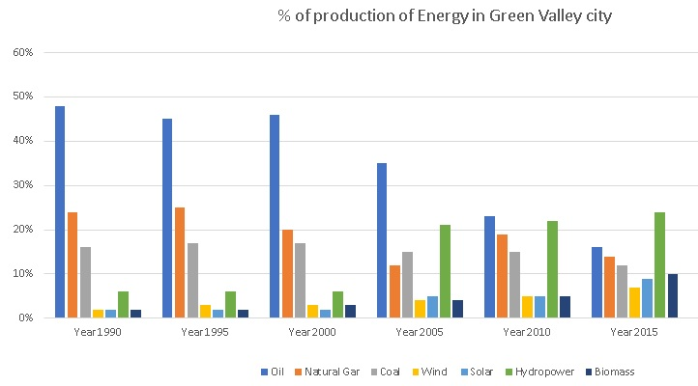
From the bar chart, it can be seen that the production of energy from oil source has drastically reduced over the years. While if we consider the natural gas and coal, then it is less or more same. But in contrast to Oil, we can observe that %production from Wind, Solar, Hydropower and Biomass has increased significantly over the years. So we can conclude that the dependency on new sources of production is increasing.
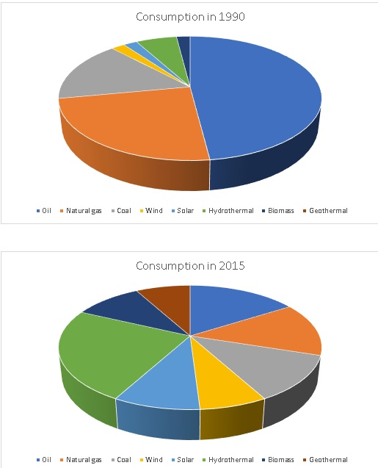
As we can observe the pie charts of year 1990 and 2015, we can infer that earlier city was highly dependent on oil and natural gas for its production. But as time has passed they have increased the on a number of means, as the second pie chart is more uniformly distribute


Process Diagram (3. 1): A Model of Hydroelectric Power Generation in the Green Valley

Table 3.2 Sales of in Oil and Natural Gas in Barrels in the Green Valley City
Month | Oil | Natural Gas
Jan | 208 | 265
Feb | 858 | 1630
March | 845 | 1276
April | 490 | 987
May | 955 | 889
June | 1217 | 1265
July | 2467 | 857
Aug | 3605 | 1228
Sept | 4876 | 1868
Oct | 2969 | 1290
Nov | 6876 | 1890
December | 2244 | 1236
(You need to change the table into a bar chart with a line graph on the same figure)
Example:
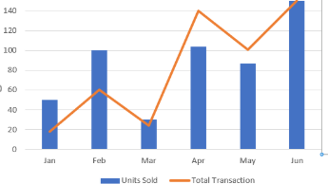
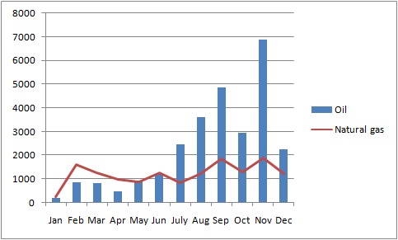
Table 3.3 Educational parameters in the Green Valley City in a decade
(Number of students in each level)
Month | 1995 | 2005 | 2015
Preschool | 423 | 657 | 814
Basic education | 567 | 886 | 1206
Secondary education | 456 | 678 | 1200
College | 678 | 987 | 2088
Graduate Schools | 12 | 68 | 208
(You need to change the table into a suitable graph/chart)
